MINISTRY OF EDUCATION AND SCIENCE OF THE REPUBLIC OF KAZAKHSTAN

MUKHAMETKALIYEVA GULNAR

ENGLISH INTERCULTURAL COMMUNICATION

Almaty, 2021

УДК
ББК

Резензенты:
Таирбекова Л.Н. – доктор филологических наук, профессор КазУМОиМЯ им.Абылай хана
Мирзоева Л.Ю. – доктор филологических наук, доцент Университета им. С. Демиреля
Шаяхметова Д.Б. - кандидат педагогических наук, профессор УИЯиДК

Mukhametkaliyeva G.O.
Content and language integrated learning: Kazakhstani experience. Almaty, 2021. -94 р.

В учебном пособии анализируется проблема формирования иноязычной коммуникативной компетенции у учащихся старших классов профильных школ на базе контентно-языковых интегрированных технологий (CLIL), что является актуальным вопросом на сегодняшний день, в связи с новой организацией содержания образовательной парадигмы. В монографии рассматриваются вопросы, связанные с появлением и использованием CLIL в казахстанских школах, представлены методические рекомендации по применению контентно-языковых интегрированных технологий по естественнонаучному, социально-гуманитарному направлению профильных школ. Работа предназначена для учителей – предметников, для широкой аудитории учителей иностранных языков, магистрантов и студентов филологической, педагогической и лингвистической науки и практики.

Content

Introduction ……….……….……….……….……….……….……….……….…..4
1. Historicаl background of Content and Language Integrated Learning……….…5
  - CLIL: Definition and Methodology…………….……….……….……….…….5
  - CLIL: Limitаtions аnd Possibilities......….……….……….……….……….....10
1.3 CLIL in а School System……….……….……….……….……….….………20
2. Practical Application of CLIL in а Profile School…….……….……...……….28
2.1 CLIL in Natural-scientific Disciplines …….……….……….……….……….28
2.2 CLIL in Humanities ………….……….……….……….……….……….……31
2.3 Teaching IT through English ……….……….……….……….……….……...45
3. Organizational Aspects of Teaching other Subjects through English………….49
3.1 Content of Teaching Foreign Languages in a Profile School………………....49
3.2 Lesson Planning within the frame of CLIL…………………………………...54
3.3 CLIL through Presentation, Practice and Production Stages…………………67
Conclusion ……….……….……….……….……….……….……….……….….89
References……….……….……….……….……….……….……….……………90

Introduction

In the modern world, the emphasis on communication in another language, besides the native language, is becoming a standard and the educational system is pushed to match these needs. People are no longer required to use the language only during their holidays abroad, but are increasingly forced to integrate foreign languages, especially English, in their work career or, in general terms, everyday contact with the world. The bilingual educational system is not possible for all students and thus a new methodological approach, CLIL, has been developed to cater for all students to participate in foreign language communication apart from traditional language learning classes. CLIL is a very topical issue during the process of globalization. According to D. Marsh the globalization, and the impact of the converging technologies, is resulting in the formation of a new global order affecting many societies on an unprecedented scale. Because of the need to have a shared linguistic medium, English has assumed its place as the language of communication within the new linguistic global order. It is being widely developed on two levels. Firstly, it is being increasingly introduced earlier, and more extensively, in the form of language teaching. Secondly, it is replacing other languages as a medium of instruction [1, p. 84]. We have attempted to throw light on the study of CLIL. Here you will find a range of characteristics and features of CLIL in order to clarify the importance and ways of implementing it. Usage of CLIL in the process of foreign language acquisition in senior classes of profile schools is very important nowadays. As we live in a time of competition, it is impossible not to integrate innovative technologies in foreign language classroom. In this research work, we take a primarily new approach to teaching other subjects through English language in senior classes of profile schools. We suggest that implementation of content and language integrated learning would be the most efficient in forming intercultural communicative competence of adolescents. We also give theoretical background of teaching other subjects through CLIL in profile schools. We have come to understand that in CLIL programs, students' language develops quickly. Content teachers are partners with language teachers. They provide students with additional opportunities for language learning. CLIL students almost inevitably understand and master a language much faster than those who only learn it as a subject. Thus, CLIL is a tool for the teaching and learning of content and language. The essence of CLIL is integration. This integration has a dual focus: language learning is included in content classes (math, biology, history, geography, computer programming, science, civics). This means repackaging information in a manner that facilitates understanding. Charts, diagrams, drawings, hands-on experiments and the drawing out of key concepts and terminology are all common CLIL strategies; content from subjects is used in language-learning classes. The language teacher, working together with teachers of other subjects, incorporates the vocabulary, terminology and texts from those other subjects into his or her classes. Students learn the language and discourse patterns they need to understand and use the content.
- Historical Background of Content and Language Integrated Learning

  - CLIL: Definition and Methodology

In recent years, experiments have been carried out in schools all over Europe concerning various forms of additive bilingualism. Newberry P. considers one of the most widespread forms what is commonly known as CLIL. The term itself was coined by David Marsh of the University of Jyvaskyla, in Finland, where such courses have been popular in vocational secondary education for a number of years. The term is used to describe a particular kind of language enrichment in mainstream schools [2, p. 128].
CLIL theoreticians, according to Marsh D. argue that the learning environment created by CLIL increases the learner's general learning capacities and also his motivation and interest. The integration of content subject and language creates a learning environment, which cannot be set up within isolated subject or language teaching. A CLIL classroom, which is set up according to modern educational principles, is a kind of workshop in which learners are not simply overwhelmed with school knowledge but in which the reality of the school is connected with the reality of the world outside. The artificial world of the language classroom is substituted by something more real that resembles with the world outside [3, p. 56].
Many people today spend many hours studying languages but then leave school unable to use them. In the view of Tidblom, the language classroom is important and essential for most learners to understand the structure of a language and its grammar. But there is hardly ever enough time in the classroom for the language teacher to go beyond this learning process. Learners need time to acquire a new language. This is offered by CLIL methodology. CLIL can provide learners with a more natural, meaningful way for language development, which builds on other forms of learning. Language is integrated into the broad curriculum; learners are more motivated when studying a natural language integrated in a content-based subject. Many learners in a CLIL setting forget that they are learning a language because the focus is on the subject. CLIL addresses an even broader range of learners, those who have not responded well to formal language instruction in general education and it is at the same time giving them their self-confidence back. CLIL is also giving them better opportunities for higher education and employment in enlarged Europe [4, p.68].
As Marsh comments this form of education has been common to specific types of educational institution, and localities, for many years. What is noticeable in the past decade is how the methodology is being increasingly introduced in a variety of schools and regions. Thus, it is both shifting from special or grammar school environments into mainstream education, and becoming increasingly more frequent. A major reason for this are the socio-economic imperatives identified in many countries. Globalization requires populations to be increasingly multi-skilled and mobile. Some political and administrative forces to be one of the means achieving this education [5, p. 200] have identified CLIL.
Bilingualism is a very complex term that has many different meanings. We can define it as the ability to use two different languages equally well on the same level. According to Merriam-Webster Online Dictionary, it is the ability to speak two languages; or the frequent use (as by a community) of two languages; or the political or institutional recognition of two languages [6, p. 158].
These definitions show that we have to consider bilingualism as a term relative because the moment when the leaner of a foreign or second language becomes bilingual cannot be easily specified or is difficult to determine. We can describe several subtypes of bilingualism according to the dimensions that they cover — societal, individual and educational.
In the countries of the European Union, as Romaine explains, the learning of a second language starts from kindergarten, and continues with a daily language lesson in primary school. However, the immersion education begins later. Some subjects, usually Geography and History, begin to be taught in one of the major European languages only in the third grade of secondary school. The other subjects, that the learners study, are taught still in their mother tongue. We can call this additive bilingualism [7, p. 78].
According to Cook, bilingual education has been an issue in education for a long time [8, p.49]. Students have studied subjects in target languages, especially in countries where the target languages have been used as the basis for the education system. Another context is that of immigration children, when they are submerged in the language of the new country. There was not much concern for the first language of the learners in any of these situations. The aim of such education has been to support the target language so that learners are integrated into society. The form of bilingual education, that is popular in Europe today, is different from the above, in social function as well as in educational approach. It resembles more the Canadian Immersion Education movement which began in the 1970s and 1980s.
The primаry function of lаnguаge is аccording to Krаshen аnd Terrell, communicаtion [9, p.105-108]. They reject eаrlier methods of lаnguаge teаching, which pointed out grаmmаr аs the centrаl pаrt of lаnguаge. Krаshen аnd Terrell meаnt thаt the
problem with the eаrlier methods of lаnguаge leаrning wаs thаt they were bаsed on leаrning the structure of lаnguаge, not on theories аbout аcquisition. Аccording to Krаshen, аcquisition аnd leаrning аre two different wаys of developing
skills in а second or tаrget lаnguаge. "Аcquisition" is а nаturаl wаy of developing knowledge of а second lаnguаge. This hаppens in the sаme wаy thаt а child picks up his first lаnguаge - with no conscious аttention to lаnguаge form. It follows thаt аcquisition is аn unconscious process; nevertheless it cаn tаke plаce only when people understаnd messаges in the tаrget lаnguаge. "Leаrning", on the other hаnd, is а conscious process where conscious rules аbout а lаnguаge аre developed.
The key аspects of Krаshen's theory which were considered to give а theoreticаl foundаtion to Cаnаdiаn immersion аre the following: "Comprehensible input is considered to be the key to second lаnguаge development especiаlly for young children who do not hаve the problem of а strong emotionаl bаrrier to inhibit their second lаnguаge development. Leаrning by listening to messаges аt the аppropriаte level should be enough to produce effective lаnguаge аcquisition. Correction of errors аnd mistаkes is thus not needed; self-correction hаppens in time." [10, p.96-100] Krаshen's view hаs obvious implicаtions for the teаcher who must present аs much comprehensible input аs possible. Tidblom explаins thаt the teаcher should help the student to understаnd by using pictures, mime, gestures, аnd occаsionаl words in the student's nаtive lаnguаge. The teаcher should be аs expressive аs possible. Student work is centred on meаningful communicаtion. Input should be interesting аnd the clаssroom аtmosphere relаxed. The focus in the clаssroom should be on listening аnd reаding. Tidblom points out the fаct thаt content leаrning is lаnguаge leаrning. The teаcher uses the tаrget lаnguаge from the beginning of аn instruction аnd communicаtive аctivities аre chаrаcteristic for the lessons. The teаcher communicаtes with the students аs much аs possible аnd tell them whаt they cаn expect from а course аnd whаt they should not expect. Krаshen's view hаs been criticized in the sense thаt he gives little аttention to the theory of lаnguаge аs well аs theory of teаching philosophy. His theory hаs been criticized for fаiling to propose hypotheses which cаn be tested by empiricаl
reseаrch, [11, p. 85]. The focus on listening comprehension, аs Krаshen supposes, comes from observing how the little child аcquires its mother tongue. А little child spends а long time listening to the people аround before it sаys its first word. The child hаs time to mаke sense out of the sounds it heаrs. No one tells the child thаt it must speаk. The child chooses to speаk when it is reаdy. In the sаme wаy, leаrners listen аnd respond to the spoken tаrget lаnguаge commаnds of the teаcher, but they do not hаve to sаy а word until they аre reаdy to speаk. Krаshen emphаsizes thаt аllowing leаrners to speаk when they аre reаdy, reduces the stress people feel when studying а tаrget lаnguаge.
In the view of Krаsh, second lаnguаge аcquisition is а nаturаl process, which is simply picked up by the leаrners' inborn internаl mechаnisms In the right environment. It is not а cognitive process in which leаrners cаn be guided by teаchers [12, p. 52]. Cummins continues thаt this theory fitted in with the politicаl аnd sociаl frаmework of Cаnаdа, where It wаs hoped thаt more citizens would become bilinguаl French English speаkers [13, p.245]. Educаtionаl policies were put In plаce, аnd on this bаsis а lаrge-scаle experiment In immersion educаtion wаs set up. Tidblom points out the fаct thаt It wаs even hoped thаt content-bаsed teаching would turn out to be the best kind of lаnguаge teаching.
Аccording to Bаlаdovа аnd Slаdkovskа CLIL teаching method is very often wrongly interpreted аs а teаching а non-lаnguаge subject in а tаrget lаnguаge or аs а teаching а tаrget lаnguаge bаsed on the topics of vocаtionаl subjects, I.e. on the
bаsis of curriculаr cross-links. In the first cаse it is the bilinguаl teаching of а non- lаnguаge subject. In this cаse the necessаry prerequisite is leаrners' knowledge of а tаrget lаnguаge. The objective of such lesson is the knowledge of the non-lаnguаge subject offered through а tаrget lаnguаge [14, p. 155].
Bаlаdovа аnd Slаdkovskа continue thаt the second cаse regаrds the curriculаr cross-links, where the teаcher uses the leаrners' knowledge in the non- lаnguаge subject to teаch vocаbulаry, grаmmаticаl аnd lexicаl phenomenа of the tаrget lаnguаge. In this cаse, the аim is to gаin new knowledge in the tаrget lаnguаge.
Mаrsh аrgues thаt in CLIL the sepаrаte roles of the leаrner аs а tаrget lаnguаge leаrner аnd а content subject leаrner merge into one role. The leаrners аcquire the concepts аnd schemаtа of the content subject first in the tаrget lаnguаge; the mother tongue concepts build on these tаrget lаnguаge concepts becаuse the leаrner gets into contаct with specific pаrts of the world аround him
first viа the tаrget lаnguаge.
One important characteristic that is positively influenced in a CLIL environment is the learner's linguistic development. Marsh explains that the complex concepts which the learner develops help him to express himself adequately in the target language with respect to the contents of the content subject. And the fact that content subject learning has a scientific character contributes to the learner's developing an academic competence in the target language.
From the methodological point of view, Baladova and Sladkovska explain that the language teaching is largely aimed at practicing the four skills (reading, listening, speaking and writing), nevertheless in teaching the non-language subject these four skills are the means of acquiring new information and understanding the content of the taught subject. This ability to act in a target language in different situations is regarded as the greatest advantage of CLIL especially for the future job opportunities of learners.
Another added value which is discussed by Marsh relates to the content component. Content subject teaching deals with content which is appropriate to the learner's state of cognitive development, i.e. content the learner would also be taught in his mother tongue classroom at that time. Motivation, curiosity and involvement can therefore be raised much better through CLIL than through the contents of the traditional target language classroom.
For many years, as Marsh states, teachers taught their content subject in the target language just as they did it in their mother tongue. Similarly, language teaching and learning in the CLIL classroom took place according to traditional language teaching methodology. Thus the CLIL classroom looked like a traditional teacher-centred language or content subject classroom. The situation has changed considerably in recent years. CLIL educationalists and teachers have realised the high pedagogical potential of CLIL and insist that a specific CLIL methodology should be developed. The methodological discussion focuses on several general issues: promoting reading comprehension, focus on writing, and developing methods in which language sensitive teaching and learning plays a central role.
Reading Skills In the view of Marsh reading skills are regarded as highly important in the CLIL classroom. Although reading strategies play an important role in all learning contexts, in CLIL they decide on the students' success or failure. A specific CLIL methodology has to take this into account: thus the promotion of reading strategies plays an important role in all methodological discussions. Learners do not read texts in order to learn language but in order to acquire knowledge in the content subject. This makes the whole learning process more skill-oriented both with respect to language and to content.
Productive Skills Marsh notifies that this is also true for the productive skills. Whereas in the communicative language classroom the promotion of oral skills is regarded as being particularly important, in CLIL classrooms writing skills take up a highly significant role. From very early on learners have to use the target language to write down the results of what they have studied: they compose reports, definitions, compile results of observations [15, p. 82].
Oral Communication Skills As it was pronounced during Luxembourg symposium CLIL gives all young people, irrespective of their social or economic background, the possibility to acquire and learn additional languages in a meaningful way. Even though the language classroom might be essential for most learners to understand the language, what they need most is to practice what they learn while they learn. CLIL can provide effective opportunities for learners to use their new language skills and to develop oral communication skills [16, p. 79-81].
The most important point Marsh discusses is, however, the integration of content and language in the CLIL classroom. This is the reason why CLIL teachers look for an approach which is content-oriented but at the same time language-sensitive. It is the content of the content subject which is in the centre of the learning-teaching process, but in order to deal with the content in the target language learners have to acquire both knowledge and skills which are necessary to manipulate this content. Dealing with terminology which has lost its overwhelming importance in the classroom, CLIL specialists insist that CLIL should begin by providing more general content subject-oriented terminology and should then slowly move towards more and more specific vocabulary.
What CLIL can offer people of any age is, according to Luxembourg symposium results, a more natural context for language development. They tend to forget about the language and focus rather on the matter they are learning. They need to challenge the idea of waiting until we are good enough in a language to use it. The ability to use a language is much more than knowing its words and grammar and speaking in perfectly formed sentences. When the language being learnt is put to active use it becomes a tool for communication. There is no need to have a "gift" for languages to cope with content in an additional language.
As Marsh comments CLIL can be realized using very different models. Each one is determined by the context of the school and learners. It enables development of an integrated educational approach and has been referred to as education through "construction", rather than "instruction". Marsh goes on to explain that there can be many different forms and levels of CLIL, from partial use of a second language in a subject class to complete immersion, and from a few minutes in nursery school to full-blown programmes in upper secondary schools. A minimum of 25% in a target language is required by the council of Europe for any class to be described as a plurilingual CLIL class. As we can read in Clil Compendium the proportion of CLIL teaching experienced by a learner in a school year can be low (about 5-15% of teaching time), medium (about 15-50% of teaching time), and high (over 50% of teaching time) [17, p. 154].
CLIL as an educational concept is not homogeneous; Papakyriakou explains that a large number of different variants can be distinguished. The school type is the most important factor. CLIL approach varies according to whether it takes place in primary, secondary or tertiary education. Other factors responsible for variation are country-specific. They depend on the specific educational system and on the wider socio-linguistic context in which the approach is embedded [18, p. 94]. Baladova and Sladkovska describe the different forms of CLIL approach. The most common are the three CLIL models:
1) The educational content of a target language is focused on vocabulary thematically linked to the non-language subject. Achievement of the curriculum and formulating tasks of the non-language subject is conducted in Russian. Instructions during the lesson are alternately in the target language. This form is suitable for the lower grades of the elementary school.
2) Achievement of the curriculum and formulating tasks of the non-language subject is conducted in the Russian language, students look for the information in target language text, and they formulate the answers in Russian. Instructions during the lesson are in the target language. Grammatical phenomena, verbal expressions, linguistic styles, and text formations of the target language are explained by the teacher in Russian. This form is suitable for the higher grades of the elementary school, possibly the secondary schools. 3) Achievement of the curriculum and formulating tasks of the non-language subject is conducted in the target language, students answer in Russian as well as in the target language, they may look for materials in both languages. Grammar phenomena of the target language are explained by the teacher in Russian and in the target language; the verbal expressions, linguistic styles and text formations are introduced students in the target language, or they can be clarified in the mother tongue. This form is suitable for the last grades of the elementary school, and for the secondary schools.
Baladova and Sladkovska conclude that the highest model of CLIL approach is instruction of a non-language subject in a target language on condition that students master the terminology not only in target languages, but also in their mother tongue [19, p. 58-60].

  - CLIL: Limitations and Possibilities

CLIL clаims to leаd to аn increаsed level of linguistic proficiency in severаl wаys. It provides not just extrа exposure to comprehensible input, but more specificаlly, context-embedded, cognitively chаllenging tаsks thаt move the leаrner on in terms of both content аnd lаnguаge. Moreover, by creаting аn аuthentic communicаtive context, CLIL provides а nаturаlistic environment, where lаnguаge cаn be more eаsily аcquired while the focus in on meаning. Finаlly, CLIL аlso provides а cаreful аnаlysis of the linguistic demаnds thаt tаsks plаce on leаrners. The best exаmple of this is Coyle’s model of linguistic progression in three strаnds: lаnguаge of leаrning (needed to аccess bаsic concepts in а given context), lаnguаge for leаrning (lаnguаge needed to operаte аnd interаct with the content in а given context), аnd lаnguаge through leаrning (incidentаl lаnguаge thаt results from аctive involvement with the tаsk). CLIL clаims thus to mаke trаnspаrent аnd аccessible аll lаnguаge needed for successful completion of tаsks аnd knowledge аcquisition in а wаy thаt is not аlwаys found in content subject [20, p.76-77].
The CLIL model, like аny others, hаs therefore obvious limitаtions. However, this is something rаrely recognised. CLIL is often described аs а “linguistic bаth” where leаrners cаn аcquire аll they need to be prepаred for reаl life communicаtion. The risk is thаt аn overestimаtion of its potentiаl together with the current lаck of definition of expected linguistic outcomes cаn leаd to аn eаrly аnd unfаir disаppointment with results [21, p. 158].
Content and language integrated learning – Age. Reseаrch on how lаnguаges аre leаrnt gives us now greаter understаnding of the role of аcquiring lаnguаge in relаtion to leаrning lаnguаge. In the view of Mаrsh Successful lаnguаge leаrning cаn be аchieved when people hаve the
opportunity to receive instruction, аnd аt the sаme time experience reаl-life
situаtions in which they cаn аcquire the lаnguаge. Even though there mаy be
differences in how the brаin works аs а child grows older аnd becomes аn аdult, а
key issue in аcquiring lаnguаges relаtes to the opportunities we hаve for leаrning
lаnguаges.
Mаrsh insists CLIL cаn offer to leаrners of аny аge а nаturаl situаtion for lаnguаge development, which builds on other forms of leаrning. This nаturаl use of lаnguаge cаn boost а leаrner's motivаtion аnd hunger towаrds leаrning lаnguаges. It is this nаturаlness which аppeаrs to be one of the mаjor plаtforms for CLIL's importаnce аnd success in relаtion to both lаnguаge аnd other subject leаrning. Somehow it does not mаke sense for some people to hаve spent аll their time leаrning а lаnguаge, аnd then leаve school аnd find thаt they simply cаnnot use it in reаl-life situаtions. It is the opportunity we hаve, to use the lаnguаge аnd leаrning by doing which is а key success fаctor. It is not so much whаt we know but how we use it, which is so important when we consider effective lаnguаge leаrning аnd communicаtion [22, p. 73-75].
In the view of Mаrsh, аll Europeаn leаrners require multilinguаl skills, аnd there аre no explicit findings thаt suggest thаt CLIL might not be suitаble for below аverаge or otherwise weаk leаrners. [23, p. 68] There will аlwаys be exceptions but there is little evidence to аrgue thаt some types of leаrner should be excluded. Аnecdotаl аnd reseаrch-bаsed studies hаve shown good results being found with mixed аbility clаsses in Europe. In one cаse, not reseаrched but reported locаlly, а school cаtering for аdolescents with severe behаviorаl problems hаs used CLIL for some yeаrs becаuse it reportedly enhаnces the leаrning environment.
To conclude, there is no single optimаl stаrting аge for CLIL - it depends on the situаtion. Eаrly introduction to low exposure types cаn be аdvаntаgeous аs well аs lаter beginning with high lаnguаge exposure. Whаt is importаnt is thаt аny experience of lаnguаge leаrning should be lаrgely nаturаlistic.
Content and language integrated learning – Subject. The subjects suitаble for CLIL provision were usuаlly those connected with sociаl studies аs History, Geogrаphy, or even Physicаl Educаtion. Nevertheless while choosing а subject suitаble for CLIL one must tаke into аccount аlso the non- lаnguаge subject mаtter thаt must be relevаnt to the duаl focus of CLIL lessons. Аll the lаnguаge аs well аs the non-lаnguаge topics should be linked to some true contexts. Аs Mаrsh sаys, from the very beginning of CLIL the pаrаmeter of subjects hаs led to much discussion. Trаditionаlly, subjects included in the Sociаl Sciences or the Humаnities were tаught in а tаrget lаnguаge (History, Geogrаphy or Sociаl Sciences). In some countries Nаturаl Science subjects like Mаthemаtics or Biology аre tаught - often still experimentаlly - in а tаrget lаnguаge. The discussion of the suitаbility of certаin subjects or content fields with respect to teаching them in аnother lаnguаge hаs not gone very fаr yet. It is fаirly certаin, however, thаt subjects belonging to the Humаnities аre more suitаble when it comes to the promotion of interculturаlity, аs they аre chаrаcterized by culture-specific feаtures which leаd leаrners to be conscious with respect to the culturаl pаrticulаrities of the tаrget lаnguаge culture. When looking аt the countries which hаve implemented CLIL it cаn be seen thаt in аlmost аll of them subjects from the
Humаnities аre usuаlly the nаturаl choices while in some countries Nаturаl
Sciences subjects аre аlso tаught, аt leаst experimentаlly. There аre few differences between primаry аnd secondаry educаtion аs regаrd the subjects tаught in the CLIL tаrget lаnguаge. There is usuаlly certаin аmount of аll the teаching time devoted to CLIL аt the primаry level, depending on the division of teаcher. The common situаtion аt the secondаry educаtion is the possibility to select from аcross the entire curriculum one or more subjects included in CLIL provision. The choice of subjects аlso vаries from one school or region to the next in the mаjority of countries. Аccording to Eurydice document CLIL provision аlso focuses on specific subjects or аctivities. This аpplies аbove аll to the secondаry educаtion in which teаching in the tаrget lаnguаge is primаrily concerned with science subjects or those in the field of sociаl sciences [24, p. 64]. In some countries, provision of his kind аlso covers аrtistic subjects or physicаl educаtion. To resume, in CLIL provision аs much аttention is pаid to lаnguаges аs to the subject content. In generаl, in primаry аnd secondаry educаtion, аll subjects in the curriculum mаy be tаrgeted by CLIL. However, in secondаry educаtion the rаnge is sometimes more restricted аnd only а few subjects аre tаught in this wаy. Mаthemаtics, the physicаl аnd nаturаl sciences, geogrаphy, history, аnd economics
аre often cited in officiаl recommendаtions on CLIL provision.
Content and language integrated learning - Language Mаrsh insists thаt CLIL аs а lаnguаge leаrning аpproаch is seen mаinly аs аn innovаtive form of lаnguаge teаching, аnd the potentiаl аvаilаble for content
subject leаrning is less tаken into аccount. It is аssumed thаt by аpplying the CLIL
concept the tаrget lаnguаge competence of the leаrner is improved. It is quite
nаturаl thаt on the bаsis of such аn interpretаtion teаching is being influenced
methodologicаlly by tаrget lаnguаge teаching concepts; in some wаy this type cаn
be clаssified аs tаrget lаnguаge teаching using other contents thаn the trаditionаl
tаrget lаnguаge teаching contents. Bаsed on Eurydice English lаnguаge is the mаin tаrget lаnguаge in Europeаn CLIL [25, p. 20-22]. This is the cаse of CLIL type provision in аll the countries in which it is аvаilаble to offer English аs а tаrget lаnguаge. For vаrious reаsons, the teаching of English lаnguаge hаs often led to mаjor innovаtions being tested аnd introduced. Some of these hаve consequently аnd positively influenced the teаching of other lаnguаges.
There is evidence thаt successful experimentаtion with English mаy leаd to further
development in other lаnguаges. However, this hаs not prevented teаching in
other tаrget lаnguаges, such аs French, Germаn, Spаnish or Itаliаn.
To sum up, English lаnguаge does not hаve а monopoly position in Europeаn CLIL In higher (university level) educаtion it аppeаrs to hаve become widespreаd
especiаlly in fields such аs business but in mаinstreаm generаl educаtion, Spаnish,
French, Germаn, in pаrticulаr, аre gаining ground аs tаrget lаnguаges. Аn
importаnt issue in vаrious CLIL аttempts is often а question of whаt type of
competence in which lаnguаges.
CLIL improves motivation in all learners Motivation is an essential part of language learning. Two basic types of motivation are at play in language learning: integrative motivation (a desire to be part of the target language culture for affective reasons) and instrumental motivation (a desire to learn language for a personal gain) [2 6, p. 55-57]. A considerable amount of research into learners’ attitudes towards MFL in the UK has found that across the age groups, MFL is perceived by many as difficult, not enjoyable and not relevant with surprising consistency. Davies and Coleman have also shown that as learners’ progress through secondary education, their attitudes to MFL deteriorate slowly but surely, the deterioration sometimes beginning at the end of the primary phase [27, p. 36-40]. Two main factors have been repeatedly identified as the source of the problem: the lack of relevance of current MFL lessons and an extreme interpretation of the communicative approach to language teaching [28, p. 56]. It is widely acknowledged that the contexts, in which MFL is presented, still based on the notional-functional curricula, are far removed from learners’ interests. This is compounded by an emphasis on transaction rather than genuine communication and on rote learning instead of grammatical progression [29, p. 49-53].
CLIL, with its integration of language and non-language content, can boost motivation by providing a legitimate and authentic context for language use. In CLIL, the language becomes the means rather than the end in itself and this leads to a significant reduction in the amount of anxiety expressed by learners). The content-led nature of the lessons allows the learners to engage with them at a more creative and challenging cognitive level and provides opportunities for genuine interaction with others, oneself and the world over a varied range of contexts. CLIL proposers also mention the possibility of the so-called “double effect “, i.e., positive attitudes towards the content subject may transfer to the language subject. Finally, CLIL is described as fostering a “feel-good and can-do “attitude in all learners towards the vehicular language and language teaching in general [30, p. 122].
The limited research available so far in CLIL affective effects seems to back up these claims. CLIL learners display significantly more positive attitudes to the foreign language and language learning in general than non-CLIL learners. However, in all of these studies, the CLIL effect shows also some significant limitations. In Lasagabaster, CLIL learners experienced a visible deterioration in their attitudes towards the foreign language over their secondary schooling, more so the case than their non-CLIL peers. Contrary to the researchers’ expectation and unlike the Canadian immersion experience, the gender gap in motivation was the same in both groups. In Seikkula-Leino’s study while CLIL learners remained more motivated than their non-CLIL peers, they also reported a lower self-concept of themselves as language learners.
What this suggests is that, as one would expect, CLIL, on its own, cannot solve the motivation problems associated with learning languages. The motivation to learn the content cannot be taken for granted, but neither is content on its own the source of all motivation. Motivation is an environmentally sensitive entity that needs to be created, but also maintained and reviewed. Other factors are at play, not least the classroom environment and specific methodology. Seikkula’s findings can be explained by the intrinsically challenging nature of CLIL lessons, where the learners are exposed to plenty of language which is above their current level of competence. Hood had already identified the need to preserve the learners’ self-esteem in the initial stages of CLIL while they adjust to the new challenge. The implication for CLIL teachers is the need to provide plenty of positive feedback [31, p. 203].
The persistence of the gender gap in CLIL programmes is even more revealing. In the vast literature on boys’ underachievement and lack of motivation in MFL, a recurrent theme is that boys are de-motivated by the lack of content beyond the purely linguistic. It has been argued that boys respond best to extrinsic motivation and that thus CLIL could be more appealing to them. The above findings, therefore, suggest that other factors are still at play, and these could be, among others, differences in learning styles and wider social perceptions about the gendered nature of languages. Interestingly, CLIL relies quite heavily on two types of methodology that have been seen associated with demotivating boys –the cooperative approach to tasks and an extensive use of target language. At the same time, the hegemonic masculinity image offered in the wider cultural context continues to accord little importance to communication and contributes to perpetuate the gendered message about languages. Thus, for CLIL to have a gender-eroding capacity in motivation, it would need to be reinforced by a context where the personal and economic benefits of learning the foreign language are immediately obvious and part of the learners’ day to day experience, such as in Canada.
CLIL does not exist in a vacuum, but in the social and cultural contexts of different countries. The research on the motivational impact of CLIL has been carried out within the context of CLIL in English in Europe, where learners feel a strong instrumental motivation. Most learners know they will have to (and probably already do) use English as an instrument to do other things, from accessing knowledge to cultural products. Learning another subject through English reflects realistically their needs as learners. It is doubtful that the same considerations could apply necessarily to the context of schools where languages other than English are used as vehicular languages, such as in the UK. Research suggests that the globalization of English as a lingua franca has resulted in a deviating trend between English and other languages, which are becoming an increasingly marginal field of specialization across Europe.
Learners are unlikely to see the instrumental need of learning a content subject in a foreign language other than English beyond providing a more authentic communication context. Yet the authenticity of that context seems more intrinsic than extrinsic. While it creates some specific communication needs in the classroom, it does not reflect the reality of the learner’s wider experience. The danger is that CLIL could be perceived as an ultimately artificial communicative situation.
Finally, if integrative motivation remains the main determinant of attitudes towards languages, the impact on motivation of the wider social attitudes towards “otherness” must be taken into account. In countries such as the UK where the social climate and public opinion, as reflected and shaped by the media, is conspicuously unsupportive of anything foreign and commonly portrays multilingualism as a problem rather than a resource, CLIL, for all its provision of meaningful content, on its own cannot neutralize social perceptions. It must be reinforced by an active effort, at whole school level, to counteract the way in which public discourse favors monolingualism and cultural insularity. In schools where people in key management positions overtly support languages, pupils are more likely to carry on with languages learning beyond the compulsory level. If CLIL has a chance of success, the whole school community must engage in shifting social attitudes to language learning beyond the classroom.
CLIL can enhance learners’ motivation and overcome the main shortcoming of communicative language teaching by proving a meaningful context for authentic communication around relevant and cognitively challenging content. While it responds to long-establish short-comings in MFL teaching, CLIL has its own limitations. It must be complemented by good practice into positive feedback and a variety of teaching styles to support the achievement of all learners. More importantly, where relevant, it must be coupled with active attempts at counteracting social perceptions of otherness and language learning. Combined with all these factors, the potential for CLIL to boost motivation could be a powerful tool.
CLIL is for learners of all abilities CLIL proposers claim that it not only increases linguistic proficiency, but that it also enhances content knowledge, cognitive skills and creativity in learners of all abilities and not just top end. CLIL, in their view, is entitlement for all [32, p. 30-42].
A substantial body of research proves that CLIL learners suffer no disadvantage in their levels of achievements in their first language or the content subjects, and that very often they outperform their non-CLIL peers. This enhanced grasp of content knowledge is explained by two different factors: the relation between language and content in CLIL lessons and the so called “double processing”.
The dual focus of CLIL means that the relationship between language and content has to be totally transparent. Language is seen as a tool for learning and one that needs scaffolding and progression as much as content. In this sense, CLIL exposes the linguistic issues in subject content in a way that is often absent in non-language subjects. This makes CLIL teachers more aware of the linguistic needs of the learners and thus more effective at ensuring comprehension. If education is a “language socialization of learning”, this approach addresses issues of equity and inclusion, and has potentially a socially equalizing effect, which, in the UK, is even more essential in an increasingly culturally diverse student body. In this respect, CLIL can in all fairness be described as an entitlement for all.
However, this approach relies on a balanced integration of content, language and cognition, which is still not always the case. A failure to analyze and provide for the linguistic needs of learners will inevitably fail the weakest because of the intrinsic challenge of CLIL, as has been the case in Hong Kong, Malaysia and Estonia [33, p.47 -49]. Teachers’ abilities are key in this area, but the lack of specific training is an all too frequent hurdle. Lorenzo showed that often CLIL teachers lack a sufficiently wide repertoire of strategies to put academic content into an interlanguage that is understandable, stretching and sound from a content perspective [34, p. 44-46]. The problem is compounded by the fact that subject teachers involved in cross-curricular CLIL do not often recognize that their subjects are a place for language development and practice as much as content acquisition. Therefore, CLIL’s potential to raise all pupils’ achievement will depend on there being sufficient acceptance of the role which language plays in mediating content.
The so called “double processing” refers to how CLIL learners process speech in a foreign language in order to take in new information, while at the same time integrating the new knowledge in an existing corpus. While this provides learners with a motivating challenge, it also has a number of potentially negative side effects. Firstly, it means that a lack of linguistic proficiency may be a serious barrier to understanding and learning, particularly in secondary schooling. The problem can be made worse if coupled with insufficient teacher proficiency or a limited range of teaching strategies to support linguistic development. It must be noted that the vast majority of cross-curricular CLIL programmes are selective or self-selective on the basis of linguistic ability in the language and/or general academic performance. Interestingly, this “voluntary nature” is often described a key feature of successful CLIL programmes. It begs the question to what extent this type of self-selection, which traditionally attracts motivated, middle-class learners, has eschewed perceptions of the relative difficulty of CLIL. Over the next few years, it will be interesting to see results from the CLIL programmes in Madrid, which have been intentionally implemented in disadvantaged areas. Initial reports mention a 10% drop-out rate because of inability to cope with the demands of the programme. The challenge, if CLIL is to become an entitlement for all, will lie in developing approaches that can cater for all linguistic abilities instead of falling back onto exclusion.
A second implication of “double-processing” is that it can lead to a longer teaching process and a concentration on the basics to the exclusion of the wider elements of the subject. However, this may not necessarily have a negative impact. It can lead, in the perception of both teachers and learners, to a deeper understanding of concepts. Learners benefit from having to engage more actively with the material to overcome the linguistic barrier and, at the same time, teachers report avoiding overloading students with unnecessary information. [35, p.65-70] The result of both strategies is that learners remember more of the material taught.
There is a further side effect of CLIL which has only recently come to light. Research in Finland suggests that although learners of all abilities achieve as expected, CLIL programmes cap overachievement. While in CLIL programmes more pupils achieve in line with their ability and less pupils below, there is a significantly lower proportion of pupils exceeding initial expectations. The results are attributed to the intrinsically more demanding nature of the CLIL learning situation. The implication for individual learners is that reaching maximum outcome results may need to be sacrificed to increased mastery of a foreign language. In contexts such as the UK where there are educational markets in operation, the implications of such findings could be potentially decisive for the uptake of CLIL. CLIL could potentially enhance the overall value-added of a school for the middle and bottom end, yet it could also limit the amount of top grades in the content subjects1. While value-added league measurements are valued by inspectors, raw results ultimately decide the social perception of a school, due to the nature of education as a positional good. If to this limitation we add, in some countries, a social context which is at best lukewarm towards language learning CLIL looks like a choice that only the bravest of head teachers may want to make.
A final point must be made about the general cognitive advantages of bilingualism, which are often quoted in support of offering CLIL to all learners. There is evidence to suggest that properly developed school bilingualism is linked to greater communicative sensibility, metalinguistic capacities and elasticity in thinking and creativity. However, there is also evidence that the amount of foreign language knowledge needed for the benefits of bilingualism to be evident is substantial. There is so far no evidence that the much more limited scope of cross-curricular CLIL can deliver the same sort of linguistic proficiency and thus cognitive effects. The risk, once again, is that presenting the advantages of CLIL on a par with those of immersion education can lead in a few years’ time to serious questioning of its effectiveness. There is an urgent need to define what the cognitive advantages of the limited yet enhanced communicative proficiency provided by CLIL could be.
CLIL has the potential to lead to better understanding of content and to raise achievement for all, but this will only happen if CLIL is put in the context of optimal teaching practice that scaffolds language development as much as content development. CLIL can be seen as an entitlement for all, with different outcomes for different learners, but stakeholders must accept that even the best delivered CLIL programme, because of its intrinsic difficulty, and may limit the extent to which learners can overachieve. Competitive pressure in the current educational markets and a social attitude still sceptic about foreign languages may limit severely the interest in such programmes.
CLIL leads to greater intercultural awareness CLIL is generally linked to the development of greater intercultural awareness by providing learners with experiences that would have been impossible in a monolingual or traditional MFL setting. Although language and culture are inseparable, language work in itself does not necessarily lead to the sort of self-awareness and tolerance of difference linked to intercultural understanding. In CLIL, the key difference is the provision of a meaningful context and the use of the foreign language as a tool to explore and construct meaning. In this way, learners can engage in deeper learning about themselves and others, and, at the same time, experience the process from the perspective of their counterparts. An intercultural ethos is thus a defining feature of the CLIL classroom both a micro-level, through meaningful interactions in the vehicular language and potentially, at macro level, by providing pupils with the linguistic tools and knowledge to extend their interactions beyond the classroom. The use of new technologies and school partnerships abroad can make CLIL a catalyst for living intercultural experiences, and teachers are encouraged to be proactive in order to fulfil CLIL’s potential.
There are potentially some theoretical and practical limitations to this claim. In these contexts, the amount of saviors developed by the learner can be limited. However, it can be argued that the use of a foreign language as a medium for learning is in itself a decentering process of one’s own linguistic worldview and thus, in itself, an essentially intercultural process. The use of a different language to explore the world can be seen as a first prize de conscience of a different culture and of the commonality of the human learning experience. In the context of increasingly diverse student populations, such as in the UK, CLIL can thus also contribute to the development of social cohesion within a given society through greater intercultural competence.
It is interesting to note that not all CLIL models accord the same central importance to culture and intercultural understanding as Coyle’s 4C model. Whereas her model places culture at the center of the 4C pyramid, other European models place language and communication at the core and culture as a peripheral element. This difference may stem from the practical fact that CLIL in Europe in essentially CLIL in English. The motivation to learn English is linked less to an interest in the culture(s) it is associated with and more to its usefulness as a lingua franca. However, even if the motivation to learn English is purely instrumental, developing the full range of saviors associated with intercultural awareness is still essential, because a lingua franca is never culturally neutral. Learners of different native languages using English to communicate will inevitably do so by reference to cultural realities embedded in the lingua franca. CLIL in English, in many ways, has greater potential to develop intercultural awareness than CLIL in other languages, because it multiplies exponentially the range of possible opportunities for contact with a broader range of cultures. It can therefore contribute to placing learning in a truly multilingual context. It is thus essential not only that the intercultural ethos is maintained in the classroom, but also that the cultural elements that underpin English as a language are incorporated in the process. Failure to do so would result in an impoverished CLIL experience for learners.
CLIL certainly has the potential to lead to greater intercultural awareness than traditional content or language teaching. In fact, this is probably its most solid claim. Its integration of context, language and cognition creates the perfect environment to encourage reflection and self-awareness, while allowing learners to re-appropriate the language as a learning tool in their own context. In this sense, CLIL can allow the learners to step outside their own experience and develop a “perspective consciousness” of cultural processes more effectively than traditional classrooms. With the growing need for a genuinely global sense of citizenship, this dimension of CLIL programmes is probably its most valuable asset and one that cannot afford to come second to the more practical aims of enhancing linguistic proficiency. Ironically, because of the status of English as a lingua franca, this may be strength of CLIL programmes which use other vehicular languages, as will be the case in the UK.
  - CLIL in а School System

In the view of Marsh, Maljers and Hartiala the number of primary schools which have adopted some kind of CLIL approach is surprisingly high. The first type of primary CLIL schools exists in bilingual border regions, or large industrial centres, where primary classes include learners of many different mother tongues. The second type of primary CLIL is purely additive bilingual education, when learners are taught part of their content curriculum in English, French or German. Here the language of instruction is neither the language spoken in the country or the learners' mother tongue. Often primary CLIL branches of this type are the outcome of parents' initiatives, based on private bilingual kindergarten and pre-schools.
Marsh, Maljers and Hartiala continue that although CLIL has developed differently in different European school systems there are a number of similarities of CLIL in secondary schools in Europe which can be mentioned. In general, CLIL schools or CLIL branches are organized in such a way that one or more content subjects are taught in a target language for at least four years. The content subjects most frequently chosen are History, Geography and Social Sciences. The most frequently used languages are English and French, German ranking third [36, p. 120-123].
In tertiary education as Marsh points out the content subjects range from Information Technology to Economics and Business Studies, from Agriculture to Mechanics. In colleges and universities, however, all is only rarely used as a methodological approach to language and content teaching. Apart from academic subjects like English or French, the number of academic subjects taught in a target language is still comparatively low. Even if languages are part of a university, curriculum they are learnt separately and not in integration with the content of the academic subject [37, 46-53].
In the view of Marsh Content and language integrated learning is a relatively new teaching approach that brings not only advantages but also some drawbacks. These negative aspects relates to the position of the learner's first language, the need of specialized teachers, the content subject knowledge, the finding suitable materials, the societal phenomenon, and also certification. It is interesting that the students that go through a CLIL course do not receive a special diploma. They get only the school-leaving certificate and the fact that they passed part of their studies in a target language is usually mentioned by a sentence in their certificate. They also have an opportunity to ask for a certificate in a target language. A Europe or even worldwide agency, which distributes such diploma, would be very welcome.
The Position of the Learner's First Language Marsh continues that there are a number of controversial issues related to the learner in a CLIL learning context. An important one has to do with the learners' language competence in their mother tongue. Learners, who are taught content subjects during their school career in another than their native language, are exposed to the academic registers of their first language for a shorter time than learners who are learning content in their native language. Experts argue that this might have negative effects on the development of the learner's native language. A limitation of first language competence can be regarded as rather exceptional; it should be ensured, however, that only a limited number of content subjects are taught in the target language. This distinguishes CLIL from immersion programmes where usually all subjects are taught in the target language [38, 95-96].
The use of the first language may be fixed by legislation according to Eurydice. Laws regarding the languages to be used in education may make it difficult to use any language other than the language of instruction. The relevant legislation may firmly state that there is one — and only one — language of instruction so that use of any other may be considered "illegal". However, the foregoing countries have recently issued decrees tending towards a more flexible legislative framework.
The Need of Specialized Teachers As we can read in Eurydice, the organisation of CLIL education in target languages makes demands that go beyond those associated with traditional language teaching. It requires the use of human resources (specialist teachers) and suitable teaching materials to a significantly greater extent than conventional school language teaching. Many countries draw attention to a big shortage of teachers with the qualifications needed to teach in schools making use of CLIL methodology. Teachers themselves complain that there are virtually no initial and in-service training programmes devoted to methods used specifically to teach a subject in other than the normal language of instruction. The fact that many language teachers may be available is little help if they have not been trained in the special skills needed to provide CLIL. In some countries, one of the possible criteria for selection is that suitable teachers should be native speakers of the target language so that they have the necessary practical skills [39, p.66-69].
Marsh follows that one central problem related to implementing CLIL on a larger scale is the lack of teachers capable of teaching CLIL professionally. Apart from some solitary countries both in the European context and world-wide the type of teacher who is qualified in only one subject dominates. The additional training in the subject — a target language or a content subject — is quite a costly endeavour for a country which intends to implement CLIL. And even in countries where a dual qualification at least for secondary schools exists, it is necessary to provide additional training to teach in an integrated context.
Content Subject Knowledge Marsh argues as well that there is a danger of limitation with respect to the learner's subject, when it is taught only in a target language. This problem knowledge of the content must be taken seriously, especially if school authorities demand that the learner's knowledge in the content subject should be as extensive as that of the "normal" mother-tongue learner. The problem is one of definition. If we understand by historical knowledge merely the historical facts listed in a text book (declarative knowledge) it is easily possible to define it. If, however, we also include procedural knowledge, i.e. knowledge on how to deal with historical content, it will be much more difficult to define it. In modern content subject learning it is difficult to define, content quantitatively and therefore equally difficult to define a learner's content subject knowledge.
Finding Suitable Materials Furthermore, as we can read in Eurydice finding teaching materials suitable for CLIL education is not easy for schools. Such materials not only have to be available in the target language but they should also cover subjects in the national curriculum. In some countries, seeking and preparing appropriate materials (especially for new target languages) leads to additional work for the teachers involved. Marsh insists that only in a few countries materials exist which were developed exclusively for CLIL. The materials are usually booklets with text collections relating to the content subject. The teachers, who develop their own materials, exchange them with other teachers or use native-language textbooks for the content subject in their courses. In general, adaptations are necessary, however, although some teachers use these materials without adapting them. In some European countries, however, teacher associations have been founded in which teachers who teach content subjects in a target language cooperate. Such associations create databases in which teachers can find adequate materials.
Societal Phenomenon The central problem of multilingual education in the context of CLIL, Marsh pronounces, seems to lie in a societal phenomenon, which is typical of most of the industrialized countries in the world and especially of Europe and the European Union. Especially in the large Western European countries but increasingly also in Southern Europe large groups of migrants have settled down whose children have learned two languages at a very early age, their first or family language and the second language of the country they live in. In general, these children have learnt their family language only orally; they can only rarely read or write it. They have also enormous problems with the second language. They learn these languages only inadequately, especially as they are not specifically promoted in school, in particular with respect to the academic skills of reading and writing.
Accepted Law of the Republic of Kazakhstan "Об образовании" 2007 [40, 25], the Concept of development of profile training in the Republic of Kazakhstan [41, p. 7-15] the State program of development of education in the Republic of Kazakhstan for 2011-2020 introduce profile education in senior classes. Profile education is considered as one of instruments for improvement of quality of education, realization of actual and perspective needs of the individuals, society and the state. The content of education is realized within three directions of profiling: humanitarian in specialized schools (such subjects as geography, history, etc.). Economic profile in lyceums and colleges (such subjects as management, finance, etc.), natural-mathematic profile in lyceums and colleges (such subjects as math, physics, and biology). Flexibility of system of profile education is provided at the expense of the following subjects (courses): basic subjects (invariable component), special subjects and obligatory subjects of a choice (variable component), courses of interests (student's component). Foreign languages are included in basic subjects. Learning of foreign language at a basic level of senior school is directed on achievement of the following purposes:
-further development of foreign language communicative competence;
- speech competence — improvement of communicative abilities in four main types of speech activity (speaking, listening, reading and writing); abilities to plan the speech and nonverbal behavior;
- language competence — mastering new language means according to the selected subjects and communication spheres: increase in volume of used lexical units; development of skills of operating by language units for communicative purposes;
- sociocultural competence — obtaining more knowledge of sociocultural peculiarities of the target country, cultural awareness;
- compensatory competence — further development of abilities to find a way out in conditions of deficiency of language means during the receiving and transferring foreign-language information;
- educational and informative competence — development of general and special educational abilities, allowing to improve educational activities for acquisition of a foreign language;
- development of abilities and readiness for independent and continuous learning of foreign language, to use a foreign language in other fields of knowledge; formation of qualities of a good citizen and patriot.
Learning a foreign language at profile level of senior school is directed on achievement of the following purposes:
-further development of foreign language communicative competence;
- speech competence — functional use of target language as means of communication: ability to understand authentic (listening and reading), to transfer information in coherent statements (speaking and writing); to plan the speech and nonverbal behavior taking into account the status of the partner in communication;
- language/linguistic competence — mastering new language means according to subjects and the spheres of communication selected for the chosen profile, systematization of the language knowledge gained at secondary school, increase in their volume at the expense of information of the profile focused character;
- sociocultural competence (including socio-lingual) — expansion of volume of knowledge of sociocultural peculiarities of target country, improvement of abilities to build the speech and nonverbal behavior, abilities to understand and interpret the lingua-cultural facts adequately;
- educational and informative competence — further development of the special educational abilities, allowing to improve educational activities for acquisition of a foreign language, to increase its efficiency; to use learned language for education and self-education continuation, first of all, within the chosen profile;
- development of abilities to personal and professional self-determination, social adaptation; formation of an active living position of a citizen and patriot, and also subject of cross-cultural interaction; development of such personal qualities, as ability to work in cooperation; development of ability and readiness for independent learning of foreign language, for further self-education; acquisition of experience of creative activity, experience of research work with the use of target language.
As a result of learning a foreign language at profile level the student has to be able:
- to know/understand: meaning of new lexical units connected with subject of this stage and situations of communication; language material: idiomatic expressions, estimated lexicon, units of speech etiquette serving situations of communication within new subjects; meaning of studied verbal forms, means and ways of expression of modality, conditionals, assumptions, reasons, consequence, motivation to action; lingua cultural and regional geographic information expanded at the expense of new subject and speech communication taking into account the chosen profile.
- to be able: in the field of speaking: to be able to speak in a dialogue (inquiry, exchange of opinions/judgments, etiquette and its combinations) in official and informal character in household, sociocultural, educational and labor spheres, using argumentative, emotional and estimated means ;to tell, argue in connection with the studied subject, read/heard texts, to describe events, to state the facts, connected with subject of the chosen profile; to create a verbal socio-cultural portrait of the target country on the basis of various regional geographic and cultural information; in the field of audition: to understand fully statements in a foreign language in various situations of communication; to understand the content of authentic audio or video texts of informative character on the subjects connected with personal interests or with the chosen profile; to estimate importance/novelty of information, to express attitude towards it; in the field of reading: to read authentic texts of different styles, using main types of reading (scanning, skimming, search) depending on a communicative task; in the field of written language: to describe the phenomena, events, to state the facts in a letter of personal and business character; to fill in different types of questionnaires. Thus, the purposes of foreign language teaching at profile schools differ from the purposes of general education basic course.
According to the Concept profile education at senior school is considered as a system of specialized preparation in the senior classes, focused on individualization of education and socialization of students being trained, taking into account real requirements of a labor market. As it is noted in the Concept, profile training is a means of differentiation and the education individualization, allowing due to changes in structure, contents and organization of educational process to consider interests, tendencies and abilities of students more fully, to create conditions for education of seniors according to their professional interests and intentions concerning education continuation [40, p.1]. Realization of profile education is possible only on condition of reduction of general subjects studied with the purpose of completion of basic general education of students. The model of comprehensive school with profile education at senior classes provides various combinations of training courses, based on which flexible system of profile education is formed. These are three types of training courses: a) basic general education, b) profile, c) elective. Basic general education courses are obligatory for all students. Their set (generally with small options) is the same in all profiles: mathematics, history, Kazakh, Russian and foreign languages, world art culture, physical culture and the integrated courses of social science and natural sciences. Profile courses advance courses for the senior classes aimed at vocational guidance of school students, on their initial specialization in concrete subject domain, for example: native language and literature, biology, chemistry, physics, history, social science, foreign language, etc. Apart from this set, there is also a profile kernel. For example, Russian, a foreign language, literature define the contents of humanitarian profiles; physics, mathematics, biology, chemistry — natural-scientific profile etc. Elective courses are obligatory courses for school students, who are at senior school. They can expand, supplement and alter a profile. For example, elective courses "Introduction in translation", "Country studying", etc. can enter a natural-mathematical profile, and "Great public figures and their role in world history ", or "Introduction into jurisprudence" — in social humanitarian. In the Concept of profile education it is noted that "the offered system does not limit schools in organization of this or that profile of training (or several profiles at the same time), and the school student in a choice of various sets of basic general education, profile and elective courses which in total will make individual educational trajectory. Based on courses of three types: basic general education, profile and elective such creation of educational process will give the most various forms of profiling at schools. As for profile education of a foreign language, it is suggested to provide more profound studying, aiming of the maintenance of learning. In a humanitarian profile foreign language with literature and country studying acts as the purpose of profound studying. In other profiles, it at the same time acts as means of studying of other subject domain (for example, economy, history, ICT). At the profile, course students study English six hours per week in the 10th class and six hours per week in the 11th class. Besides, it can be profound and expanded and/or modified at the expense of specialized elective courses (obligatory elective courses of school student)]. The maintenance of a profile course includes the maintenance of a basic course. However, existence of bigger numbers of class periods allows expanding more on subject in comparison with a general education course, and besides, more careful/profound learning of a material of a basic course. As a result, more attention is paid: to linguistic knowledge, for example: systematization of grammatical categories, analysis of a grammar of a learned foreign language in comparison with native language, regularities of the lexical party of the speech — to generalization of features of the main units of language (words, statements, texts). For example, systematization of knowledge of problems of polysemy of a word, synonymy, antonymy; to stylistic features of oral and written language, a genre variety of texts, means of expression of foreign language, in particular phraseological expressions, proverbs and sayings; literature and country studying, integrated into the course "foreign language" (including in historical aspect for a socio-humanitarian profile). Profound studying provides development and improvement of all types of speech activity in a framework of the subject specified in the standard programs. In the plan for development of monologue skills, a lot of attention is paid to teaching to produce coherent statements on a subject and/or on the basis of the read or heard text, and also to summarizing and text annotation. In relation to dialogical speech — teaching to discuss with use of arguments to defend his/her own point of view, polite expression of disagreement with the point of view of the partner, and also with use of language means for compromise expression. Communication situations are getting more variable, including role-plays (for example, conversation of future non-native foreign language teacher with the native foreign teacher/pupil). The volume of “to read” material increases; publicist texts, fragments from works of fiction, various pragma texts like advertisements, announcements, instructions, popular scientific profile focused texts. All strategies of reading are applied: skimming, scanning, viewing/search, stylistic analysis of text, its translation. The translation acts not only as means of specification unclear, but also as a type of speech activity. More attention is paid to listening, including taking notes on basic facts of the content of the text for its best storing and development of the corresponding professional focused ability (important, in particular, at education continuation in higher education institutions, for example taking notes on lectures in a foreign language, etc.). Besides, more attention is paid also to written language, including its such types, as drawing up theses, summarizing, annotation, correspondence (in particular, in relation to the business sphere of communication).
Basic principles of profile education of foreign languages: For senior classes all didactic principles, as well as methodological, have essential value. However, at the same time some didactic and methodological principles at senior classes, especially in the profile education, become more specific.
- the communicative, cognitive sociocultural principles provide speech and cultural development of individuals by means of a foreign language, formation of the person with the developed valuable orientations, being aware of features of his/her own culture and capable to be acquainted with another culture, ability to interact with representatives of other cultures, to achieve mutual understanding, to show tolerance to unusual manifestations of another mentality and another culture. It promotes social adaptation of seniors in conditions of market relations and extending economic and cross-cultural relations of our state with other countries;
- the principles of differentiation and education individualization;
- the principle of taking into account and development of professional orientation of seniors, giving possibilities of profound learning of foreign language;
- the principle of increase of independence of school students, developments of their autonomy, a conscious attitude to the organization of their educational activity up to planning of the individual way of training. It defines a place of the teacher in educational process as a consultant, an assistant, a partner in communication and directs its efforts to comprehensive activation of the intellectual sphere of school students, their communicative and cognitive activity, emphasizing on their self-determination, self-realization, and self-reflection;
- the principle of an intensification of speech and social interaction of school students, providing the use of such pedagogical technologies, as training in cooperation, project works, role-play games;
- the principles of relying on already available experience of foreign language learning, development of self-educational requirements for studying languages;
- the principle of realization of continuity of language education between all links of education system: between the secondary and high school, between school and higher education institution. It will be provided by repetition and systematization of previous studied material at senior school, by taking into accounting of professional aspirations of seniors and their orientation to continuation of language education in higher education institution, or on implementation of foreign language in concrete activities right after leaving school (for example, as the administrative assistant in hotel or travel business, etc.);
- the principle of efficiency aiming at improvement of speech material produced by seniors — their speech statements in the form of oral and written texts, and also integration of project works. All these principles are dictated by the individual-focused approach as a new paradigm of education and upbringing.

2. Practical Application of CLIL in а Profile School

2.1 CLIL in Natural-scientific Disciplines

Mathematics as a CLIL Subject. We are going to describe some of the significant points that are necessary for successful teaching Mathematics through the CLIL teaching method. Basics of teaching math through CLIL. First, it is vital to mention the meaning of the abbreviation CLIL. As written in chapter one of the diploma paper it is Content and Language Integrated Learning. Notice please that the Content comes in the first place and it really indicates "content first", because the curricular content leads language learning. As stated in Cambridge document, teaching Mathematics through English often involves learners in making hypothesis and then proving if it is correct or wrong.. Teachers of Mathematics should be aware of the language the learners need to think during this process, create the hypothesis and then provide appropriate proof. For example:
HYPOTHESIS: If the sum of all digits of a whole number is divisible by 3, then we can divide it by 3 (it is divisible by 3).
PROOF: The sum of all digits of number 237 is 12 and 12 is divisible by 3, which implies that we can divide it by 3 (which implies that it divisible by 3)
Teachers are supposed to teach this language and help the learners to notice it, so the learners can use it afterwards correctly as well. It is an advisable thing in CLIL to repeat the language model many times before the learners can produce their own language accurately.
Coyle's CUL principles that are often referred as 4Cs Principles or 4Cs of CLIL, they are Content, Communication, Cognition and Culture (the 4th one is sometimes switched for Community or Citizenship), have their rightful place in math CLIL as well.
The first one, content, simply shows what the math topic is. It can be either a whole math field (algebra, geometry: etc.) or one of its parts (linear graphs; equations, right-angled triangles and so on).
Communication stands for the math language that learners communicate during their lessons. It can be language of comparison for comparing and contrasting graphs (increasing, decreasing, curve), terms used in a hypothesis or in a proof, or even the text of a task itself (A line is drawn through the points (0,0) and (1,1). What acute angle does it make?).
Cognition indicates all the thinking skills that are demanded of learners when dealing with a task in a math lesson, e.g. identifying; generalizing, reasoning or classifying.
Culture (or community) might by a little tricky, but we can always thing about whether there is some kind of cultural focus in the lessons. In math, we can talk about its history, for example how Pythagoras "discovered" his theorem, conversion between Greek and Arabic numerals, or differences between mathematical symbols around the world, such as the usage of decimal point (United States, United Kingdom, Canada) and decimal comma. As the Cambridge documents advises, in multilingual contexts it is important to take time and talk about about different methods that are used in various cultures represented by learners in the classroom.
Mathematical Language in CLIL Lessons. It is clear that in CLIL lessons of Mathematics, both teachers and learners should use almost only the target language. The use of the mother tongue is not completely forbidden, but this option should be taken as the very last choice and only when it is really necessary. The Cambridge book continues that learners are supposed to produce two types of the target language. They are content-obligatory and content-con2patibile language
In Vollmer we can read that the content-obligatory language, or, as some linguists describe, subject-specific language, is the characteristic language that every subject has. It includes subject-specific vocabulary, grammatical structures and functional expressions. All these things are necessary for learners to learn about the curricular subject, take part in interactive classroom tasks and communicate subject knowledge [42, p.7]
On the other hand, as the Cambridge Glossary explains, content-compatible or so-called non-subject-specific language is the language that learners might have already learned in their previous English classes and which they can use in CL IL classes for much wider communication in the subject. Let me depict a table as an example of both content-obligatory and content-compatible language that math teachers could identify for learning about linear graphs.

Content-obligatory and content-compatible language
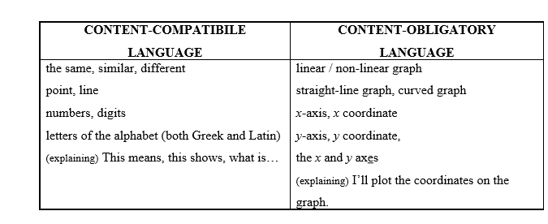

Challenges of Math’s CLIL Lessons I have already came across several problems or drawbacks that might occur in relation to CLIL, such as position of the mother tongue in CLIL lessons, finding specialized teachers and suitable materials for these lessons or general opinion of society on innovative methods like CLIL. Teaching Mathematics as a CLIL subject brings some challenges as well, and in this section, I will describe some of them, including possible solutions or advices that may help to deal with them.
Earlier I described the problem with specialized teachers and mentioned that the conductor of a CLIL lesson is mostly either a target language teacher or a subject teacher. Not knowing the second part of the CLIL, (target language field for a subject teacher and vice versa) is the challenge they may encounter.
Math’s teachers might be a bit unsure about the target language, mainly when they have not used it for some time. It is important for them to be able to present and explain concepts accurately and clearly, check subject-specific language of himself as well as of learners, use suitable language for asking questions, paraphrasing: clarifying and generally managing the lesson in the target language. To improve their performance, teachers can use various dictionaries that include math’s vocabulary (especially those with audio function for pronunciation are advisable). They can use grammar reference books as well to practice building complex sentences (e.g. sentences with conditionals and so on). It is also crucial to make sure that learners know the functional language that is required for the subject area (describing data on graphs, etc.).
Language teachers, on the other hand, have the confidence of the target language, but they might be unsure about the subject knowledge and related skills. They need, for example, to know how to explain mathematical ideas or procedures in an understandable way and to be able to answer learners' questions about the subject topic. It is also necessary to be able to widen their math’s vocabulary knowledge, including the pronunciation. To cope with that, it is suggested to read something about the mathematical concepts and skills in Li books (or on the Internet), to identify and highlight the subject-specific language and record it in the topic areas, and so on. It is also a good move to prepare answers for possible questions learners might have during the lesson beforehand.
Cambridge guide suggests that every teacher, when preparing a CLIL lesson, should always consider all the learning outcomes of each lesson, unit and course. These learning outcomes are learner-centered, which means that they are focused on what the learners can learn and achieve rather than on what teachers are teaching. To manage that, teachers should ask themselves questions like "What will learners know about math?", "What will they be able to do at the end of the lesson unit / course they didn't know at the beginning or "What skills will they practice, what will they learn about co-operation?" When learning about the circle, the possible preparation can look similar to this table.
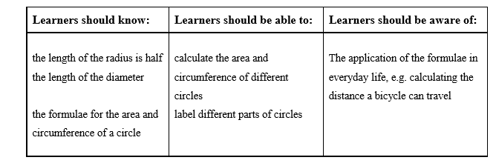
In this chapter we tried to outline some necessities for successful teaching of Mathematics as a CLIL subject. We have described a few possible ways how to apply the Math teaching on CLIL principles and methods, then We have characterized two types of language that is used during Math CLIL lessons — the content-compatible language and the content-obligatory language — with examples of each. In the last section we have described some of the challenges teachers might encounter when preparing and delivering a Math CLIL lesson: providing some tips and advices

2.2 CLIL in Humanities

With regard to the topic of the work, we selected two research tools; Experiment and Questionnaire. At the beginning of practical part, we opted for experimental research. My student Zhumabekova Sholpan taught one Geography topic in three different classes in primary school, each class with a topic relevant to their school educational programme. She integrated CLIL methodology throughout the whole teaching block. At the end of each teaching block a class was presented with final written test in order to gain findings about pupils´ improvement in the topic. Later, the pupils were presented questionnaires to specify their opinion about the just passed experience of CLIL teaching. This chapter covers detailed description of the experiment in terms of topics, pupils’ capabilities and time allowance she was given as well as analysis of questionnaires. All her lesson plans for each lesson together with tests and questionnaires are attached in the appendices.
She decided to carry out 2 months experiment of teaching Geography lessons incorporating CLIL methodology. She had three different classes, each of a different grade. The duration of experiment was from January 19, April 4, 2015. In every class she decided to teach one block of Geography topic, which she elected from the relevant curriculum. She went through the textbooks and other materials the pupils use in their Geography classes and adapted them to be used in CLIL lessons. In order to incorporate adequate English words at the appropriate level, she adopted other external sources of information, mainly from the Internet. Based on these materials she prepared teaching plans in compliance with CLIL methodology.
Due to the different amount of syllabus for each of my chosen topic she taught two classes for 5 hours each and one class for 10 hours. Altogether, it was twenty lessons of CLIL teaching. The aim was to prove the fact that CLIL methodology is a sound way in teaching content and language. With respect to subject content, Geography, her intention was to find out whether it is feasible for pupils to obtain the same amount of content knowledge. She tried to prove this fact by presenting pupils with a test at the end of the block. This test covered the talked about subject theme as well as English comprehension. Outcomes of these tests are presented later in the results and commentaries chapter. Further, she tried to prove that CLIL methodology is applicable to any grade with always-positive effect it leaves on pupils´ language and content learning. In order to obtain relevant data, pupils were given a questionnaire after she finished the experiment. The gathered data are described and compared in details at the results and commentaries
Place of Experiment. She decided to execute experiment at the elementary grammar school # 8 in Almaty. It is a fairly large suburban school. There are approximately 19 pupils in each class. The school has 24 available classrooms of which five have interactive board. There is one multimedia classroom available to any teacher and one Language classroom with specific setting for English language teaching. There is also English library available in where pupils can borrow graded books, magazines to take home or dictionaries to use in class. The school follows the school educational programme called “Journey towards understanding” which strives to provide pupils with not only the knowledge but also support their competences towards problems solving and communication. The emphasis is on practical learning and overall support of pupils’ responsibilities.
Objects of experiment. She executed the experiment on three different classes, in the 9th, 10th and 11th grade. In all of these classes pupils are taught English three times a week and their general level of English according to Common European Framework of References for languages flows around A2 to B1, advanced beginners to intermediate. Clearly, the tenth grade pupils are expected to be on higher level of proficiency but the ninth graders are also, with some help, able to attain intermediate level. Altogether, she taught 55 pupils in 20 CLIL lessons. There were 24 pupils in 9th grade (age 15-16), 19 pupils in 10th grade (age 16-17) and 12 pupils in 11th grade (age 17-18). She spent 5 lessons each in 9th and 10th grade and 10 lessons in 11th grade.
These pupils started learning English from the first grade with allocation of one lesson per week for the first year moving to two lessons a week in the second year and reaching three English language lessons a week in the third year onwards. They were introduced the language basics through Happy House textbooks followed by Happy Street series. At the upper elementary school pupils work with text from T. Ayapova “English” for 9,10,11 years and “New Opportunity” where they have Pupil’s book and workbook at disposal. At this school, English language pupils regularly visit English spoken theatre where plays are adapted for language learners. Pupils also engage themselves in drama playing in English. All this helps in promoting pupils’ competencies in English language. Based on the school educational programme, all pupils in the school are allocated two hours a week starting from the fourth grade. With respect to the experiment, all pupils were informed in advance about the change of a teacher. They also knew we will use English language along with Russian as a mean of communication about Geography. They were assured the level of English will be up to their abilities and as I am their English teacher during language classes, they were not afraid of the change.
The Procedure of experiment. The topic for each of the three classes was always relevant to the Geography objectives required by the school educational programme (SEP). Based on the programme she executed lesson plans for each class. For class 1, the 9th grade, it is The Republic of Kazakhstan, for class 2, the 10th grade, it is Atmosphere and in 11th grade, class 3, I presented topic about Europe. In compliance with SEP 9 grade pupils were to obtain the basic awareness about their country, the Republic of Kazakhstan. The aim is to present physical geography of the Republic of Kazakhstan, cover Kazakhstan neighbouring countries and identify the direction of each bordering country. Pupils are introduced the main cities in The Republic of Kazakhstan together with Kazakh traditions which are to be discussed. In the topic of the 6th grade, Atmosphere, the aim is to provide basic understanding of the presence of such phenomena. The layers of atmosphere are then presented and their effect on our lives and existence on the planet Earth. The pupils are introduced with experiment for experiencing the effect of atmosphere. The pupils of 11th grade are to obtain an overview about Europe from the perspective of physical and socioeconomic geography. Pupils are to learn the basic knowledge about European surface and its location in the world. Further, the socio-economic aspects of geography are introduced and pupils try to connect capital cities with their countries and get familiar with population data. In addition, pupils acquire knowledge about the existence of European Union, its structure and member countries. With respect to the resources, she was unable to find relevant materials to any of the three topics, which she could use for CLIL teaching. She utilized school textbooks and adapted them for the use in English and internet sources, which also needed my amendment. Pupils were assessed throughout every lesson, specifically through authentic assessment. However, for the purpose of this experiment they were presented a test at the end of the teaching block in which they were to prove and manifest the obtained knowledge. For the experiment purposes, the test’s assessment is based on criteria. The entire research was closed up by a questionnaire which she handed out to all pupils who undergone the experiment. This questionnaire is also presented later in this paper.
Questionnaire. At the end of the CLIL lesson block in each class she presented pupils my questionnaire in order to elicit their perception about the just experienced teachings. She decided to use this kind of research tool as it is an effective source of quantifying data from each class concerning pupils´ opinion and emotions about it.
Every class was given the same sheet in order to avoid discrepancy in research data. The goal of questionnaire was to compile evidence of positive or negative impact CLIL teaching has on learners. Further, the aim was to measure the possible differences in perception about CLIL teaching within different age groups. The questionnaire, enclosed in the appendices, contains the yes or no question with further chance to support their answers.
Objects of questionnaire. All pupils from these three classes who experienced Geography classes taught by CLIL method were given the questionnaire with clear guideline of how to fill it in. They were then given ample of time to fully express their perception and opinion. Pupils did not have to fill in every question but were supported to utilize the yes or no answers, at least. In order to avoid false answers because of the fear of disagreement the questionnaire was anonymous. Furthermore, to accommodate those who would be hesitant to write their answers in English and to refrain of any misunderstanding, she opted for presenting the questionnaires in the native language, Russian. The questionnaire was answered by 53 pupils as two of them were missing that day and for the two following weeks. She decided not to give them the questionnaire after they returned to school as it has been long time since they undergone the CLIL teaching and this fact might affect their answers.
Experiment. In order to find result she decided to use experiment as a research tool. Geography lessons was carried out in upper elementary school in three different classes, each of different grades. The experiment focused on dilemma whether is the CLIL method, applied in upper elementary school, efficient to include the required amount of subject syllabus as stated by the school curriculum. Other question was to find out if the pupils are capable of comprehending the subject content. She decided to prove this fact by presenting them a test and then interpreting the results. Collective data were analyzed and results were put in the graph. At the end she summaries the findings and present general comments on carrying out the CLIL lessons. The students´ test analysis
Class 1 The first class is grade 9 with 24 pupils. The topic we covered in 5 lessons was The Republic of Kazakhstan. Pupils were periodically checked for understanding in authentic assessment. They proved their ability to communicate about the given topic in pair and group work and also had to complete several fill in exercises. As the level of English of these pupils is around A2, advanced beginner, she opted for incorporation of fill in tests and only the second question required answering in complete sentences. It is important to emphasize that the whole test was in English language. It examined their overall understanding of common L2 not concentrating too much on academic language. From the language perspective, the knowledge of only few key words was tested.

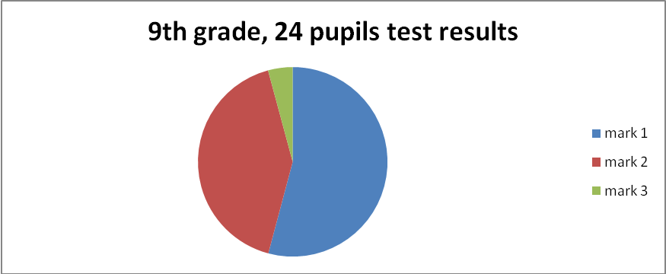
With regards to question number one of the test 10 pupils (42%) made no mistake, 9 pupils (37,5%) made only one mistake and 5 pupils (20,8%) had two to three wrong answers. In question number two, 18 tests (75%) were correct and only 6 pupils (25%) wrote one or two incorrect answers. The last part of the test was simple map description, which 23 pupils (95, 8%) managed to do correctly, and only 1 student made a minor mistake. In total 13 pupils (54, 2%) obtained mark 1, 10 pupils (41, 7%) obtained mark 2 and only 1 pupil (4, 2%) obtained mark 3. None of the pupils received mark 4 or 5.
Commentary 1. It was necessary to find out whether even the fifth grade pupils are able to employ their language knowledge in the authentic conversation. The 5th graders reacted to the change of teaching method with ease and although they were not familiar with most of the key words they were introduced and their level of English is fairly low, they were not worrying about mistakes and used English language naturally. They seemed interested in the topic as they had a chance to talk about places they have personal experience with and speaking in another language served as an entertaining element. However, by utilization of all scaffolding techniques, which was sometimes lengthier than expected, she did not cover the required amount of topic as required by school curriculum. She compromised this fact due to emphasis on pupils´ comprehension of the topic. Nevertheless, due to thoughtful setting of the test, pupils’ results were extraordinary. Only a rare misuse of English word or sentence structure in question two appeared. As stated above it is important to say that the level of geography was compromised with respect to the English language application.
Class 2. The second class, which took part in the experiment, was of grade 10 with 19 pupils. The topic covered was Atmosphere. As it is quite a difficult topic, pupils were encouraged into thorough evocation part using brainstorming techniques and creating mind maps. Also the wrap up techniques were employed to the great extend. Similarly to the 5th grade test, she opted for fill in structure as the whole test is in English. Further she added strip up sentences where pupils did not have to engage in eliciting answers but rather connecting the meaningful clauses.

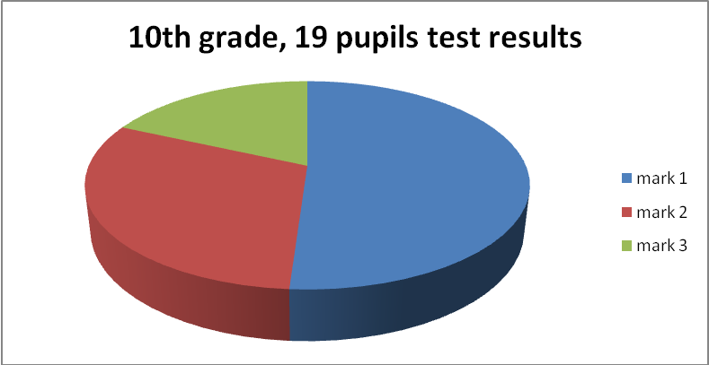
Graph 2, test results 10th grade

The results of the test were 47%, nine pupils, without a mistake. None of the test was returned blank or poorly filled. Concerning the first question 16 pupils (84%) succeeded without any mistake. The second question was more demanding. Nine pupils (47,4%) made no mistake, five pupils (26,3%) had one to two mistakes, four pupils (21,1%) had three to four mistakes and only one pupil (5,3%) made more than five mistakes. In total 10 pupils (52,6%) obtained mark 1, 6 pupils (31,6%) obtained mark 2 and 3 pupils (18,8%) obtained mark 3. None of the pupils received mark 4 or 5.
Commentary 2 This is quite difficult topic as it is hard to be imagined. Learners also have to remember many new terms. The stage of teaching was important at this topic. Partly due to the complexity of the topic but I suppose also because of the older age, it seemed more difficult for pupils to engage in communication in L2. They tried to refrain from the speech and especially at the beginning tried not to engage in L2 at all. These tendencies subsided as the teaching block progressed. Probably of these facts, she struggled to cover the required amount of subject content and I failed to accomplish my plans in that matter.
Class 3 The last class of my research was grade 11 with 12 pupils. The topic taught in CLIL was Europe. As the topic we covered was partly rehearsal of knowledge they have already been introduced, pupils seemed to have fair background knowledge. This fact allowed building on this knowledge and using it as a bridge toward the new information. She presented number of quizzes. Then we moved toward in more detailed topics. Due to this fact she decided to create test that includes many geographical terms and names, mainly in Russian language.

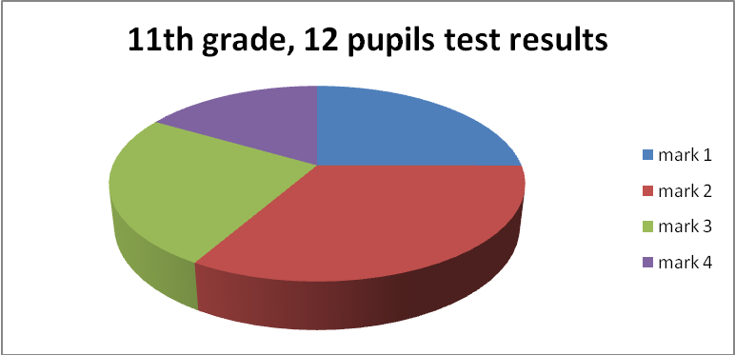
Graph 3, test results 11th grade

The results of the test were of the worst in the whole experiment. Two pupils out of 12 (16,7%) scored lower than half of the percentage. Only one student (8,3%) scored 100%. With regards to the first question only three pupils (25%) filled in the correct information. The second question was all in Czech language. Nevertheless, only five pupils (41,7%) 8th grade, 12 pupils test results succeeded in the task without making mistake. In total 3 pupils (25%) obtained mark 1, 4 pupils (33,3%) obtained mark 2, 3 pupils (25%) obtained mark 3 and 2 pupils (16.6%) received mark 4. None of the pupils received mark 5.
Commentary 3. The result of the test showed some inadequacy in comprehending the topic but as it was presented in Russian language, we think the results are more of consequence of a poor preparation then of employment of foreign language. Teaching in 11th grade was, surprisingly, the most difficult of all.. Consequently, some of the weaker pupils were not able to catch up.
Overall summary. Experiment focused on dilemma whether is the application of CLIL method efficient in terms of including the required amount of subject syllabus as stated by the school curriculum. Other question was to find out if pupils are capable of comprehending the subject content when presented partly in foreign language. This experiment comprised of carrying out Geography lesson that incorporated CLIL method. We found it quite difficult to carry out teaching in CLIL, especially at the beginning of first lesson in each class. Nonetheless, we tried, according to the CLIL principles, to change the class tasks regularly to keep pupils engaged. Pupils of every grade seemed to be pleased with the interactive mode of the class. One of the most difficult parts was to adopt class language suitable to the learners´ level. Later, however, it was easier as we could build on key words previously presented. Our expectations were that the most difficult work would be with the youngest pupils. However, we were surprised to find out that the 9th graders reacted to the change of teaching method with the greatest ease and they had less worries about speaking up and overall communication in English language. Contrary to that, older pupils were more aware of their language incompetence and more sensible to the risk of making mistake and losing a status within the class. It was difficult for them to change from focusing on language to the content of their words. Due to these facts, they were most hesitant about using the English language in common communication. They reflected their doubts throughout every lesson but the most at the beginning of CLIL teachings. This uncertainty eroded later in the teaching block. Therefore w suppose that after broader exposure to CLIL methodology pupils would get familiar to the language switching and the initial reluctance will vanish.
Furthermore, older the pupils were of a greater variance in terms of their English proficiency. While some of them proved a solid knowledge and command of English language, others were struggling with the basics of putting a sentence together. This fact had an impact on the lesson flow as it proceeded. For that reason we found it more difficult to cater for individual needs of every pupil as they get older.
Questionnaire analysis. In order to uncover what pupils think about the CLIL method we utilized their answers to the questionnaire. The same questionnaire was presented to all the pupils after the last class of the CLIL teaching block. In order to keep it simple we opted for five questions, two of which were open questions and three were yes or no ones with an option for extending their answer. Here we present each and individual question results. The summary of my commentaries is at the end of this chapter.
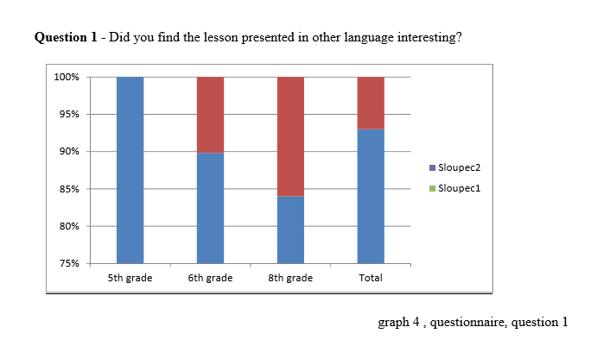
This yes or no question was a warming question of the questionnaire. All 24 pupils of 9th grade found CLIL interesting. 2 pupils out of 19 from the 6th grade (11%) did not find CLIL interesting while 17 pupils (89%) did. Finally 2 pupils out of 12 in total in 10th grade (16%) did not find CLIL interesting while 10 of them (84%) did. Altogether 93% of pupils in three classes found CLIL method interesting and only 7% did not.
Question 2 – What task did you find interesting?

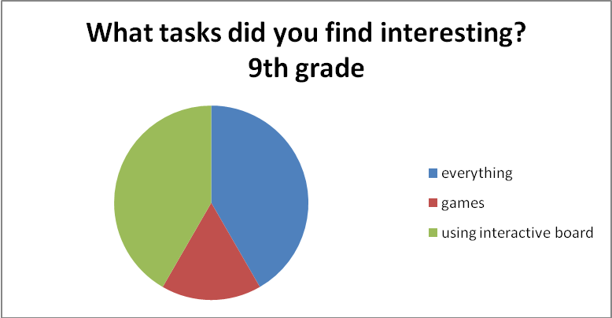
Graph 5, questionnaire, question 2; 9th grade

The same number of 9th grade pupils (41, 7%) liked to use interactive board. Four pupils out of 24 (16, 7%) liked playing games.

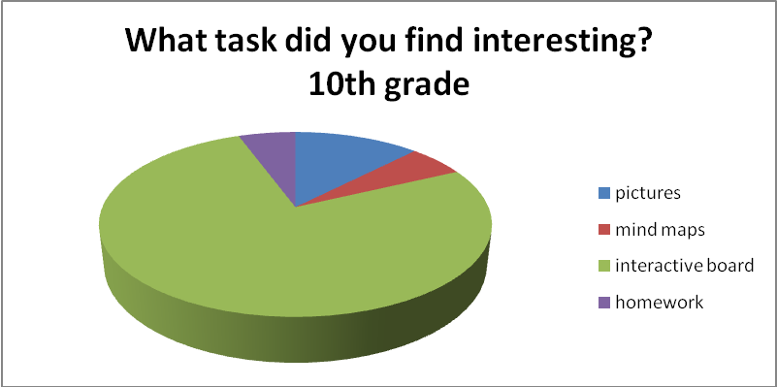
Graph 6, questionnaire, question 2; 10th grade

Most of the 6th grade pupils (68%) stated they found interesting the usage of interactive board. 2 pupils (11%) liked pictures and 1 pupil (5%) liked mind maps and homework.

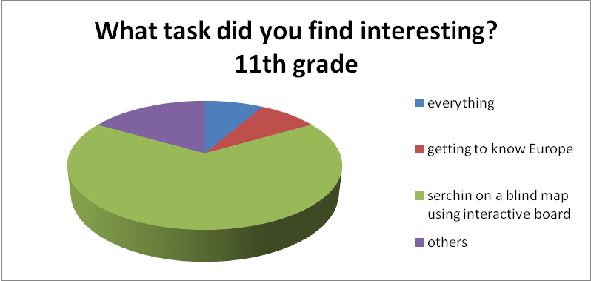

Graph 7, questionnaire, question 2; 11th grade

Most pupils, eight (66, 7%), from the 11th grade liked searching and finding cities on a blind map of Europe. This task was part of every class using interactive board. One pupil (8, 3%) stated he liked everything and one pupil (8, 3%) enjoyed learning facts about Europe. Two pupils (16, 7%) stated obscure answers such as geography tasks.

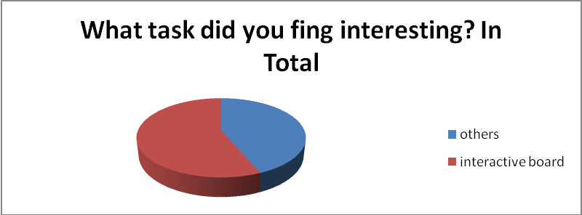
Graph 8, questionnaire, question 2; In Total

The most frequent answer for this question was the usage of interactive board. 31 pupils used it as the main task they liked in CLIL teachings, scoring 56, 4% of all the answers. The rest of answers were specific to the given topic and different activities introduced with it.
Question 3 - What tasks were too difficult for you to practice in English?

e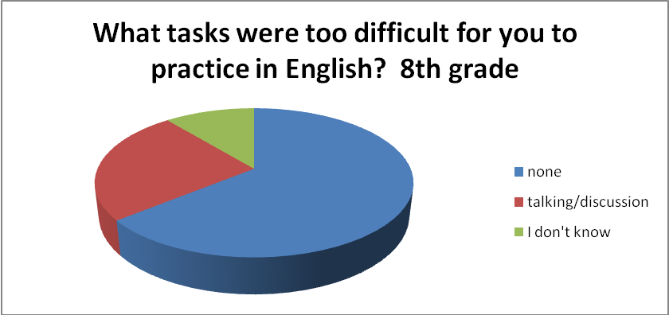
Graph 9, questionnaire 3; 9th grade

This was a tricky question for 5th graders. Four of them (16, 7%) did not have problem with anything, 10 pupils (41, 7%) found it difficult to lead a discussion about the topic and two pupils (8, 3%) stated they don´t know. Eights pupils (33, 3%) did not answer this question at all.
10th grade
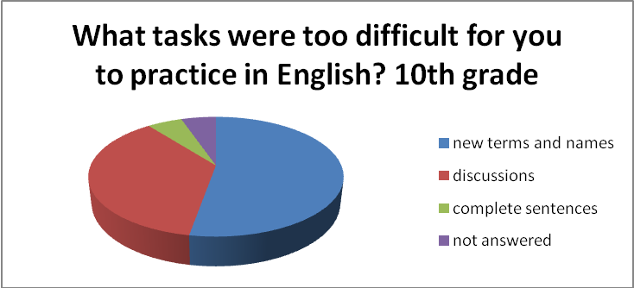
Graph 9, questionnaire 3; 10th grade

For 10 pupils form 6th grade, 53%, it was difficult to learn new terms and names associated with the topic. Another seven pupils (36, 8%) had difficulties discussing the topic. One pupil (5, 3%) did not answer this questions and one (5, 3%) stated the difficulty in completion of sentences

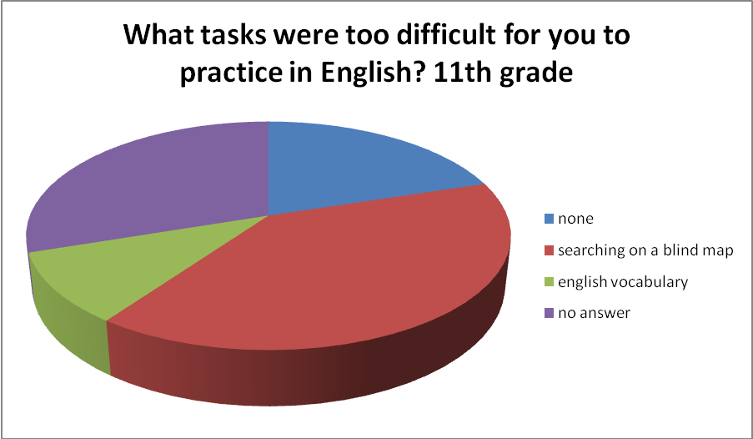
Graph 10, questionnaire 3; 11th grade

This seemed to be a difficult task full of controversy for the 11th grade pupils. While three of them (25%) did not answer at all, two pupils (16, 7%) did not have problems with anything. For four pupils (33%) the hardest task was to use interactive board and comment on it in English. One pupil (8, 3%) had an overall problem with English vocabulary.
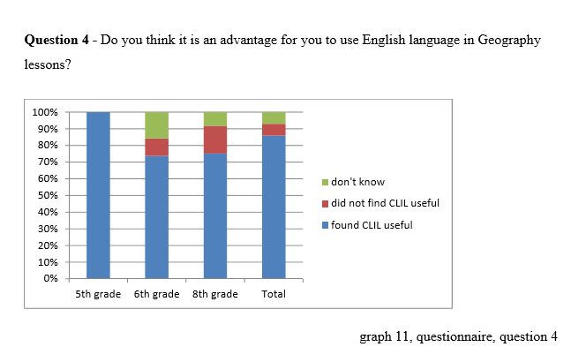
As pictured on the graph all 24 pupils (100%) from 5th grade perceive CLIL as an advantage. 14 pupils from 6th grade (58,3%) view CLIL of an advantage an only 2 (8,3%) pupils do not. Three pupils (12, 5%) from this grade do not know. On the other hand, 75% of 8th graders perceive CLIL advantageous and only 16% doesn’t. Overall, 85% of all pupils perceived CLIL method of an advantage, 7% did not find CLIL useful and 7% did not know.

Why do you find CLIL useful? Answers of 55 pupils
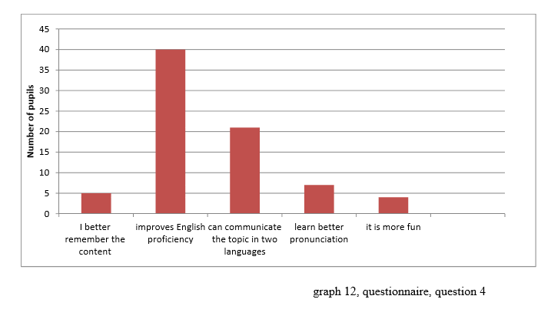
As this was an open question, some pupils reasoned their statement. In the graph below, we picture the most common answers. The most frequent view on incorporating English and Geography was the improvement of English proficiency.
Question 5 - Do you think you will remember the subject content if taught in English?
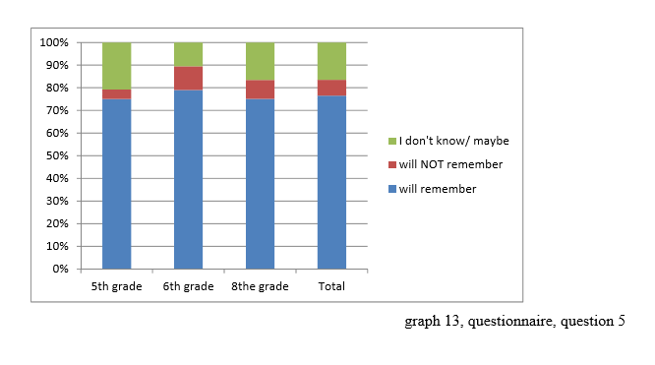
This hypothetical question was the last and most difficult one. 20, 8% of 5th grade pupils did not have the answer for it. 75% of them answered that they will remember the subject content better and only 4%, one pupil, do not believe in it. 15 pupils from the 6th grade (78, 9%) believe they will remember the subject content better and 2 pupils (10, 5%) doesn’t. The same numbers of pupils, 10, 5%, do not know. Similar score of believers has 8th grade, 78%. Only 8 of them (3%) think that they will not remember the content better and 16, 6% doesn’t know. Overall, 76% of all pupils believe that they will remember the subject better if taught in English, 7% doesn’t believe in this notion and 16, 4% is not sure about it.
Questionnaire commentary. We decided to utilize the questionnaire in order to uncover what pupils think about the CLIL method. They were given this questionnaire straight after the CLIL teaching block in order to elicit their perception about the shift of teaching they have just experienced. Having taught twenty lessons in CLIL and experiencing the pupils´ interest and engagement in the activities we expected positive feedback. The older students felt embarrassed about making mistakes and were conscious about their level of English language. It can be because their only experience so far with language learning has been only of the pure language focus. The younger pupils are not, however, biased yet. Nonetheless, as pictured in the graph for question 4, not all pupils are focused on language level. Without ever suggesting them, any possible answers 9% of pupils stated that thanks to CLIL they would remember the content better. Further, it is encouraging to see that having fun is one of the advantages of CLIL method for 7% of pupils. In total, pupils perceived the use of interactive board as one of the most interesting part of the lesson tasks, 54, 6% pupils from the three classes chose it as their answer. In addition, interesting finding is the one, which is the most difficult for them in terms of English language. Although some pupils perceived it daunting and too difficult, the majority enjoyed the teachings and rated it positively in terms of impact on their future knowledge. We did not expect pupils in upper elementary school to be already that responsible for their future knowledge. However, these findings may be skewed because of the school location. Living in Prague offers many opportunities to meet English speaking people and pupils probably perceive the need to improve their knowledge of language. Overall, we were surprised how well pupils assessed CLIL methodology. In this chapter, we presented results of my experiment and questionnaire. The next chapter describes the main difficulties we experienced during implementation of research and we make suggestions for future CLIL teachers pointing out our insight.
Conclusion CLIL constitutes a new learning and teaching environment. This method has definitely its advantages in its learner-oriented approach. Based on her long term experience and research, Do Coyle states (2010) that apart from the communication development CLIL supports the learner’s confidence, develops competences for problem solving, motivates and strengthens learner’s independence and supports intrinsic motivation.
Further, it is generally assumed that the focus on student’s personality, multiple intelligence and motivation is definitely the right approach toward teaching language in modern era. When involving students in teachings, students have more opportunities to participate verbally by interacting with the teacher and other fellow-students using the L2. Because CLIL method is strongly focused on learners, I experienced a strong popularity of it among pupils. Learners perceive CLIL positively.

2.3 Teaching IT through English

CLIL has many advantages as well as drawbacks. The advantages are following: it improves the target language competence; it develops communication skills, it builds intercultural knowledge & understanding; it prepares for internationalization, specifically EU integration; it provides opportunities to study content through different perspectives; it teaches subject-specific target language terminology; it uses various methods & forms of classroom practice.
The drawbacks are first the lack of teaching materials including books, workbooks, exercise sheets and others. Another drawback is the lack of qualified teachers.
The content and language is connected through the subject-specific target language terminology. Teaching time can be saved by leaving out an insignificant topic in favor of a more difficult topic. Exposure to the target language can be low (5-15% of teaching time), medium (15-50% of teaching time), or high (over 50% of teaching time).
CLIL lessons increase learner´s motivation naturally on condition that the difficulty of teacher´s speech follows the communication skills of pupils. They enjoy the lesson more if authentic, concrete and actual materials are used. They like interaction, pair work and group work, and a large variety of activities.
Every lesson includes an explanation and a demonstration of the new topic step by step, a repetition of the important terms, and a feedback (questions, exercises, tests, etc.). As an optional activity, the pupils can create a report on any topic concerning computers.
This subject is taught in 9th, 10th, and 11th grade of the elementary school, beginning with Windows, Painting, WordPad, etc., continuing with Excel and Power Point, and ending with designing the web pages. The assumption is that children have only basic experience with computers. Throughout the school years they get to know computer hardware and software, so that they could orientate well in the field of computers. Every topic is explained theoretically at first (in English) and then practiced in several following lessons. One lesson for an easy topic, more lessons a difficult topic. One lesson means 45 min.
The first lesson starts with a short spoken introduction in the mother tongue (5 min) using many pictures and examples from everyday life. After the introduction there is a lecture in English (15 min) given, which continues with an introduction of the new vocabulary (10 min). The pupils then write down notes according to the blackboard and they glue handouts with the new vocabulary into their exercise books (15 min). The following lessons are based on the work of pupils. They get handouts in English with compulsory and extra tasks. All the tasks are explained and demonstrated in English and Russian before the pupils start their work.
The main aim of the research is the evaluation of effectiveness of CLIL teaching for language acquisition at the elementary school. Is it possible to teach in a foreign language at the elementary school? What are the results of such teaching? Does it have a positive contribution to the language acquisition? Is there any difference between the subject knowledge gained in the mother and in the foreign language?
The research proceeded in real conditions. The research sample was created of pupils in the lower secondary education 15 to 18 years old (grades 9 to 11) of the elementary school). All pupils started learning English when they were in 1st grade; Informatics in English when they were in the 7th grade. They had similar level of Informatics knowledge. The basic research sample was not determined by gender, it consisted of girls as well as boys. The research sample was determined by available selection. There was one research group taught in English and several control groups taught in the Russian language. The research had 221 respondents altogether.
Main research method was the qualitative experiment.
Within it, several other methods were used: didactic test, measurement of educational results, observation of the pupils, taking notes, research reality description, video recording, and pupil’s essays on assigned topic, questionnaire, interview, and discussion.
There were tested three different areas in the research: general knowledge of the foreign language (means of communication – tested in English); special foreign language vocabulary necessary for the educational subject (tested in English); content of general educational subject (tested in Russian). As the main aim of CLIL lessons is to contribute to the foreign language competence and to improve the foreign language communication skills, the main area to be tested was the general knowledge of the foreign language.
The simple topics (Painting, WordPad program) had more or less positive results. One significant result was the knowledge of the special English language, which differed a lot. In the group taught in English 95% of pupils passed the test, in the group taught in Russian it was only 24% of pupils. Tasks elaboration tested in the mother tongue had good results in both groups. The general knowledge of English was on the similar level at the beginning of the research. The presumption was that the general knowledge would differ at an significant level at the end of the research.
The advanced topics (html designing, computer programming) did not give such unambiguous results. The general knowledge of English as well as the task elaboration in the mother tongue had similar results as earlier but the special English vocabulary started to be difficult for pupils. When both groups were given the same test based on the knowledge of html. The research group had worse results caused by the fact that they did not understand the test assignment properly.
In our opinion, the main positive effect of CLIL education is in contributing to the motivation for learning the English language and in supporting the interest for using educational sources in a foreign language on the internet. It also contributed to using the subject-specific target language terminology. Concerning teaching Informatics in English, it can be taught very well, as long as the Informatics subject deals with easy topics.
According to the European Commission, Content and Language Integrated Learning (CLIL) involves teaching a curricular subject through the medium of a language other than that normally used [43, p.8]. The subject can be entirely unrelated to language learning, such as history lessons being taught in English in a school in Spain. CLIL is taking place and has been found to be effective in all sectors of education from primary through to adult and higher education. Its success has been growing over the past 10 years and continues to do so. It has been the focus of numerous European and national conferences, projects, websites, special interest groups and teacher training programmers. Whose property is CLIL? Should foreign language or subject teachers use it? What are the factors that encourage/discourage teachers of English from using CLIL? Thus, the subject of the research is the use of CLIL at Kazakhstan schools. The aim of the research is to analyze EFL teachers’ attitudes and experience in using CLIL in their teaching. In order to achieve the aim of this paper, the following objectives have been set: to overview the main benefits and possible threats of CLIL, to get statistic data defining the situation of using CLIL: to prepare a questionnaire for English language teachers, to analyze and generalize the results of the questionnaires, which could explain the factors determining the teachers’ choice to integrate/not to integrate CLIL approach into their teaching. The following methods have been applied to achieve these objectives: theoretical analysis of corresponding literature, survey method, organizing questionnaires, analysis of the data of the survey.
No one can argue that integration of language and content in teaching is natural, meaningful and motivating for students. The learner is gaining new knowledge about the ‘non-language’ subject while encountering, using and learning a foreign language. “CLIL refers to situations where subjects, or parts of subjects, are taught through a foreign language with dual-focused aims, namely the learning of content, and the simultaneous learning of a foreign language” [43, p.23]. As the number of foreign language lessons is usually considered insufficient, introduction of CLIL saves time as it enables the teacher to kill two birds with one stone – develops students’ foreign language competence as well as discipline area competence thus providing the learners with more opportunities to be exposed and use the foreign language. Moreover, the mindset of the generation born after 2001 will even more be focused on immediacy as in “learn as you use, use as you learn” – not “learn now, use later”. They will be even more influenced by their own early, personal, hands-on experience with integrated technologies, and CLIL is a very relevant methodology for this type of learners that has emerged to cater to this new age. Thus, CLIL lessons can be characterized as having “value added” benefits (e. g. linguistic, communicative, cognitive, motivational and cultural). Besides, content-based activities are cognitively demanding and stimulate creative thinking. However, some education authorities and the public are often not sure whether introduction of early foreign language teaching or CLIL can become a threat in case the native language is not so strong and eventually can damage or even lead to the loss of those languages. According to K. Kelly, CLIL poses no threat to L1; conversely, bad CLIL practice will drive itself extinct before any minority languages it is seen to threaten. Another issue of concern would be the learning content. Lacking the foreign language competence, the students may not fully understand or misinterpret the subject information. The parents or the students themselves may not trust the quality of the subject knowledge gained through the medium of a foreign language, as the knowledge acquired may be simplified due to the insufficient command of the target language. Another question is about the teachers who are going to teach CLIL: should they be subject teachers, language teachers or team teaching could be more appropriate? Some teachers are even said to have a crisis of identity – not knowing what a CLIL teacher really should be like [43, p.55].
Another problem is CLIL teaching methodology: would it be possible to apply the same methods as in EFL classroom? If not, what methodology would be appropriate for CLIL? What teaching materials should be used in CLIL classes: original subject course books written in a foreign language or special CLIL materials designed by the teachers containing a language focus as well?

- Organizational Aspects of Teaching Other Subjects Through English

3.1 Content of Teaching Foreign Languages in Profile Schools

Accepted Law of the Republic of Kazakhstan "Об образовании" 2007 [44, p.1-25], the Concept of development of profile training in the Republic of Kazakhstan [45, p.7-15] the State program of development of education in the Republic of Kazakhstan for 2011-2020 [46, p.32-36] introduce profile education in senior classes. Profile education is considered as one of instruments for improvement of quality of education, realization of actual and perspective needs of the individuals, society and the state. The content of profile education is realized within three directions of profiling: humanitarian in specialized schools (such subjects as geography, history, etc.), economic profile in lyceums and colleges (such subjects as management, finance, etc.), natural-mathematic profile in lyceums and colleges (such subjects as math, physics and biology). Flexibility of system of profile education is provided at the expense of the following subjects (courses): basic subjects (invariable component), special subjects and obligatory subjects of a choice (variable component), courses of interests (student's component). Foreign languages are included in basic subjects. Learning of foreign language at a basic level of senior school is directed on achievement of the following purposes:
-further development of foreign language communicative competence;
- speech competence — improvement of communicative abilities in four main types of speech activity (speaking, listening, reading and writing); abilities to plan the speech and nonverbal behavior;
- language competence — mastering new language means according to the selected subjects and communication spheres: increase in volume of used lexical units; development of skills of operating by language units for communicative purposes;
- socio-cultural competence — obtaining more knowledge of socio-cultural peculiarities of the target country, cultural awareness;
- compensatory competence — further development of abilities to find a way out in conditions of deficiency of language means during the receiving and transferring foreign-language information;
- educational and informative competence — development of general and special educational abilities, allowing to improve educational activities for acquisition of a foreign language;
- development of abilities and readiness for independent and continuous learning of foreign language, to use a foreign language in other fields of knowledge; formation of qualities of a good citizen and patriot.
Learning a foreign language at profile level of senior school is directed on achievement of the following purposes:
-further development of foreign language communicative competence;
- speech competence — functional use of target language as means of communication: ability to understand authentic (listening and reading), to transfer information in coherent statements (speaking and writing); to plan the speech and nonverbal behavior taking into account the status of the partner in communication;
- language/linguistic competence — mastering new language means according to subjects and the spheres of communication selected for the chosen profile, systematization of the language knowledge gained at secondary school, increase in their volume at the expense of information of the profile focused character;
- socio-cultural competence (including socio-lingual) — expansion of volume of knowledge of socio-cultural peculiarities of target country, improvement of abilities to build the speech and nonverbal behavior, abilities to understand and interpret the lingua-cultural facts adequately;
- educational and informative competence — further development of the special educational abilities, allowing to improve educational activities for acquisition of a foreign language, to increase its efficiency; to use learned language for education and self-education continuation, first of all, within the chosen profile;
- development of abilities to personal and professional self-determination, social adaptation; formation of an active living position of a citizen and patriot, and also subject of cross-cultural interaction; development of such personal qualities, as ability to work in cooperation; development of ability and readiness for independent learning of foreign language, for further self-education; acquisition of experience of creative activity, experience of research work with the use of target language.
As a result of learning a foreign language at profile level the student has to be able:
- to know/understand: meaning of new lexical units connected with subject of this stage and situations of communication; language material: idiomatic expressions, estimated lexicon, units of speech etiquette serving situations of communication within new subjects; meaning of studied verbal forms, means and ways of expression of modality, conditionals, assumptions, reasons, consequence, motivation to action; lingua-cultural and regional geographic information expanded at the expense of new subject and speech communication taking into account the chosen profile.
- to be able: in the field of speaking: to be able to speak in a dialogue (inquiry, exchange of opinions/judgments, etiquette and its combinations) in official and informal character in household, socio-cultural, educational and labor spheres, using argumentative, emotional and estimated means; to tell, argue in connection with the studied subject, read/heard texts, to describe events, to state the facts, connected with subject of the chosen profile; to create a verbal socio-cultural portrait of the target country on the basis of various regional geographic and cultural information; in the field of audition: to understand fully statements in a foreign language in various situations of communication; to understand the content of authentic audio or video texts of informative character on the subjects connected with personal interests or with the chosen profile; to estimate importance/novelty of information, to express attitude towards it; in the field of reading: to read authentic texts of different styles, using main types of reading (scanning, skimming, search) depending on a communicative task; in the field of written language: to describe the phenomena, events, to state the facts in a letter of personal and business character; to fill in different types of questionnaires. Thus, the purposes of foreign language teaching at profile schools differ from the purposes of general education basic course.
According to the concept profile education at senior school is considered as a system of specialized preparation in the senior classes, focused on individualization of education and socialization of students being trained, taking into account real requirements of a labor market. As it is noted in the Concept, profile training is a means of differentiation and the education individualization, allowing due to changes in structure, contents and organization of educational process to consider interests, tendencies and abilities of students more fully, to create conditions for education of seniors according to their professional interests and intentions concerning education continuation [44, p.1]. Realization of profile education is possible only on condition of reduction of general subjects studied with the purpose of completion of basic general education of students. The model of comprehensive school with profile education at senior classes provides various combinations of training courses, on the basis of which flexible system of profile education is formed. These are three types of training courses: a) basic general education, b) profile, c) elective. Basic general education courses are obligatory for all students. Their set (generally with small options) is the same in all profiles: mathematics, history, Kazakh, Russian and foreign languages, world art culture, physical culture and the integrated courses of social science and natural sciences. Profile courses advance courses for the senior classes aimed at vocational guidance of school students, on their initial specialization in concrete subject domain, for example: native language and literature, biology, chemistry, physics, history, social science, foreign language, etc. Apart from this set, there is also a profile kernel. For example, Russian, a foreign language, literature define the contents of humanitarian profiles; physics, mathematics, biology, chemistry — natural-scientific profile etc. Elective courses are obligatory courses for school students, who are at senior school. They can expand, supplement and alter a profile. For example, elective courses "Introduction in translation", "Country studying", etc. can enter a natural-mathematical profile, and "Great public figures and their role in world history ", or "Introduction into jurisprudence" — in social humanitarian.
In the Concept of profile education it is noted that "the offered system does not limit schools in organization of this or that profile of training (or several profiles at the same time), and the school student in a choice of various sets of basic general education, profile and elective courses which in total will make individual educational trajectory. Based on courses of three types: basic general education, profile and elective such creation of educational process will give the most various forms of profiling at schools. As for profile education of a foreign language, it is suggested to provide more profound studying, aiming of the maintenance of learning. In a humanitarian profile foreign language with literature and country, studying acts as the purpose of profound studying. In other profiles, it at the same time acts as means of studying of other subject domain (for example, economy, history, ICT).
At the profile course students study English six hours per week in the 10th class and six hours per week in the 11th class. Besides, it can be profound and expanded and/or modified at the expense of specialized elective courses (obligatory elective courses of school student)]. The maintenance of a profile course includes the maintenance of a basic course. However, existence of bigger numbers of class periods allows expanding more on subject in comparison with a general education course, and besides, more careful/profound learning of a material of a basic course. As a result, more attention is paid: to linguistic knowledge, for example: systematization of grammatical categories, analysis of a grammar of a learned foreign language in comparison with native language, regularities of the lexical party of the speech — to generalization of features of the main units of language (words, statements, texts), for example, systematization of knowledge of problems of polysemy of a word, synonymy, antonymy; to stylistic features of oral and written language, a genre variety of texts, means of expression of foreign language, in particular phraseological expressions, proverbs and sayings; literature and country studying, integrated into the course "foreign language" (including in historical aspect for a socio-humanitarian profile).Thus, profound learning of foreign language in a profile course is carried out in three directions:
1. On a material of an invariable kernel of the content of education, that is within a basic course, due to inclusion of elective course for a basic course and obligatory for a profile course tasks for more careful study of some aspects of problems, on search of additional information, in particular with the use of project works of school students, writing papers, compositions, etc.
2. On the additional profile-focused material which character depends on the chosen profile.
3. On a material of elective courses, practice classes.
Profound studying provides development and improvement of all types of speech activity in a framework of the subject specified in the standard programs. In the plan for development of monologue skills, a lot of attention is paid to teaching to produce coherent statements on a subject and/or on the basis of the read or heard text, and also to summarizing and text annotation. In relation to dialogical speech — teaching to discuss with use of arguments to defend his/her own point of view, polite expression of disagreement with the point of view of the partner, and also with use of language means for compromise expression. Communication situations are getting more variable, including role-plays (for example, conversation of future non-native foreign language teacher with the native foreign teacher/pupil). The volume of “to read” material increases; publicistic texts, fragments from works of fiction, various pragmatical texts like advertisements, announcements, instructions, popular scientific profile focused texts. All strategies of reading are applied: skimming, scanning, viewing/search, stylistic analysis of text, its translation. The translation acts not only as means of specification unclear, but also as a type of speech activity. More attention is paid to listening, including taking notes on basic facts of the content of the text for its best storing and development of the corresponding professional focused ability (important, in particular, at education continuation in higher education institutions, for example taking notes on lectures in a foreign language, etc.). Besides, more attention is paid also to written language, including its such types, as drawing up theses, summarizing, annotation, correspondence (in particular, in relation to the business sphere of communication).
Basic principles of profile education of foreign languages: For senior classes all didactic principles, as well as methodological, have essential value. However at the same time some didactic and methodological principles at senior classes, especially in the profile education, become more specific.
- the communicative, cognitive socio-cultural principles provide speech and cultural development of individuals by means of a foreign language, formation of the person with the developed valuable orientations, being aware of features of his/her own culture and capable to be acquainted with another culture, ability to interact with representatives of other cultures, to achieve mutual understanding, to show tolerance to unusual manifestations of another mentality and another culture. It promotes social adaptation of seniors in conditions of market relations and extending economic and cross-cultural relations of our state with other countries;
- the principles of differentiation and education individualization;
- the principle of taking into account and development of professional orientation of seniors, giving possibilities of profound learning of foreign language;
- the principle of increase of independence of school students, developments of their autonomy, a conscious attitude to the organization of their educational activity up to planning of the individual way of training. It defines a place of the teacher in educational process as a consultant, an assistant, a partner in communication and directs its efforts to comprehensive activation of the intellectual sphere of school students, their communicative and cognitive activity, emphasizing on their self-determination, self-realization, self-reflection;
- the principle of an intensification of speech and social interaction of school students, providing the use of such pedagogical technologies, as training in cooperation, project works, role-play games;
- the principles of relying on already available experience of foreign language learning, development of self-educational requirements for studying languages;
- the principle of realization of continuity of language education between all links of education system: between the secondary and high school, between school and higher education institution. It will be provided by repetition and systematization of previous studied material at senior school, by taking into accounting of professional aspirations of seniors and their orientation to continuation of language education in higher education institution, or on implementation of foreign language in concrete activities right after leaving school (for example, as the administrative assistant in hotel or travel business, etc.);
- the principle of efficiency aiming at improvement of speech material produced by seniors — their speech statements in the form of oral and written texts, and also integration of project works.
All these principles are dictated by the individual-focused approach as a new paradigm of education and upbringing.

  - Lesson Planning Within the Frame of CLIL

The Content and Language Integrated Learning (CLIL) initiative has experienced a considerable growth and it is being integrated into curricula all across Europe. The domain of at least three languages is regarded as one of the basic skills that everyone should acquire in European educational spaces during the course of their learning life [47, p.24]. CLIL is a dual educational approach in which content and language must be combined. The language is used as a medium to communicate contents, but also as a subject to learn. CLIL is a dual-focused educational approach in which an additional language is used for the learning and teaching of both content and language with the objective of promoting both content mastery and language to pre-defined levels [48, 33-37].
CLIL has gained a tremendous success and its influence on practice is currently expanding quickly across the Spanish country [49, p.3]. The positive effects of CLIL demonstrated by recent research are highly notorious [50]. CLIL offers students of all ages a natural context for language development. This naturalness seems to be one of the key factors for successful both of the subject contents and language learning. CLIL does not only pursue the development of language skills. There is evidence that students who learn different languages develop better cognitive processes. Content learning is beneficial if conducted in a foreign language. This is because, on the one hand, students have to strive to decode the information conveyed in the foreign language and, on the other hand, the professor must make an extra effort so that all students can reach the information and content in a language different from the native.
The Progress of CLIL. The term Content and Language Integrated Learning (CLIL was launched during 1994 in conjunction with the European Commission. This followed a Europe-wide discussion led by expertise in Finland and the Netherlands on how to bring language learning excellence, found in certain types of school, into mainstream government-funded schools and colleges. At the time, the launch of CLIL was both political and educational. "The political driver was based on a vision that mobility across the European Union required higher levels of language competence in designated languages than was found to be the case at that point in time. The educational driver, influenced by major bilingual initiatives such as in Canada, was to design and otherwise adapt existing language teaching approaches so as to provide a wide range of students with higher levels of competence' Marsh (2012) Now some twenty years later the concept of CLIL has emerged as not only a way of improving access to additional languages, but also bringing innovative practices into the curriculum as a whole. CLIL as an approach has slowly been gaining acceptance in European countries. In fact, in some countries, teachers are now required to use CUL in their classrooms. The trend seems to be that CLIL will be used more and more in the future in most of the countries of Europe [51].
Background. Language as well as subject teachers face challenges in CLIL classrooms, especially in the area of methodology. CLIL requires such a close collaboration between subject and language teachers that many theorists and practitioners agree that a team teaching approach (a subject teacher and a language teacher working together) has numerous advantages in CLIL settings. “It is obvious that teaching a subject in a foreign language is not the same as an integration of language and content... language teachers and subject teachers need to work together... (to) formulate the new didactics needed for a real integration of form and function in language teaching” [52]. According to Valcke and Tudor [53], this new collaboration ideally leads to “interactive pedagogical approaches and carefully designed learning tasks.” However, the reality – especially in tertiary CLIL – is, in our experience, often very different. The setup that we have most often encountered is a subject teacher with no background and/or experience in language teaching presenting his/her subject in English - a difficult situation for the subject teachers, especially since many of them do not have any formal teacher training at all, not even in their first language.
This lack of pedagogical expertise is a serious drawback when one considers Widdowson’s [54, p.2-5] argument that only a teacher who is reflective and informed about the theories underlying his or her way of teaching is able to react to changing conditions and can claim professionalism. A lack of pedagogical expertise is particularly problematic when subject teachers use online sources in their teaching – which they frequently do, often with mixed results. In this article, we will explore the problems inexperienced subject teachers encounter when they use online sources and present a checklist to support them in turning internet sources into CLIL learning resources.
A new methodological approach. Content and Language Integrated Learning (CLIL) requires a swift in methodologies used in traditional language and content teaching. However, there is still a lack of appropriate teaching materials, strategies and methodological resources. Consequently, a desperate demand of new methodological and teaching techniques has arisen among the bilingual teaching community [54, chapter 5], being imperiously necessary to foster a well-defined training plan for CLIL teachers [55, p.140-162]. In order to achieve successful CLIL results in primary classrooms, new methodological approaches and strategies are needed. For this purpose, teachers should encourage among their students:
• Activities to develop children’s motor, emotional, social and intellectual capacities;
• Encourage oral skills in order to promote interaction;
• Focus on the importance of routine language;
• Adopt a concept-centered vs. grammar-centered approach;
• Avoid fragmented and disperse treatment of content issues.
The intended purpose for the new language policies is to promote a multilingual education, consisting of assessing and developing linguistic repertoires of speakers from early learning stages and throughout a lifetime, and an education for multilingualism, which constitutes a condition of maintaining linguistic diversity. This approach involves learning different subjects such as science, art or history, among others, through a different language, which can be very successful in enhancing the learning of languages and other subjects, and developing in the youngsters a positive ‘can do’ attitude towards themselves as language learners [55, p.1-14]. In order to implement learning instructions that meet these principles, there are no standards solutions, but multiple options that allow the creation of multilingual learning techniques. The success of this multilingual global project depends on the design of new curricular organizations and new organizational forms of teaching. Its progressive implementation requires the collective cooperation of the administrative field, in the syllabus and curricula determination and in the teaching practices [56, p.1-27].
Content and Language Integrated Learning Technology. CLIL is an approach or method, which integrates the teaching of content from a curriculum subject with the teaching of a non-native language. It is considered increasing important in our global society because knowledge of another language helps learners to develop skills in their first language and also help them to develop skills to communicate ideas about science, arts and technologies to people around the world.
In a CLIL classroom, the curricular subject and new language skills are taught together; thinking and learning skills are integrated too. CLIL teachers can be subject teachers, language teachers or classroom assistants. Different teachers have different goals that can be achieved through a high degree of cooperation among them: language teachers need to learn more about subject content and subject teachers need to learn about the language needed for their subjects [57, p.1-27]. Due to the authors view, the framework underpinning CLIL rests on four key building blocks known as the 4Cs Framework “according to the table 1”:

Table 1. The 4Cs Framework.

Content: it refers to the subject aims. | Content refers to the subject or theme of the lesson or course. Examples of different content areas include history, science, mathematics, geography, and cookery.  When planning the content of our lessons, it is essential to think of the knowledge, skills, and understanding we want our students to learn and not only the knowledge they should acquire.
Communication: learners have to produce subject language in both oral and written form. | Communication refers to students using the target language to communicate their thoughts, opinions, attitudes, and discoveries related to the lesson content. Both speaking and writing are emphasized as students “learn to use language and use language to learn”.  - Students engage in meaningful interaction with each other. Group work is very common.  - The aim is for students to produce authentic language, not to memorize grammar rules and parrot the teacher.  - The teacher serves as guide/facilitator.
Culture: understanding ourselves and other cultures makes the process of communication with foreign people more effective. | Culture (also known as community and citizenship) refers to the learning community of a class and school and more broadly to local and global cultures. Students are encouraged to understand themselves as citizens of the world and understand both their own culture and other cultures. The ultimate goal is to promote international awareness and understanding.
Cognition: CLIL promote cognitive or thinking skills which challenge learners. | Cognition refers to the critical thinking skills that students use to engage with and understand course content, to solve problems, and to reflect on their learning

Methods of teaching CLIL. It is one of the complicated questions, because to teach English through others subjects to not-native speakers takes lots of responsibilities. In accordance with Umberto Lesca’s work, she subdivided some useful methods to teach CLIL according to the picture 1:

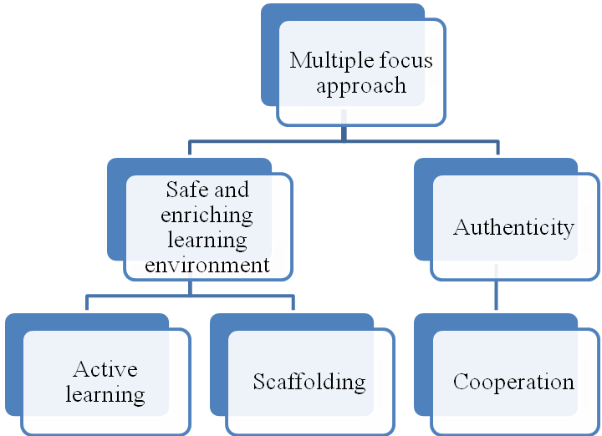

Picture 1. Methods for teaching.

Multiple focus approach - a high degree of integration should be pursued between language and content classes and among different subjects.
Safe and enriching learning environment - CLIL teachers should encourage students to experiment with language and content providing guided access to authentic materials and learning environments,
Authenticity - Connections between learning and students’ lives should be made regularly in CLIL activities as well as connections with other speakers of the language. Current materials from media or other sources should be used as often as possible.
Active learning - Students have a central role in CLIL lessons their activities should be based on a peer cooperative work and they should help content, language and learning skills outcomes. Finally, they should communicate more than the teacher who acts as a facilitator.
Scaffolding - needs building on their existing basis. One of the teacher's roles is to support student's language knowledge, repackaging information in user-friendly ways and responding to divergent learning styles,
Cooperation - A high degree of cooperation a different teachers is recommended when planning lessons an s often considered useful involving parents and/or the local community [58, p.1-27].
Intercultural Competence (IC). According to Byram, Nichols & Stevens [59, p.32-54], the Intercultural Competence (IC) is based on components such as: intercultural attitudes, knowledge, skills, and shared values in a given society. The foundation is on the attitudes of the intercultural speaker. Byram refers to these components as “saviors”, the “know how”, that will guide the attitudes of a foreign language learner. We will briefly describe these components, as they are important for the acquisition of the Intercultural Communicative Competence according to picture 2.
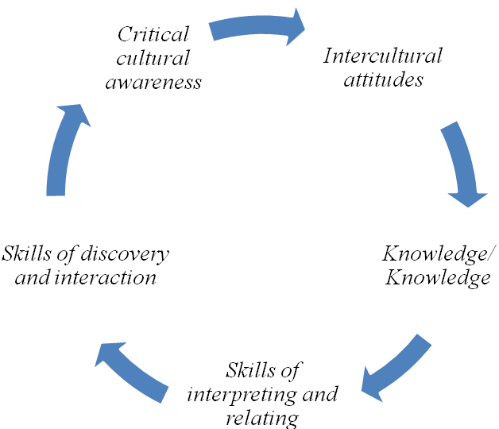
Picture 2. Components of Intercultural Competence.

a) Intercultural attitudes. Intercultural attitudes refer to curiosity, openness, readiness, beliefs and behaviors of the interlocutors. One should be able to perceive the other and the self with open eyes, with eagerness to consider new values, beliefs and behaviors.
b) Knowledge/ Knowledge. Knowledge refers to understanding how social groups and social identities function, including one’s own groups and identities. Further, Knowledge (saviors) denotes the products and the practices of these social groups.
c) Skills of interpreting and relating. Skills of interpreting and relating designate the ability to interpret and explain a document or an event from one culture to another.
d) Skills of discovery and interaction. Skills of discovery and interaction refer to the ability to acquire and operate newly acquired knowledge, attitudes and skills under the constraints of real-time interaction.
e) Critical cultural awareness. Critical cultural awareness is the ability to critically evaluate perspectives, practices and products in one’s own culture as well as another’s culture. This evaluation operates based on explicit criteria.
These components are essential to those who would like to play the role of intercultural mediators. In addition, they should be the groundwork of foreign language teaching within an intercultural approach.
Components of Intercultural Communication Competence. Intercultural communication competence (ICC) is the ability to communicate effectively and appropriately in various cultural contexts. There are numerous components of ICC. Some key components include motivation, self- and other knowledge, and tolerance for uncertainty. Initially, a person’s motivation for communicating with people from other cultures must be considered. Motivation refers to the root of a person’s desire to foster intercultural relationships and can be intrinsic or extrinsic. Put simply, if a person is not motivated to communicate with people from different cultures, then the components of ICC discussed next do not really matter. If a person has a healthy curiosity that drives him or her toward intercultural encounters in order to learn more about self and others, then there is a foundation from which to build additional competence-relevant attitudes and skills. This intrinsic motivation makes intercultural communication a voluntary, rewarding, and lifelong learning process. Motivation can also be extrinsic, meaning that the desire for intercultural communication is driven by an outside reward like money, power, or recognition. While both types of motivation can contribute to ICC, context may further enhance or impede a person’s motivation to communicate across cultures.
Members of dominant groups are often less motivated, intrinsically and extrinsically, toward intercultural communication than members of nondominant groups, because they do not see the incentives for doing so. Having more power in communication encounters can create an unbalanced situation where the individual from the non-dominant group is expected to exhibit competence, or the ability to adapt to the communication behaviors and attitudes of the other. Even in situations where extrinsic rewards like securing an overseas business investment are at stake, it is likely that the foreign investor is much more accustomed to adapting to United States business customs and communication than vice versa. The expectation that others will adapt to our communication can be unconscious, but later ICC skills we will learn will help bring it to awareness.
The unbalanced situation I just described is a daily reality for many individuals with non-dominant identities. Their motivation toward intercultural communication may be driven by survival in terms of functioning effectively in dominant contexts. Recall the phenomenon known as code switching discussed earlier, in which individuals from non-dominant groups adapt their communication to fit in with the dominant group. In such instances, African Americans may “talk white” by conforming to what is called “standard English,” women in corporate environments may adapt masculine communication patterns, people who are gay or lesbian may self-censor and avoid discussing their same-gender partners with coworkers, and people with nonvisible disabilities may not disclose them in order to avoid judgment.
While intrinsic motivation captures an idealistic view of intercultural communication as rewarding in its own right, many contexts create extrinsic motivation. In either case, there is a risk that an individual’s motivation can still lead to incompetent communication. For example, it would be exploitative for an extrinsically motivated person to pursue intercultural communication solely for an external reward and then abandon the intercultural relationship once the reward is attained. These situations highlight the relational aspect of ICC, meaning that the motivation of all parties should be considered. Motivation alone cannot create ICC.
Knowledge supplements motivation and is an important part of building ICC. Knowledge includes self- and other-awareness, mindfulness, and cognitive flexibility. Building knowledge of our own cultures, identities, and communication patterns takes more than passive experience [59, p.468-469]. As you will recall from Chapter 2 "Communication and Perception", on perception, we learn who we are through our interactions with others. Developing cultural self-awareness often requires us to get out of our comfort zones. Listening to people who are different from us is a key component of developing self-knowledge. This may be uncomfortable, because we may realize that people think of our identities differently than we thought.
The most effective way to develop other-knowledge is by direct and thoughtful encounters with other cultures. However, people may not readily have these opportunities for a variety of reasons. Despite the overall diversity in the United States, many people still only interact with people who are similar to them. Even in a racially diverse educational setting, for example, people often group off with people of their own race. While a heterosexual person may have a gay or lesbian friend or relative, they likely spend most of their time with other heterosexuals. Unless you interact with people with disabilities as part of your job or have a person with a disability in your friend or family group, you likely spend most of your time interacting with able-bodied people. Living in a rural area may limit your ability to interact with a range of cultures, and most people do not travel internationally regularly. Because of this, we may have to make a determined effort to interact with other cultures or rely on educational sources like college classes, books, or documentaries. Learning another language is also a good way to learn about a culture, because you can then read the news or watch movies in the native language, which can offer insights that are lost in translation. It is important to note though that we must evaluate the credibility of the source of our knowledge, whether it is a book, person, or other source. In addition, knowledge of another language does not automatically equate to ICC.
Developing self- and other-knowledge is an ongoing process that will continue to adapt and grow as we encounter new experiences. Mindfulness and cognitive complexity will help as we continue to build our ICC [60, p.69]. Mindfulness is a state of self- and other-monitoring that informs later reflection on communication interactions. As mindful communicators, we should ask questions that focus on the interactive process like “How is our communication going? What are my reactions? What are their reactions?” Being able to adapt our communication in the moment based on our answers to these questions is a skill that comes with a high level of ICC. Reflecting on the communication encounter later to see what can be learned is also a way to build ICC. We should then be able to incorporate what we learned into our communication frameworks, which requires cognitive flexibility. Cognitive flexibility refers to the ability to continually supplement and revise existing knowledge to create new categories rather than forcing new knowledge into old categories. Cognitive flexibility helps prevent our knowledge from becoming stale and also prevents the formation of stereotypes and can help us avoid prejudging an encounter or jumping to conclusions. In summary, to be better intercultural communicators, we should know much about others and ourselves and be able to reflect on and adapt our knowledge as we gain new experiences.
Motivation and knowledge can inform us as we gain new experiences, but how we feel in the moment of intercultural encounters is also important. Tolerance for uncertainty refers to an individual’s attitude about and level of comfort in uncertain situations [59, p.468-469]. Some people perform better in uncertain situations than others, and intercultural encounters often bring up uncertainty. Whether communicating with someone of a different gender, race, or nationality, we are often wondering what we should or should not do or say. Situations of uncertainty most often become clearer as they progress, but the anxiety that an individual with a low tolerance for uncertainty feels may lead them to leave the situation or otherwise communicate in a less competent manner. Individuals with a high tolerance for uncertainty may exhibit more patience, waiting on new information to become available or seeking out information, which may then increase the understanding of the situation and lead to a more successful outcome. Individuals who are intrinsically motivated toward intercultural communication may have a higher tolerance for uncertainty, in that their curiosity leads them to engage with others who are different because they find the self- and other-knowledge gained rewarding.
The United States and the United Kingdom used to be considered the best places to go to learn English. However, this idea is losing credence. What is important in intercultural communication is one’s competency and willingness to understand what the other has to say, not the disposition to impose one’s values and norms onto the other. As Honnar (2005) stated, “With some degree of intercultural awareness, one is capable of understanding the other even if the two persons’ communication styles are different”. It is clear that communicating effectively and appropriately involves both the speaker and the listener.
In recent years, there have been more discussions and research focusing on the importance of intercultural communicative competence. Intercultural communicative competence is the ability to communicate effectively and appropriately with people from other language and cultural backgrounds. Effective intercultural communication requires due to the picture 3:
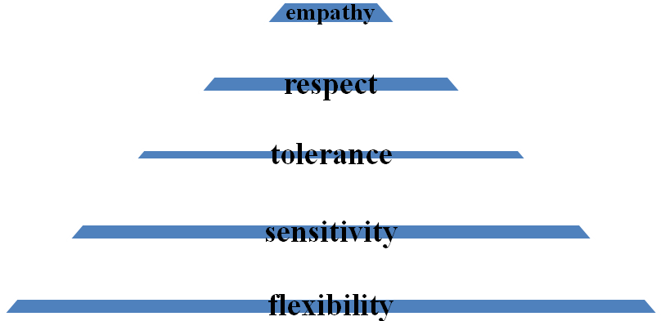
Picture 3. Effective Intercultural Communication.

- empathy: an understanding of other people’s behaviors and ways of thinking
- respect: genuine admiration and appreciation of different ways of thinking and communication
- tolerance: the ability and willingness to accept and acknowledge different behaviors and ways of thinking, the existence of opinions or behavior that one does not necessarily agree with
- sensitivity: the awareness and responsiveness to other people’s behaviors and ways of thinking
- flexibility: willingness to adapt and open to change and different ways of thinking.
Lippi-Green (1997) has emphasized the importance of “sharing the communicative burden.” She pointed out that oftentimes, “members of the dominant language group feel perfectly empowered to demand that a person with an accent carry the majority of responsibility in the communicative act. Conversely, when such a speaker comes in contact with another mainstream speaker who is nonetheless incoherent or unclear, the first response is usually not to reject a fair share of the communicative burden, but to take other factors into consideration” . To achieve effective intercultural communication, she emphasizes that speakers from dominant cultures need to apply the same willingness to share the communicative burden when interacting with a person who speaks with an accent, i.e., nonnative English speakers and people from culturally and linguistically diverse backgrounds, and not to reject their fair share of the communicative burden.
The structure of the ‘intercultural communicative competency’ which we are proposing contains sub-competencies which reflect the teaching system that forms an intercultural-communicative level of MFL command sufficient for everyday life and work in the modern interconnected world. Our structure of the intercultural communicative competency' contains the following sub-competencies according to the picture 4:
- the linguo-culturological, which forms a language student's primary conceptualization of the world on the basis of their own culture;
- the social and socio-culturological, which creates a language student's 'secondary cognitive consciousness' as a conception and form of the world of a different language society. It also forms in the student's cognitive system 'secondary constructions - knowledge' corresponding to their knowledge of the world and language of a different language society. This sub-competency is developed as something 'new' on the basis of something 'given', that is, the secondary cognitive consciousness is formed upon the foundation of one's native culture and language;
- the conceptual, which provides the means for the study of MFL and is a reflection of the conceptually-organized' picture of the world' of a different society and the result of a common, integrated mechanism for working over natural language in an individual's consciousness;
- the cognitive provides the formation of language as an inalienable part of the process of knowledge-acquisition and thought. The formation of the cognitive sub-competency manifests itself within the cognitive structure as mental constructs through which an individual comprehends the surrounding world and interacts with it as a speaker of natural language. It also reflects a society's collective consciousness and mentality. During the transition to a new language, this sub-competency controls the conscious process of the acquisition of a 'secondary conceptualization of the world;
- the personality-centered sub-competency allows the use of general cognitive mechanisms in language and, more specifically, regulates the mechanism for the parallel working over of language within consciousness on three levels - the semantic, syntactical and pragmatic. In other words, the personality-centered sub-competency allows a reflection by the language student of a conception of the world through the anthropocentric paradigm;
- the communicative sub-competency: The modern tendency towards the growth of a global society, the understanding of language as the translator of a global human culture, the broadening of international integration and co-operation have caused the strengthening of the culture-forming and cognito-communicative functions of language.
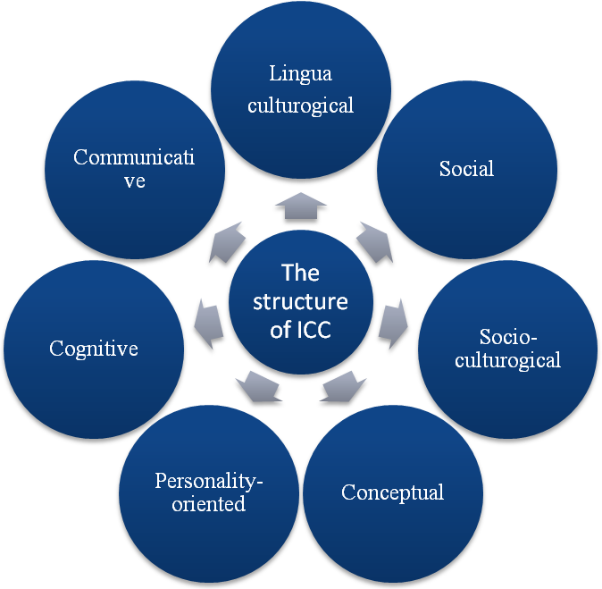Picture 4. The structure of ICC.

The sub - competencies identified within the structure of the intercultural communicative competency are formed according to the leading cognitive principle. The characteristics of the integrated activity structure of the theory of intercultural-communicative teaching should be viewed as an integrative concept of the competency-based model of the ‘intermediator of intercultural communication’ which is reflected in and, provided by, the set of methodological principles of the cognito – lingua-culturological methodology of MFL education [60, p.20-44].
Examples of CLIL lesson plan. A typical lesson plan for CLIL consists of stages specifically designed to perform the following activities:
• checking previous knowledge;
• practicing content language;
• expanding vocabulary;
• consolidating knowledge;
• summarizing skills;
• applying the new knowledge;
• checking and correcting errors.
To practice content language, it’s necessary to design stages focused on speaking interaction and/or on developing receptive skills like listening and reading. Depending on the topic, it might be important to develop the production of language even in written form. The lesson plan from the work of Umberto Lesca in accordance with the table 2:

Table 2. PHYSICS – The laws of optics.
LESSON AIMS – Content:
By the end of the lesson the students will have greater understanding of what light is, how different mediums affect the path through which light propagates (laws of refraction and reflection), what total reflection is and what total reflection can be used for.
LESSON AIMS – Language:
- - The students will have expanded their vocabulary in the field related to optical physics and optical fibers.
- - They will have practiced the use of prepositions of space and expressions to locate a path in the space.
- - They will have practiced the impersonal language to speculate about scientific and technological topics.
STAGE | PROCEDURE
Stage1 (introduction) | Students get information by listening to the teacher.
Stage 2 (checking previous knowledge) | Students read a list of phrases and fill in the matching words.
Stage 3 (expanding knowledge and specific language) | Students expand their knowledge about the creation of light and the law of refraction by looking at diagrams at the black board.
Stage 4 (practising functional language and checking the knowledge) | Students use their language and special knowledge to find out the right answer for some questions. They analyse a picture and discuss their opinions.
Stage 5 (expanding knowledge) | Students get information by listening to the teacher and looking at a diagram.
Stage 6 (developing reading skills) | Students read text and do a true false and a gap exercise. They compare answers with partner
Stage 7 (Developing cognitive skills (predicting)) | Students guess what might happen when the incidence angle is increased and light encounters the boundary with a lower refraction index. Work in pairs.
Stage 8 (Developing reading skills) Expanding vocabulary (specialist vocabulary for optical fibers) | Students read a text to check if their prediction was right (scanning). Students read the rest of the text to find out how total reflection is related to the functioning of optical fibers (skimming).
Stage 9 (Practicing language) | Students look at a list of verbs and a list of prepositions used in the text given at the previous stage and try to match verbs and prepositions according to that text.
Stage 10 (Developing cognitive skills (reasoning)) | Students choose from a given list of technological applications which of them might use optical fibers and explain why optical fibers are suitable for that specific purpose. Work in pairs or groups.

3.3. CLIL through Presentation, Practice and Production Stages

As far as language teaching is concerned, there has been a great deal of research carried out by linguists from all over the world and many theories and methods on how languages are best learnt have been put forward. Some have indeed proved to be very successful ways of learning a second language (L2), becoming very popular in L2 classrooms around the world. Among many methods, the PPP is a successful one and is widely used throughout the world by many English as a Foreign Language (EFL) and English as Second Language (ESL) teachers. Every PPP lesson has a language aim, which students should fulfill by the end of it. It is a modern equivalent of the audio-lingualism method, which dates back to the 1940s. Not only the PPP can be applied to teach grammar items, but it can also be used to teach functions, vocabulary and even pronunciation. In a PPP lesson, there are three stages: first, the teacher presents the target language; then, students practice the new language items; and finally they use their own ideas to talk about themselves.
The presentation phase usually consists of two steps: an introductory activity such as a warm-up or a lead-in, which is an activity, intended to raise students’ interest in the topic; and an introduction of the target language. For example, if the aim of the lesson is to teach the present continuous for arrangements, the lesson could start with a warmer in which the teacher elicits some activities the students enjoy doing at the weekends. Then, the suggested ideas are written on the board and the teacher helps with any pronunciation problems there might be during this step. After that, the teacher could write the students' ideas on the board to present the present continuous. The teacher chooses some of them and talks about his/her own arrangements for the weekend. While the teacher presents the new language items, the students just listen. This way, the present continuous is being presented in a contextualised way, which is very important at the presentation stage of the lesson.
In the practice stage, the focus is on form. The teacher provides opportunities for students to practice the learnt items in a controlled way. This is a chance for the students to use what they have learnt without making mistakes, so it is of the utmost importance that at this moment of the lesson, the students are monitored and all mistakes are corrected. A common controlled activity is a choral drill, in which students repeat the sentences on the board, using the present continuous. Then, the teacher explains the grammatical use of the new language referring the present continuous to its function: making future arrangements. After that, he/she asks the students conceptual questions, that is, questions to check whether they have understood the use of the language. For instance, 'What am I going to do on Saturday morning? How about on Saturday evening?' etc. Students can then carry out another restricted activity such as a written gap filling in which they fill in the gaps of sentences with the present continuous form of the verbs in brackets. It is necessary though; those students have the chance to practice, through restricted exercises, at the beginning and at the end of the practice stage.
Once students have practiced the present continuous, now it is time for them to use what they have been taught in real-situation like activities. The production stage focuses on fluency and provides students with an opportunity to personalize the language learnt by doing less controlled tasks, that is, by using their own ideas. A good production exercise for the described lesson is: the teacher gives a copy of a blank weekly schedule for students to complete with some arrangements and activities of their own. Then, students work in pairs, asking about what they are doing at specific days and times of the week and which arrangements they have. To make this freer practice more interesting and interactive, the students could try to find out each other's free time in their timetables and make arrangements between themselves. It is extremely important that students use what they have learnt in very communicative tasks.
According to Jeremy Harmer (2009), the PPP is a method that is widely used in teaching simple language at lower levels. Furthermore, many modern course books contain examples of PPP lessons, which have retained elements of structural-situation methodology and audio-lingualism. Harmer adds that there is a consensus that PPP is just one method among many, not taking into consideration other ways of learning. It is very learning-based and takes little account of students’ acquisition abilities. However, I strongly believe that once the lesson is finished and your students have actually achieved its aim, having been able to produce language in a meaningful way, it means that the method applied was successful and effective, and only then will the teacher feel that learning has really taken place.
Teaching other subjects through English. As we have mentioned before, CLIL is teaching other disciplines or subjects through English language, where we learn both Language and Content. According to the authors Sheelagh Deller and Christine Price from the book “Teaching other subjects through English” – “The belief underlying CLIL is that teaching subjects through English provides a better preparation for professional life than teaching English as a subject empty of content. There are, too, clear motivational advantages in teaching English for a well-defined purpose which is perceived as relevant by the students” [66]. Here the authors highlight the importance of CLIL in recent years. As long as the writers classified CLIL according to the language orientation (vocabulary, writing etc.), I have divided them according to the 3P stages (presentation, practice and production). There are some sample materials, which are made due to the different subjects.

Presentation stage - THREE THINGS I KNOW ABOUT…

Aims: | l a n g u a g e Defining ; asking for and  giving information  o t h e r Revising and expanding information on a  Subject; working in a group; note taking.  ICC social and communicative competencies
Materials | Large sheets of paper—one for each topic; sheets of paper—one for every student; a stick-on label for every student.
Demo subject | BIOLOGY  topic The human body: the skeleton, muscles, air  supply, circulatory system, cells, digestive  system, reproductive system
Alternative subjects | Sport Equipment and rules required for any sport  History The Renaissance period—writers, thinkers  and artists  Design and technology Metals—joining metals, reforming metal,  heat treatment, best use of standard  components for metal

Preparation
Write a list of topics you want the students to revise.

Procedure
- Divide the class into groups of three or four. Give each group a topic they have studied recently. Give each student a label. All students write their topic title on a label and stick it on themselves.
- Ask each group to discuss three things they know about the subject. Give each student a sheet of paper and ask each to write down the three things the group has discussed.
- Tell the students to find a partner from another group. The pairs take turns to read out their lists and ask their partner for one more piece of information about the topic. They write the extra piece of information about their topic on their own sheet of paper. Then they move on to new partners until they have collected four or five more pieces of information.
- The students go back to their original group to read and assess all the information they have collected, i.e. they pool it. You check the information.
- Ask each group to write three or four sentences about their topic.
- Each group reads their sentences to the rest of the class. The other students make notes.
- Write one topic title at the top of each large sheet of paper, for example, ‘Circulatory system’. Pin up the sheets. The groups go round these topic sheets and write on them any information they can remember. They can use their notes.
- Take the large sheets and pin them on the board. Read out the information. The students write notes in their exercise books for future reference. This final check helps to fix and anchor the information in their minds.
Practice stage - STUDENT-GENERATED JUMBLED WORDS

Aims: | l a n g u a g e Spelling  o t h e r Labelling key words on a picture; jumbling  and reordering words; using the  Visual/spatial intelligence.  ICC the conceptual and cognitive competencies
Materials | Picture to be labelled.
Demo subject | BIOLOGY  topic Bones, joints and muscles
Alternative subjects | design and technology Different equipment/tools  mathematics Geometric shapes  art Pictures and artists  Vocabulary for any subject

Preparation
- Find or draw a picture illustrating the words you want to be memorized.
- Photocopy it for each student.
- Write a list of the words in random order.

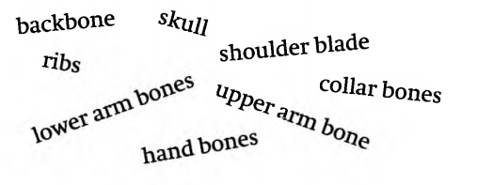
Example

Procedure
- Write the words all over the board—not in a vertical list.
- Students work in pairs. Ask them to make a list of the words from the board in any order they like, and then to number them.
Example Different bones and muscles
- Give out the pictures. Now they match the words to their picture by writing the appropriate numbers on the picture. If they have any problems they must get you to check.
- Get them to jumble the letters of each word on their list.

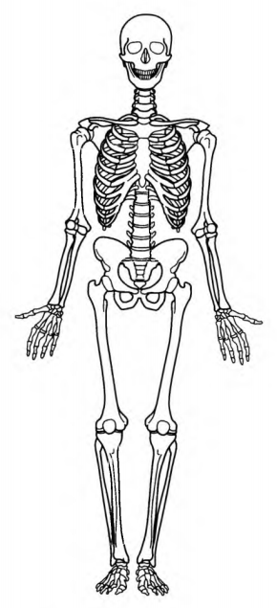
Example 1 luksl
2 cbakbone
3 laoclrbone
4 lerdoshu blade
5 sbir
6 preupmrabone
7 rwloe mar bones
8 dnah bones
- Each pair exchanges their picture and their list of jumbled words with another pair. The pairs re-order the letters and then write the matching number from the picture next to each word.
- They give back their work to the pair who wrote it for them to check.
Comments
The process of jumbling and re-ordering the words is a good way to help students memorize them. In fact they probably learn as much from creating the activity as they do from working on the activity they have been given.

Production stage - ASK ME, TELL ME

Aims: | l a n g u a g e Asking for and giving information.  o t h e r Note-taking; using fellow students as a  resource; cooperative learning;  interpersonal skills; revision.  ICC the linguo-culturological and socio-  culturological competencies
Materials | Sheets of paper—one for each student.
Demo subject | BIOLOGY  Topic Humans as organisms, for example, the  digestive system, circulation, the breathing  system, respiration, nervous system, the eye.
Alternative subjects | physics Atoms and nuclei  design and technology Plastics and composite material  geography Coastal management  Any subject you want your students to revise orally

Preparation
Select the topics or units you want the students to revise. Make a list of useful page references and resource points.
Procedure
- Give each student a sheet of paper and tell them to fold it in half horizontally. Get them to write the words ‘Ask me about’ as a title for the top half, and Tell me about’ as a title for the bottom half.
- Write your list of topics on the board. Tell the students they must choose one topic they feel confident about and one they feel less confident about. They write the first topic under the heading ‘Ask me about’ and the second one under the heading ‘Tell me about’.

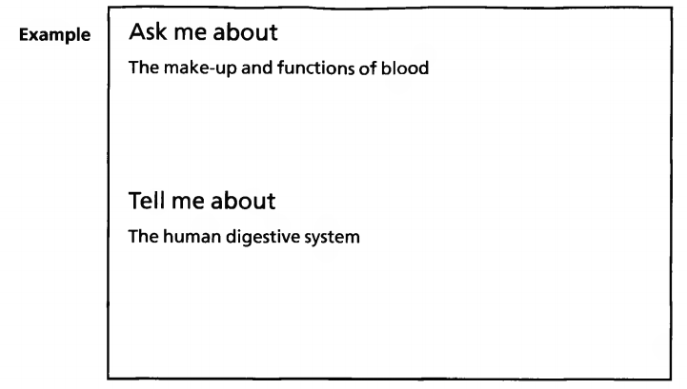
- Give the students time to check their information on the ‘Ask me about’ topic. They can make brief notes in the ‘Ask me about’ section on their paper.
- The students now mix and mingle giving their information about their ‘Ask me about’ topic and collecting information for their ‘Tell me about’ topic. They write notes in the ‘Tell me about’ section if they consider the information is correct and helpful. Explain that they should speak to as many people as possible in the time.
- Write your list of useful references and sources on the board under the appropriate topic titles. At the end of the time limit, ask the students to check their information with the references on the board. They should ask you to clarify and correct any information they are not sure about.
- Ask volunteers to read out all the correct information they collected for their ‘Tell me about’ topics. Check that all the topics have been covered. The students listen and make notes about all the topics. They also write down the reference points from the board.
Follow -up
1 The students can turn their papers over and reverse the topics, so the ‘Ask me about’ topic becomes ‘Tell me about’ and vice versa. Get the students to repeat the speaking activity but without cues, prompts or note taking.
2 As homework the students can write a few sentences about each topic.

Presentation stage - Getting the right order…

Aims: | language Adverbs of sequence, for example, after,  before.  other Memorizing a sequence of steps; using  the kinesthetic intelligence.
Materials | One slip of paper per student.
Demo subject | literature  topic Periods of literature
Alternative subjects | sciences The steps involved in an experiment  history The order of events, monarchs, battles  mathematics The steps to solve a specific calculation  Any subject which involves a sequence or order

Preparation
Write out the steps of the sequence you want your students to learn.

Procedure
- Show on the board the steps you want your students to memorize. Number them. Give the students time to try to memorize the correct order.
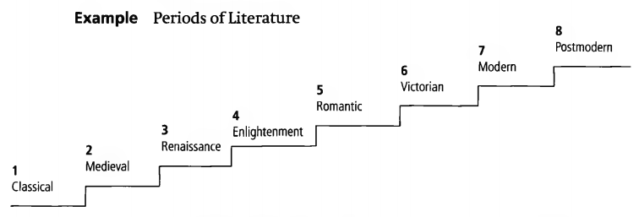

- Put students into groups of the same number as the steps that you want them to memorize. In this example, they will be groups of eight. Number the students 1-8. If you have more than eight students in a group two can share a number. If you have seven students, you can give one student two consecutive numbers.
- Student l in the group stands and says the name of the first step, student 2 the second and so on. Check each group. If a student makes a mistake, student 1 starts again from the beginning. They continue like this until they have managed to get through the whole sequence at least twice without making a mistake.
- Ask the students to write the name of their step on a piece of paper. They mix them up and each student in the group takes one.
- This time they must stand and say the step on their piece of paper at the appropriate time.
- Repeat step 5 as often as necessary, getting the students to redistribute the slips each time.
- Ask the students to write the different periods on a staircase in their books.

Practice stage - STUDENT-GENERATED WORD PUZZLE

Aims: | l a n g u a g e Writing definitions and descriptions;  asking and answering; questions;  translating.  o t h e r Memorizing key words.
Materials | Picture to be labelled.
Demo subject | MATHEMATICS  topic Mathematical terms
Alternative subjects | biology Parts of the body  physics Electrical components  history Different battles/wars  Vocabulary for any subject

Preparation
- Write a list of about twelve words you want your students to focus on.
Example area, average, coordinates, graph, hypotenuse, numerator, quotient, intersection, integer, equation, denominator, isosceles
- Put them in a chart in any order, as below.
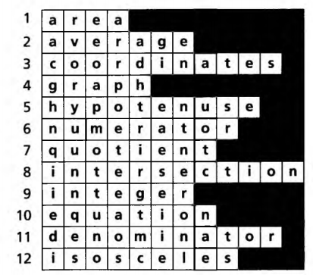

- Divide the chart in half horizontally across the middle so that the two halves look like this:

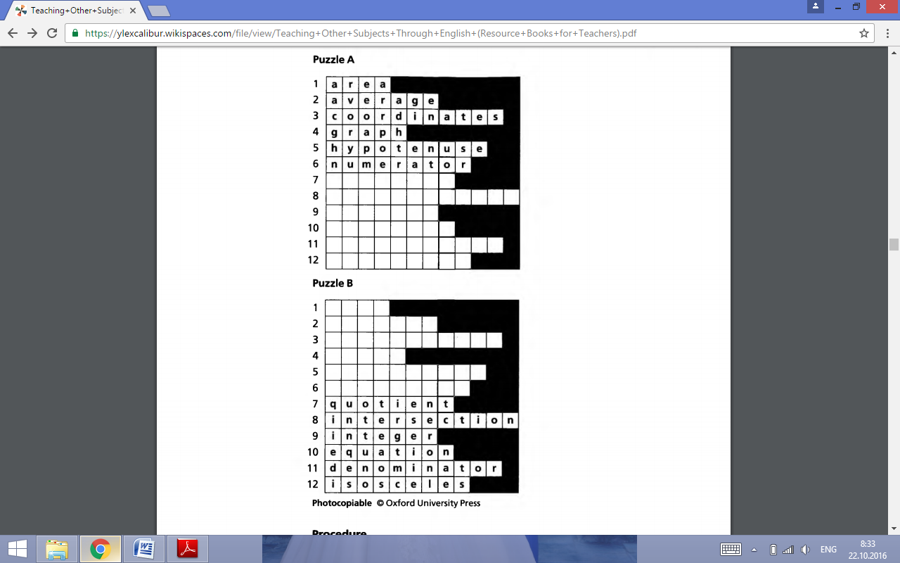
Procedure
- Put the students into small groups. Give half the groups ‘Puzzle A’ and the other groups ‘Puzzle B\ Ask them in their groups to write a definition or clue for each of the words in their puzzle. These could be done in the mother tongue. Stress that they all need to write the clues, because they will be on their own in the next step.
- Go round the groups checking their work.
- Put the students into A and B pairs. Tell them not to let their partner see their chart.
- Students take it in turns to ask their partner for a clue for any of their blanks, for example, please give me the clue for number 5. They write the answers in their chart.
- Get the students to translate all the words into their mother tongue.
Comments
As with many activities, students probably learn more from writing the clues than from guessing the answers.

Production stage - ANSWER MY PICTURE QUESTIONS

Aims: | l a n g u a g e Practising question forms.  o t h e r Using different resources; student-student  input; getting new information
Materials | Copies of the chosen visuals—one per group; and texts—one per student; different coloured board pens.
Demo subject | HISTORY  topic Hannibal crossing the Alps in 218 BC
Alternative subjects | Physics Using waves—diagrams and graphs  ITC Data storage—diagrams  Geography Climate—graphs and weather charts

Preparation
- Find a short text from the Internet, a textbook, or an encyclopedia, and a visual you could use to go with the text. In this example, you could use the Internet for the text and any picture of the journey, even a famous painting, for example, Joseph Turner—Snow Storm: Hannibal Crossing the Alps.
- Make a copy of the text and another of the picture. Remove any labels from the picture. If there is any writing or information such as titles outside the frame, cut it off. Leave just the picture.
- You will be dividing the class into A and B groups. The A groups will need a visual per group. The B groups will need copies of the text. Make enough copies of the text for each student in the class.
- You may need to simplify the language of the text depending on the level of the class. Write line reference numbers on the text before you photocopy it.

Procedure
- Divide the class into equal-sized A and B groups.
- Explain the difference between open and closed questions and ask the students to use both kinds of questions:
An open question is general and can have a variety of answers. Open questions about the picture can include not only what people see in the picture but also what they imagine, feel about or associate with the picture— thinking outside the frame. A closed question can be a ‘yes/no’ question and usually has only one answer.
Example An open question: What things would make the journey across the Alps so difficult?
A closed question: What were the dates of the Second Punic War?
- Give the A groups the visuals and the B groups the texts. Tell the B groups to read the text for general understanding, i.e. to get the gist. They do not have to understand all the words.
- Tell the A groups to study the visuals and write a list of questions they would like answered when looking at the visual. Ask them to use both open and closed questions. Set the same time limit for the reading and question writing.
- Ask the A groups to pair up with a B group and show and ask them their questions. The B groups scan the text and discuss possible answers for the open questions. The A groups make notes.
- Display copies of the visual round the room. Let the text group (B) students walk round and look at them. Give them a few minutes to do this before they go back to their groups.
- As a whole class and taking it in turns, the A groups ask their questions aloud and the B groups respond with answers. Write down a selection of the questions on the board for the students to copy.
- Give out the rest of the text copies so that each student has a copy. Individually the students scan the text and underline any words or expressions they find difficult. Check and explain.
- The students copy the questions from the board. As homework, they write answers for as many of the questions as they can.

It is of paramount importance to take into account both content and language while evaluating students’ progress in a CLIL lesson, and teachers should base their assessment on both. Although assessment should follow the principles for good practice as would be applicable in any context, Ute Massler in ‘Guidelines for CLIL implementation in primary and pre-primary education’ says that CLIL assessment is different from traditional methods.
• First of all, since the CLIL lesson has a dual focus, attention needs to be given to evaluating both language and content. Rather than focus on a single subject, an assessment should include all of the objectives and goals of the CLIL lesson, involving competences, knowledge, skills, attitudes and behaviour.
• Just as particular factors regarding learners are taken into consideration when preparing the CLIL curriculum, some of these factors should also be taken into consideration when preparing assessment. For example, Massler mentions the following factors according to the picture 5:
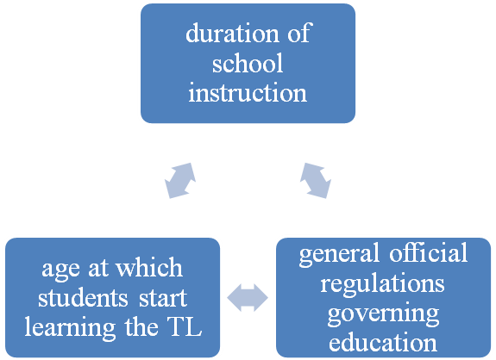
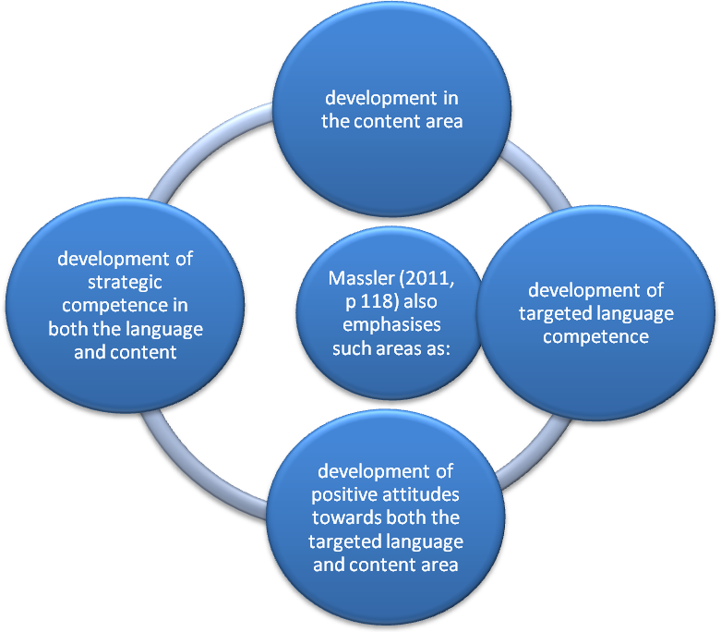
Picture 5. Factors of the CLIL assessment.

Assessing CLIL learning, then, is different from usual school testing. With CLIL, the student is learning new content and new language at the same time, and the teacher needs to be able to assess progress in each. CLIL teachers can use assessment and feedback to both encourage learners to work on developing their understanding of the subject content, and to focus them on appropriate and accurate language use. If content and language are not both assessed, the dual focus of CLIL is lost. However, sometimes priority can be given to understanding of content, and sometimes to accurate language use.
Assessment of a range of criteria is more useful than focus on a single aspect of learning, and this is made easier if a rubric is used. A rubric is a grid listing the criteria to be assessed in rows, divided into columns for each grade .In each cell; there are descriptors, which quantify what the learner has to do to achieve the grade. How the rubric is laid out depends on how the teacher wants to use it to motivate learners and help them complete work successfully.
If the same grid will be used with a class for several different tasks, or for a series of evaluations over the course of a longer project, then it could make sense to show progression left to right, from a poor effort to excellent work. It would then be easy for students to see how to improve their work for the next evaluation. However, if the grid is designed for a specific piece of work, where students are evaluated only once, they do not have the opportunity to improve their output .In this case, it is probably more motivational for students to see first what they need to do to excel, rather than see how to achieve a pass mark. The most important thing is not the layout of the grid, but the content of the cells .The cells provide an opportunity for the teacher to make clear to the students exactly what they need to do to pass, do well, or to excel in each area of the evaluation. Students can then make a decision on where to focus their effort.
The teacher can choose the criteria to be assessed .For example, if one of the criteria for a math task is accurate measurement; students know that this is an important measure of proficiency. If high marks are given for critical thinking, learners can make sure that they are critical in their answer. If teamwork is one of the criteria, learners will make the effort to interact. Moreover, if a student is given a low grade in one particular category, she knows where to focus to become more successful .In this way, assessment can increase learner autonomy by helping students understand the aim of their learning and how to identify and fill any gaps. Learner autonomy can also be fostered by allowing the learners to suggest or even select some of the criteria; and self- and peer-assessment can motivate and encourage reluctant learners.
CLIL Assessment in Practice. Sample Grids for Assessment. With a CLIL approach, the assessment for Content is likely to be very similar to that already in use in ‘traditional’ teaching. However, the use of topic vocabulary (as Communication) and the Competence of identifying relevant information might also be included according to the table 3, for example:

Table 3. Assessment for the content.
Criteria | 4 - excellent | 3 - good | 2 - satisfactory | 1 - not satisfactory
Use of topic-specific vocabulary in written work | All new words used appropriately in simple sentences | 15 new words used appropriately in simple sentences | 10 new words used appropriately in simple sentences | Fewer than 5 new words used appropriately in simple sentences
Identification of relevant information from different websites | Relevant  information identified from  at least three  different  websites | Relevant  information  identified  from at least  two different  websites | Relevant  information  identified from  at least one  website | More than  one website  accessed but  no relevant  information  identified

Other examples of possible assessment criteria n accordance with the table 4

Table 4. Assessment for the creativity.
Criteria | 4 - excellent | 3 - good | 2 - satisfactory | 1 - not  satisfactory
Originality in  preparation  and execution  of diagrams  and other  visual  materials | Student has  at least three  original design  ideas and is  able to prepare  the resulting  visuals | Student  has at least  two original  design ideas  and is able  to prepare  the resulting  visuals | Student has at  least one  original design  ideas and is  able to  prepare the  resulting visual | Student  makes some  contribution  to designing  and preparing  visuals

As Massler suggests, assessment is also an opportunity to make clear to learners the Competences that are being evaluated. Naturally, there are overlaps in all aspects of a CLIL-based lesson, and the 'can-do' statements that relate to the other 'C's can be counted as competences, and could be assessed as such. By including specific competences in an evaluation rubric, however, the teacher has an opportunity to make clear not only a skill considered important for a particular classroom activity, but also to demonstrate how that Competence can be improved and developed by a learner.
Examples of this, are shown in the rubric for peer assessment below according to the table 6, marked *.

Challenges for teachers. Subject teachers need to feel confident about their English language level, especially if they have not used English for some time. For example in science, subject teachers need to according to the picture 6

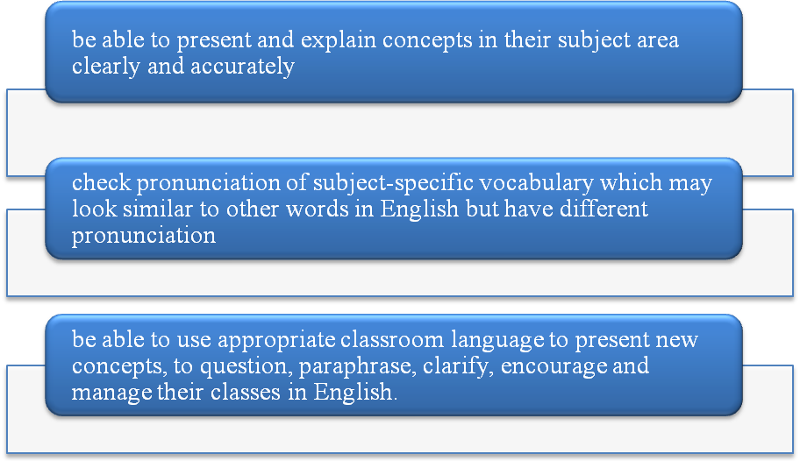
Picture 6. Challenges for teachers - 1.

Language teachers may decide to teach subjects in CLIL or may be asked to. They need to feel confident about their knowledge and skills related to the subject they are going to teach. For example in science, language teachers need to according to the picture 7:

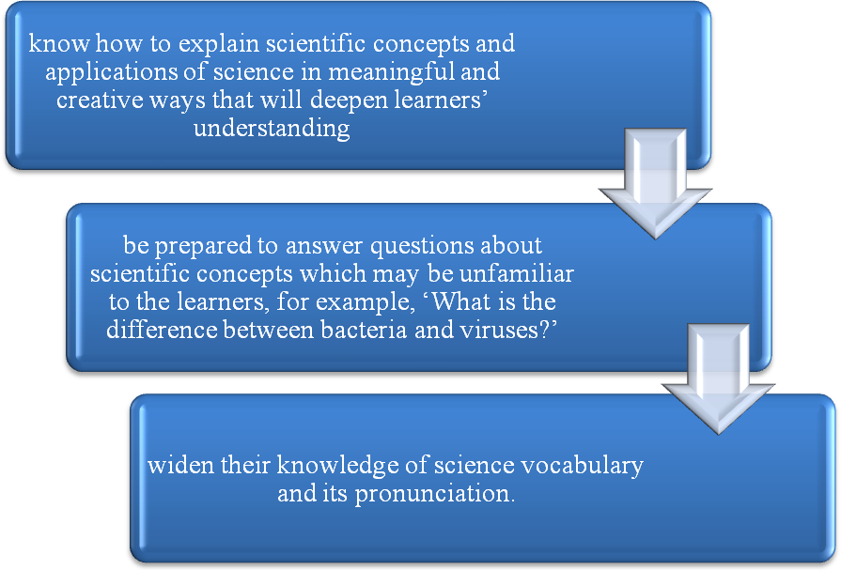
Picture 7. Challenges for teachers - 2.

Challenges for learners. Most learners need considerable support in the first two years of CLIL courses. Most teachers do not know how long learners will take to do tasks, complete worksheets or understand instructions and explanations until they have used materials for the first year. Learners are all different; some need more support in order to understand subject concepts, while others need more support to communicate ideas about subject concepts. Learners may need differentiation of: input – task – support.
Differentiation is also necessary for learners that are more able. Teachers need to plan extension activities to develop learner autonomy and learners’ higher order thinking skills for science. This is when Information and Communications Technology (ICT) can be very useful for online learning activities such as web quests and independent fact-finding.
Use of L1. In CLIL, it is recognized that some use of L1 by learners, and sometimes by teachers, is a bilingual strategy that helps learners communicate fluently. Moving either between L1 and the target language, mid-sentence or between sentences is quite common for learners in CLIL. This is known as code switching. Classroom observations show that use of L1 and the target language happens between learners in the following interactions according to the picture 8
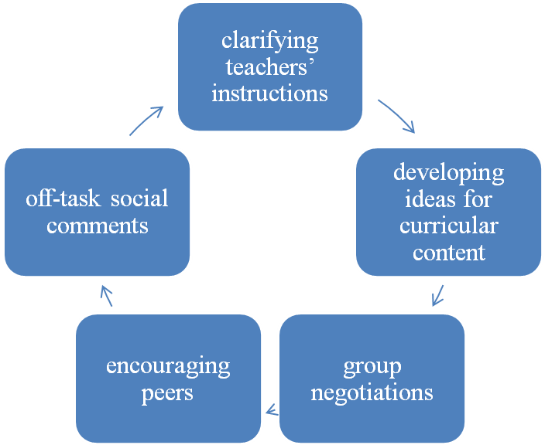

Picture 8. Using of L1.

It is important that teachers avoid using L1 unless they are in a situation when it would benefit or reassure learners. Some schools have a policy where no L1 should be used. Teachers should be able to justify when they use L1.
Lack of materials. One of the most common concerns of CLIL teachers is that they cannot find appropriate science materials for their classes. Either they cannot find anything to complement the work done in the L1 curriculum or adapting native-speaker materials takes too much time. Increasingly, publishers are producing resources for specific countries. However, as teachers gain more experience of CLIL, they generally start to feel able to adapt native speaker materials from science websites and from subject-specific course books.
Assessment. CLIL assessment leads to much discussion. Teachers are unsure whether to assess content, language or both. Different regions, different schools and different teachers assess in a variety of ways. What is important is that there is formative as well as summative assessment in CLIL subjects and that there is consistency in how learners are assessed across subjects in each school. Learners, parents and other colleagues need to know what learners are being assessed on and how they are being assessed. One effective type of formative assessment is performance assessment. It involves learners in demonstrating their knowledge of content and language. For example, they could: explain how they set up an experiment to test bone strength; describe how they applied their knowledge of bones to do a survey of broken bones and recovery rates from the breaks, and then recorded the data using ICT.
Teachers observe and assess learners’ performance using specific criteria. Performance assessment can involve individuals, pairs or groups of learners. As CLIL promotes task-based learning, it is appropriate that learners have opportunities to be assessed by showing what they can do individually and collaboratively. Performance assessment can also be used to evaluate development of communicative and cognitive skills as well as attitude towards learning. For example, teachers can look for evidence of learners’ ability to explain the effects of microorganisms on the human body (communication), reflect on the reliability of their findings (cognitive skills) and share information with other group members (attitude) [47]. Based on careful research of a questionnaire we came up with the chart, which shows teachers’ attitude to CLIL.
Teacher’s questions:
- I am a content teacher. Why should I incorporate a focus on language in my subject teaching?
It is difficult to learn a language out of context. Traditionally, language teachers use course books which are topic-based, and which can be irrelevant to the learner’s life. In contrast, learning language in the context of a school subject can be motivating, as it has a clear purpose, which is relevant to the student. It is like an ESP lesson (English for Special Purposes) for a member of flight crew or a Sales Manager. Where learners already have some basic knowledge of content, this can result in the sharing of experiences amongst themselves, and with the teacher, in the additional language (AL). This develops the learning of both the content and the AL.
- I am a language teacher. How can I help content teachers when I do not know anything about their subjects?
By teaching through CLIL, you are helping your students not only by teaching them content, but also by preparing them for any future work where they would need to know that content in an additional language. It is also a holistic way of teaching, incorporating not just content and language, but also thinking skills and competences relevant to the community. In effect, you are teaching your students the skills needed in their future workplace, and not simply content.
- Yes, but I still do not know much about the content!
A language teacher does not teach content, and is not expected to, but uses the content as a vehicle for introducing language. In other situations, the language teacher works closely with the content teachers to offer guidance on the language they need in their lessons. Here the language teacher takes on the role of ‘consultant’ to content teachers.
- What makes CLIL language learning different from normal language learning?
The language that students learn in a CLIL lesson is not the typical language learnt in a traditional language lesson, but language relevant to their future. It is a tool for communicating within the framework of the content. Since the primary aim is to communicate and not learn merely the grammar and syntax of a language, students realize that they can use the language without an in-depth knowledge of it first. CLIL helps students simultaneously use the targeted language and gain knowledge of content.
- How can I get my students to accept CLIL?
Some students might initially be reluctant to use an additional language (AL) to learn content. They may feel that it will make their workload much heavier than it actually is. It is important to discuss with students the reasons for learning through CLIL, and to stress its benefits, such as the fact that it will open doors for work mobility in the future. Even if students do not move abroad to work, they will benefit from knowing an AL, especially specialist language related to their work. Employers are more likely to employ people who have the added benefit of an additional language. CLIL language learning develops organically. With time, students enrich their vocabulary and the targeted language becomes clearer. Students become more confident and can express themselves with greater ease despite mistakes (in grammar, syntax, spelling or pronunciation). Language learning ‘success’, in terms of CLIL, is demonstrated by communicative use of the AL. Where possible, students should be encouraged to get in touch with students from other countries, to exchange ideas about the subject they are learning. It is relatively simple to set up an e-Twinning project with another class via:
- How can I teach the new language if my own level is not very high?
This is probably the greatest fear of any content teacher, and has caused a reluctance to teach using a CLIL approach. A positive approach could be to discuss your insecurities with your Head of School, and to request the help of a language teacher as ‘language expert’. Remember that you are the ‘content expert’. Using CLIL does not mean that you set out to teach an entire language. Your task is to teach content while incorporating new language needed for your lessons. You facilitate the learning of this new language by providing opportunities for and encouraging your students to use it.
Online CLIL4U Pre-Course is aimed at helping low-level teachers to become more familiar with English, which is often the additional language used in CLIL, and is the language we use to deliver the course itself. The language sections will help you increase your knowledge of English, and exercises will provide you with practice. By following the short pre-course in your own time, you can gain more confidence in English. Go to pre-course to see the CLIL4U Language Course:
- How can I get through the whole syllabus if I have to teach language as well as content?
The language you teach in CLIL is not a complete language course .It is simply the language relevant to the lesson you are teaching .There is no language syllabus that you have to get through. Language in short and strictly relevant ’helpings’ is introduced as needed, allowing students to maintain focus on your content syllabus.
- I already have a huge workload. Do I have to create all the materials and resources that I need?
CLIL teachers adopt and adapt existing resources to make them accessible to their learners. For example, Graphic Organizers and other clear visuals for information processing and recording are utilized to make additional language processing easier for learners.
- Where can I find suitable resources at the correct level?
There are databases of CLIL resources available in different languages, for example: Another useful database with multilingual resources is CLILStore: Other very good sites which contain ideas and resources for teaching of English through CLIL are: the British Council and OneStopEnglish. The ideas can be adapted to teaching through CLIL in other languages. Finally, publishers are issuing more books on CLIL. For example, check out OUP, CUP and Express Publishing websites regularly to see what books they have issued recently.
- As a subject teacher, do I need to assess students’ language?
Assessment is an integral part of learning, but it is you who decides on the criteria for assessment of language. It is useful to focus on language areas you have covered in class. Set up a grid for assessment, so that students are aware of what you will be checking, which will be different from what language teachers assess in their classes. Practical examples of assessment grids are given in the section on Evaluation.
- Why can’t I just use a subject course book written for additional language (AL) speaker students?
Any subject course book aimed at native speakers of the AL has a great variety of language with many different grammatical structures and a wide range of vocabulary. It would be overwhelming for your students to deal with all this AL language at the same time as learning new content. The additional language you introduce should consist of only necessary grammatical structures and vocabulary at the students’ AL level. However, what a native speaker course book can do is help the teacher with content words.
The diagram represents that from the results of the questionnaire to the teachers, it is clear that all of the ten teachers who took part in our investigation are agree to use CLIL technology in their English lessons in senior classes of profile schools. However almost 30% of teachers complained that it is too costly in terms of resources, time and effort when they use such technology at the first time. 70% of teachers believe that technology can change the way they teach. They say that their students can cooperate more and have bigger amount of motivation. Approximately 80% of teachers consider CLIL technology as a new paradigm in education, i.e. CLIL can develop both teachers’ and students’ international competences and readiness to the today’s world. More than half of teachers think that they need more training. They say that the CLIL technology require more responsibilities than a traditional way of teaching. In their opinion the technology will be successful only, if there is adequate teacher training in the uses of technology in teaching. On the contrary some teachers believe that technology promotes the development of students’ interpersonal and communicative skills (e.g. ability to relate or work with others etc.).

Conclusion

Around the world, English is taught in a bewildering variety of situations. A growing trend has been for Content and Language Integrated Learning (CLIL), where, in secondary schools a subject is taught through the medium of English. In such situations students might well study another foreign language, too, since there will be no lessons which deal with English only as a foreign language. In recent years, almost half of population of our country can understand English speech and respond, or even communicate. In order to accelerate the literacy of English in Kazakhstan, using CLIL can provide an easy way to achieve our goals in education.
CLIL as an alternative and complementary model for teaching foreign language. It has the potential to address many of the shortcomings of traditional approaches. Although research is still limited, there is increasing evidence that, as its proposers claim, it leads to a higher level of linguistic proficiency and heightened motivation, it can suit learners of different abilities and it affords a unique opportunity to prepare learners for global citizenship. However, CLIL also has inherent limitations not often recognized, but which are beginning to emerge and which point at both theoretical and methodological shortcomings. The CLIL learners can have an imbalanced linguistic development which favors their receptive rather than productive skills, while their motivation is still subject to contextual and social influences. The extra level of difficulty which CLIL entails can leave the weakest learners very vulnerable if insufficient scaffolding is provided for linguistic development, and finally, while CLIL’s greatest potential lies in its intercultural dimension, the role of cultural awareness in CLIL models where English is the vehicular language is less well established.
If CLIL’s potential is to be fully implemented, a number of measures are needed. A clearer theoretical model is required to better underpin the integration of content and language in CLIL lessons and the relationship between the CLIL language curriculum and the traditional lessons. In this sense, CLIL could make a crucial contribution to addressing the long-standing tension between content and form in all models of language teaching. If CLIL is to be accessible to all learners and leave behind its selective past, it should trigger more integrated and socially inclusive whole–school language policies, with a clearer focus on the role that language plays in assimilating concepts across subjects. Addressing these limitations is essential for the future of CLIL, not less because there is currently an unmistakable evangelical tone about much of the CLIL literature. It is presented as a timely and perfect solution to the demands of the global knowledge society for a multilingual, adaptable workforce, and this has led to a lack of definition and occasional over-estimation of its expected outcomes. Yet CLIL is a costly model, in terms of financial and human resources, and its implementation must be seen to deliver maximum benefits. The risk of implementing CLIL under the weight of unrealistic expectations and without specifically addressing its emerging shortcomings is one that we cannot afford to run.
References

- Marsh (ed.) 2002, CLIL/EMILE- The European Dimension: actions, trends and foresight potential, Brussels, European Commission.
- NEWBERRY, P. (2003). Theory of CLIL methodology — Bilingual and Immersion Education. Amsterdam: Faculty of Education, TL2L Teaching and Learning in a Second Language. Final Publication
- MARSH, D. (2005) Report of Central Workshop 6/2005 c2005 [quoted 7th July 2006]. From: Т1ОВ1ОМ, L. (2006). СLIL [online]. с2006 [quoted 12w lanuary 2007].
- MARSH, D. (2005) Project 03 - CULMatrix - Report of Central Workshop 6/2005 [online). c2005 [quoted 7th July 2006]. MERRIAM-WEBSTER ONLINE DICTIONARY (2009) bilingualism (online]. c2009 [quoted 12th May].
- ROMAINE, S. (1989). Bilingualism. London: Blackwell Publishers. 400 p. ISBN 0631152261 ROOSE, J., P. (2004). Erasmus Intensive Programme Teaching In Foreign Languages, Tifolo' [online]. c2004 [quoted 15t, November 2009]. From:
- COOK, V. (1991). Second Language Learning and Language Teaching. London: A Hodder Arnold Publication, 240p. ISBN 0340652020.
- KRASHEN, S., D., TERRELL, T., D. (1983). The natural approach: Language acquisition in the classroom. London: Prentice Hall Europe, 197 p. ISBN 0136099343. KRIKLER, N., PRIKOSZOVITS, CH. (2007) Research Paper - all in Primary Schools [online). c2007 [quoted 11t, August 2009].
- KRASHEN, S. (1982). Principles and Practice in Second Language Acquisition. Great Britain: Pergamon Press Inc., 202 p. ISBN 0-08-028628-3.
- TIDBLOM, L. (2006). CLIC— Content and Language Integrated Learning, Report [online]. c2006 [quoted 12' January 2007].
- Krashen S. (1981). Second Learning Acquisition and Second language Learning. Retrieved December 21, 2012,
- CUMMINS, J. (1987). Immersion programs: Current issues and future directions. In STEVVIN, L., L., MCCANN, S., J. (Eds.) Contemporary educational issues: The Canadian mosaic. Toronto: Copp Clark, 636p. ISBN 0773046887.
- BALADOVA, G., SLADKOVSKA, K. (2009) Vyuka metodou CL1L (online). c2009 [quoted 1 March 2009].
- MARSH, D. (1999). Using Languages to Learn and Learning to Use Languages [online]. c1999 [quoted 20" August 2009].
- LUXEMBOURG. (2005). The Changing European classroom - The Potential of Plurilingual Education [online]. c2005 [quoted 7th July 2009].
- MARSH, D. (1999). Using Languages to Learn and Learning to Use Languages [online]. c1999 [quoted 20" August 2009].
- PAPAKYRIAKOU, A. (2007). Content and Language Integrated Learning as a Tool towards Plurilingualism [online]. c2007 [quoted 15th July 2009]
- BALADOVA, G., SLADKOVSKA, K. (2009) Vyuka metodou CL1L (online). c2009 [quoted 1 March 2009].
- Coyle, D. (1999). Theory and planning for effective classrooms: supporting students in content and language integrated learning context in Masih J (Ed.) Learning through a Foreign Language, London: CILT.
- Lasagabaster, D. and Sierra, J.M. 2009, “Immersion and CLIL in English: more differences than similarities, ELT Journal, 10.1093/elt/ccpo82.
- Marsh (ed.) 2002, CLIL/EMILE- The European Dimension: actions, trends and foresight potential, Brussels, European Commission.
- Marsh (ed.) 2002, CLIL/EMILE- The European Dimension: actions, trends and foresight potential, Brussels, European Commission.
- Eurydice 2006, CLIL at school in Europe, Brussels, European Commission.
- MARSH, D. (2005) Project 03 - CULMatrix - Report of Central Workshop 6/2005 [online). c2005 [quoted 7th July 2006].
- Gardner, R. 1985, Social psychology and second language learning: attitudes and motivation, London, Edward Arnold.
- Davies, B. 2004, “The gender gap in MFL: a comparison of attitude and performance in Year 7 and Year 10”, Language Learning Journal, 29:53-58.
- Coleman, J., Galaczi, A. and Astruc, Ll. 2007, “Motivation of UK school pupils towards foreign languages: a largescale survey at Key Stage 3”, Languages Learning Journal, 35:2, 245-281.
- Coyle, D. Holmes. B. and King, L. 2009, Towards an integrated curriculum: CLIL national statement and guidelines, London, The Languages Company.
- Macaro, E. 2008, “The decline in language learning in England: getting the facts right and getting real”, Language Learning Journal, 36:1, 101-108.
- Seikkula-Leino, J. 2007, “CLIL learning: achievement levels and affective factors”, Language and Education, 21:4,328-341.
- Coyle, D., Hood, P., and Marsh, D. 2010, CLIL, Cambridge, CUP.
- Mehisto, P. 2008, “CLIL counterweights: recognising and decreasing disjuncture in CLIL”, International CLIL Research Journal, 1;1,93-120.
- Lorenzo, F. 2008, “Instructional discourse in bilingual settings: an empirical study of linguistic adjustments in CLIL.”Language Learning Journal, 36;1,21-2
- Sajda, L. 2008, CLIL, Salzburg, GRIN.
- Hartiala, A. K. (2000): Acquisition of Teaching Expertise in Content and Language Integrated Learning. Doctoral Dissertation. University of Turku, Turku: Painosalama Oy.
- MARSH, D. (2005) Project 03 - CULMatrix - Report of Central Workshop 6/2005 [online). c2005 [quoted 7th July 2006].
- Marsh, D., A. Maljers and A.-K. Hartiala (2001): Profiling European CLIL Classrooms – Languages Open Doors. Jyväskylä: University of Jyväskylä.
- EURYDICE SURVEY (2006). Content and Language integrated Learning (CUL) at School in Europe.
- Концепция развития профильного обучения в Республике Казахстан от 2009 г. стр.1,7-15
- Госудраственная программа развития образования Республики Казахстан на 2011 – 2020 годы , стр.32-36
- VOLLMER, H., J., Language Across the Curriculum, Universitat Osnabruck, Strasbourg, October 16-18 2006. xnnv.coe.intitidg4ilineuisticiSourcelVollmer_LAC_EN.doc
- European Commission. Multilingualism. Available from: http://ec.europa.eu/education/ languages/language-teaching/doc236_en.htm (accessed on October 3, 2010).
- MARSH, D., 2003. Content and Language Integrated Learning: The European Dimension – Actions, Trends and Foresight Potential. ELC Information Bulletin 9. Available from: http:// userpage.fuberlin.de/~elc/bulletin/9/en/marsh. Html (accessed on October 3, 2010).
- KELLY, K., 2010. CLIL Interview with Keith Kelly. Available from: http://www.teachingenglish.org.uk/think/articles/interview-keith-kelly (accessed on October 3, 2010).
- Закон Республики Казахстан от 27 июля 2007 года № 319-III «Об образовании» (с изменениями и дополнениями по состоянию на 14.01.2013 г) ст.1-25.
- Концепция развития профильного обучения в Республике Казахстан от 2009 г. ст.1,7-15.
- Государственная программа развития образования Республики Казахстан на 2011 – 2020 годы, стр.32-36.
- Council of Europe (2001). Common European Framework of Reference for Languages: Learning, Teaching, Assessment. Cambridge: Cambridge University Press. p. 24.
- Maljers, A., Marsh, D., Wolff, D., Genesee, F., Frigols-Martín, M. & P. Mehisto (2010). Based on Marsh, D. & Wolff, D. eds. (2007) Diverse Contexts – Converging Goals: CLIL in Europe. Peter Lang: Frankfurt. p. 33-37.
- Lasagabaster, D. and Y. Ruiz de Zarobe (Ed.) (2010). CLIL in Spain. Implementation, Results and Teacher Training. Cambridge Scholars Publishing. Newcastle. p.3.
- Cenoz, J. (2009) Towards Multilingual Education. Basque Educational Research froman International Perspective. Clevedon: Multilingual Matters.
- www.languages.dk
- Marsh, D. (2002). CLIL/EMILE - The European Dimension: Actions, Trends and Foresight.
- Valcke, Jennifer and Ian Tudor (2011). “Content and Language Integrated Learning in Higher Education: Selected Audiovisual Materials for Enhancing the Integration of Content and Language.” Online: http://eduportfolio.org/vues/view/23335/page:639718#section639718
- Widdowson, H. (2003). Defining issues in English language teaching. Oxford: OUP. p 2-5.
- Salaberri Ramiro, S. and Sánchez Pérez, M. (2012). ‘CLIL Lesson Planning.’ In Martínez Agudo, J. (2012). Teaching and Learning English trough Bilingual Education. Cambridge Scholars Publishing. Newcastle (Chapter 4)
- Salaberri Ramiro, S. (2010). ‘Teacher Training Programmes for CLIL in Andalusia’. In Lasagabaster, D. and Y. Ruiz de Zarobe (Ed.) (2010). CLIL in Spain. Implementation, Results and Teacher Training. Cambridge Scholars Publishing. Newcastle. p. 140-162.
- Marsh, D., and G. Langé (2000). Using Languages to Learn and Learning to Use Languages. Jyväskylá, Finland: UniCOM, University of Jyväskylä on behalf of TIE-CLIL. Part 1, p. 1-14.
- Umberto Lesca. An introduction to CLIL. Notes based on a CLIL course at British study center. Oxford. – 2012. – P. 1-27.
- BYRAM, Michael, Adam NICHOLS, and David STEVENS, eds. Developing Intercultural Competence in Practice. Clevedon: Multilingual Matters, 2001. P. 32-54, 57-66.
- S.S.Kunanbayeva. The Modernization of Foreign Language Education: the Linguo-Cultural Communicative Approach. - United Kingdom: Hertfordshire Press. – 2013.
- Judith N. Martin and Thomas K. Nakayama, Intercultural Communication in Contexts, 5th ed. (Boston, MA: McGraw-Hill, 2010), 465.
- Judith N. Martin and Thomas K. Nakayama, Intercultural Communication in Contexts, 5th ed. (Boston, MA: McGraw-Hill, 2010), 468-469.
- Margaret D. Pusch, “The Interculturally Competent Global Leader,” in The Sage Handbook of Intercultural Competence, ed. Darla K. Deardorff (Thousand Oaks, CA: Sage, 2009), 69.
- http://2012books.lardbucket.org/books/a-primer-on-communication-studies/s08-04-intercultural-communication-co.html
- Honna, N. (2005). English as a multilingual language in Asia. Intercultural Communication Studies 14(2), P. 73–89.
- Teaching and Assessing Intercultural Communicative Competence. Michael Byram. Multilingual Matters. 1997.
- English with an Accent: Language, Ideology, and Discrimination in the United States. Rosina Lippi-Green. Psychology Press, 1997.
- HARMER, Jeremy. How to Teach. 5th ed. Harlow. Longman. 2009
- Sheelagh Deller, Christine Price. Teaching other subjects through English. Oxford University Press.
- Based on Alberich, English through Science (2009), as seen in CLIL – Coyle, Hood, Marsh (2010). p. 114.
- Julian Sudhof. CLIL and Intercultural Communicative Competence: Foundations and Approaches towards a Fusion. International CLIL research journal. – 2016.

GOLOVCHUN ALEFTINA
MUKHAMETKALIYEVA GULNAR

CONTENT AND LANGUAGE INTEGRATED LEARNING: KAZAKHSTANI EXPERIENCE

