**INTERACTIVE TEACHING IN THE EDUCATIONAL ENVIRONMENT OF A UNIVERSITY**

Gulmira Tashkeyeva1, Kenzhekhan Medeubaeva2, Fatima Assilbayeva3, Gulnara Shokobaeva4 and Nadira Mukhamejan5

1Al-Farabi Kazakh National University, Al-Farabi Avenue, 71, Almaty, 050040, Republic of Kazakhstan

*2* Kazakh State Women’s Pedagogical University, Aiteke Bi St 99, Almaty, 050000, Republic of Kazakhstan

*3* Kazakh State Women’s Pedagogical University, Aiteke Bi St 99, Almaty, 050000, Republic of Kazakhstan

4Al-Farabi Kazakh National University, Al-Farabi Avenue, 71, Almaty, 050040, Republic of Kazakhstan

5Kazakh-German University, Nazarbayev Avenue 173, Almaty, Republic of Kazakhstan

**ABSTRACT**

Modern education is a special type of mastering knowledge, a purposefully designed process of cognition based on the use of innovative technologies. In the traditionally instrumented pedagogical process it is possible to really organize interactive training only for the trained part of the students.

The use of interactive methods and forms of instruction greatly activates the creative activity of students, contributes to the development of a whole complex of qualities of the creative personality: mental activity; quick learning; aspirations to obtain new knowledge necessary for the performance of specific practical work; independence in choosing and solving problems; responsibility; the ability to see the general, the main thing in different and different in similar phenomena, etc .; they promote the development of their cognitive needs and interests in creative activity and, on the whole, contribute to the improvement of the quality of the pedagogical process. This is reflected in the increase in the performance of students and in a number of indicators of their personal growth.

**Keywords:** interactive training, interactive educational methods, educational environment, university, intensification of creative activity

**INTRODUCTION**

Modern education is a special type of mastering knowledge, a purposefully designed process of cognition based on the use of innovative technologies. In the traditionally instrumented pedagogical process it is possible to really organize interactive training only for the trained part of the students.

Interactivity is a specially organized cognitive activity, which has an expressed social orientation. Those methods of teaching that organize the process of social interaction, on the basis of which the participants will have a certain ‘new’ knowledge born directly in the course of the process or is its result, are determined as interactive methods. The use of interactive teaching technology allows the teacher to link the activities of each learner (there is a whole system of interactions: (teacher-student, teacher-audience, student-audience, student-student, group-group), combine educational activities and interpersonal cognitive communication.

As a result of contrasting of the traditional system of education and training to innovative, when new knowledge is extracted by a person from practical activities and personal experience, two concepts that have emerged: the ‘learning pyramid’ and ‘the Edgar Dale’s cone of experience’. American pedagogue Edgar Dale’s ‘Cone of experience’ clearly illustrates which different educational outcomes can be achieved by using different means or "carriers" of the content of training (figure 1) [1]. The concept of the "learning pyramid", formulated on the basis of the results of the study of the US National Training Laboratory, demonstrates the dependence of teaching methods and the degree of the material mastering. Studies conducted by the National Training Center (USA, Maryland) showed that passive methods (lecture – 0.5%, reading – 10%) showed the smallest percentage of mastering, and the largest, i.e. interactive (discussion groups – 50%, active practice – 75%, training others or immediate application – 90%).

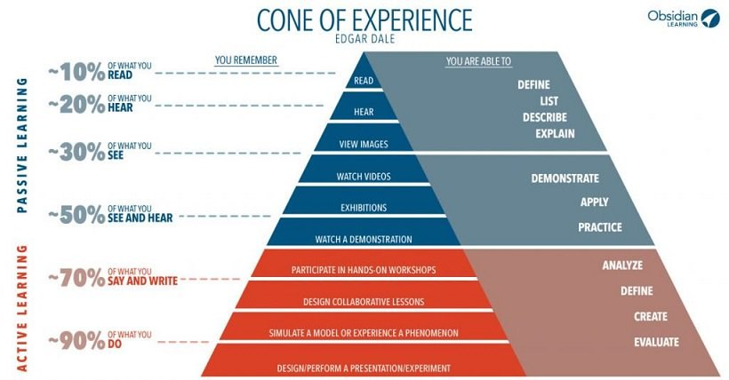

**Figure 1.** ‘Cone of experience’

As you can see, the results of the research confirm the proverb: ‘Tell me and I shall forget. Show me and I shall remember. Let me do it and it will become mine forever’. These results provide a rich food for thought about the role of teaching methods and emphasize the importance of interactive methods. The revealed trend correctly reflects the high potential of interactive methods, allowing discussion in groups, practicing and mastering skills in class and in real life. This way, since interactive methods involve not only the consciousness of the learner, but also their feelings, will, actions and practice; will engage a person in the learning process as whole being.

Thus, it can be concluded that passive learning methods are mostly oriented only to levels of cognition and comprehension, while interactive ones involve all levels of learning.

Analysis of ‘the learning pyramid’ (figure 2) [2] demonstrates that for achieving significant results it is necessary to look for new methods of involving students into specific activities. Let us give some examples. ***The parsing and analysis of the situation.***This method consists of the following: it is necessary to allocate typical situations, then to give students an opportunity to evaluate them, to offer their solutions and to project the further course of events. As a result, the students form professional thinking, the ability to assess the situation, make decisions and directly apply professional knowledge. ***Game methods.*** Role-play games are used for the demonstration of behavior in typical situations. ***Imitation.*** This type of activity is necessary so that students can master professional skills through games imitating the rules and norms of behavior in particular situations. ***Project.*** The following method is used to enable the learner to join the solving of a real practical task through the implementation of teamwork. Thus, he or she gets the opportunity to learn fulfilling certain tasks in a team. The project participants are forced to establish working relations within the team through the joint activity. The preparation of handouts is one of the time-consuming stages of interactive learning.

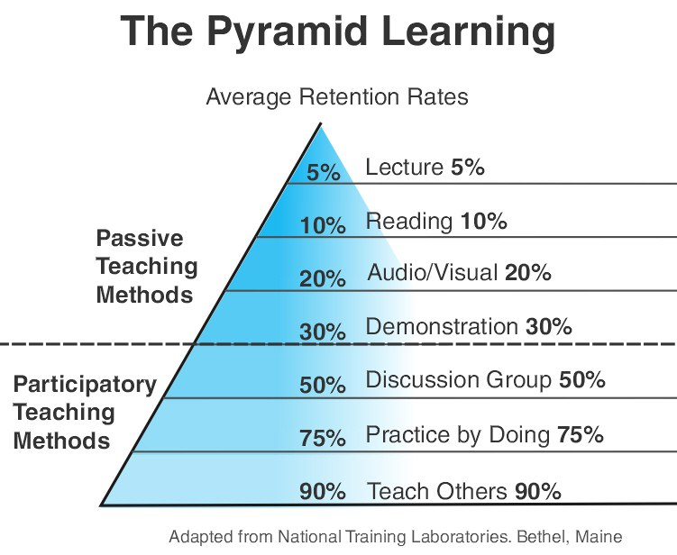

**Figure 2.** ‘The learning pyramid’

The aim and objectives of getting an education at the university are solved with creating an educational environment conducive to successful learning activity. In the process of teaching, it is possible to allocate at least an informative (what to teach), procedural (how to teach), motivational (how to activate the students performance) and organizational (how to structure the activities of the teacher and students). Each of these parties corresponds to a number of concepts. Thus, the informative side corresponds to the concept of meaningful generalizing, the generalization of educational material, the integration of educational subjects, the consolidation of didactic units and so forth. The procedural side – the concept of programmed, problematic, interactive training, etc. Motivational – the concept of motivational support of the learning process, the formation of cognitive interests, etc. Organizational – the idea of humanistic pedagogy, the concept of pedagogy cooperation, "immersion" in the subject, concentrated training etc. All these concepts are in turn provided with technologies. For example, concepts of problematic training correspond to technology: problem-dialogic training; problem-solving; problem-algorithmic; problem-model; problem-modular; problem-computer training.

In our opinion, the creation of an interactive environment conducive to the achievement of success in the activities of students is possible in the educational environment of the university, where the pedagogical process is characterized by the need to form the students' skills of mastering innovative forms and methods of teaching, including interactive technologies.

In our opinion, the educational environment of the university should be regarded as the unity of the constituent environments: teaching and educating. Let's imagine schematically the interaction of "environments" affecting the activation of creative activity of university students (Figure 3).

The learning environment is aimed at arming students with deep and comprehensive knowledge and skills of their specialty. The educational environment includes two main components - social relations and the material environment.

Interactive learning as one of the components of an effective educational environment depends on the following factors:

* technical: the state of the auditorium (lighting, area, availability of appropriate furniture and its location, availability of space, ventilation of the premises, etc.);
* information technology: the provision of methodical literature and literature on the subject; free access to Internet resources; availability of computer equipment;

**Figure 3.** Interaction and mutual influence of ‘environments’ on the student's personality

* information technology: the provision of methodical literature and literature on the subject; free access to Internet resources; availability of computer equipment;
* methodical: knowledge and ability of the teacher to apply new technologies and innovative methods of teaching; the skills of conducting interactive classes;
* social: the readiness of the department, faculty to introduce interactive teaching methods; the nature of the student audience, its openness to methodological innovations;
* personal: the desire and motivation of the teacher to experiment and apply new methods of teaching; methodical preparedness of the teacher.

As we see, when creating an effective educational environment, the biggest part is given to the teacher: he or she must teach students to receive and process, analyze and apply information to solve specific problems, must simultaneously work in three directions:

- *subjective* - here appears as an expert who can divide the essential from the subordinate, form the meaning, the contexts for the details, approach the subject of teaching in a practical and simple way;

- *methodical-didactic* - organizes an educational environment that implements structured and diverse teaching, submits material available, organizes an optimal learning activity;

- *interpersonal* - acting as a partner in studies, takes care of the study requests and difficulties of students, contributes to stability and integration in the group.

Modern education requires strengthening of joint work, when a teacher and a student make up one team and work for a common goal, while developing the abilities and showing the talent of each student.

The following principles are basic for the interactive teaching: the use of student’s own experience and co-operative learning.

It is assumed that at the *starting stage* students use personal experience and gain experience in the course of specially organized interaction in the framework of the educational activity. The *stage of reflexive observations* presupposes critical supervision from students and discussions in order to gain experience. The teacher should strive to create conditions for the students’ reflection and give them the opportunity for free discussions without departing from the topic. At this stage students must possess the ability of interpreting experience from different perspectives and approaches. As the result of the joint reflection of participants a new type of knowledge arises at the *stage of abstract conceptualization*. The obtained knowledge is of creative and collective nature as it was gained through the interaction of participants. The results of interaction are expressed in the form of conclusions and inferences. At this stage student must have the ability to the holistic cognition, elaboration of statements and representations, generalization of observations into the consistent theory. At the final stage, t*he stage of active experimentation*, the formulated conclusions are checked, which leads to the discovery of new experiences. At this stage, the student must have the ability to use his theoretical knowledge to make decisions, solve problems.

Consider the elements characterizing the effectiveness of cooperative learning (Table 1).

*Table 1.*

|  |  |
| --- | --- |
| Cooperative learning | |
| Aim: make every participant of the education process individually stronger on their position. Students collectively study what they can use individually in the future. | |
| The effectiveness of the cooperative learning | |
| Positive interdependence | the teacher explains to the students that they are connected with others and can not succeed until others do their work, creates an atmosphere of group success. The student feels responsible for studying the presented material, ensuring that all members of the group study it. |
| Individual responsibility | student activity is evaluated by the individual testing. Each group is monitored, the contribution of each member of the group is documented. |
| Challenging interaction | the teacher ensures the students' stimulation of each other's success, explains how to solve problems, how to link the current learning process with the previous one. Members of the group get an opportunity to get to know each other on a personal and professional level. |
| Social skills | the teacher teaches students the necessary social skills: leadership skills, decision-making, building trust, communication and conflict management ensuring their use. |
| Teamwork | the teacher helps the student to join the group work during which the participants describe what actions were useful to ensure effective working relationships, whether all the members of the group have achieved the set learning goals, which behavior models should be developed further and which ones should be changed. |

One of the key principles of interactive learning is the lack of the desire to reduce everything to a single correct answer, there is always the possibility of developing a common conclusion from various options during the discussion. Interactive training contributes to the development of the ability to perceive different positions on the same issue, while developing their own. Students, acting in the educational process as consumers, build up their own knowledge, which is not imposed from the outside, but is formed by themselves, while they determine what knowledge they need in real life.

When organizing and conducting interactive classes, the following should be considered:

- the process of constructing one's own knowledge is possible through the open conflict of one's own doubts and contradictions with the doubts and contradictions of others;

- everyone learns in their own way, so not all methods, materials, assignments are equally perceived by all students;

- in educational activities of groups there are business and socio-psychological aspects that affect each other and the effectiveness of training.

The role of the teacher in the process of creating an effective educational environment is to create an atmosphere of goodwill, responsibility, constructiveness with the desire to listen and hear another. For this purpose at first sessions it is possible to use brainstorming with students to develop uniform rules of conduct, hang them in a prominent place of the classroom and monitor their implementation. At the first lesson, students should be familiarized with the principles of interactive learning – the using of their own experience and the principle of cooperative learning.

Feedback, as an element of interactive learning, should be organized in each lesson. The teacher assesses the activities of students, and students assess the effectiveness of the organization of the educational process by the teacher. The effectiveness of feedback can be improved by following these simple rules:

1. the teacher should respect students and their opinion. The goal of any lesson is to do everything possible to encourage students in their quest to improve his result;
2. it is necessary to give students the opportunity and the right to speak first, this will allow them to be more independent in decision-making, the ability to think and gives an opportunity to assess their work independently;
3. the teacher should begin to evaluate the work of students with the allocation of positive moments, which allows motivating them to further self-improvement, but the weak points of work should be mentioned as well;
4. do not discuss more than 3 or 4 topics, since the concentration of students' attention is lost.

After the discussion is over, the results of the session should be summed up, asking students to comment on what useful and new they have learned. Conducting systematic feedback allows the teacher to strengthen the effectiveness of the educational environment, to form groups of like-minded people and share the responsibility for learning outcomes between participants.

One of the most difficult tasks in implementing an effective educational environment for interactive learning is the problem of choosing a teaching method, which requires a high level of methodical and professional training of the teacher and the careful analysis of the group. The teacher should determine the purpose of using a particular method, understand the type of problems that can be considered with its help; take into account its capabilities, the difficulties in applying this method and think over the technical conditions for its use. The choice of the method is determined by the purpose of the lesson, the experience of the teacher and students.

The development of communication and teamwork skills is realized through the group work. Working in groups has a significant potential for the development of these skills and abilities, as it is based on the activity of each subject of the educational process, the ability to make independent decisions and make choices, as well as the coexistence of different points of view and free discussion. A group is a "community consisting of two or more interacting and influential individuals". When organizing and conducting methods of group work, it is possible to solve a range of educational problems: an awareness of the existence of different views on the problem and on the ways of its solution; the development of norms of interaction as a result of joint activities of the group members; awareness of the importance of one's own position, its influence on the decision-making process; mastering knowledge, forming the skills and competences necessary to solve a specific problem; activation of creative performance, training in self-esteem and mutual respect.

When composing groups it is desirable: to create heterogeneous groups, including students with different levels of training; change the composition of groups; combine individual and team work, competition. The complexity of organizing group work is the qualitative and quantitative composition of the groups. Students are not always motivated for effective education, some students do not want to do anything, however the teacher must work with all students. The organization of interactive group work in class can promote the activation of students who are not motivated to study, and also apply an individual approach to each student. The number of students in the groups being formed is determined by the type of work or the nature of the assignment. Studies have shown that ‘a small group’ (2-3 people), often show good results in solving didactic tasks, but has weak opportunities for socialization. A big group (8-9 or more people) is poorly manageable and often breaks up into subgroups during the process. The most effective work is demonstrated by groups of 4-6 students. At the same time, for small assignments, the best group will be 4-5 people. Big groups are better suited for performing large tasks, when these tasks are divided into separate exercises.

The use of active and interactive methods is due to the fact that today students not only need to assimilate a certain amount of knowledge and create professional skills, but also to activate creative performance, develop communicative and research abilities, be able to transfer theoretical knowledge to specific situations. The techniques used by the teacher and methods of activating the creative performance of students in learning should consider the gradual, purposeful and systematic development of the students' thinking and the simultaneous formation of motives for their learning.

The structure of the learning process with the use of interactive learning technologies can be divided into the following stages:

1. Orientation. The stage of participants’ and experts’ preparation. The teacher offers a mode of work, develops the main goals and objectives of the lesson together with students, formulates the educational problem. Further, he gives a description of the simulation and the rules, an overview of the general course of the lesson, and issues packages of materials.

2. Preparing for the holding. This is the stage of studying the situation, instructions, installations and other materials. The teacher sets the script, stops on cognitive-creative tasks, rules, roles, procedures, rules of scoring. Students collect additional information, consult with the teacher, discuss the content and process of the session among themselves.

3. Conducting. This stage includes the actual learning process. Since the beginning of the lesson, no one has the right to interfere and change its course. Only the facilitator can correct the actions of the participants if they deviate from the main goal of the process. The teacher, having started the lesson, should not without necessity take part in the activity of the students. Teacher’s task is to monitor the learning activities, results, scoring, clarify ambiguities and provide assistance, at the request of the participants, in their work.

4. Discussion. The stage of analysis, discussion and evaluation of the results. The teacher conducts a discussion during which experts speak, participants exchange views, defend their positions and decisions, draw conclusions, share their impressions, talk about the difficulties that have arisen in the course of the lesson, the ideas that came to mind.

Organization of interactive teaching at the university should be based on a comprehensive diagnostic material. Here is an example of developing a plan-scheme of training sessions in Table 2.

*Table 2*

|  |  |  |  |  |
| --- | --- | --- | --- | --- |
| Lecture plan on the topic:  Characteristics of methods (project, problematic presentation of the material, discussion, interview, etc.)  The strategy of interactive learning: questions of efficiency and methodology.  Educational tasks:  - familiarize students with the theory, methodology and principles of interactive learning;  - formation of students' work competences in groups;  - development of students' skills and abilities to conduct a discussion;  - development of students' skills and abilities to independently work with handouts. | | | | |
| № | Activities during lectures | Handout materials | Methods | Time  (50 min) |
| 1 | Familiarization of students with the purpose and objectives of the course. The main problems of the course. The logic of the course. The logic of the handout. |  | Monologue of the teacher | 5 mins |
| 2 | Justification of the need to introduce interactive teaching methods in the course as the most effective for mastering the material. |  | **The pyramid of learning.**  **Taxonomy of Bloom's educational goals.**  **The learning cycle through the experience of Kolb.** | 5 mins |
| 3 | The division of students into groups of five people for the interactive game "Aquarium". | Texts | Interactive game ‘Aquarium’ | 8 mins |
| 4 | Discussion of the results of interactive games with students.  Questions:  What did you feel when you were doing the assignment?  How did the group work?  What helped and what hindered the work?  What helped to solve the task? |  | Polylogue | 6 mins |
| 5 | Familiarization of students with interactive teaching methods.  Cooperative training:  - positive interdependence;  - individual responsibility;  - promoting of mutual success. |  | Monologue of the teacher | 6 mins |
| 6 | Discussion of the problem of creating an effective educational environment and changing the function (role) of the teacher in teaching students. | Three planes of teacher qualification | Discussion, work with handouts | 6 mins |
| 7 | Conclusion |  | Polylogue | 5 mins |
| 8 | Securing the use of interactive techniques through repetition of key points.  What methods were used during the lecture? |  |  | 4 mins |
| 9 | Feedback |  | Essay writing | 5 mins |

The organization of interactive learning in the university's educational environment requires careful planning of the activities of both the teacher and students. During the lesson the teacher should not only observe the actions of the students, but have the opportunity to timely approach them to help, to simulate the necessary procedures. He is obliged to inform students of the results of their activities in due time, to analyze the course and quality of the actions performed.

Successful organization of the interactive educational environment contributes to strengthening the key points of the lesson, emphasizes the students' attention to the relationship of the material with the new one, determines the prospects for further development of the studied topic. The methods by which the lesson ends are as important as the content, the completion must correspond to the lesson itself.

**CONCLUSION**

Summarizing the above, we would like to note that the educational process is not permanent, it must always be improved and modernized. Methods and ways of teaching at the university are, first of all, means of solving educational problems, so they need to be used by taking into account the specifics of each academic discipline.

An important role here is given to the educational environment, which allows realizing the real integration of educational subjects, the idea of intersubject connections, the development of the independence of thinking, the creativity of the learners. In daily activities, the teacher must constantly develop forms, methods, teaching expedients that contribute to the active participation of students in an educational environment conducive to the development, creative understanding of the process of teaching, to the fundamentals of the future profession. The teacher can rearrange the content of the curriculum in accordance with the chosen approaches to the organization of the training (project training, methods of collective-cognitive activity, modular training, etc.). Creativity certainly requires freedom of action, but it is necessary to perform a great deal of preliminary work.

**REFERENCES**

# 1. Lubos Janoska. What Really Is The Cone Of Experience? https://elearningindustry.com/cone-of-experience-what-really-is

2. The Learning Pyramid http://www.fitnyc.edu/cet/adjunct-faculty/learning-pyramid.php

3. G.K.Tashkeyeva, B.T.Abykanova, A. Sariyeva, D.Sadirbekova, A.Marhabaeva. Application of methods of interactive training in the educational environment of higher educational institutions. 16th International Multidisciplinary Scientific GeoConference SGEM 2016, www.sgem.org, SGEM 2016 Conference Proceedings, ISBN 978-619-7105-67-4/ISSN 1314-2704, June 28 - July 6, 2016, Book5 Vol. 3, 747-754 pp.

4. N.Trigubova Interactive methods of training as means of the organization of vzaimo-action in pedagogical process//the AU Bulletin of Abay, the Pedagogical Sciences series. – 2003. – No. 3 (5). – P. 77-80.

5. New pedagogical and information technologies in the system of education. E.Polat, M.Bukharkina, M.Moiseyeva, A.Petrov – M.: Publishing center "Akademiya", 2004.

6. N.Dvulichanskaya Interactive methods of training as means of formation of key competences//http://technomag. edu.ru/doc /172651.html

7. L.Korneyeva Modern interactive methods of training: foreign experience//University management.-2004.-№4. - Page 78-83.

8. I.Chernyh, Theories of integration: technology of interactive training. – Almaty, 2004. – 112 pages.