DOES AN entrepreneurship JOURNALISM IN KAZAKHSTAN?

The problem of the labor market in journalism and business of media education in Kazakhstan is universally valid, it reflects the diverse state of the media in the post-Soviet media model. This is, first, the search for a national identity. Secondly, market competition. Thirdly, the reform of the system of journalistic education in the conditions of state independence and the transition from the ideology of communism to a democratic society. The President of the country sets the goal of "training personnel adapted to the global competition in the field of knowledge."
At present, 77% of the population has access to the Internet in the country. Mobile communication provides access to information, influences the platform for receiving news. Advertising passes, as elsewhere from traditional printed media to online, the state subsidy is mainly reserved only for state-owned media -29.8%.
In these conditions, the principle of entrepreneurship becomes relevant in the system of journalistic education. This new understanding of media journalism. However, there is an acute lack of a planned educational tradition in the field of teaching the basics of entrepreneurial journalism. Relevant issues are the update of educational programs, activities in the field of professional development as journalists - the number of media - 2,286, and teachers of faculties and departments of journalism in 28 universities of the country.

Keywords: entrepreneurship, journalism, education, competition, civil journalism, regional management, online media

The relevance of studying entrepreneurial journalism in Kazakhstan’s media space is primarily due to the interests of the democratic development of society at the country level as well as the need to modernize Kazakhstan’s media, the competitiveness of which is important to improve.
What is meant by entrepreneurial journalism? Many researchers tend to associate entrepreneurial journalism with management. Others refuse with this wording, believing that the concept of "entrepreneurship" is alien to the high art of journalism. But there are pragmatic scientists like Khlebnikov N.V., who believes that entrepreneurial journalism exists and it is now actively being formed, and its components: - a new financial model; - new ways to interact with the audience; - Internet technologies and tools.
Indeed, new technologies, development and distribution of new media sites, the creation of equal conditions for collective and personal media start-ups. It is difficult, requires considerable financial investments, creativity, knowledge of the needs of the audience.
To understand the conditions for the existence of entrepreneurial journalism in Kazakhstan, we, as researchers decided to first of all find out what the country's journalists themselves think about this.
Currently there are 2,286 media operating in Kazakhstan. Of these, printed - 86%, electronic 11%, information agencies - 3%. State media about 30%, the rest of the media non-state.
As of January 1, 2018, according to the Office of Internal Policy of Akimat of Kostanay region, 120 mass media are functioning: 10% of them are state-owned, 8% are state-private, more than 83% are private. Including 87 print publications, 33 electronic media. In the same statistics, there are 5 information agencies and network resources that are gaining popularity among students as places of professional practice and further employment. Meanwhile, according to estimates by managers and the media, the last 3 years have been observed up to 25-30% - current statistics and up to 30% - reduction in the circulation of social and political publications due to the spread of Internet resources.
The dynamics of the “flow” of journalistic personnel in a network resource is not as active as it can be in the cities of Almaty and Astana. Most journalists prefer traditional forms of employment. Monitoring conducted by the department confirms that over the past 3 years more than 26% of employed graduates find use in the newspaper (18 out of 68 employed) and the same on television. And only 3% went to work in the Internet media. (More than 20%) of graduates who have been hired by the press service of various industrial enterprises, state and other institutions, which indicates the increasing role of public relations as a type of human activity.

Research Methodology.
For the study, a questionnaire was created for Kazakhstan journalists on the topic “Entrepreneurial Journalism”. For the credibility of the study, the entire journalistic audience was covered through journalistic organizations and social networks, as well as one of the regions - the Kostai region. This allows you to trace the general and focus on special trends topics.
The questionnaire was composed of 8 questions that specifically reflected the topic in the field of practical journalism and in the field of journalistic education. In general, 51 journalists became experts in Kazakhstan, 22 journalists in the Kostanay region. The survey was conducted from 8 to 11 January 2018. The questionnaire was processed in the Surveymonkey.com program.
The first question helped to understand the number of editorial boards in order to determine the approximate total number of journalists in the country. According to data 42, 55% are editors from 5 to 15 people and so on. (See: Table 1), which predicts on average the number of journalists in Kazakhstan to 400 thousand.
The number of students of the faculties of journalism: Al-Farabi Kazakh National University - more than 700 people, in 28 universities in the departments and departments of journalism in the regions from 500 to 150 students, which is up to 5 thousand students and undergraduates.
A study on the situation in regional journalism (Kostanay) showed that among the accepted participants: 30% work in newspapers, 24% - the press service, 20% each show television, the Internet media in equal importance. Almost 10% of survey participants are representatives of social networks and bloggers.

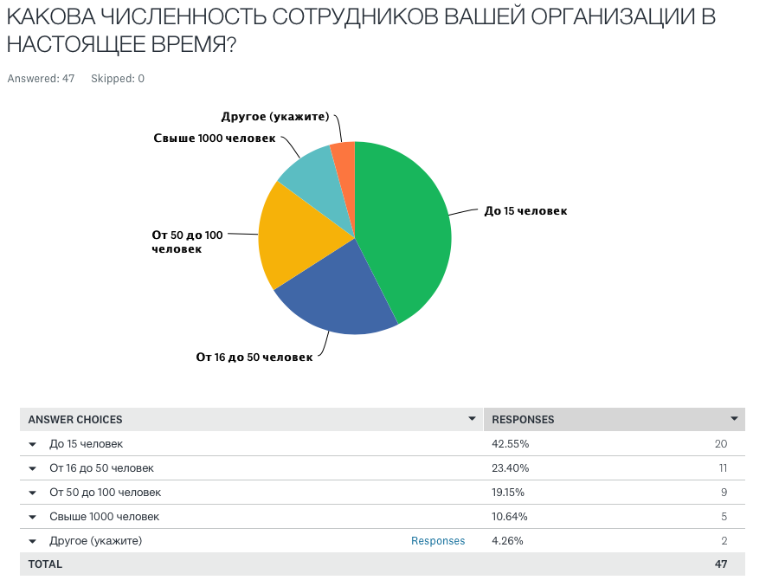

The second question was aimed at determining which media areas the journalism of Kazakhstan represents? If, according to research conducted in the country, the numerical advantage of users of television, then the analysis data show the superiority of Internet journalists 34.04% to 31.92% on television. (See: Table 2 and 2 a).

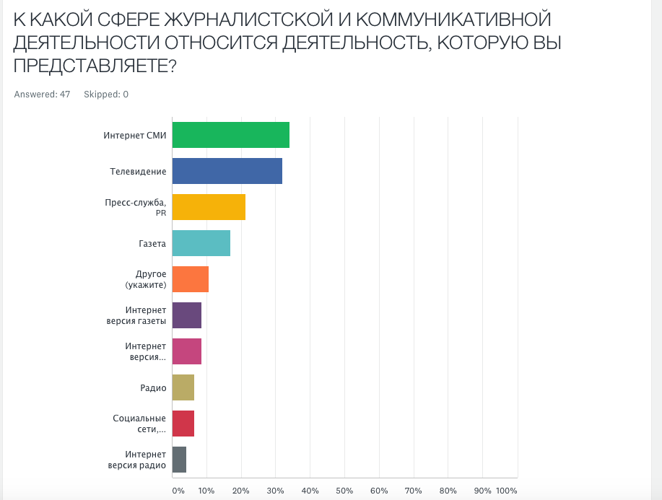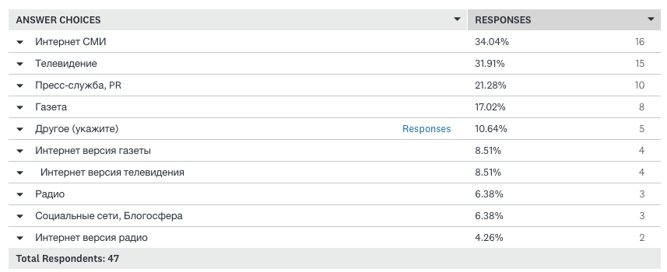

There are several journalistic organizations and NGOs in Kazakhstan. These are Adil soz, the Media Alliance of Kazakhstan (headed by A.Dzhalilov) plus 12 media NGOs from 8 regions of Kazakhstan, the Union of Journalists of Kazakhstan, the Kazakhstan Media Club (Media Kuryltay), the International Journalism Center MediaNet, NAT, and others. In October 2017 another media union is the Media Alliance. (leader - A. Byptasov).
Practice shows that at the moment there are three main areas of media activity: support from one of the oligarchs; "Yellowness" of the publication; state order or state subsidy.
The development of entrepreneurial journalism can be an incentive for creating citizen journalism, which will allow journalists to work based on their initiatives and knowledge, national values ​​and patriotism. The study, which was conducted as part of the global survey “Journalism Students across the Globe Professionalization, Identity and Challenges in a Changing Environment”, showed that one of the specialty motives is not only romance and a desire to do good, they have a clear understanding that hard and difficult work, with students expressing their readiness to defend their state in the information sphere, to defend its national values ​​and cultural priorities. Gender analysis showed that motivation: the opportunity to earn money, is in last place among young men, compared with other motivations. (See: Table 3.)

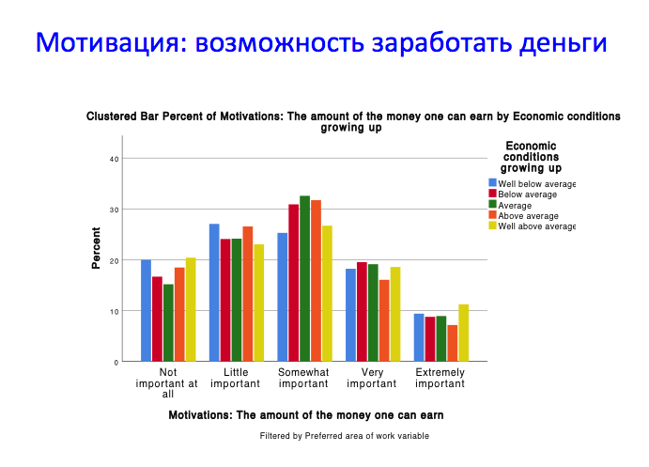

The volume of the advertising market in Kazakhstan is about 37 billion tenge, and experts expect a further decrease in its volume by about 10%. Such data during the “Media Kurultay 2016” was voiced by Tatyana Startseva, CEO (TNS Central Asia). State-owned mass media receive directly and state order, which is implemented through tenders. The share of the latter is only 10%, while 90% is the direct distribution of budgetary funds in state-owned media. It is even more remarkable that the volume of the state order market exceeds the volume of the advertising market - these are 40 and 37 billion tenge, respectively.
When asked about the number of competitors in the field of journalism, 65.95% answer that their number has increased. (See: Table 4).

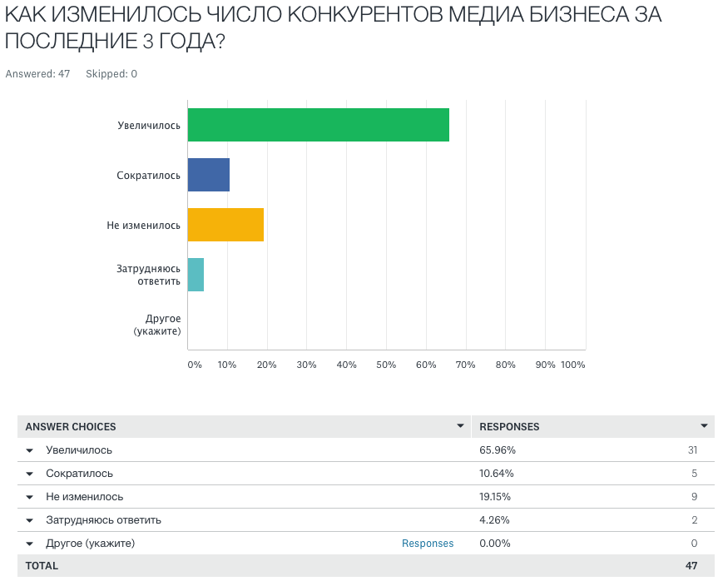

A question on the education of journalists showed that journalists of practice require the educational institute to teach “writing skills”, “multimedia”, “marketing”, “professional ethics”, etc. (See: Table 5 and 5a). Regional experts (Kostanay) pointed out the shortcomings in approximately the same sequence as the general Kazakhstani experts.
Table 5

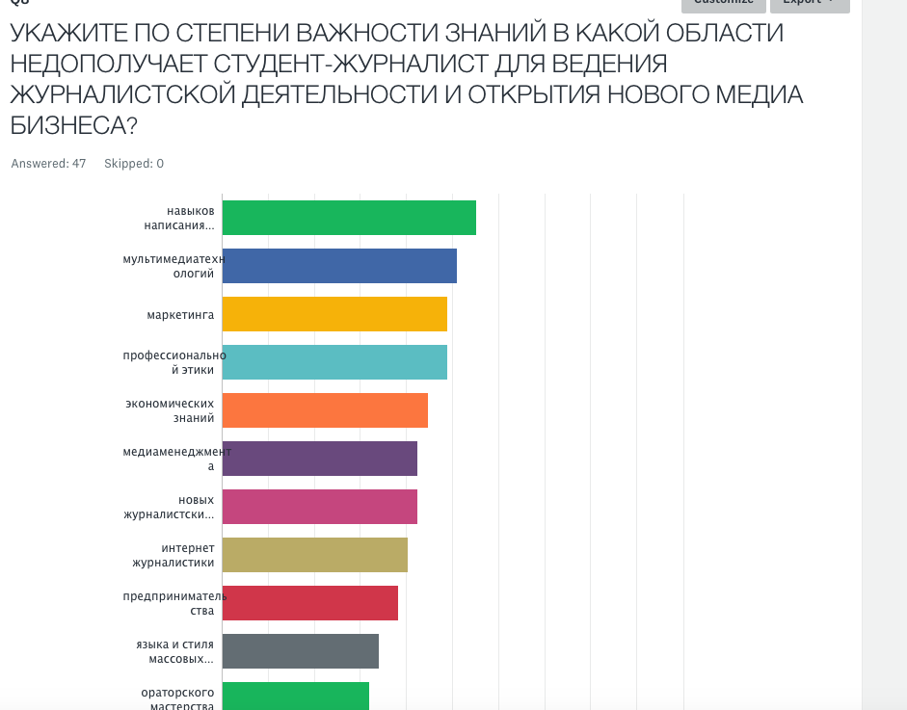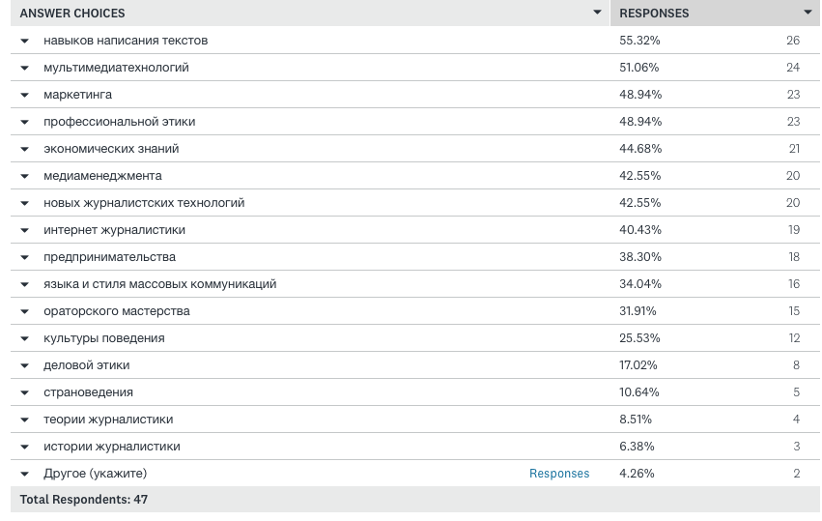

Experts call one of the major barriers to journalistic work “poor training of journalists at universities”, “low wages”, “restriction of creative freedom”, “ineffective management”, etc. (See: Table 6 and 6 a).

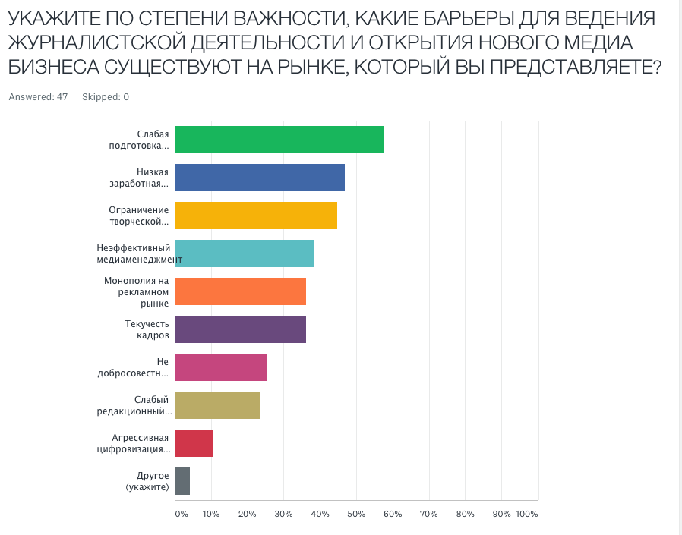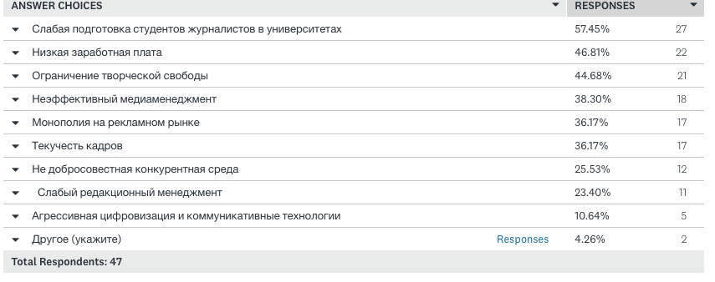

On the question of surmountable barriers to conducting journalistic activities and opening a new media business, experts are optimistic and believe that it is possible to organize high-quality journalistic education, effective media management, a competitive environment. (See: table 7 and 7 a).

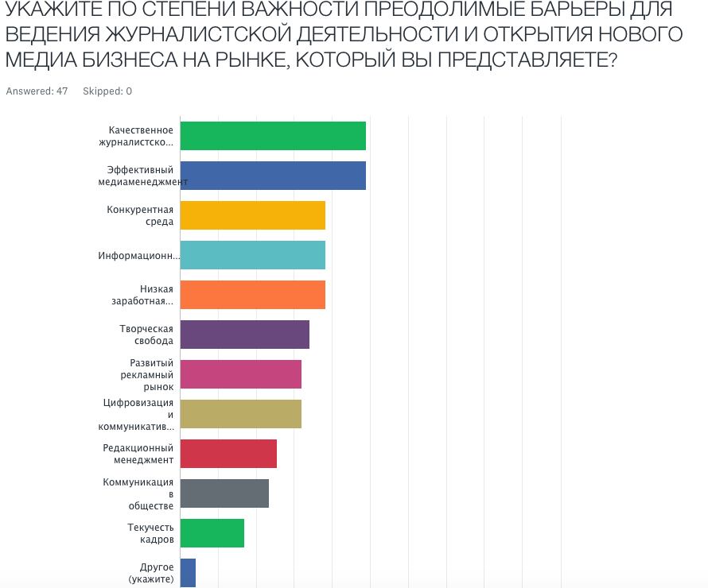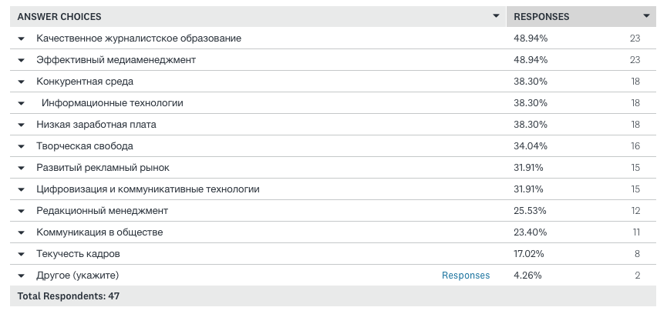

Thus, the need for a special course on Entrepreneurial Journalism is not only a requirement of the market environment, but also the civil position of the young generation of journalists.
At this time, al-Farabi University has developed a favorable business environment, which stimulates the creation of its own start-up companies, self-supporting enterprises based on the university. To do this, all conditions are offered, such as the provision of premises, electricity, Internet, security, accounting services and so on. Thanks to this, hundreds of start-up companies appeared at the university.
At the Faculty of Journalism there are attempts to create student start-ups for rendering services in conducting press conferences at the base of the Student Press Center, video and photo shootings at the base of the student television studio, publishing brochures - printing laboratories, organizing advanced training courses for journalism teachers waiting for regional universities and journalists. But this work, although not systematically, is carried out. It develops entrepreneurial skills in both teachers and students. However, many start-up companies are experiencing difficulties in doing business. Affect the lack of entrepreneurial experience, organizational skills.
The teachers of the Faculty of Journalism with certain difficulties adapt to the new modern conditions of the labor market. The Faculty of Journalism is looking for new business models with the introduction of innovations and the creation of new forms of journalism education that fit into the digital age. For example, a laboratory of Immersive Journalism has been set up at the faculty, research is being conducted. However, new journalism platforms are perceived with difficulties.
A survey conducted in January 2018 found that universities use a variety of approaches to teaching innovation and entrepreneurship, but at the same time most of the respondents mentioned that journalists need knowledge in the field of entrepreneurship. Although there is a moment of “low motivation for making money” among young men, nevertheless, the opinion of those polled remains that “knowledge will help students make money in journalism or even start their own enterprise that will generate a steady income.” The survey results highlighted the contradictions between that journalism should serve the public interest — be a “fourth estate” as opposed to power — and the need for journalistic organizations to strive for economic sustainability. their way, schools of journalism provided an unprecedented opportunity to participate in the creation of new digital journalism and look for ways to finance it. It's not just for universities, the formation of the educational process that usually takes a long time that conflicts with the rapidly changing market situation.

References:

1. N.Nazarbayev "Looking into the future: modernization of public consciousness". http://www.akorda.kz/ru/events/akorda_news/press_conferences/statya-glavy-gosudarstva-vzglyad-v-budushchee-modernizaciya-obshchestvennogo-soznaniya
2. http://mic.gov.kz/ru/pages/dostizheniya-v-sfere-sredstv-massovoy-informacii
3. ibid
4, Khlebnikova N.V. Media business changes the concept of journalistic education // Conference of the European Association of Journalistic Education - 2017. International scientific readings in Moscow “Mass media and mass communications -2017”. Journalism education without borders. Abstracts - October 19-20, 2017 - Printed in Moscow, Russia. - C.185-186.
5 http://www.fergananews.com/articles/9191
6. Ibrayeva G. and others. The motivation for studying journalism from the perspective of future journalists (according to the results of the global survey “Journalism Students across the Globe Professionalization, Identity and Challenges in a Changing Environment”, 2015-2016) International ICA Research Conference San Diego, 2017.
7. According to the Ministry of Information and Communication of the Republic of Kazakhstan as of July 1, 2016 http://mic.gov.kz/ru/kategorii/deyatelnost-7

