B.Belgibayev, M. Berik*
Kazakh National University Named after al-Farabi
E-mail: Berik.magzhan@gmail.com

Automate the system of control fluid level in the storage tank drip irrigation process with LOGO! microcontrollers

The object of research is the storage tank for drip irrigation system and methods of automated fluid level control management system in the storage tank. There are conducted technical design of the system structure and given samples of programs in the languages LAD and FBD for LOGO! microcontroller.
Keywords: drip irrigation systems, automated system of liquid level control, SCADA system, sensors, storage tank, FBD, LAD

Б.А.Белгибаев , М.Т.Берік
LOGO! микроконтроллері базасында тамшылап суғару үдерісінің жинақтауыш шанындағы сұйықтық деңгейін басқару жүйесін автоматтандыру

Зерттеу нысаны ретінде тамшылап суғару жүйесінің жинақтауыш шаңы және сұйықтық деңгейін басқару жүйесін автоматтандыру әдістері болып табылады. Жүйенің техникалық құрылымын жобалау жолы және LOGO! микроконтроллері үшін FBD және :AD тілдеріндегі бағдарламалары көрсетіледі. Қондырғыдағы сұйықтық көлемін бақылауда ұстау не үшін қажет деген сұрақ төңірегінде талдау жүргізіледі
Кілттік сөздер: Тамшылап суғару жүйесі, сұйықтық деңгейін автоматтандырылған басқару жүйесі, SCADA жүйесі, қадағалар, жинақтауыш шаң, LOGO!, FBD тілі, LAD тілі

Б.А.Белгибаев , М.Т.Берик
Автоматизация контроля уровня жидкости в накопительном баке системы капельного орошения на базе микроконтроллера LOGO!

Объектом исследования являются накопительный бак системы капельного орошения. и методы построения автоматизированной системы управления контроля уровня жидкости в накопительном баке. Проводиться проектирование технического состава системы и пример программы на языках FBD и LAD для микроконтроллера LOGO!.
Ключевые слова: Система капельного орошения, Автоматизированная система Контролья уровня жидкости, SCADA система, датчики, накопительный бак, FBD, LAD

Efficient using of water resources is one of the urgent problems that needs to solve in our country. Today, the lack of drinking water, the use of transboundary water resources in Central Asia has become one of the most difficult issues. Kyrgyzstan and Tajikistan are located upstream, it means that they regulate the flow of water to the rest of the Central Asian countries. Kyrgyzstan controls the Syr Darya river, and Tajikistan controls Amu Darya river. According to the National Institute for Strategic Studies of Kazakhstan, we depend on imported river 42%, on Uzbekistan - 77%, on the Turkmenistan 94% [1]. Hence explore the ways of rational using the water resources in Kazakhstan may reduce the level of dependence on other countries. Therefore, for the rational use of water resources facilities, in particular, we need to control the water level in the drip irrigation system.
Let us talk about why we need the device that control the amount of fluid. Various reports of the liquid level measurement and control products and technology are found in many parts of: technological processes, or environmental monitoring or security, transport and storage conditions; The relevance of the grinding fluid level control is directly related to the increase in the volume of process automation. To solve the following tasks can be used:
- In agriculture: control the artificial irrigation systems volume of water in the irrigation channels, in order to prevent floods in the rivers and lakes;
- Housing sector: control the water level monitoring of water pumping stations in villages, cities and institutions;
The volume of device may differ from the given area of using. We need to find software solutions based on microcontrollers, that specifically automate the control of the water level in that particular case. For this purpose, the main reason for the choice of microcontrollers LOGO capacity and capabilities. Speaking more precisely, the microcontroller mid-level automation systems in a convenient, affordable and simple population of cultivated land, allows certification of drip irrigation. The software is available free software and the user will be able to create a system with the features of the program itself. That is a relatively small amount of loss will represent a drip irrigation system to automate the situation.
Next, let us speak about the LOGO based microcontrollers that allows you to automate the process of drop irrigation system and its characteristics. Following Figure-1 shows the structure of the system:

Figure-1. Structure of control system.

Automated control system consist of "Time management of the irrigation system", "liquid level control system," and the "SCADA system”. Hence, to be able to organize the work of the system's technical solution, firstly you must be able to organize and the right software solutions. Бұл статьяда біз сұйықтық деңгейін басқару жүйесінің құрылымы мен бағдарламалық шешіміне тоқталып өтеміз. In this article, we are going to speak about the structure of the management system and software decision of liquid level.

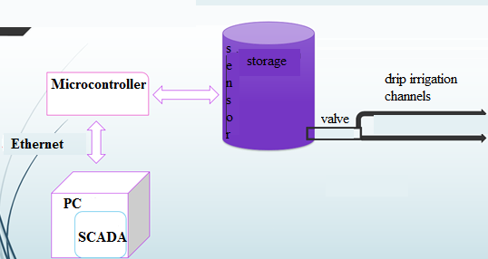
Figure-2. architecture of drip irrigation system
If you look at the irrigation system architecture, you can see that LOGO microchip inserted into the drive from dust and Scada system Setting up connected between the user device, and the liquid is based on the management to ensure control of the level sensor. If you look at Figure-3, you can see the storage requirements for dust of drip irrigation system (for example, dust should be placed at least 1.5 meters high platform).

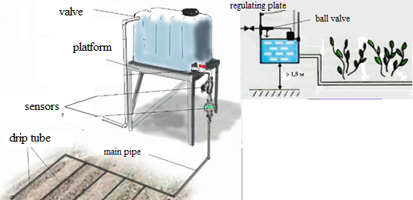
Figure-3. The technical solution of the drip irrigation system

If you look to the decision of the system software in detail, you can see that the LOGO! microcontroller systems have been created due to the characteristics of the medium makes it possible to modify or supplement the program. For example, consider the following picture:

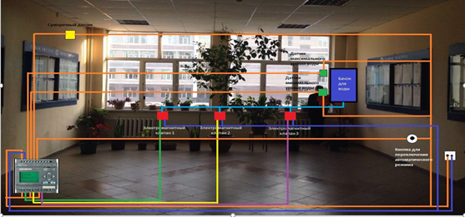
Figure-4: The scheme of the process of drip irrigation management system

Figure-4 shows three types of plants, taking into account the time described in the control system, allowing automatic irrigation it consist of: 3 solenoid valves (Q1-Q3), twilight sensor (I3) tripped off mode button (I4), the maximum and minimum liquid level sensors (I2, I3).
This scheme will be able to determine on the basis of our management system software solutions.
The next figure shows construction of the microcontroller program on the basis of the above-described scheme in FBD. During the development of the program we have "SwitchON" such as time tracking functions (V001, V005 and V007 units) and logical functions. The scheme of the program, describes the relationship between the change in the output signal depending on the input signal.
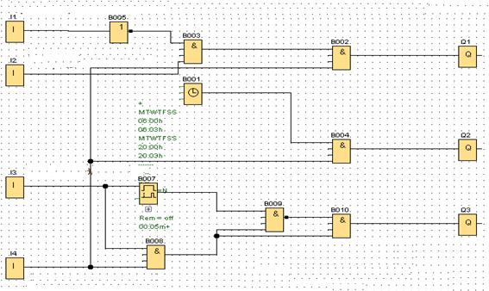
Figure-5: program in FBD

Program in FBD described in Figure-6 shows the logic of the laws of the microcontroller program in LAD view, which allows you to define the scheme of power during the installation of the system.

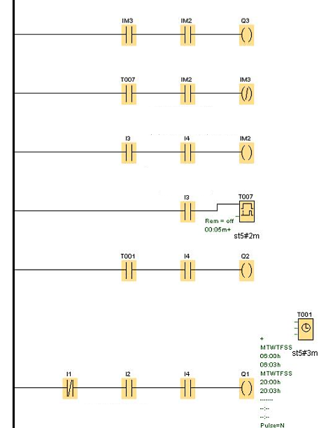
Figure-7: LAD language view of the program

Operation of the system is largely dependent on the liquid level sensor. In particular, for the functioning of the normal operation of the system, the sensors (for example, float level meter or circuit breaker) amplification factor must be at least k = 0.07. This, in turn amplitude and phase of the system will contribute to the frequency indicated in the following figure.
Figure-8: The schedule of the frequency of the amplitude and phase characteristics of the system

In conclusion, drip irrigation process the level of the liquid storage based on LOGO! Microcontrollers – we convinced that we can improve or change the features of the system created to automate the management control system design. The main advantage of the system is the possibility of integration with other automation and control system, therefore LOGO! Microcontrollers is answer to the chosen question.

REFERENCES

- Final Report on the August 14, 2003 Blackout in the United States and Canada: Causes and Recommendations, U.S.-Canada Power System Outage Task Force, Washington, DC, April 2004.
- Common Vulnerabilities in Critical Infrastructure Control Systems, Jason Stamp, John Dillinger, William Young, and Jennifer DePoy, Sandia National Laboratories report SAND2003-1772C, Albuquerque, New Mexico (2003).
- Sustainable Security for Infrastructure SCADA, Jason Stamp, Phil Campbell, Jennifer DePoy, John Dillinger, and William Young, Sandia National Laboratories report SAND2003-4670C, Albuquerque, New Mexico (2003).
- Automate decision-making processes in /V.S.Simankov control systems Yu.K.Lushnikov, V.A.Morozov et al .: Analytical Review, 1970-1985., № 4087. -M .: TSNIITEI 1986 . - 42 sec.
- Andreev NI The theory of statistically optimal control systems. -M .: Nauka, 1980. -155 p.
- Adryuschenko VA Theory of automatic control systems. -A .: LSU, 1990. -251 p.
- Karimov GH, J. Sh Fazliev Automation of intensive garden seedlings' drip irrigation // Young scientist. - 2015. - №10. - S. 212-214.
- Skugorov VN Frequency level sensor. Instrument 1965, №10.
- http://www.kazinform.kz/kaz/article/2694303

