Synthesis of Mesoporous Alumosilicates
Gulzira Vassilina¹, Raisa Moisa², Assyltas Khaiyrgeldinova¹,
Elmira Yermoldina¹, Tleutay Abildin¹, Kamilla Umbetkalieva¹
¹4Al-Farabi Kazakh National University, Kazakhstan
²Scientific Research Institute of New Chemical Technologies and Materials, Kazakhstan

Keywords: mesoporous alumosilicates, hydroisomerization, hydroisodewaxing, the highest n-alkanes.

Abstract. Synthesis techniques of the mesostructured alumino-silicates were developed. Synthesis with various Si/Al ratios was carried out. Textural characteristics and structure's orderliness of the mesostructured alumino-silicates' synthesized samples were investigated.
Introduction
Mesoporous alumosilicates are promising carriers for catalysts of various processes in oil refining and petrochemistry [1-5]. Mesoporous molecular sieves were first obtained by researchers at Mobil in 1992 using a silicates- and alumosilicates-based template synthesis and had significant specific surface values (up to 1,100 m²/g, with a porosity of 0.7 cm³/g, pore diameter 20-100 Å) [6, 7]. A general approach to synthesis is that the structure of the material forms during the deposition of hydrated aluminum and silicon oxides on the micellas of the template, while the latter acts as a surface-active substance. Subsequently, the template is removed by air calcination at temperatures of 500-650 °C. As acidic catalyst components, mesostructured aluminosilicates are of interest thanks to the peculiarities of their structure, since the size of their pores happens to be larger than the size of most molecules making up the raw material. Besides, the acidity of mesoporous aluminosilicates may be varied both during the synthesis and by modifying the finished material
Experimental
In this paper, mesoporous alumosilicates with a high aluminum content were synthesized. Aluminum isopropoxide (Al(Oi-Pr)₃) was used as the source of aluminum, and tetraethylorthosilicate (Si(OC₂H₅)₄) was used as the source of silicon. Hexadecylamine was used as the template. Alumosilicates were synthesized using a method [8] in which significant changes had been made, mainly pertaining to a change in the nature of the reagents and temperatures. Mesoporous alumosilicates were synthesized in a joint hydrolysis of tetraethyl orthosilicate and aluminum isopropylate in an alkaline medium. Aluminum isopropylate was dissolved in dehydrated isopropanol wherein isopropylate concentration in the solution was 6.4 percent by weight. Then, a calculated amount of the solution was mixed with 5 ml of tetraethylorthosilicate. The molar ratio (Si(OC₂H₅)₄) and (Al(Oi-Pr)₃) in the reaction solution was 10, 20, and 30. A 1.5-gram mixture of hexadecylamine was dissolved in distilled water while heating up to 50 °C, after which 6.6 ml of 18% aqueous ammonia solution was added to the resulting solutions. A mixture of tetraethyl orthosilicate and aluminum isopropoxide was added dropwise to the solutions containing hexadecylamine, then stirred for one hour, after which the precipitate was filtered, washed, dried and calcined in the air at 550 °C.
The synthesized samples of mesoporous aluminosilicates were studied using narrow-angle X-ray scattering and capillary nitrogen condensation at 77 K.

Results and discussion

In order to confirm the mesoporous structure of the synthesized samples, they were studied for their physical and chemical characteristics. The specific surface area and porous structure of the samples was determined using low-temperature nitrogen adsorption-desorption and the BET model. The results of physical and chemical characteristics for synthesized aluminosilicates with a Si/Al ratio of 10, 20, and 30 are shown as an example in Table 1 and Figure 1.

Table 1. Physico-chemical characteristics of Al-HMS(X)* materials

Mesoporous alumosilicates | Molar Si/Al ratio in a reaction mixture | Properties of the materials
Mesoporous alumosilicates | Molar Si/Al ratio in a reaction mixture | BET area  [m²/g] | Pores diameter [Å] | Pore volume  [cm³/g]
Al-HMS(10) | 10 | 870 | 34 | 1,0
A1-HMS(20) | 20 | 530 | 41 | 1,1
A1-HMS(30) | 30 | 510 | 46 | 1,2
* X: Atomic Si/Al ratio in a reaction mixture

According to the data obtained in low-temperature nitrogen adsorption/desorption, aluminosilicates have a significant specific surface, a high porosity index of up to 1.2 cm³/g, and an average size or pores, between 34 and 46 Å. The highest specific surface area, 870 m/g, was shown in a sample of Al-HMS (10), which is about 1.6 times higher than A1-HMS (20) (530 m/g). No clear correlation was observed between the aluminum content of the samples and the size of their pores (refer with: Table 1).

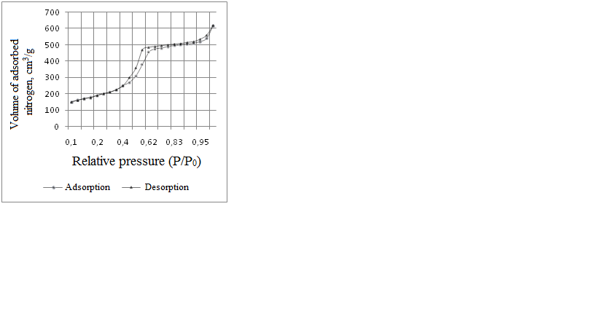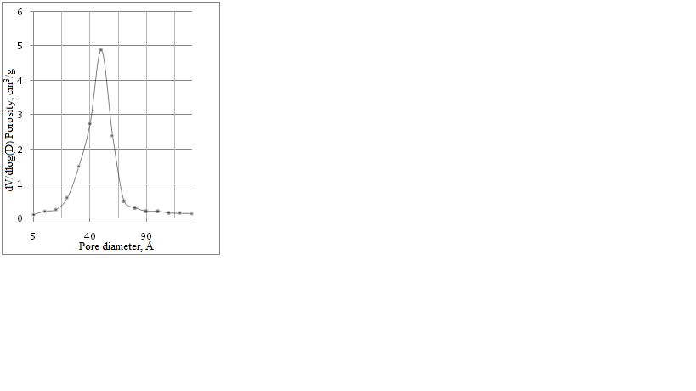
a b
I

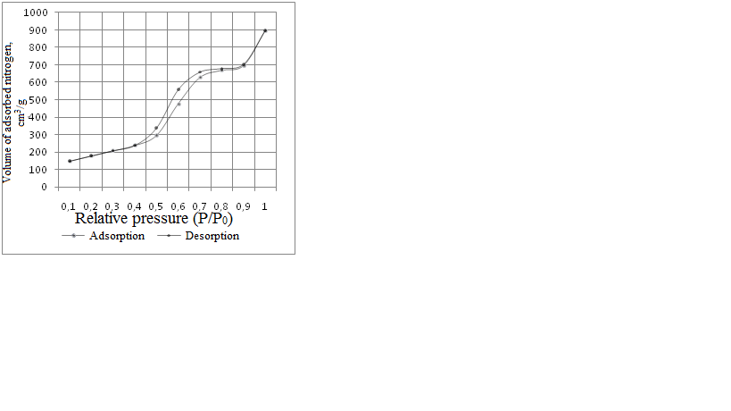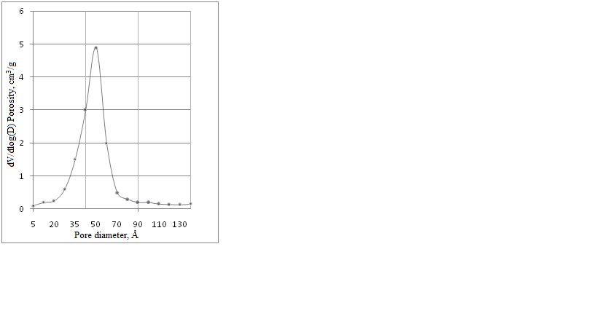
a b
II
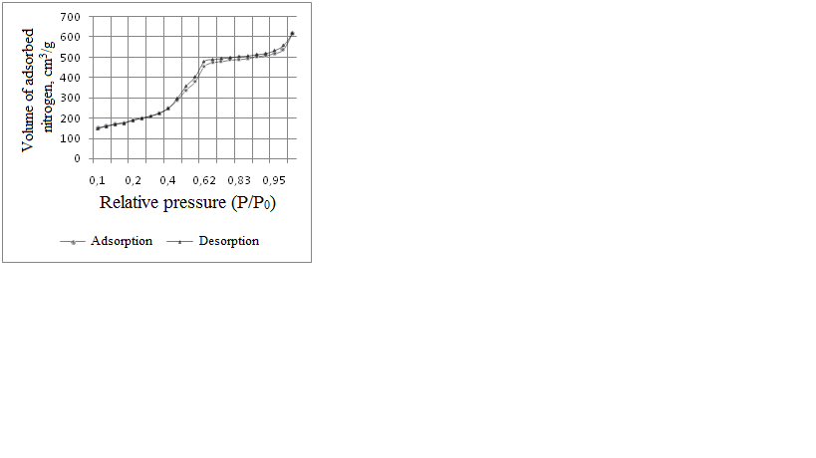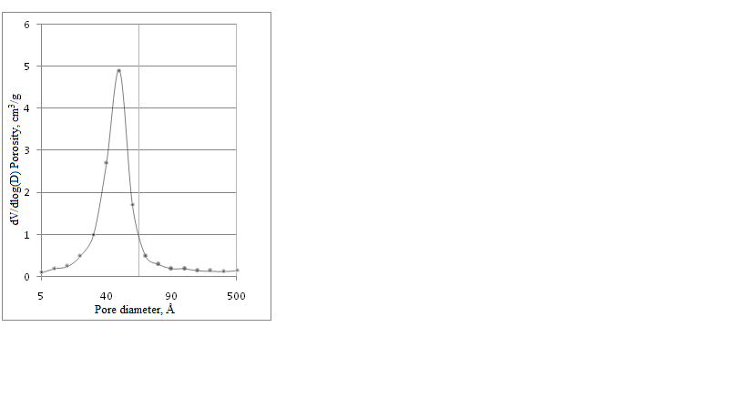
a b
III
Figure 1. Isotherm of adsorption/desorbtion (a) and pore size distribution (b) for samples Al-HMS(10) (I), A1-HMS(20) (II) and A1-HMS(30) (III)

The isotherms of adsorption of nitrogen on samples that were studied were of IV type according to the Brunauer-Emmett-Teller classification; presence of a hysteresis loop and a narrow placement of pores size-wise confirms their mesoporous structure. For all samples, a maximum on the pore size distribution curve is observed at 34-46 Å. The average pore size of all three samples is explained by a fair amount of macropores in the material. Therefore, the more informative value for the obtained mesoporous aluminosilicates seems to be the average size of mesopores, as calculated based on the adsorption/desorption isotherm.
Synthesized samples of Al-HMS (10) and A1-HMS (30) were also studied using the narrow-angle X-ray scattering method. The results of the study are shown in Figure 2.

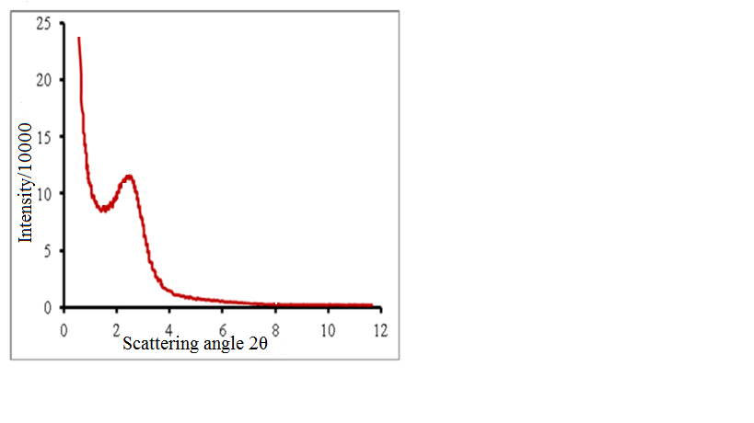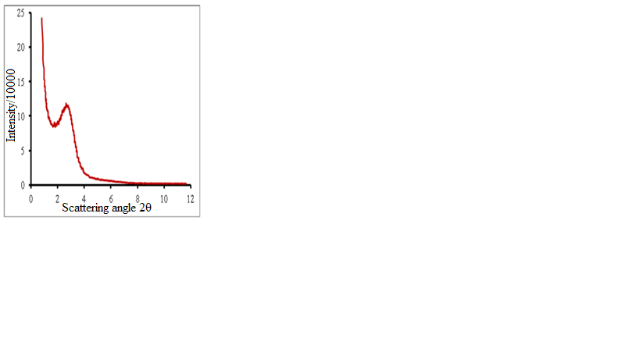
a b

Figure 2. Narrow-angle X-ray scattering curves for samples of Al-HMS (10) (a) and A1-HMS (30) (b)

According to the data in Figure 2, pronounced peaks in the area of angle values of 2θ 2-3° speaks for the presence of a regular structure. For Al-HMS (10), an intensity peak is found in the area of 2.7°, for A1-HMS (30) it is found in the area of 2.3°, which, at the wavelength used in the study of 1.54 Å, corresponds to interplanar distances of 33 Å and 39 Å, respectively.
Conclusions
Therefore, a synthesis of mesoporous alumosilicates of the A1-HMS type was carried out in mild conditions with a Si/Al ratio varying between 10 and 30; those alumosilicates having mesopores between 35 and 49 Å in size, and a significant specific area varying from 510 to 870 m²/g. The mesoporous structure and the presence of a regular structure in synthesized samples was proven using the methods of nitrogen adsorption/desorption and narrow-angle X-ray scattering.
Acknowledgement
This research was financially supported by the Ministry of Education and Science of the Republic of Kazakhstan.
References
[1] S.I. Shirokopoyas, S.B. Baranova, A.L. Maksimov., S.V. Kardashev, A.B. Kulikov, E.R. Naranov, V.A. Vinokurov, S.B. Lysenko, E.A. Karakhanov, Hydrogenation of aromatic hydrocarbons in the presence of dibenzothiophene over platinum-palladium catalysts based on Al-SBA-15 aluminosilicates, Petroleum Chemistry. 54 (2014) 94-99.
[2] E.A. Karakhanov, S.V. Kardashev, A.L. Maksimov, S.B. Baranova, A.B. Kulikov, V.A. Ostroumova, S.I. Shirokopoyas, S.B. Lysenko, Hydroisomerization of n-dodecane on bifunctional catalysts containing mesoporous aluminosilicates, Petroleum Chemistry. 52 (2012) 228-232.
[3] M. Heba Characterization and catalytic activity of NiO/mesoporous aluminosilicate Al-SBA-15 in conversion of some hydrocarbons, Egyptian J. Petroleum. 21 (2012) 1-10.
[4] Y.-H. Yue, A. Gedeon, J.-L. Bonardet, J. B. d`Espinose, N. Melosh, J. Fraissard, Direct incorporation of Al in SBA mesoporous materials: characterization, stability and catalytic activity, Stud Surf Sci Catal. 129 (2000) 209-218.
[5] Wenhao Ye, Zheng Lin, Beibei Dong, Jinfeng Kang, Xiucheng Zheng, Xiangyu Wang, Preparation and Catalytic Properties of Ti-SBA-15 Mesoporous Materials, Materials Sciences and Applications. 2 (2011) 661-668.
[6] J.S. Beck, J.C. Vartuli, W.J. Roth, M.E. Leonowicz, C.T. Kresge, A New family of mesoporous molecular sieves prepared with liquid crystal templates, J. Am. Chem. Soc. 114 (1992) 10834-10843.
[7] С.Т. Kresge, M. E. Leonowicz, W.J. Roth, J.C Vartuli, J.S. Beck, Ordered mesoporous molecular sieves synthesized by a liquid-crystal template mechanism, Nature. 359 (1992) 710-712.
[8] I.V., Kolesnik, A.A. Eliseev, A.P. Malakho, A.V. Garshev., V.P. Tarasov, A.V. Lukashin, Y.D. Tret'yakov, Synthesis of aluminum-rich mesoporous aluminosilicates, Doklady Chemistry. 395 (2004) 78-81.

