Renewable energy in buildings and cities
Development of energy devices based on photovoltaic panels WITH EXTRA consumer properties
Mikhailov L., Mikhailova S.¹, Ismailova G.², Yar – Muhammedova G., Sokolov S.
Al-Farabi Kazakh National University, Physico-Technical Faculty
¹E-mail: skysvetik91@mail.ru
²E-mail: guzal_a81@mail.ru

Introduction

The challenge of this time for renewable energy is low cost of traditional energy resources. Therefore, the economical task of this project is to improve the profitability of devices using renewable energy, due to giving them additional consumer functions and improving performance in difficult air conditions in the city. Leading countries in the production and usage of photovoltaic devices are China, the USA, Japan, and the EU representatives. However, the efforts of manufacture companies of these countries are focused on the creation of large-scale solar power plants specialized only in the production of electricity. Now, efforts of well-known companies are to make solar cells with average efficiency (10-15%) cheaper. Efforts of manufacturers for installation and operation of photovoltaic systems in the cities associated with the installation of solar cells on roofs and sun facades of buildings, specialized only in the production of electricity.
In the previous two decades, it have been studied and designed combined PVT systems [1 -8] which should increase the efficiency of solar energy conversion due to trapping and even heat energy, as well as improving the efficiency of photovoltaic conversion, due to decreasing of the photoconverters temperature. In [9] described in detail the design and calculations for PVT power plant for the city (in Sweden). Payback of small power plants with such panels, according to the calculations in [9] is 35 years even with high Swedish energy costs. Despite the disappointingly low margins, large-scale environmental problems require the renewable energy sources in the energy turnover, and use primarily those that will have the greatest return on investment. The cost of energy greatly increases the length of communications and storage of large amounts of energy, so it is necessary to minimize their use. The lowest additional costs of renewable sources framing are directly nearby to the majority of consumers, i.e. in the city.
At the same time due to the increased accident rate of urban distribution energy networks and rising prices of consumed energy, from year to year the needs and redundancy for energy savings increases, by adding to its production renewable energy. The environment of cities is getting worse due to cars’ emissions and dust that pollute the atmosphere and threaten the health of people. This determines the need for active work on cleaning the air, increasing comfortable environment for residents. Elements and components of renewable energy sources can be charged in some of these works. However, It is hard to imagine that due to the fall in prices for traditional energy sourses, independent urban consumers will demand expensive energy from renewable sources. On the other hand, only whiz the urban consumers’ density is possible to achieve at least some small but steady demand for renewable energy devices. In the structure of residential costs, energy needs reach less than 5%. There is no needs to rely on the fact that these consumers will buy these devices because of the desire to save money on electricity with 1-2% of its budget in 15-20 years after the installation of renewable energy sources (RES). Therefore, the most attractive way to distribute renewable energy among independent urban consumers is - embed them in the home appliances with demand in market. Among these needs can be health care, a comfortable housing, the reliability and safety of the consumer devices, the aesthetics, and similar needs.

Tasks and Possibilities

Scientific and technical task of the project is the construction of modular power units with additional consumer functions. They increase profitability of the device using renewable energy, enhance its relevance in everyday life, and help to solve environmental and social problems. Among these functions, are street and house dust collecting, room lighting, decoration of facades, additional insulation of buildings, the accumulation of heat and cold in the room by heat accumulating material and passive heating, cooling of the room by battery-cooler.
Important design tasks of the project are: development of the installation system of solar panels on the facade, assembly the thermal energy accumulator inside the room, protection the panels from the mechanical and abrasive effects etc.. To ensure the maximum demand, the devise should have autonomous modules that meet each their own consumer function. The user can choose the modules himself with necessary functions, such as eliminate the function of conditioning, dust collecting, or may be lighting.
The basic module is a construction that provides the taking out and fixing of solar panels and connects all modules. The solar panel is framed by the duralumin corners that allow sliding on a ”sled base module” and forms so called grooves for pulling the film. In fact, the base unit - is a corner construction fastened with wall and windowsill, which fixes a solar panel, and it provides a connection with other modules. In Figure 1 we can see a base module on the Physico-Technikal Faculty facade in Al-Farabi Kazakh National University. The solar panel can slide along the guide unit through the open window, first vertically, then turned out the window frame in a horizontal position before transferred at about 30 and then by the end of the corners to the into the vertical (parallel to the facade) position.

 | 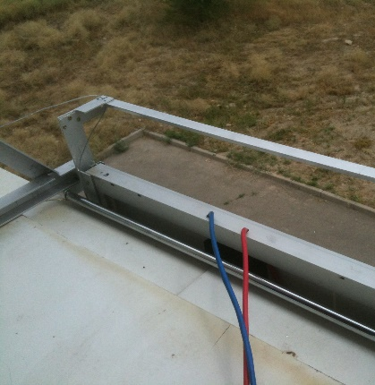 | 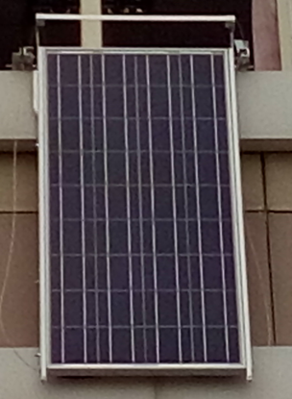 | 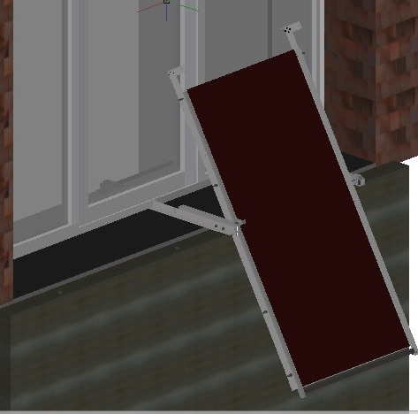
Figure 1 – Basic module with a solar cell on the facade.

The device includes several modules providing consumer functions, depending on what the user selects. If you want to collect the dust, protect the panel from abrasion and wash the solar panel by the wiper – you can connect dust collecting module. Dust can be collected automatically in the tub, or you can wipe it manually. If there is such a climate useful for conditioning, this panel may be “converted” to the PVT module by inserting heat taking part into the solar panels cavity (the inner side). The coolant may a be liquid used in the car industry - antifreeze. Heat and cold from the solar cell can accumulate into heat sinks, which serve as a heater or a cooler of the room.

Variants of use

Of course, the most reasonable use of photovoltaic energy, in terms of profitability, is to use its facilities for low-voltage LED lighting fixtures. On the one hand, it is important consumer function; on the other hand it allows smoothing of peak electrical overloads. In this paper we look in detail to other facilities. For instance, ensuring continuous operation of solar panels in all weather conditions will be due to their cleaning from dust, dirt and snow through the periodic movement of "wiper" on the face side of the panel. Also it will be due to reducing the temperature of the panels in the active mode, due to protecting the panels from the effects of dust and dirt in a passive mode. Scheme with a set of functional modules for air conditioning, lighting and dust collector is shown in Figure 2.

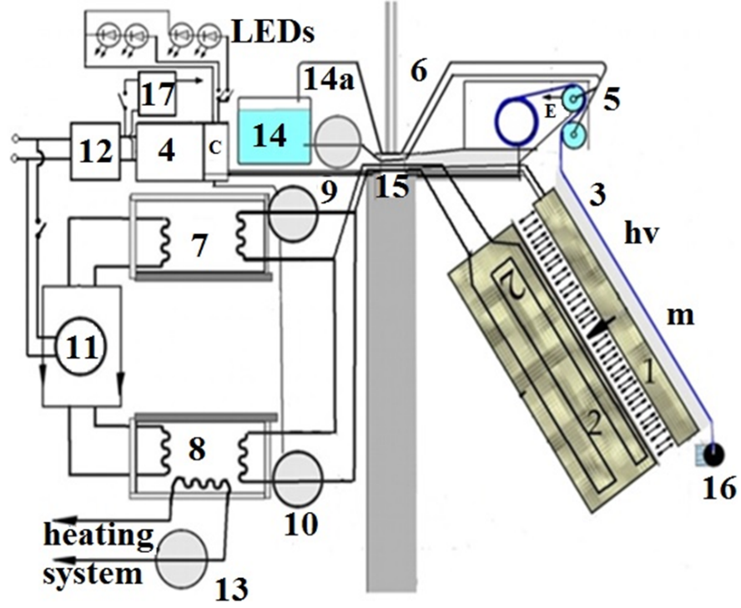
1 - solar cell; 2 – heatsink and coolant; 3 - mobile dust collecting film; 4 – accumulator; 5 - unit of electrical charge and washing of film; 6 – geared motor; 7, 8 – heat and cold sink with heat exchanger; 9,10 – circulation pumps of heat exchangers; 11 – the heat pump compressor; 12 - uninterruptible power supply; 13 - circulating pump to the outside with the heating system; 14,14a – liquid sink and circulation pump; 15 – pipeline, bracket; 16 – light weight and film holder; 17 – module of management.

Figure 2. Set of functional modules of the device.

Variant of functional and structural schemes with a set of modules for the Curtain, which controls the solar flux and picks up the dust from the street is shown in Figure 3.

a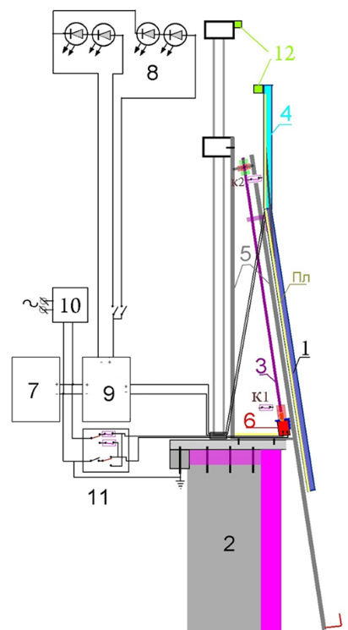 | b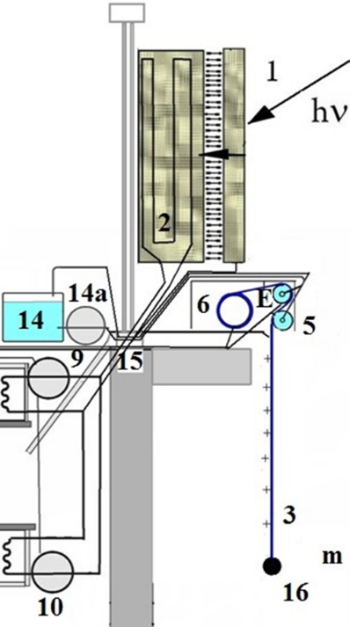
1 - solar cell; 2 – heat sink and coolant; 3a - peg; 3b- mobile dust collecting film; 4 – shutter; 5 a – corner sled; 5b - unit of electrical charge and washing of film; 6 – geared motor; 7- accumulator; 8 – LEDs; 9a – controller; 10 a – charge; 9 b,10 b – circulation pumps of heat exchangers; 11 – switchers; 12 – rubber damper, 14,14a – liquid sink and circulation pump

Figure 3 a,b – Variant of the “curtain”

The lavsan polyester film carries out protection against dirt and abrasive effects when the solar panel is not used in the photovoltaic or the radiator mode. Electrostatic dust collection and washing of the front side panels is made of the same film and electrified wiper. The cleaning liquid is supplied to the system by the circulation pump to film washing tubes, so the dust from the film gets into the liquid reservoir. Spilled portion of the liquid moisturizes the wiper. The film a small weight moves slowly by the motor-reducer, for a few minutes that allow to wipe the film manually with the high voltage switched off. Protection against dirt and abrasive effects and electrostatic dust collection and washing of the front side of the panel by wiper is shown on the Figure 4.

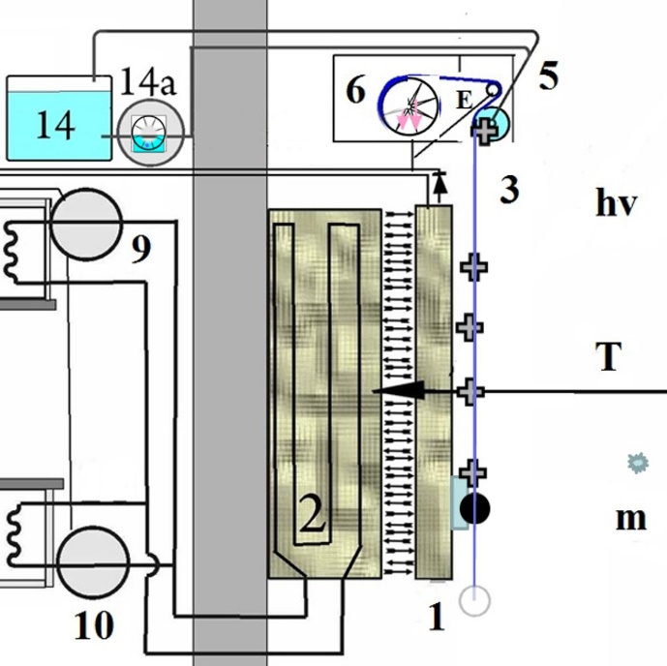
1 - solar cell, 3b- mobile dust collecting film, 5b - unit of electrical charge and washing of film; 6 – geared motor, 9 b, and 10 b – circulation pumps of heat exchangers, 14,14a – liquid sink and circulation pump

Figure 4. Functional scheme of the protection against dirt and electrification mode.

Using a box 2 with a removable heat circuit. Solar cell can be turned into a PVT - module for heat exchange with the environment. In the variant depicted on the Figure 4, the device can perform as the air conditioner, which additionally heat the room or accumulating the heat in the heat sink 8, It is possible both due to the “solar” heat at low air temperatures, and due to the convective exchange with air at positive temperatures. The film redistributes the heat from solar panels in the way where most of it go the the box 2. The lowered film “redistributes" the heat of the solar panels so that most of it go the cooler 2. At the outside temperatures below zero heat from can be moved in the cold sink 7, the heat from which is pumped into the heat pump to the heat sink 8. Due to the heat storage, process of heating and heat accumulating can be separated in time.
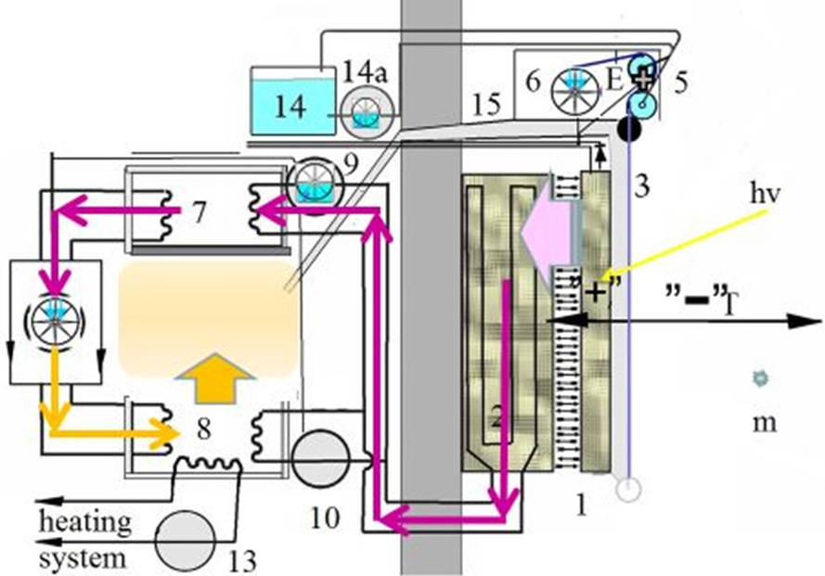
1 - solar cell; 3 - mobile dust collecting film; 5 - unit of electrical charge and washing of film; 6 – geared motor; 7, 8 – heat and cold sink with heat exchanger; 9,10 – circulation pumps of heat exchangers; 11 – the heat pump compressor;13 - circulating pump to the outside with the heating system; 14,14a – liquid sink and circulation pump; 15 – pipeline, bracket;

Figure 5 - “Winter type” conditioner

The device can work as air conditioner that cooling the room or accumulate the cold in cold sink 7. In this case, the process of cooling the room and the process of accumulation of cold are separated in time. So, the panel acts as an external radiator air conditioner type "summer", taking out the heat into the environment.

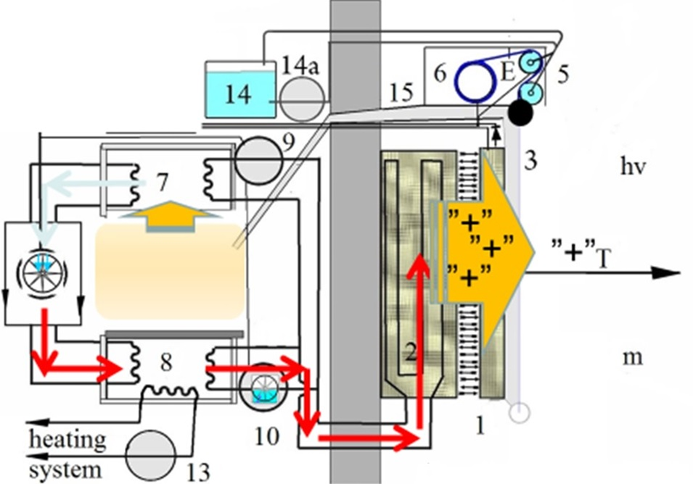
1 - solar cell; 3 - mobile dust collecting film; 5 - unit of electrical charge and washing of film; 6 – geared motor; 7, 8 – heat and cold sink with heat exchanger; 9,10 – circulation pumps of heat exchangers; 11 – the heat pump compressor;13 - circulating pump to the outside with the heating system; 14,14a – liquid sink and circulation pump; 15 – pipeline, bracket;

Figure 6- “Summer type” conditioner

Components

Electromechanical part of the device uses inexpensive and common components: low-power refrigerator compressor, low-power 12 - volt circulation pumps and gear motor with a DC motor of 12 volts.A variant with two solar cells with 120W installation power allows operate with the kW of heat power, with 200 W photovoltaic power, clear the nearby air (0.5 m/s) from dust with particle size more than 10 microns and the speed of 0.1 m³/s.
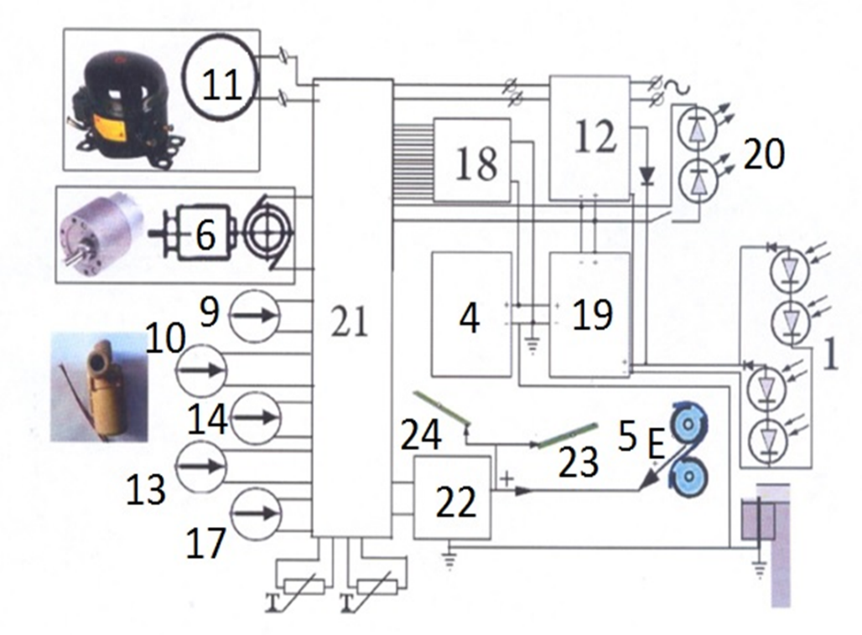
1- solar cell; 4 - 200 A*hours accumulator; 5- high-voltage electrode for electrifying the dust collecting film; 6- reversing geared motor; 9 - circulating pump - radiator of cooling and solar panels; 10 - circulation pump storage radiator of heat and solar panels; 11 - the heat pump compressor; 12 - uninterruptible power supply with an access to the external battery; 13 - the circulation pump connecting the central heating to the heat radiator; 14 - circulation pump for films washing and solar panel; 17 – circulation pump for mixing of crystalline hydrate; 18 - switching control unit; 19 – controller of the Battery; 20 - LED Illuminator; 21 - Switching Module; 22 - voltage multiplier; 23,24 - foil electrodes under the dust-collecting radiators drives T-thermistors.
Figure 7 Details and components of the device.

Conclusion

Currently, due to the low price of traditional energy resources, there are practically no alternatives to the use of cost-effective solar panels and collectors except of use them in home appliances, which are in demand among the people. The rest of the options should be donated. Such devices can be sold as a manufacturer of household functions, not only electric energy source. To increase the profitability of the use, it performs the following functions:
- photovoltaic panels are protected from dirt and dust and the abrasive effects, by using wash itself transparent film;
- accumulated electricity,
- heat and cold for the emergency room;
- due to the connection of LEDs because of accumulators peak congestion in the urban network is smoothed, while the light is turned on by many consumers;
- thermal collector of solar energy is combined with a solar cell;
- performed the role of an external radiator heat for the exchange with the atmosphere for active heating and cooling systems (air conditioning room)
- combined with central heating and air conditioning facilities accumulation of heat and cold;
- collects dust and fumes from car emissions.
Each of these functions can be connected or disconnected at the demand of the consumer, without affecting other functions of the device.

Bibliography
[1] China's International Conference for the Solar Industry, December 11-13, 2012 Combination between the Solar Water Heating System and Civil Architecture Ning Zhu
[2] China's International Conference for the Solar Industry, December 11-13, 2012 Design and Optimization Mounting System for PV Power Florian Roos
[3] China's International Conference for the Solar Industry, December 11-13, 2012 Towards Solar Cities : Low Energy Building for a Renewable Energy Future Chiel Boonstra
[4].M.Meytin – Photovoltaics: Materials, Technologies and Prospects,//ELECTRONICS. Science, Technology, Business, 2000, page 40-46
[5] Jerry Yudelson - Green Building Through Integrated Design ISBN-13: 9780071546010, Publisher: McGraw-Hill Professional Publishing Publication date: 10/21/2008, Series: McGraw-HiH's Green Source Series
[6] Arjun Basnet -Architectural Integration of Photovoltaic and Solar Thermal Collector Systems into buildings. Master’s. Thesis in Sustainable Architecture. June 2012, Trondheim, Norwegian University of Science and Technology Faculty of Architecture and Fine Arts Department of Architectural Design, History and Technology
[7] Grid connected PV power source of the ICPE's solar park, INFRASOLAR. Issues. Quality. Future The 12th WEC CENTRAL & EASTERN EUROPE REGIONAL ENERGY FORUM - FOREN 2014- June 2014, Bucharest -www.icpe.ro
[8] Joshua Pearce -Combined photovoltaic solar thermal systems (PVT) - literature review, Michigan Tech's Open Sustainability Technology Lab. 2014,01.04
[9] Mustafa Kaya -Thermal and Electrical Performance Evaluation of PV/T Collectors in UAE, Master of Science Thesis EGI 2013:037MSC, KTH School of Industrial Engineering and Management Energy Technology EGI-2013-037MSC, SE-100 44 STOCKHOLM, May 13, 2013.

