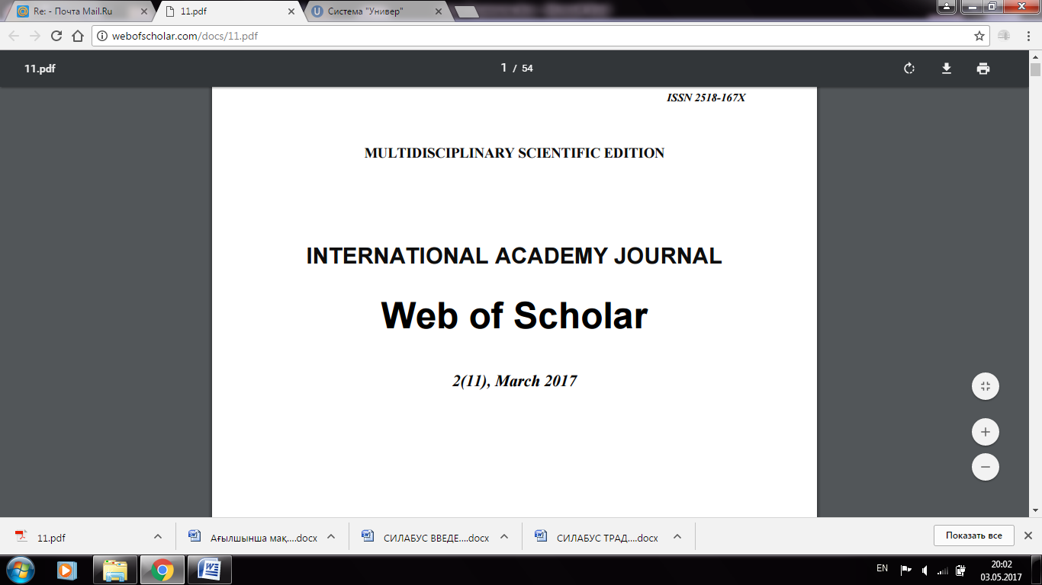
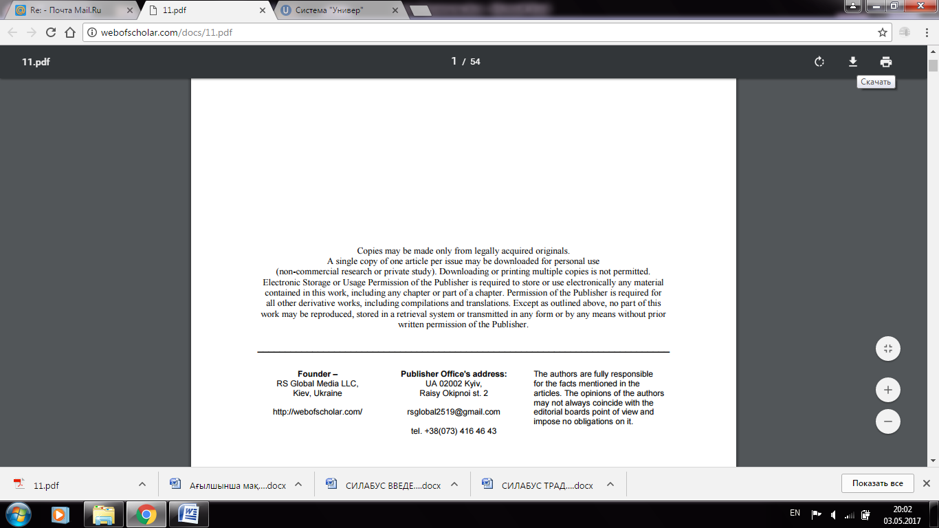
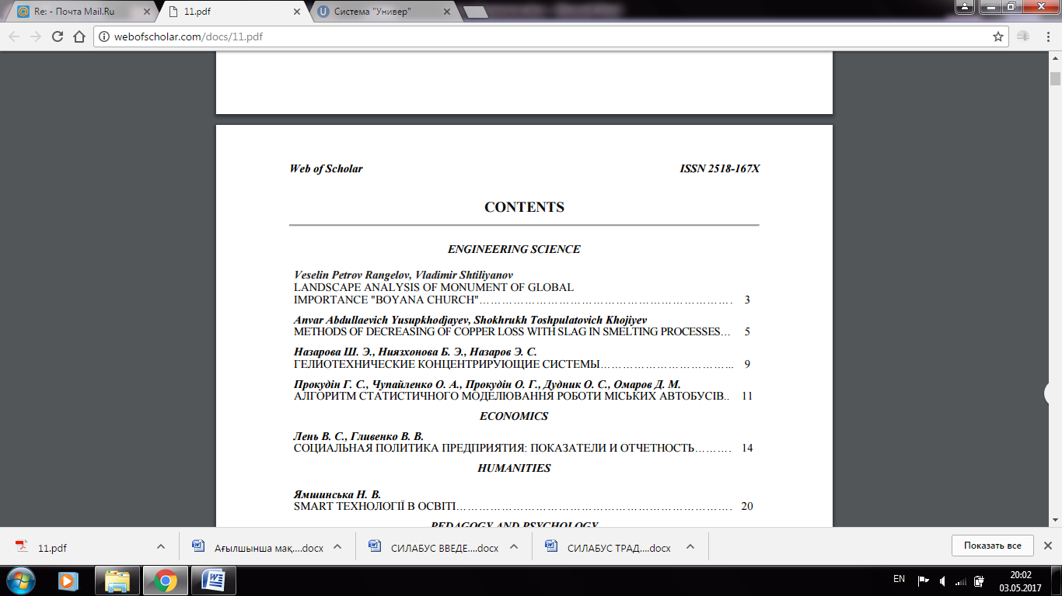

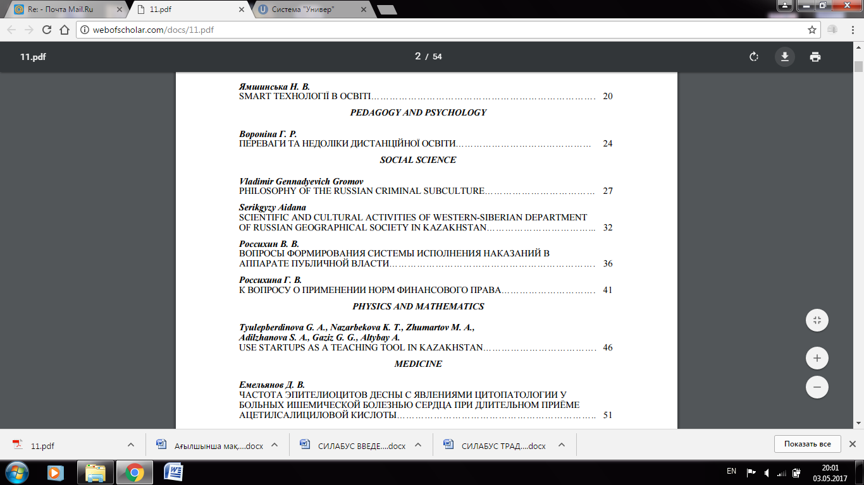
INTERNATIONAL ACADEMY JOURNAL Web of Scholar 2(11), March 2017

Serikgyzy Aidana SCIENTIFIC AND CULTURAL ACTIVITIES OF WESTERN-SIBERIAN DEPARTMENT OF RUSSIAN GEOGRAPHICAL SOCIETY IN KAZAKHSTAN……………………………... 32

