УДК 54.052

T. Dmitriyev, Ch. Daulbayev, B. Topanov, E. Aliyev, Z. Mansurov

3D PRINTING AS AN ALTERNATIVE METHOD OF ALLOYS OBTAINING

JSC “Institute of Combustion Problems”
172 Bogenbay batyr, Almaty
timur_dmitriyev@yahoo.com

ABSTRACT

It has been developed and assembled an experimental setup based on 3D printer with the wire feed system. In addition, two types of plasma torches were assembled: with direct and indirect arc. Several series of experiments on the production of CuSn alloy were carried out. During the experiments, the optimal operating mode of the plasma torch was identified. Consequently, a sample of bronze was obtained. This sample was examined using scanning electron microscopy, energy dispersive, X-ray and Vickers microhardness analysis. Microhardness in accordance with the published data is similar to the sculpture bronze.

Key words: additive manufacturing, layered synthesis, 3D printing, plasma heating, CuSn, bronze

INTRODUCTION

Additive manufacturing also known as 3D printing, rapid prototyping, layered synthesis is a new technology where the computer file of 3D digital model can be converted to a 3D physical object using a special equipment called a 3D printer. Additive manufacturing works by reading 3D-files and duplicate them on the additive manufacturing setup. 3D-files can be developed using any 3D-modeling program such as AUTOCAD, FreeCAD, or you can download free file from the Internet. Once a digital 3D model of the object is created, the computer program in the digital form cuts the model in the layers. Each layer is sent to the 3D printer which builds physical objec layer by layer, as long as the shape occur in 3-dimensions [1].
Up to now, a bulk of scientific works were done using polymers as a raw material. But great attention is paid to the production of metallic structures by additive manufacturing.
Additive manufacturing is considered as a “green” manufacturing process, since the process takes place minimum waste production, therefore, low cost materials and efficient use of energy and raw materials. Figure 1 shows a vivid example that compares conventional metal processing and additive manufacturing.

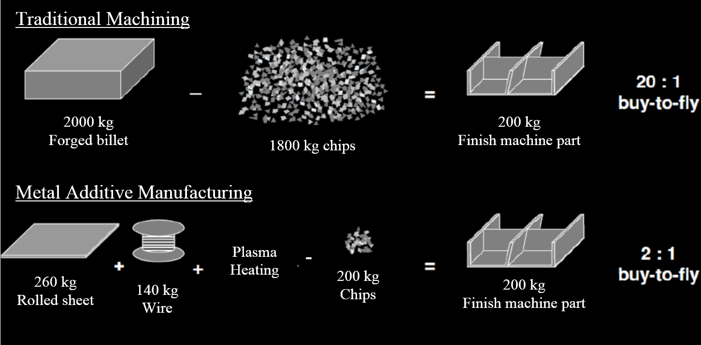
Figure 1. Additive Manufacturing as a Green Manufacturing Process [2]

In other words, the raw material costs by using additive manufacturing technology in comparison with traditional methods of processing metal products reduced 10 times. As a result, the additive manufacturing offers significant savings in resources, such as raw materials, energy, fewer chemicals in the form of cutting fluids and lead times, as compared to conventional production methods. Economy of resources, ultimately, leads to a significant cost reduction.
Since the conventional method of obtaining a bronze is casting, the proposed method of layered synthesis is represented as alternative method of producing metals and alloys. There is a work [3] that describes a method of layered synthesis of copper and tin powders.
In the present work, the use of plasma chemical heating in conjunction with feeding the metal wires is suggested.
There are some bronze marks doped with elements such as tin, nickel, phosphorus, lead, etc., which affect the various physico-chemical and mechanical properties of the alloy [4]. In this regard, bronze alloys are widely applied in jewelry and sculptural craft, as well as in mechanical engineering [5].
Tin bronze is used since ancient times, and they are well mastered by the industry. Besides the basic α-solid solution of tin in copper, there are electronic compounds present in alloys: β-phase (Cu₅Sn); δ-phase (Cu₃₁Sn₈); ε-phase (Cu₃Sn) and γ-phase – a solid solution based on chemical compounds the nature of which is not clarified [6].

EXPERIMENTAL

On the basis of earlier work [7] an experimental setup for obtaining metal alloys including CuSn alloy, was assembled. This installation was assembled based on 3D printer brands of Han-Bot 3D Printer (China) with the microcontroller brand of Melzi Ardentissimo (Arduino). The gist of the process is to melt metallic wires through plasma heating (water-cooled plasma torch). On figure 2 the experimental setup is presented.
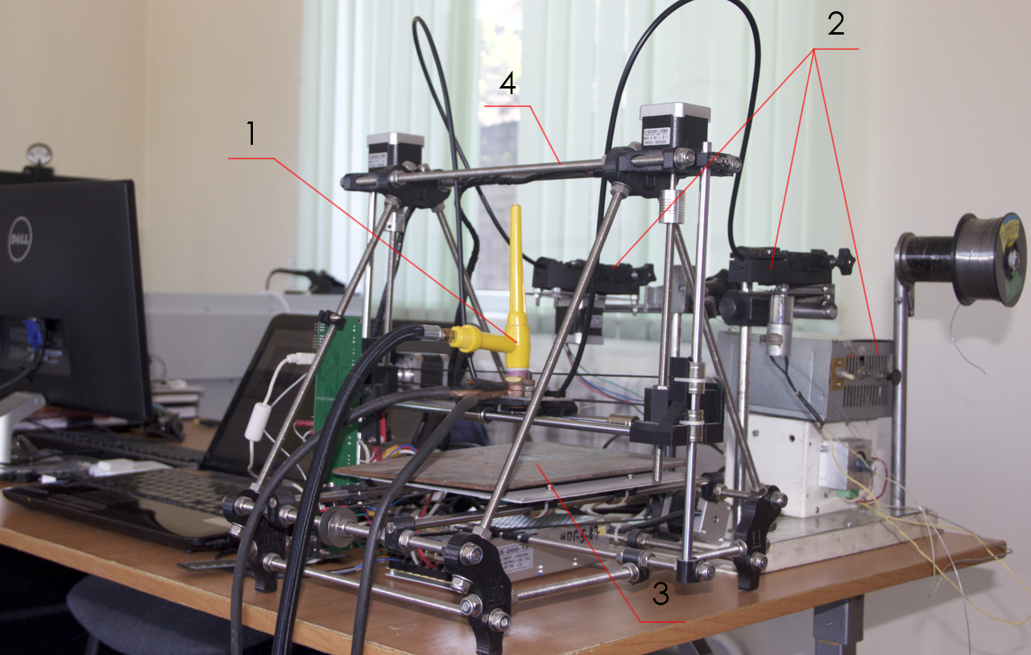  а) | 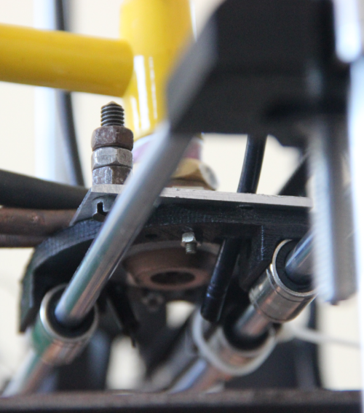  b)
Figure 2. a) 1 – Water-cooled plasmatron with indirect arc mounted on the carriage;
2 – wire feed system; 3 – 4 mm thick metallic substrate; 4 – 3D Printer with computer;
b) external view of plasmatron with wire feeding

The experimental setup includes 3D Printer (Han-Bot 3D Printer), microcontroller (Melzi Ardentissimo), plasma torch with water-cooling system (argon gas), wire feed system, welding invertor, rotameter for gas consumption measurement.

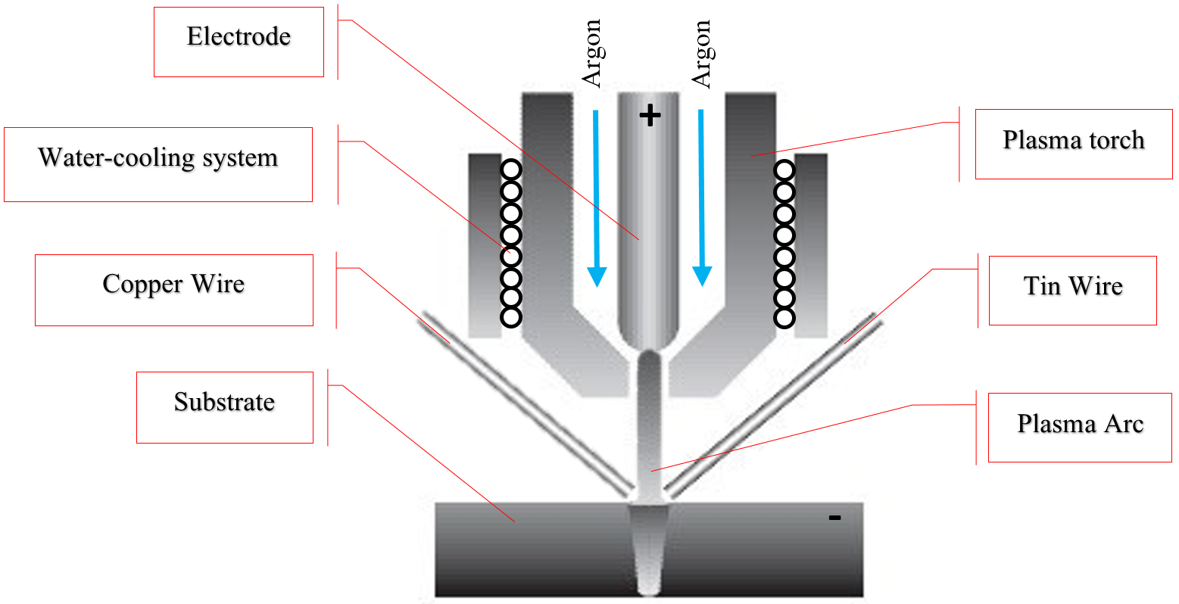
Figure 3. Scheme of plasma torch with direct arc

Figure 3 shows a schematic diagram of the experimental setup. For this experiment direct plasma arc was used, positive contact that is connected to the tungsten electrode and the negative - to a metal substrate. In consequence of that between the substrate and the tungsten electrode creates an electric arc, and when gas (argon) goes through the nozzle its ionization takes place and plasma arc lights, which melts the metal wire.
For the selection of the optimum melt temperature, a series of experiments on the measurement of the temperature of the plasma arc was held. The temperature is measured with a digital pyrometer Multimax. Table 1 below shows the results of temperature values depending on the current and gas flow (argon).

Table 1. Temperature Dependency (⁰C) by the plasma arc current (A) and the plasma gas flow rate (l / min)
Gas flow  rate (l / min)  Current,  А | 10 | 20 | 35 | 50 | 65 | 80 | 95
1 | 1010 ⁰C | 1085 ⁰C | 1250 ⁰C | 1330 ⁰C | 1450 ⁰C | 1530 ⁰C | 1680 ⁰C
5 | 870 ⁰C | 950 ⁰C | 1180 ⁰C | 1340 ⁰C | 1440 ⁰C | 1560 ⁰C | 1640 ⁰C
10 | 890 ⁰C | 960 ⁰C | 1130 ⁰C | 1300 ⁰C | 1410 ⁰C | 1570 ⁰C | 1620 ⁰C

RESULTS AND DISCUSSION

As a result, by the method of layered synthesis sample shown in Figure 4 was obtained.
Experiments were carried out according to the following operating parameters of the process:
- wire feed rate of 0.9 mm diameter copper wire and 1 mm tin solder was 5 mm/sec
- gas flow rate (argon) – 1 l/min
- current – 30 A
- heating temperature – 1100 ⁰C

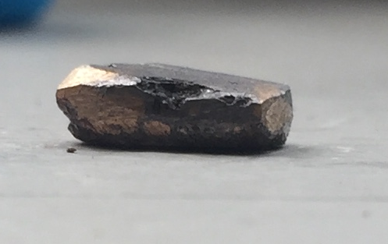
Figure 4. Photograph of bronze sample

Obtained sample was studied by scanning electron microscopy brand of Quanta 3D 200i (FEI Company (USA)). Pictures of different areas and at different magnifications were obtained. In all areas of the surface of the alloy non-uniform structure is found. As shown in figure 5 (b), some areas of the sample have a grain structure that is likely indicates an incomplete interaction of raw materials in the melting process. However, pictures (a, c) in Figure 5 shows the field with a monolithic structure, which in subsequent studies confirmed the presence of the CuSn phases.

а) | b) | c)
Figure 5. SEM-pictures of obtained sample

SEM-EDS analysis at ×100 magnification revealed surface of the entire sample (Figure 6), where there are distinct areas of CuSn alloy, besides the individual areas that contain lead, and silicon oxide compounds have been found. Lead was formed as a separate structure in the process. The reason of the appearance of lead in the sample is the fact that the tin solder has flux (lead sulfide). The presence of silicon is due to the surface grinding process of the sample. Oxides of the elements takes place because of oxidation during the melting, since the experiments were carried out on an open air.
On SEM-picture is clearly visible dark area corresponding to the alloy CuSn. Also worth noting is the fact that the tin distribution in the sample volume is quite uniform, it cannot be said about the distribution of lead, which has separate area of high concentration.
The elemental composition of the described area is shown in Table 2.
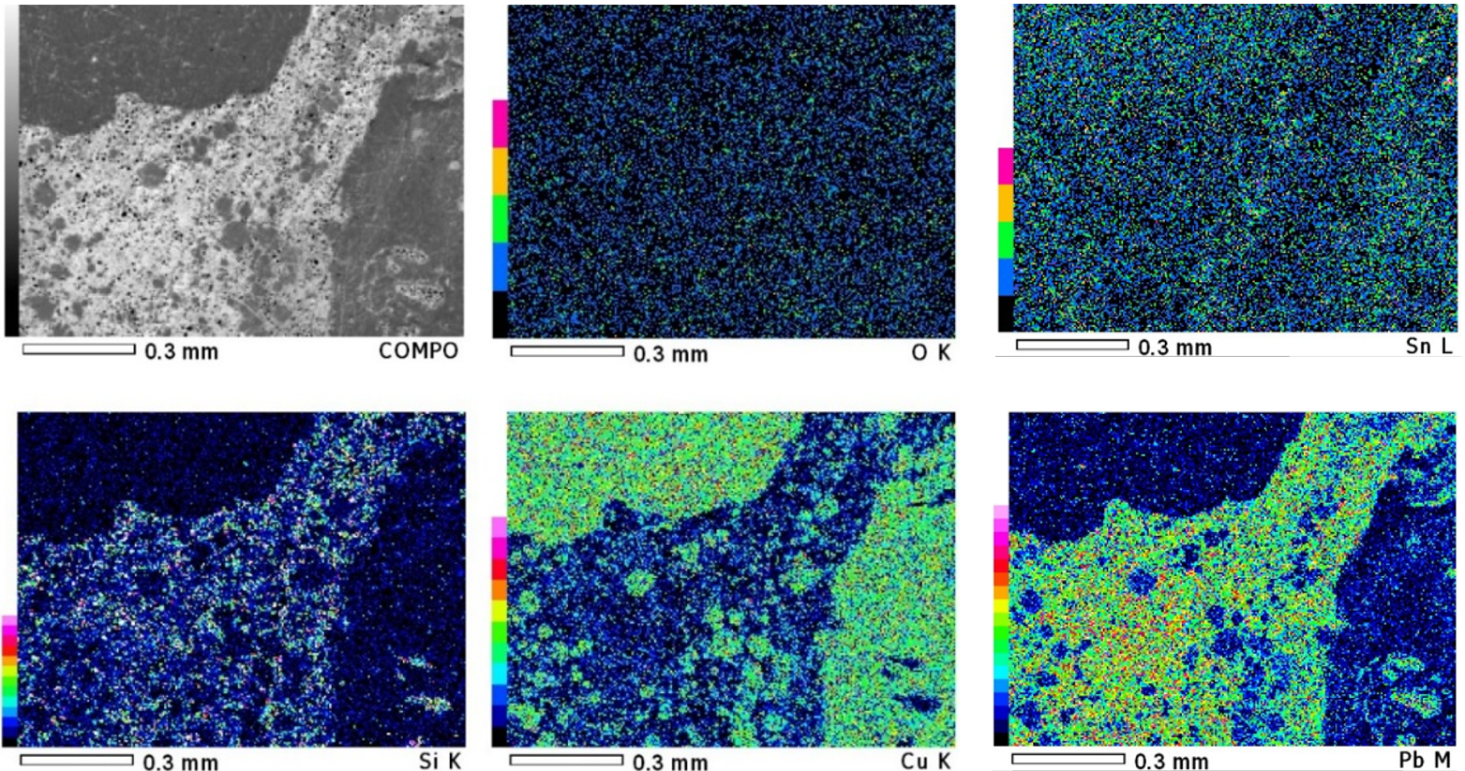
Figure 6. Results of SEM-EDS at ×100 magnification

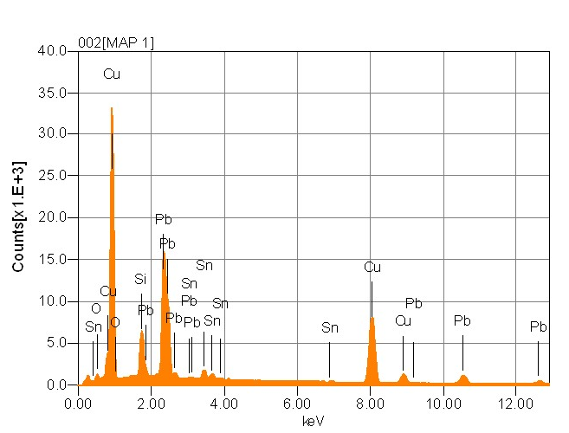
Table 2. Data of elements concentration built by JOEL program
Elements | mass % | mol %
O | 1.76 | 9.29
Si | 4.26 | 12.79
Cu | 41.86 | 55.53
Sn | 3.94 | 2.80
Pb | 48.17 | 19.60
Total | 100 | 100

In addition, at ×500 magnification area with tin bronze alloy was investigated (Figure 7). The results of the analysis of this region showed that the alloy of copper and tin was successfully obtained by the proposed method of layered synthesis. This region is characterized by a uniform distribution of the sample surface concentrations of copper and tin, in turn lead concentrates only in certain areas.
The content of copper and tin in this area is indicated in Table 3.

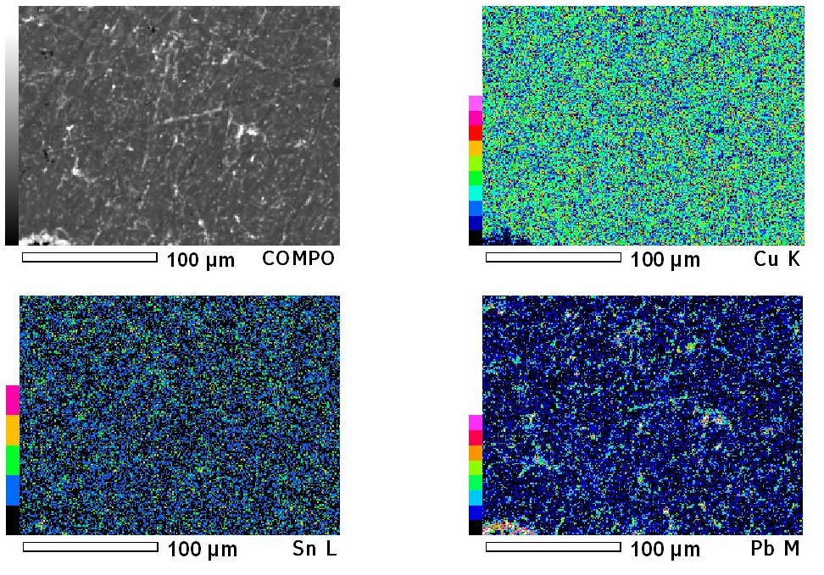
Figure 7. Photographs of the sample surface in the Cu Sn alloy

Table 3. Data on the concentration of copper and tin built by program JOEL
Elements | ms % | mol %
Cu | 83.35 | 92.66
Sn | 6.55 | 3.90
Pb | 10.10 | 3.44
Total | 100 | 100
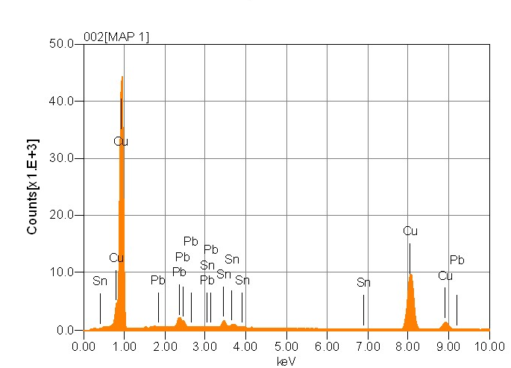

X-ray diffraction analysis was performed on diffractometer brand D8 ADVANCE Bruker (Producer - Germany). This analysis showed the presence of copper (34.5%), tin bronze (Cu41Sn11) (26,3%), lead (24.2%) and tin oxide (15%). The main radiograph (Figure 8a) shows a number of peaks, referring to elements and chemical compounds. However, on the chart there is Cu Sn alloy peak (Figure 8b). The blue spectrum shows the presence of Cu41Sn11 alloy.

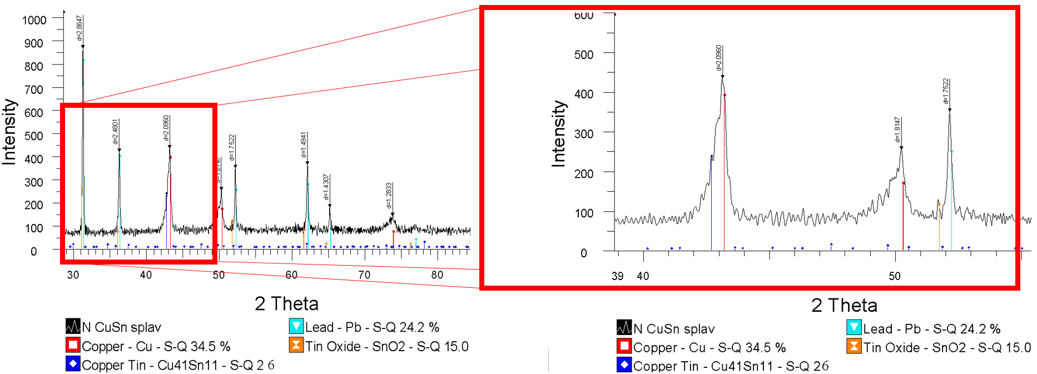
a) | b)
Figure 8. Radiograph of obtained bronze sample

Table 4. Content of CuSn-alloy
Name | Formula | S-Q %
Copper | Cu | 34.5
Copper-Tin | Cu₄₁Sn₁₁ | 26.3
Lead | Pb | 24.2
Tin oxide | SnO₂ | 15

Table 5. Cubic lattice parameters of CuSn-alloy

Lattice parameter | Standard | Obtained sample
a: | 17.96460 | 17.89895

Vickers microhardness determination
To measure the hardness Micro Durometer HV-1000B (China) was used. Diamond indenter penetrated to the surface with a load of 200 g, the duration of retention of the indenter was 10 seconds. For the yellow area (bronze alloy), the average hardness of 80 HV (Hardness Vickers). The gray area (area of lead and other elements) is much softer and its hardness was 10-8 HV.
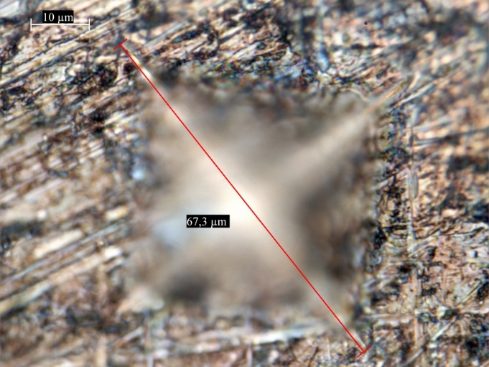  а) | 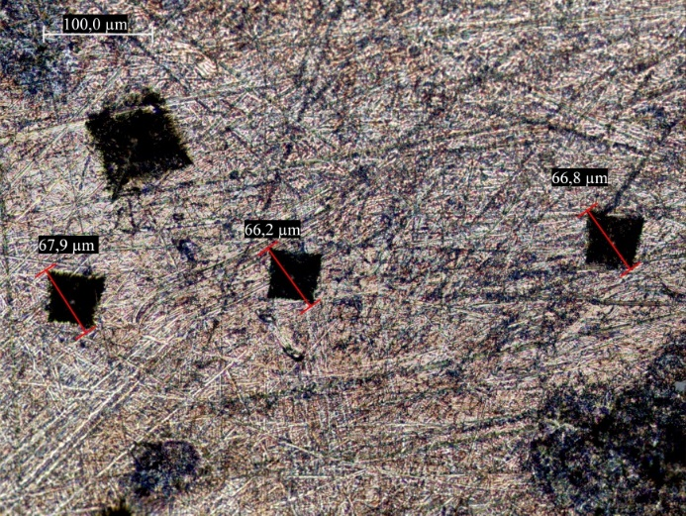  b)
Figure 9. Images captured after the measurements of Vickers microhardness
a – Zoomed penetration of diamond pyramid mark; b – general view of all prints

Table 6. Results of determination of Vickers microhardness of copper alloys
Alloy | Type | Content, wt. % |  |  |  |  |  | HV
 |  | Рb | Sn | Zn | Sb | Fe | Cu
Tin Bronze | Sculpture bronze [8] | 0,7 | 5,7 | 0,1 | 0,01 | 0,25 | Balance | 79
Tin-Lead Bronze | Obtained sample | 10,10 | 6,55 | - | - | - | Balance | 80

CONCLUSION

- During the work an experimental setup based 3D printer (Han-bot 3D printer, China), wire feeding system with two types of electric motors have been developed and assembled. In addition, two types of plasma torches were made: with direct and indirect arc.
- Several series of experiments on the production of CuSn alloy have been performed. During the experiments, an optimum operating mode of the plasma torch was identified. In the result a sample of bronze was obtained.
- The sample was examined using scanning electron microscopy, energy dispersive analysis and X-ray analysis. Research results confirmed the formation of tin bronze with some irregularities in the structure, namely the presence of separate regions of silicon and lead.
- The results of microhardness showed that the sample is similar to the bronze sculpture and has an approximate value of hardness in accordance with the published data.

References

- Journal of Material Processing Technology. June 2012, Vol. 212, pp. 1377-1389.
- Electron Beam Freeform Fabrication: A Metal Deposition Apparatus to Build Components Directly from CAD. Taminger, Karen. Arlington, Texas: NASA Langley Research Center, 2008. WBT Showcase.
- Behrokh Khoshnevis and Jing Zhang. "Selective Separation Sintering (SSS) - An Additive Manufacturing Approach for Fabrication of Ceramic and Metallic Parts with Application in Planetary Construction", AIAA SPACE 2015 Conference and Exposition, SPACE Conferences and Exposition
- Осинцев О.Е., Федоров В.Н. Медь и медные сплавы. Отечественные и зарубежные марки: справочник. – М.: Машино-строение, 2004. - 336 с.
- Фетисов Г.П., Карпман М.Г., Матюнин В.М. и др. Материаловедение и технология материалов - М.- В.Ш., 2000 - 182с.
- Колачев Б.А., Ливанов В.А., Благин В.И. Металловедение и термическая обработка цветных металлов и сплавов.- М.: Металлургия, 1972. -480 с.
- Дмитриев Т.П., Топанов Б.Г., Алиев Е.Т., Мансуров З.А., «Разработка установки для применения технологии послойного синтеза (3D принтинг) металлических изделий с плазменным источником энергии», "Proceedings of the Joint International VIII Symposium "Combustion & Plasmachemistry" and Scientific & Technical Conference "Energy Efficiency-2015"", с. 287, 2015
- Калиш М.К., Естественные защитные пленки медных сплавов, М., 1971

Дмитриев Т.П., Даулбаев Ч.Б., Топанов Б.Г., Алиев Е.Т., Мансуров З.А.
РГП на ПХВ «Институт проблем горения», ул. Богенбай батыра 172, Алматы
3D ПРИНТИНГ, КАК АЛЬТЕРНАТИВНЫЙ МЕТОД ПОЛУЧЕНИЯ СПЛАВОВ
На базе 3D принтера модели HanBot была разработана и собрана экспериментальная установка с системой подачи проволоки. Кроме этого разработаны два вида плазмотронов: с прямой и косвенной дугой. Проведена серия экспериментов по получению сплава CuSn. В ходе экспериментов подобран оптимальный режим работы плазмотрона. В последствие был получен образец бронзы. Полученный образец был исследован с помощью сканирующей электронной микроскопии, энергодисперсионного и рентгенофазового анализов, а также изучена микротвердость по Виккерсу. Основываясь на литературных данных, микротвердость полученного образца схожа со скульптурной бронзой.

Ключевые слова: аддитивное производство, послойный синтез, 3D принтинг, плазменный нагрев, сплав CuSn, бронза.

HanBot модельді 3D принтер негізінде сым беру жүйесі бар тәжірибелік құрылғы өңделіп жинақталды. Одан өзге, тікелей және қосымша доғалы плазматронның екі түрі өңделді. CuSn құймасын алу бағытында тәжірибелер жүргізілді. Тәжірибелер барысында плазматронның жұмыс жасауының тиімді режимі таңдалынды. Нәтижесінде қорғасын үлгісі алынды. Алынған үлгі сканирлеуші электронды микроскоп, энергодисперсиялық және рентгенофазалық талдаудың көмегімен зерттелінді. Сонымен қатар, Виккерс әдісі бойынша микроқаттылығы зерттелінді. Әдеби шолуларға сүйене отырып, алынған үлгінің микроқаттылығы мүсіндік қоламен ұқсас екені дәлелденді.

Түйінді сөздер: қоспа өндіру, қабатты синтез, 3D принтинг, плазмалық жылыту, CuSn қорытпасы, қола.

Сведения об авторах

- Дмитриев Тимур Петрович, Ph.D докторант 2 курса КазНУ им. аль-Фараби, младший научный сотрудник РГП на ПХВ «Институт проблем горения»
- Даулбаев Чингис Баянович, Ph.D докторант 2 курса КазНУ им. аль-Фараби, младший научный сотрудник РГП на ПХВ «Институт проблем горения»
- Топанов Болат Габбасович, токарь-механик РГП на ПХВ «Институт проблем горения»
- Алиев Ерхан Тастемирович, к.ф.-м.н., заместитель генерального по науке и инновационным технологиям РГП на ПХВ «Институт проблем горения»
- Мансуров Зулхаир Аймухаметович, д.х.н., профессор, генеральный директор РГП на ПХВ «Институт проблем горения»

