**Electronic simulation of the gluing bifurcation**

AkhtanovS.N., Al-Farabi KazNU, Almaty

Research supervisor: doctor of physical and mathematical sciences, prof. Zhanabaev Z. Zh.

The analog circuit for solving the system of differential equations for gluing bifurcation is described. This circuit can be applied in telecommunications and for solving particular problems of neural systems.

This work is devoted to research bifurcations transitions similar to Feigenbaum bifurcations, but the transition from periodic oscillations to chaos is realized according to several unusual scenario with a sequence of so-called homoclinic (gluing) bifurcations [1].

For the description of the bifurcations we can use the following system of differential equations:

   (1)

The circuit consists of three integrators, one for each is variable, The nonlinear terms are represented by use of analog multipliers. The first step of designing the circuit is to rescale both three state variables x, y, and z in order to fit within the dynamical range of the source [-15 V, 15V]. We use the new variables u=x/5, v=y/5, w=z/10, τ=t/T, T=100. This rescaling of variables leads to the following set of differential equations, in which u, v, w are voltages on the three capacitors of the circuit. Time is expressed in seconds,

   (2)

These equations have been used for modeling of the electronic circuit shown in Fig. 1.



Fig.1. An analog circuit to solve differential equations system (2).

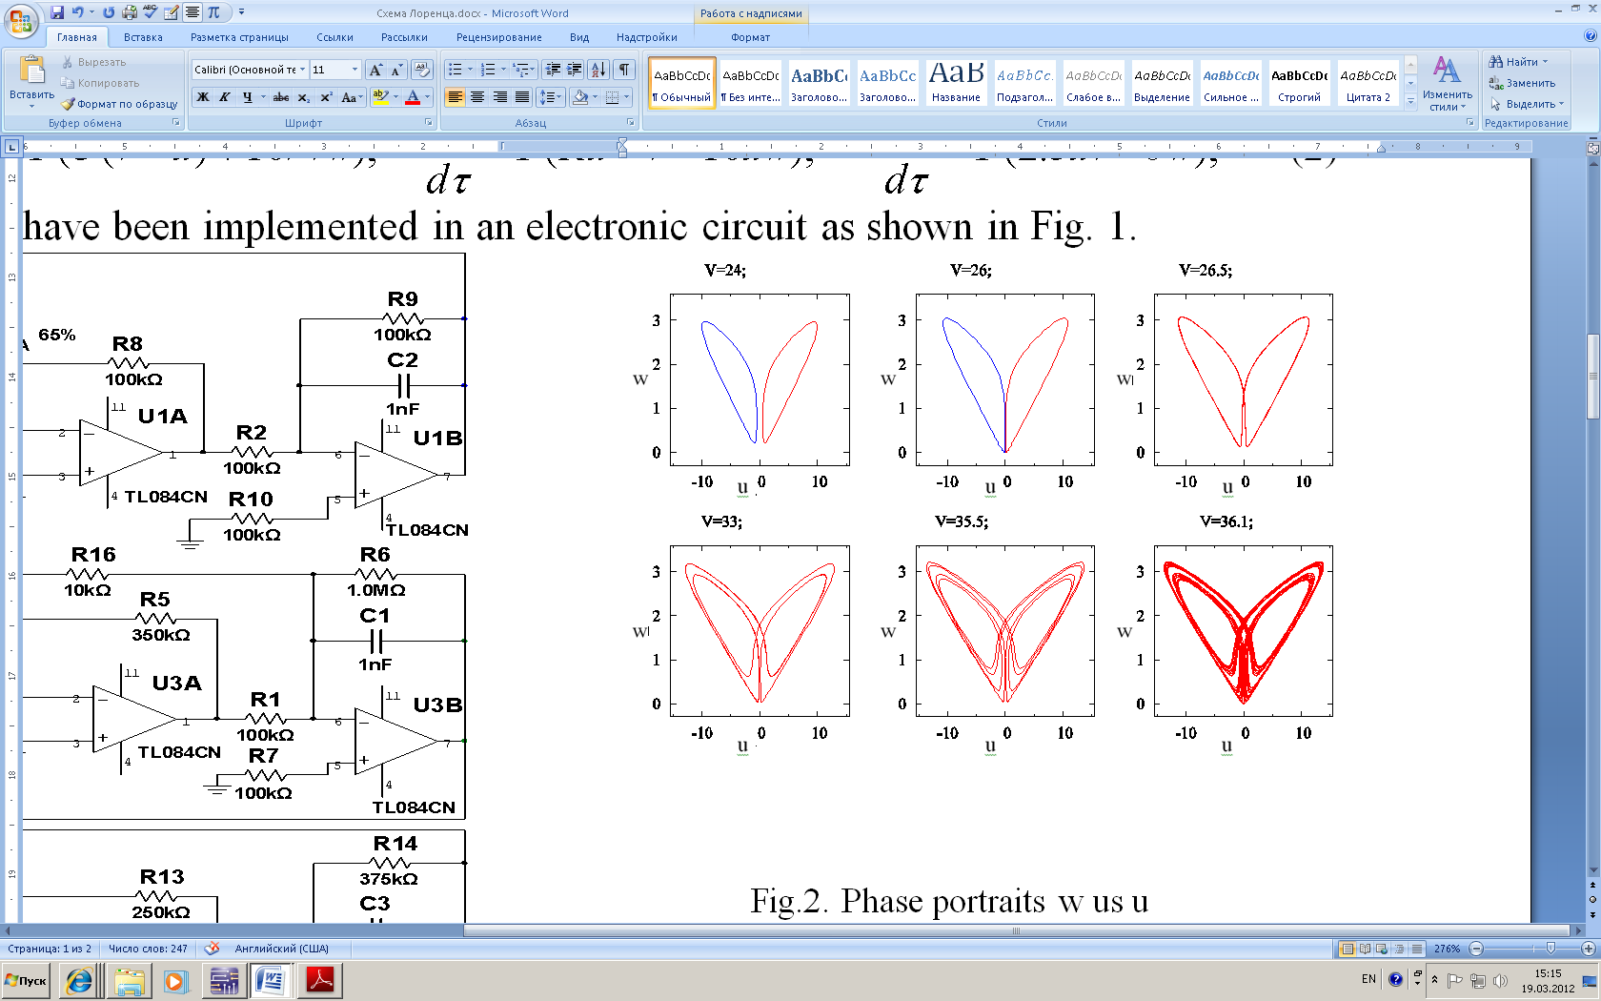 Fig.2. Phase portraits w us u

In this case parameters of equations (2) is , ,  The parameter V is varied. At small V the system is stable. At V = 21 oscillations appear and at V = 26.183 they are glued to each other. (This is a homoclinic bifurcation, "gluing").

These fact are shown in Fig.2.

The theoretical results completely correspond to the experimental data.

References:

1. M. A. Zaks. Scaling properties and renormalization invariants for the "homoclinic quasiperiodicity"// Physica D 62 (1993) 300-316.