IRSTI 19.21.07

¹Shyngyssova N.T., ²Ospanova Zh.O.

¹Doctor of Philological science, Prof., the head of the Department of UNESCO, International Journalism and Media in Society,
Al-Farabi Kazakh National University, Kazakhstan, Almaty,
e-mail: nazgul.shyngyssova@gmail.com;
²master, Al-Farabi Kazakh National University, Kazakhstan, Almaty,
e-mail: 363695@mail.ru

Comparative performance analysis of VTR and CTR in digital video advertising

The PR market is gaining momentum every day, and specialists in this field use new technological solutions for greater productivity. Modern PR in practice gradually goes online with the target audience. But PR and marketing as a science do not keep pace with modern realities in assessing the effectiveness of certain technological tools. Subsequently, often new untested tools lead to a loss of traffic and budget. This is what makes the goal of the study evaluating the effectiveness of advertising in digital environment relevant and significant in practice in comparison with the classical tools of PR-technologies.
This article provides a comparative analysis of the effectiveness of VTR (viewability) and CTR (clickability) in digital video advertising. Video advertising on the modern Internet and Smart TV is a frequent phenomenon and at this time is considered one of the most effective types of online advertising. Advertising companies and customers use CTR to a greater degree and focus on greater click-throughness of advertising. But the visibility and the moment of the effect of advertising remain outside the attention of customers and customer-oriented marketers.
According to the analysis carried out, video advertising turned out to be more effective in the context of public relations and image than direct sales and marketing. The article also reveals the new side and analyzes the effectiveness of video advertising on CTR and VTR indicators, also provides statistical data for visual comparison.
Analysis, methodology and conclusions of this work are relevant, they make a significant contribution to the effectiveness of the work of specialists in the field of PR and marketing, and can also serve as educational material in the training of new specialists.
Key words: video advertising performance, VTR, CTR, digital, image, PR, marketing.

¹Шынгысова Н.Т., ²Оспанова Ж.О.

¹д.ф.н., проф., зав. каф. ЮНЕСКО, международной журналистики и медиа в обществе,
Казахский Национальный Университет им. аль-Фараби, Казахстан, г. Алматы,
e-mail: nazgul.shyngyssova@gmail.com;
²магистр, Казахский Национальный Университет им. аль-Фараби, Казахстан, г. Алматы,
e-mail: 363695@mail.ru

Сравнительный анализ эффективности VTR и СTR в диджитал видеорекламе

Рынок PR набирает обороты с каждым днем, и специалисты в данной сфере используют новые технологические решения для большей продуктивности. Современный PR в практике постепенно переходит в онлайн вместе с целевой аудиторией. Но PR и маркетинг как наука не успевают за современными реалиями в оценке эффективности тех или иных технологических инструментов. В последствии часто новые непроверенные инструменты приводят к потере трафика и бюджета. Это и делает цель исследования оценки эффективности рекламы в диджитал среде актуальной и значимой в практике в сравнении с классическими инструментами PR-технологий.
В данной статье приводится сравнительный анализ эффективности VTR (досматриваемость) и CTR (кликабельность) в диджитал видеорекламе. Видеореклама на современных просторах интернета и Smart TV частое явление и на данное время считается одним из эффективнейших видов онлайн-рекламы. Рекламные компании и заказчики в большей степени используют CTR и ориентируются на большую кликабельность рекламы. Но досматриваемость и момент эффекта рекламы остаются вне внимания заказчиков и клиенториентированных маркетологов.
Согласно проведенному анализу видеореклама оказалась более эффективной в контексте связей с общественностью и имиджа, чем прямых продаж и маркетинга. В статье также раскрываются с новой стороны и проанализированы оценка эффективности видеорекламы по CTR и VTR показателям, также приведены статистические данные для наглядного сравнения.
Анализ, методология и выводы данной работы – актуальны, несут значимый вклад в эффективность работы специалистов в сфере PR и маркетинга, а также могут служить учебным материалом в подготовке новых специалистов.
Ключевые слова: эффективность видеорекламы, VTR, CTR, диджитал, имидж, PR, маркетинг.

¹Шыңғысова Н.Т., ²Оспанова Ж.О.

¹ф.ғ.д., проф., ЮНЕСКО, халықаралық журналистика және қоғамдық медиа каф. меңгерушісі,
әл-Фараби атындағы Қазақ Ұлттық университеті, Қазақстан, Алматы қ.
E-mail: nazgul.shyngyssova@gmail.com;
²магистр, әл-Фараби атындағы Қазақ Ұлттық университеті, Қазақстан, Алматы қ.
E-mail: 363695@mail.ru

Диджитал видеожарнамадағы VTR және СTR тиімділігін салыстырмалы талдау

PR нарығы күн сайын қарқынды дамып келеді және бұл саладағы мамандар өнімділікті арттыру үшін жаңа технологиялық шешімдерге жүгінеді. Қазіргі PR-қызметі мақсатты аудиториясымен бірге біртіндеп онлайн кеңістікке ауысуда. Алайда PR мен маркетинг ғылым ретінде технологиялық құралдардың тиімділігін бағалауда қазіргі тәжірибедегі үрдіске ілесе алмауда. Осының салдарынан жаңа тексерілмеген құралдар трафик пен бюджетті жоғалтуға алып келеді. Бұл диджитал саласындағы жарнама тиімділігін бағалауды зерттеудің мақсатын PR-технологиялардың классикалық құралдарымен салыстырғанда тәжірибелік тұрғыда өзекті және маңызды етеді.
Бұл мақалада диджитал видеожарнамадағы VTR (аяғына дейін көру) және CTR (кликабельділік) тиімділігінің салыстырмалы талдауы келтірілген. Қазіргі заманғы ғаламтор және Smart TV кеңістігінде видеожарнама жиі кездеседі және қазіргі уақытта онлайн-жарнаманың тиімді түрлерінің бірі болып саналады. Жарнама компаниялары мен тапсырыс берушілер көбінесе CTR-ды пайдаланады және жарнаманың кликабельділігі бағдарланады. Бірақ жарнаманың аяғына дейін көрілуі мен тимділігі тапсырыс берушілер мен клиентке бағытталған маркетологтар назарынан тыс қалады.
Видеожарнамаға жүргізілген талдауға сәйкес бұл құрал тікелей сатылымдар мен маркетингке қарағанда қоғаммен байланыс және имидж контекстінде неғұрлым тиімді болып шықты. Мақалада сондай-ақ CTR және VTR көрсеткіштері бойынша видеожарнаманың тиімділігін бағалау жаңа қырынан ашылды және талданды, сондай-ақ көрнекі салыстыру үшін статистикалық деректер келтірілді.
Бұл жұмыстың талдауы, методологиясы және қорытындылары өзекті, PR және маркетинг саласындағы мамандардың жұмыс тиімділігіне елеулі үлес қосады, сондай-ақ жаңа мамандарды дайындауда оқу материалы бола алады.
Түйін сөздер: VTR, CTR, диджитал, имидж, PR, маркетинг.

Introduction.

In the modern world, where everything changes every minute, when technologies emerge with the help of which we can reach our target audience without leaving home, PR has acquired a completely new look. PR is now more important than at any other time. Companies open entire PR departments, marketing and PR today at the same level, but the role of PR is relatively increasing. PR is not a temporary trend, but a new social science. PR is the science of relations between subject and society. Sarah Tomley writes in the book “The sociology book” “Sociality is the spirit of the XXI century, the century of technology and the transience of time” (Tomley S., Hobbs M., Todd M. Weeks M., 2015). Every day, PR specialists reveal new ways to influence the target audience, the public. But the basics of public relations remain unchanged and form the basis of new technologies, trends and tools. The basis of PR is the attitude of target public groups (audiences), the basis of marketing - sales (Jefkins F., 1994).
The PR market is gaining momentum every day, and specialists in this field use new technological solutions for greater productivity. Modern PR in practice gradually goes online with the target audience. But PR and marketing as a science do not keep pace with modern realities in assessing the effectiveness of certain technological tools. Subsequently, often new untested tools lead to a loss of traffic and budget. This is what makes the goal of the study evaluating the effectiveness of advertising in digital environment relevant and significant in practice in comparison with the classical tools of PR-technologies.
This article provides a comparative analysis of the effectiveness of VTR (screening) and CTR (clickability) in digital video advertising.
What is VTR and CTR? Why do we examine their effectiveness?
VTR is an indicator based on the number of views before the end of the video to the total number of impressions, and CTR is the indicator of the number of clicks to the shows. There are also many other indicators for evaluating advertising effectiveness, such as CPM, CPI, CPT, CPA, etc. But research is conducted in the context of PR, VTR is more effective in this direction, and CTR is the most popular and most common unit of measurement (DMM., 2018).
Video advertising on the modern Internet and smart TV is a frequent phenomenon and at this time is considered one of the most effective types of online advertising (Mowat J., 2018). Advertising companies and customers use CTR to a greater degree and focus on greater click-throughness of advertising. But the visibility and the moment of the effect of advertising remain outside the attention of customers and customer-oriented marketers.
The purpose of this study is to analyze the performance indicators of the effectiveness of VTR and CTR of a technologically advanced tool such as digital video advertising that is widespread in marketing, and to prove the most effective video advertising in terms of image and PR using data analysis.
In this work, we use the following qualitative and quantitative research methods to collect information and materials: a focus group method, an online and offline survey method, a survey method. The method of focus groups was chosen specifically to identify key aspects, highlighting issues that reveal the essence of the project. Focus group is determined by the method of questioning. After they are presented with a project presentation, a discussion is held on this topic, questions are asked and answers are found. The first-year undergraduates of the faculty of journalism of Al-Farabi Kazakh National University, more precisely, students of specialties of PR, international journalism, general journalism, publishing and design take part in the method of focus groups, questioning and offline polling. The online survey method on the SurveyMonkey.com platform involves everyone from the city of Almaty in an amount of not more than 100 respondents.
According to the analysis carried out, video advertising turned out to be more effective in the context of public relations and image than direct sales and marketing. The article also reveals the new side and analyzes the effectiveness of video advertising on CTR and VTR indicators, also provides statistical data for visual comparison.
The analysis, methodology and conclusions of this work are relevant, they make a significant contribution to the effectiveness of the work of specialists in the field of PR and marketing, and can also serve as educational material in the training of new specialists.

Research Questions

Determining the objectives of the study is a priority in this article, since it focuses on a narrower and clearer goal - to evaluate the effectiveness of VTR and CTR video advertising. In this study, we set the tasks in the form of questions that will look for an answer. In the article we consider the following questions:
RQ1: What are the View-through rates, by what factors is it more effective than the traditional Click-through rates in general?
RQ2: For what purpose it is advisable to use video advertising: image, PR or direct sales, marketing?
RQ3: How productive is the use of VTR or CTR of evaluation indicators in digital video advertising in PR campaigns?

Literature review

Online video is the trend of recent years, along with the growth of mobile traffic. These topics affect virtually every industry conference and every market review. We see how the share of online video in clients' splits is growing from year to year, this is especially relevant against the background of falling television views and annual inflation on TV (Kataria A., 2018).
In this matter, it is impossible not to note the insight of social. networks that, just after catching the breath of wind, immediately changed their profile - a kind of chameleon effect. Now they are no longer just about pictures of friends in the news feed - they are competing with the largest video platforms for their piece of video advertising pie. There was a whole galaxy of out-stream video networks, which are also not far behind in the hunt for promising advertising budgets (Social Media Today, 2017).
Many traditional TV advertisers have thought about reshaping their modality, increasing investment in online video. This bold decision somewhat outpaced market realities - the question of assessing the effectiveness of online video is still relevant (Camp N., 2014). There are still rhetorical questions in the market in the spirit of “Is online video as effective as TV?” As long as this question is not closed, the current market situation looks like trust in advance. A rather precarious situation, therefore, in the interests of all participants, it is important to continuously work on the transparency of the audit, improving the approaches to the assessment and increasing the effectiveness of this channel (Cossa.ru, 2018).
One of the key problems of online video is a lack of understanding of the channel specifics. It is easy to get lost in all these terms, the abundance of platforms and formats, procurement models, show mechanics.
The video on the Internet is only two or three seconds to interest the user. We live in an era of content consumption in the style of Tinder and Snapchat. Here the issue of clinging content is as sharp as possible, because the user can either skip the video or not. It is very important that the creative takes into account precisely these moments, and not the festival ambitions of its creators.
The model of content consumption in social networks is somewhat different from the model of content consumption in video hosting sites, where people purposefully come to watch the video.
Important point: in the social. Network viewing in reports is called a three-second view. The very three seconds for which the user decides whether to watch a video or not. Of those three seconds, after watching which, with a 90% probability, the video will be oversubscribed by more than 50% of users.
It is very important on the part of analysts and decision-making media managers to look at more detailed statistics on inspections, in quartiles or seconds, and recalculate the CPV for that viewing duration, which is designed for maximum effectiveness of the video. We'll talk about how to determine effective viewing below, but for now let's fix - viewing three seconds is not equivalent to effective contact, for three seconds the user passively expresses his attitude to the creative, and, if he has not hooked it, it means that the show is idle.
While we are still living in that time frame when online video remains a powerful trend, I would like to talk about how to approach the assessment of the quality of platforms at the stage of strategy development and recommendations for media split.
Evaluation of the quality of advertising material provides an understanding of how you can improve the quality of advertising appeal: its content, form of presentation, placement (point of contact with the consumer). Usually such an assessment is made in the complex of communicative performance.
On this topic there are no research papers, scientific works. The topic is also rarely present on the Internet. About what VTR is and what functions it performs the basic information is present in the application instructions on functional sites specifically designed for targeting and remarketing such as Google Adwords, Yandex Direct, Facebook Business account (often for Instagram promotion), and Youtube video advertising. According to google support View through Rate (VTR) VTR = Complete views (not skipped) / Impressions ’(Google Sluzhba Subderzhki, 2014). The difficulty in determining the economic effect achieved through the use of advertising, is that the full effect of any campaign, as a rule, does not occur immediately. As well as an increase in turnover, (and hence profits) during promotional events sometimes occurs for reasons not related to the holding of these actions. It is the second commercial component that causes the most controversy in the methods of evaluation, because it must be measured in numbers and show the effectiveness of the costs of promotion.
VTR (view-through rate) is an indicator of the attractiveness of advertising on sites. The analysis includes directly the format and content (message). Measured using the number of impressions and views (Wikipedia, 2015).
In Kazakhstan, the effectiveness of VTR is promoted by the marketer, Vitaly Savkov. He claims, that the easiest way to learn VTR is to install a special counter on the pages. It allows you to get information about the attendance of the donor site and the directly promoted resource (GRP.kz, 2016).
In the first case, such data may be provided:
• layout, charts, graphs;
• the number of impressions and clicks on the ad (usually grouped by any basis: days, method of publication, specific materials, etc.);
• CTR;
• information about users (contacts, survey results, registrations, IP addresses) (Walter E., 2014).
As for the second situation, instead of counters, you can use hosting logs to analyze the advertised resource. However, this will require appropriate software.
In total, there are three main parameters that are involved in the analysis:
• marketing - take into account the results of the promotion, the quality of the campaign;
• organizational - compliance of the planned activities with the current promotion scheme (if any), as well as the general activity of the company;
• economic - evaluation of financial performance (Hensley D., 2013).
These factors are analyzed at the time of the advertising campaign. Specialists engaged in promotion, monitor the situation, identify strengths and weaknesses. As a result, you can edit, supplement the marketing process or remove some items from it that have not shown a positive result.
When selecting a site for placing an ad, it is worth analyzing: attendance, pricing, number and reputation of partners. Thus, you can select a suitable resource where the planned advertising campaign will be successfully implemented (Jarboe G., 2009).
VTR calculation algorithm:
For this it is important to define three concepts:
• show - demonstration of ads on the site. The user simply notices him with a glance, takes no action;
• viewing - the visitor was attracted by the content of the advertisement, he became interested, put the mouse cursor on a video, photo or link (depending on the content placed) and kept it there for at least 2 seconds. As a rule, this is due to effective calls to action;
• transition - a person clicked on an ad and got to the advertiser's site. Transitions are the purpose of publishing on partner resources (Robot.txt., 2017).
Directly VTR is calculated as the ratio of the number of views to shows, multiplied by 100%. The resulting value will allow to judge the attractiveness of the ad, its effectiveness, the need for changes (The Online Advertising Guide, 2017).

Materials and research methods

The impact of promotions on a person and on the motive of his purchases, the assessment of attracting his attention, memorability of advertising, etc. shows the communicative effectiveness of advertising. In this study, both qualitative and quantitative research methods were applied. Qualitative research, including in-depth interviews with specialists in the field of marketing (3), PR (3), especially with specialists of digital and video advertising (5). The interview focused, firstly, on how video ads are affected, what result it gives to advertisers at the exit. Secondly, what indicators do they focus on when evaluating the effectiveness of video advertising, how often they use VTR and CTR indicators. According to the interviews, marketers were completely focused on CTR, and not very often on CPA. VTR was met in their reports, but mostly only because of the Google Adwords, Youtube toolkit. In fact, the VTR is not analyzed by the main number of marketers. An interesting indicator was that PR-specialists also rarely used look-out indicators and other tools besides CTR and CPA. Experts in video advertising claim that the first indicator on which you need to focus is viewing. Youtube for 2019 ranks first in relevance in Kazakhstan. And it offers promotional tools like ‘True view Discovery’, True view for Action ’, True view In-stream’, ‘Bumper Ads’ (Scott M., Goeldi A., Daum K., Hein B., 2012). Online companies have the opportunity to use True View for Action, it is profitable for them to pay for the target action that the target audience performs. But as the experience of video marketing-oriented marketing has shown: the target action is performed mainly by those who watched the commercial to the end. It is also more efficient to convert a commercial through Bumper Ads to those who watched the video. For the target audience, it will be like an echo effect. Behavioral targeting or remarketing involves using watched videos, that is, VTR scores (Wooshi help learning Center, 2014). Before offering a targeted action, the advertisement should tell about the product, try to interest the consumer, and only after that can she offer targeted action. This means that the evaluation of the audience’s interest is paramount. The longer the video, the easier it is to make contact and get more memorable. A long viewed video gives more results than a lot of short and intrusive videos in the context of trust. CTR in this respect is losing efficiency, since many sources of advertising offer to click on advertising and it will disappear, there are also special sites that collect clicks from bots. The problematics of bots, children's audiences and irrelevant audiences makes CTR assessment indicators practically ineffective. Over 90% of clicks are not relevant. Statistical studies by ‘Imperva incapsula’ showed that ‘In 2016, more than 50% of the traffic generated bots’. In 2017, according to this company, advertisers also lost $ 7.2 billion due to fake traffic (Incapsula, 2017).

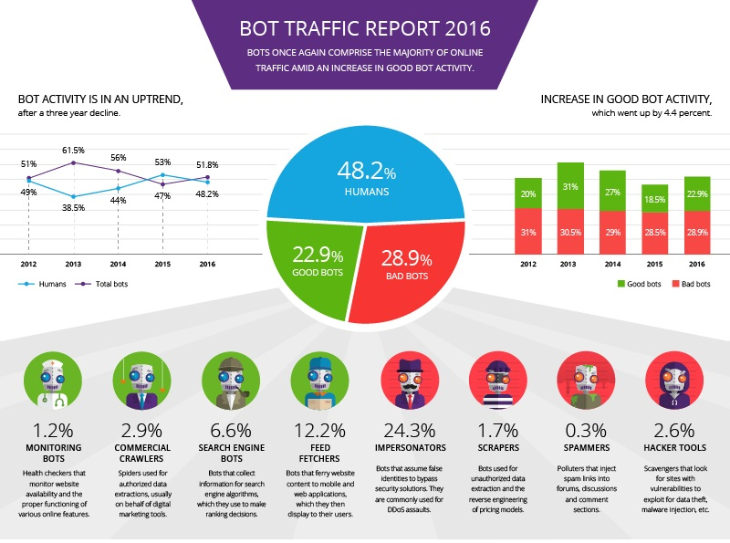
Table 1. Statistics ‘Imperva incapsula’ for 2016 (Incapsula, 2017а).

Video ads rated by CTR indicators mainly attract false traffic, bots. The VTR indicator is also used to solve this problem. A long video rating of viewing is not profitable for traffic and price for bots (Elektronnaya biblioteka KiberLeninka, 2015).
Using the focus group method, we analyzed our data after in-depth interviews with specialists. The focus group discussed each research question and the results of quantitative research methods. When discussing, we tried to give rather equal attention to CTR and VTR. The focus group drew attention in this regard to the fact that both performance indicators are not sufficiently effective separately. If we use only VTR or CTR indicators, we will not get the full picture. Interesting fact: 80% of prestigious advertising does not give the effect of increasing profits. But companies go to these costs to prevent losses and maintain a favorable market situation, as well as for the sake of the prestige of the company and its products. Using the obtained technical data, it is possible to calculate 3 main generally accepted indicators that provide information about the effectiveness of Internet advertising:
CTR (Climate-Through Rate) - clickability or visitor response to advertising is the main indicator of the effectiveness of Internet advertising.
CTV (Cliques-To-Buy rating) - conversion rate - reflects the transition of visitors to customers.
CTI (Climate-To-Internet) - an indicator of the number of interested visitors who scrolled through several pages of the site, or returned again, remembered the address of the site.
CTR depends on the type of presentation of advertising appeal and the circumstances of its display. CTB and CTI depend only on the advertiser's site (Strike Social, 2017).

Results

OLV - video advertising before showing the main video.
The basic principles of OLV that we identified during the focus group are:
1. The video should be promoted on the site, which focuses on the video.
2. The roller should move in areas with high potential for coverage.
3. The video should be visible (viewability).
4. The video should be audible.
The first two points are suitable for the initial stage of screening and drawing up a long list of relevant platforms for placement.
As for visibility and hearing, these are the main indicators of the quality of contact with the roller, which help us to determine which platform suits us most accurately and which does not. It is these two indicators that are key elements of the success of TV and it is the loss of audibility from OLV that raises the question of the ability to fully replace TV with OLV (Weynand D. Piccin V., 2016).
These two indicators (visibility and audibility) relate directly to media efficiency and it is worth looking at them at the stage of drawing up a short list of platforms for placing and identifying a key partner. Here, the accumulated data of independent audit systems (market and agency benchmarks) and internal data of platforms help.
But the media strategy is like a headless horseman: it lacks the most important thing - creativity.
An indicator of user engagement is added to the four principles of media strategy, which in online video is called VTR (View-through rate) (Rouhiainen L., 2013).
Examination (VTR), not clickability (CTR), is an indicator of the quality of creativity. Displays the level of user interest in the content of the video.
So, the principles of the 360 ​​° OLV-strategy.
1. The video should be promoted on the site, which focuses on the video.
2. The roller should move in areas with high potential for coverage.
3. The video should be visible (viewability).
4. The video should be audible.
5. The video must be engaging (VTR).
The first stage of the strategy without changes is the compilation of a long list of platforms for placement based on the first two points. But the second stage will cover in more detail.
The first thing to do in the second stage is to assign the weight (value) of each of the three indicators.
Weight indicators directly related to the commercial. If the timing of a video is 5–6 seconds, then its weight is VTR (full viewing) will be lower than that of a video with a timing of 30 seconds, since the visibility of a short video is higher than that of a long one. Accordingly, the value of watching a long clip than a short one.
There are different variations of the VTR definition for weighing. It depends on marketing goals.
If in the 30-second video a brand appears for the first time only at the 15th second, and the marketing KPI of the campaign is Brand Awareness, then it makes sense to weigh the VTR 50% (inspection to the middle of the video), and not the VTR 100% (full view).

Table 2. The results of the experiment-survey on the inspection of various types of videos and on the memorability of the video, brand, key message.
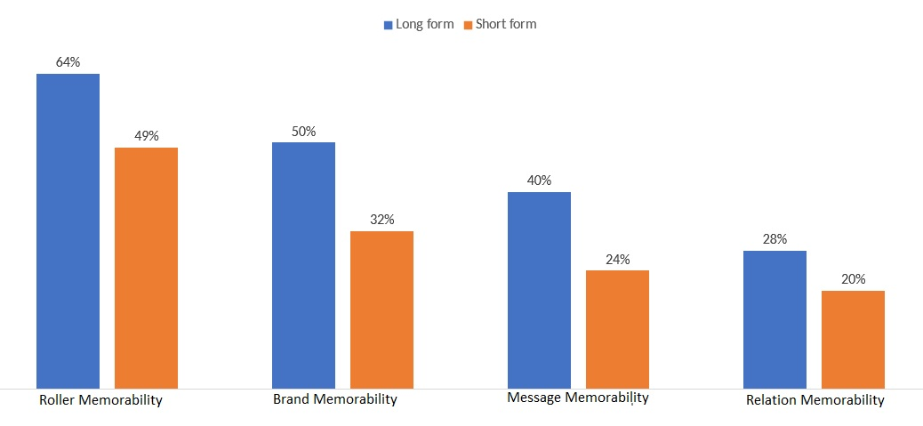
Another example: if the goal of a campaign is to increase the readability of a message, so that the audience has a certain brand image postponed in the head, and this message is embedded in a 30-second clip from the 15th to the 22nd second, then you should weigh the VTR 75% (view video).

Conclusion

Many clients like large numbers in the “coverage” column, so very often sites get to their media splits for OLV only due to the potential of coverage. If we delve a little into the quality assessment of such coverage, then it can be understood that most of the coverage is actually a dummy, not literally, but figuratively.
Impressions occur, coverage increases, but there is no exhaust from such coverage, because coverage and frequency are increased on platforms that do not correspond to the content consumption model of users, and very often a feature of such platforms is the inability to use all patterns of people's perception of information.
Therefore, it is very important to take a serious approach to analyzing the compliance of the set marketing objectives, features of creativity and specific features of the platforms for placement of the video. The average in the market from 19% to 30%.
The best way to increase the effectiveness of video advertising is to create the most targeted material in the user's language. But this is almost impossible to achieve due to the complexity and high cost of the high cost of production.
How to improve the effectiveness of video advertising:
• adapt the TV spot for the Internet
• make adjustments to the media plan in real time
• installation of videos with reduced timing - from our practice, the most watched videos were 15 seconds long.
CTR depends on the quality of advertising material and some functions, for example, as Wow-roll-format. Then the video from the usual video turns into something more. In addition, you can turn off the "skip ad" button - then more users who previously missed the ad will click on it. This method also contributes to the improvement of indicators demonstrating the effectiveness of video advertising. Average: 4-5%.

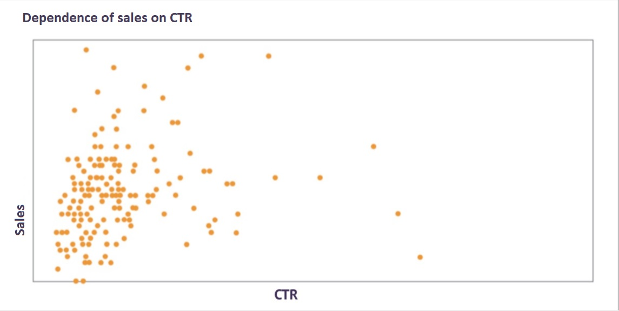
Table 3. Summary of statistical research and survey results (Survey Monkey, 2018)

According to the data we obtained as a result of a survey of marketers based on the results of their latest video advertising campaigns, we deduced that there is no correlation between sales and CTR indicators, although it is accepted that the more clicks, the more sales. Many clicks as we described above are interrelated with bots, fake traffic, child audiences and random clicks.
This figure is traditionally the highest in digital advertising, but you need to remember: not all clicks talk about user involvement. Some people click to skip commercials, and some are just random. Therefore, we do not recommend evaluating the effectiveness of video advertising only by CTR - this is only one of the factors.
To improve the effectiveness of video advertising, it is worth analyzing the results after a change in the call to action. It's about the inscription on the screen "Go to the advertiser's site", which is replaced by a suitable or more relevant call-to-action. This will help increase the number of people involved and truly conscious transitions.

Electronic resources:

Cossa.ru (2018) Kak ne soblaznyatsya ohvatami, a kak schitat realnuyu effektivnost reklamnyih OLV-rolikov. Rezhim dostupa: https://www.cossa.ru/152/220165/
DMM. (2018) View-Through Rate, VTR Calculator and VTR meaning. Rezhim dostupa: https://digitalmediametrics.com/brand/VTR/index.html
Elektronnaya biblioteka KiberLeninka. (2015) Reklamnyiy trafik v internete: problemyi otsenki effektivnosti. Rezhim dostupa: https://cyberleninka.ru/article/n/reklamnyy-trafik-v-internet-problemy-otsenki-effektivnosti
GRP.kz (2016) Kak izmerit effektivnost onlayn videoreklamyi v Kazahstane. Rezhim dostupa: https://grp.kz/effectiveness-of-video-advertising-in-kz/
Incapsula (2017) Bot traffic report 2016. Rezhim dostupa: https://www.incapsula.com/blog/bot-traffic-report-2016.html
Robot.txt. (2017) VTR – eto pokazatel privlekatelnosti reklamyi na saytah. Rezhim dostupa: http://robotstxt.org.ru/wiki/vtr
Sluzhba podderzhki Google. (2014) VTR. Rezhim dostupa: https://support.google.com/authorizedbuyers/answer/2961338?hl=en
Social Media Today. (2017) Why Understanding 'View Through Rate' is Important to your YouTube Ad Campaign. Rezhim dostupa: https://www.socialmediatoday.com/technology-data/why-understanding-view-through-rate-important-your-youtube-ad-campaign
Strike Social. (2017) Understanding your Youtube campaign’s view through rate. Rezhim dostupa: https://strikesocial.com/blog/view-through-rate-youtube-ad-campaign/
Survey Monkey. (2018) Online Survey Platform. Rezhim dostupa: https://surveymonkey.com
The Online Advertising Guide. (2017) View-Through Rates definition. Rezhim dostupa: https://theonlineadvertisingguide.com/glossary/view-through-rate/
Wikipedia. (2015) View Through Rate. Rezhim dostupa: https://ru.wikipedia.org/wiki/View-through_rate
Wooshi help learning Center. (2014) What is view through rate (VTR)? What is good VTR? Rezhim dostupa: https://wooshii.com/help/view-rate-vtr-good-vtr/

References:

Camp N. (2014) The Video Effect: Market Your Business With Effective Online Video ISBN: 8601410645328. Release Date: 2014.
Hensley D. (2013) Click-through rate 28 Success Secrets - What You Need To Know. Release Date: 2013.
Jarboe G. (2009) YouTube and Video Marketing: An Hour a Day, 2nd Edition. Release Date: 2009.
Jefkins F. (1994) Public Relations Techniques. ISBN:9780750615631, Release Date: 1994.
Kataria A. (2018) Google Adwords Secrests. ISBN 9811148686. Release Date: 2018.
Mowat J. (2018) Video Marketing Strategy: Harness the Power of Online Video to Drive Brand Growth - Kindle edition. Release Date: 2018.
Rouhiainen L. (2013) 101 Video Marketing Tips and Strategies for Small Businesses, ISBN: 9781494770020. Release Date: December 2013.
Scott M., Goeldi A., Daum K., Hein B. (2012) Video Marketing For Dummies. Publisher: For Dummies. Release Date: April 2012.
Tomley S., Hobbs M., Todd M. Weeks M. (2015) The Sociology Book: Big Ideas Simply Explained. ISBN: 9780241182291, Release Date: 2016.
Walter E. (2014) The Power of Visual Storytelling: How to Use Visuals, Videos, and Social Media to Market Your Brand, ISBN: 9780071823937. Release Date: 2014.
Weynand D. Piccin V. (2016) How Video Works: From Broadcast to the Cloud 3rd Edition. Release Date: 2016.

