http://atlas.usv.ro/www/codru_net/index.html

Anuar Galiev, Kulipa Baisultanova, Zhanar Yesserkepova, Marzhan Dautbekova, Aliya Isayeva,
Mythologized History and Politics in Post-Soviet Kazakhstan and Kyrgyzstan// Codrul Cosminului. Volume23. Issue 1. July 2017.
View Current Issue (Volume 23, Issue 2, December 2017)

The studies published in volumes No. 10-23 can be found online.

Browse the Archive
Numarul curent (Volumul 23, nr. 2, Decembrie 2017)

Studiile publicate în volumele nr. 10-23 pot fi consultate on-line.

Arhiva
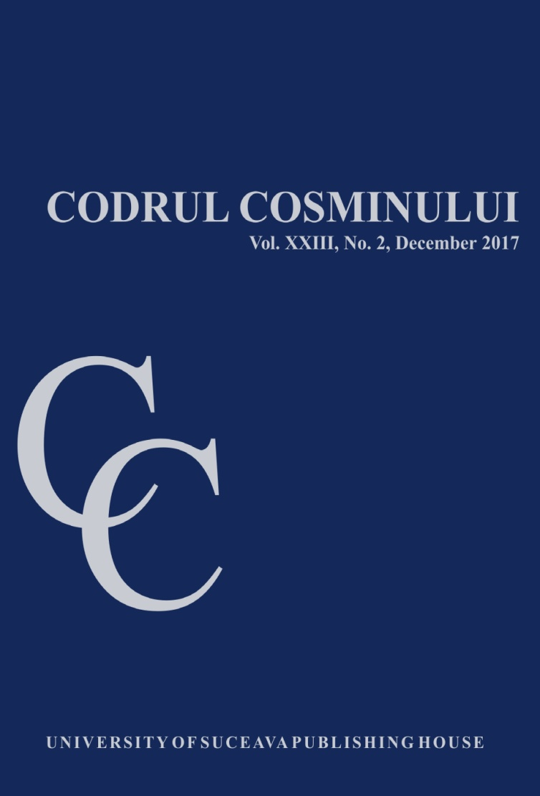
Through science and tolerance,
to cooperation and integration

"Codrul Cosminului" is a bi-annual academic journal that focuses primarily on the results of scientific research inspired by historical and cultural phenomena. Since 1995, it re-engages a tradition on publishing the Chernovcy University journal, that used to appear in the inter-war period (1924-1939). Preserving the practice of ethnic, cultural, and confessional tolerance and cooperation in the former Duchy of Bukovina and promoting the humanistic values, the journal is open to cooperation with representatives from the academic, scientific, and cultural community. Without limiting the scope of research to a certain geographical area or to a certain historical period, "Codrul Cosminului" covers a wide spectrum of approaches, inter- and multidisciplinary aspects of analysis, including developments in analytical methodology, instrumentation and interpretation. It publishes empirical, theoretical and methodological articles.
The Journal welcomes the submission of manuscripts that meet the general criteria of significance and scientific excellence. "Codrul Cosminului" does not accept papers that have been published or are under consideration for publication elsewhere. The editorial staff does not charge any submission or processing fee.

ISSN: 1224-032X
EISSN: 2067-5860

Department of Human, Social and Political Sciences, 2006 - 2017
The journal is indexed in the following international databases:
- Scopus
- ERIH PLUS
- Directory of Open Access Journals
- Index Copernicus International
- Socionet
- MIAR (Information Matrix for the Analysis of Journals)
- UlrichsWeb - Global Serials Directory
- Open Directory Project

Codrul Cosminului has entered into an electronic licensing relationship with EBSCO, the world's most prolific aggregator of full text journals, magazines and other sources. The journal will be found on EBSCO's upgraded database once the collection is complete.
Update : December 30, 2017
C O N T E N T S
CULTURE, IDENTITY AND ELITES
Olha Tarasenko, Kyiv "St. Volodymyr" University School of History: Sketches for a Creative  Portrait of Volodymyr Tsykh (1805-1837) ..................................................................................... | 265
Stepan Borchuk, Ukrainian Encyclopaedic Tradition of the 20th Century ......................................... | 275
Julia Nikolaeva, Natalia Bogoliubova, Vladimir Fokin, Vladimir Baryshnikov, Pavel Klevtsov, Elena Eltc, Cultural Mega-Events as an International, Cultural, and Political Tool ........................... | 293
Iryna Dobrzhanska, From Totalitarian to Democratic Society in the Post-Soviet Space:  Management and Implementation Process of Gender Policy in Ukraine (1991-2017) .......... | 307
SOCIETY, RELIGIONS, CONFLICTS
Volodymyr Velykochyi, Myroslav Voloshchuk, The Catholicization of Pokutia: Ethno-  Confessional and Historical Myth of the Ukrainian Historiography ......................................... | 321
Radu Florian Bruja, The End of the Slovak Army Epic on the Eastern Front and the Change  of the Romanian Strategy towards Bratislava ................................................................................ | 345
Svetlana Pavlovskaya, The Influence of the Ideological Structures of the Red Army  on the Territory of Ukraine upon Romanian Servicemen During the Second World War ..... | 367
POLITICS AND INTERNATIONAL STUDIES
Renata Moish-Shiman, Edvard Beneš’ Demarches concerning Carpathian Ruthenia  and Moscow's Position (September 1939 - June 1941) ................................................................ | 391
Roxana Georgiana Holcă-Nistor, Romania's Position towards the 1967 Arab-Israeli Conflict ...... | 411
İsmail Köse, The Premiere of the Post-Cold War Crisis in Balkans: CIA Documents  on the Disintegration of Former Yugoslavia (1989-1992) ........................................................... | 425
NOTES ON CONTRIBUTORS .................................................................................................................... | 445
INSTRUCTIONS FOR AUTHORS .............................................................................................................. | 449

