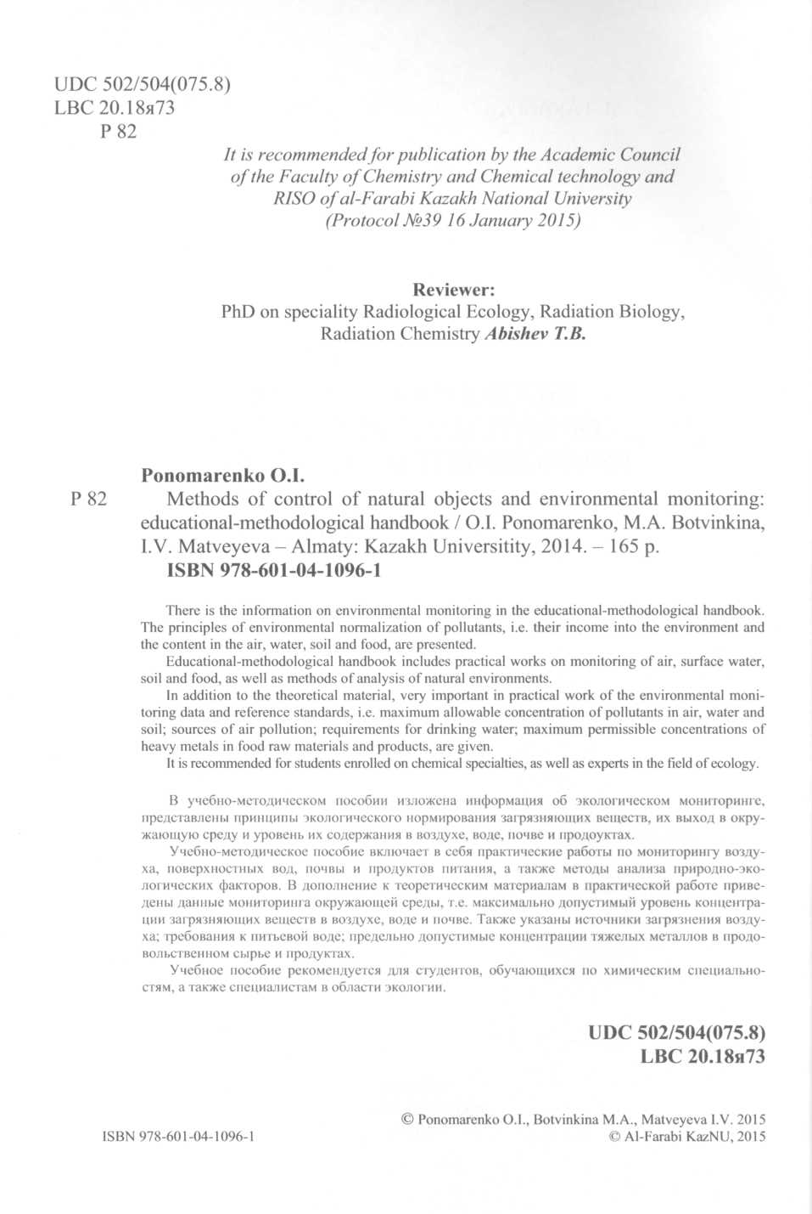

Computer page makeup: K. Umirbekova Cover designer: K. Umirbekova

www.<http://gis-lab.info/docs/osgeo/ru/overview/kosmo_overview.html>