<https://novapublishers.com/shop/advances-in-materials-science-research-volume-47/>

Chapter

# 2-D Photonic Crystals: Rigorous Electromagnetic Models for Infinite, Spatially Limited and Defective Structures

Yuriy Sirenko1,2,[1]*, Seil Sautbekov3,   
Merey Sautbekova4, Kostyantyn Sirenko1,   
Hanna Sliusarenko1 and Nataliya Yashina1

1Department of Diffraction Theory and Diffraction Electronics,   
O. Ya. Usikov Institute for Radiophysics and Electronics,   
Kharkiv, Ukraine

2Department of Applied Mathematics,   
V. N. Karazin Kharkiv National University, Kharkiv, Ukraine

3Department of Physics and Technology,   
Al-Farabi Kazakh National University, Almaty,   
Republic of Kazakhstan

4National Nanotechnological Laboratory of Open Type,  
Al-Farabi Kazakh National University, Almaty,   
Republic of Kazakhstan

## Abstract

New rigorous approaches to the mathematical modeling and electromagnetic analysis of 2-D photonic crystals infinite, limited in space and structures with defects are suggested in the chapter. The approaches are based on the frequency-domain (FD) and time-domain (TD) methods: analytical regularization method and method of exact absorbing conditions. These methods had proved themselves as ones providing accurate and reliable numerical results even for resonant waves scattering and long-duration simulations.

Using developed approaches several actual methodological and physical problems have been solved and presented in the chapter. The results demonstrated the effectiveness of the proposed approaches and considerable potential for further theoretical and practical applications.

In particular, new results have been obtained for the theory of bandgaps and passbands of spatially limited crystals, electromagnetic properties of resonant cavities and basic waveguide components in photonic crystals, energy accumulation in resonant cavities, and radiation effects caused by the backward waves in photonic crystals.

**Keywords**: 2-D photonic crystals, infinite and spatially limited structures, initial boundary value and boundary value electrodynamic problems, exact absorbing conditions method, analytical regularization method, eigenmodes, resonant defects, ultra-wide bandgaps

## 1. Introduction

In 1987, papers [1, 2] were published, which opened, as it is now conventional to say, a new trend in studying periodic structures – 1-D, 2-D and 3-D photonic crystals that are of interest from points of view of both fundamental and applied science due to their property not to transmit electromagnetic waves in certain frequency ranges as well as a number of other unusual properties. This chapter will consider ideal 2-D photonic crystals (infinite dielectric or metal-dielectric structures that are homogeneous in the  direction and periodic in  and  directions) and their analogs, limited in space, whose geometry could be purposefully deformed in certain local areas.

Obtaining reliable numerical results that provide an accurate interpretation and detailed description of *2-D photonic crystals* and their derived components are gaining an increasing interest in modern electromagnetics and wave optics. With conventional approaches [3] one can calculate accurately the isofrequencies of infinite dielectric structures within the selected bandwidth and in coordinates associated with the wave vectors of the eigenwaves as well as the dispersion curves for a finite number of such waves – usually, on line segments, by connecting corner points of the *nonreducible part of Brillouin zone*. The relevant data provide a basis for qualitative and approximate quantitative analysis of finite regular photonic structures oriented to the implementation of the effects of practical interest [3–6]. However, such analysis has usually an advisory or assumptive character and cannot be directly used in practice. It is important for applications that theoretical models provide (via computational experiments) an adequate description of the physics of wave propagation and scattering – in the form of characteristics conventional for numerical simulations; similar to the models of the classic theories of waveguides or gratings.

To be able to solve complicated problems mentioned above, we use the *method of exact absorbing conditions* (EAC-method) [7–18]. It allows us to get reliable information about space-time and space-frequency transformations of the electromagnetic field in parameter ranges where resonant scattering is possible.

In this chapter, within the framework of EAC-method, several specific (but not elementary) problems of 2-D photonic crystals theory are considered. Addressing each of these problems, new physical results have been obtained.

The chapter is structured as follows: after the introduction, in Section 2, we present the analytical regularization method for calculating of eigenmodes of infinite 2-D photonic crystals [19–21]. In Section 3, we briefly describe the EAC-method for electromagnetic analysis of spatially limited structures and structures with defects. In Section 4, we study *bandgaps* (BGs) of limited in thickness and finite photonic crystals [22, 23] and give the examples of solutions to the specific physical problems related to the wave transformation in resonant cavities and waveguide components, to the different radiation effects in the passbands of finite 2-D photonic crystals [22]. Finally, we conclude the chapter in Section 5.

We use the SI system of units for all physical parameters except the time  that is measured in meters,  is the product of the natural time and the velocity of light in vacuum. Dimensions are omitted in the text, but most of the presented results can be easily read both in terms of quantities whose dimensions differ from the accepted ones, and in terms of dimensionless quantities.

## 2. Doubly-Periodic Photonic Crystals: Analysis Of Spectral Problems

The problem discussed in this section has been appeared long time ago in the theory of 2-D and 3-D photonic crystals [3, 24]. It is associated with the convergence or stability convergence violation of computational schemes while implementing the standard algorithms for spectra calculation of free oscillations of electromagnetic field in such periodic structures and spectra of their eigenwaves [24, 25]. We mean the grid technique algorithms in frequency domain, and the so-called ‘*plane wave method’*. The algorithms of the time-domain methods are out of such deficiencies, they permit one to calculate accurately all spectral characteristics of particularly any opened and closed resonant structures (complex eigenfrequencies, configuration and Q-factor of free oscillations of the field) related to the selected finite frequency band [12, 16, 26, 27].

As a reason causing the violation mentioned above can be a lack of smoothness of the function describing the material parameters of the crystals and this phenomenon may be eliminated by increasing the smoothness artificially. Stability and ‘inner’ convergence of the scheme can be recovered at times [25]. However, there is an open-ended question: whether the data, to which the convergence is observed, provide the exact solution of the problem? The point is that the implemented algorithms are conceptually reduced to the substitution of some ‘exact’ infinite homogeneous system of linear algebraic equations  ( – infinite *matrix-function* of the complex spectral parameter ) by their finite-dimensional analogue  and to the solution of the dispersion equation , i.e., to the definition of such values , for which the system  has a nontrivial solution. However, one can guarantee the convergence ,  when  ( is nontrivial solution of the problem  for the value ), as well as the existence of the sequences  and , converging to all exact values  and , only in the case when the matrix-function  has a number of specific properties for mathematical objects like that [28, 29].

We show by a simple example that in the standard approach to the solution of spectral problems for 2-D photonic crystals the corresponding conditions may not be fulfilled. It means that the standard computational schemes are not correct enough and should be regularized. We place the description of one of the possible methods of analytical regularization previously used in the theory of *non-self-adjoint operators* [29] in the final subsection of this section.

### 2.1. Formulation of the Problems

A dielectric structure, which is infinite and homogeneous in  direction but periodic in  and  ones [3,24], is commonly named as 2-D photonic crystal (see, for example, Figure 1:  and  – are the length of the periods of the structure along the axis  and ;  is sufficiently smooth surface, where the material parameters of the wave propagation medium are discontinuous). The electromagnetic waves generated in the structure by quasi-periodic current sources



and propagating here normally to  direction~~~~ are given by the problems [12, 16]



Here,  in the case of *-polarization* (-waves: , , ,  ) and  in the case of *-polarization* (-waves:  , , , ); , , ,  etc. are components of the intensity vectors of electric () and magnetic () field;  is the external current density vector;  is a wavenumber,  is the length of electromagnetic wave in free space;  is a piecewise continuous (in -polarization case) or a piecewise constant (in -polarization case) function of coordinates; functions  and  are the specific conductivity and the relative permittivity of dielectric elements;  is the impedance of free space;  and  are the electric and magnetic vacuum constants;  is the plane ;  and , . The time-dependence of the processes under consideration is determined by the factor . All physical parameters are measured in the SI system. But time  is measured in meters: it is the product of the natural time and the velocity of light in vacuum.

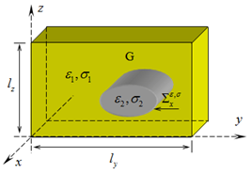

Figure 1.The cross section of one cells of 2-D photonic crystal by two parallel planes .

The orthonormal system of functions  is complete in  [30]. This makes it possible to represent the solution  to the problems by infinite series



Function satisfies the *quasi-periodicity conditions* (two last lines in the problems ). The unknown complex amplitudes  should be chosen so that they satisfy the differential equation of the problems and boundary (on boundary ) conditions imposed on the tangential component of the field that are uniquely determined by the function .

Spectral problems of 2-D photonic crystals theory could be derived from equations suggesting that . When the values  and  are fixed one arrives to the problem of complex eigenfrequencies  and the corresponding free oscillations  of the field in the crystal. When the value of real  is fixed, one arrives to the problem of complex propagation constants  and  of eigenwaves  in crystal. In practice, when one calculates the isofrequencies of periodic structure for the selected bandwidth in the coordinates connected with the wave vectors of eigenwaves or dispersion dependences for finite number of such waves (usually along the boundary segments of nonreducible part of the Brillouin zone), as a rule, one addresses the first of these problems. We will consider this problem below by restricting to one of the possible cases of field polarization, namely, to -polarization case or the case of -waves.

### 2.2. Analysis of Problems and Their Algorithmization

Let us construct the *canonical Green function* of 2-D photonic crystal – the solution to problems for ,  ( is the Dirac delta function) and . Function is the solution of problems only if

.

From equations , and we obtain



(symbol ‘’ stands for complex conjugation). A simple analysis [31, 32] shows that the function



has all properties of the searched Green function for real  and save these properties in the analytical continuation to the complex values of the frequency parameter. Natural boundaries of such a continuation determine the complex plane  as a variation domain of complex eigenfrequencies of 2-D photonic crystals.

Let us consider problems , when function  is bounded in  and  is continuous in  and has continuous partial derivatives over  and . We assume that  as the function of parameter  does not have any singularities in . It is not difficult to show, that, as follows from [32], a function , holomorphic in some region , is defined by the equation



and is extended from the region  to the whole plane  as a *meromorphic function* of the variable . In the part of  where the function  remains holomorphic, it is a solution to problems (2).

Indeed, the fact that the solution  of equation (6), if it exists and is unique, is the solution for problems (2), follows from the properties of the canonical Green’s function (5). Then, from the *complex power theorem* in the integral form formulated for the nontrivial solutions for homogeneous (spectral) problems (2) it follows [19] that when  all the eigenfrequencies of the crystal are located on the real axis, otherwise when the conductivity  is not identically zero then all the eigenfrequencies  of the crystal are located in the lower half-plane of the plane . This means that for any values  on the plane  there are points  where the solution to problems (2) exists and is unique. Compactness of a *finite-meromorphic operator-function*

 (7)

allows us to use the *meromorphic Fredholm theorem* [32–35] in order to prove the conclusion formulated in the previous paragraph.

This conclusion can be generalized to the case of discontinuous of functions  along the curve consisting of a finite number of differentiable arcs [31]: function  and its first partial derivatives remain continuous along this curve, and, consequently, the continuity condition of the tangential components of the electromagnetic field on the surface  holds.

Formally, simplifying the conditions, we assume the poles  of function  are simple. This assumption does not limit us fundamentally. In addition, it can be rigorously proven for all real values  [32]. The poles  form a spectrum  of the eigenfrequencies of the photonic crystal are nothing more than countable set of points  that are not accumulating anywhere in the finite part of the plane , and residues  determine linearly independent free oscillations  of the field corresponding to these frequencies. The last statement follows from Keldysh theorem on the representation of the main part of the resolvent  of operator equation (6) [16, 33]. Here,  is the identity operator and  is the operator-function (7) with values from space  of completely continuous (compact) operators [29]. The number  of free oscillations corresponded to each of the eigenfrequencies  is finite, the coefficients  are determined by the function  and by the choice of the canonical system  of eigenelements of the operator-function  [16, 33].

We determine all eigenfrequencies  and fields  of free oscillations corresponding to these frequencies by solving the operator equation  equivalent to the homogeneous (spectral) problems . The plane wave method permits one to pass to matrix form  of this equation, namely, to perform the following changes



Here,  is the Kronecker symbol; ; ;  is the scalar product in ;  is the space of infinite sequences;  and it is not important what of the possible rules of recalculation of index values  and  by values  and  is used here.

The algorithm of solving the spectral problem is usually based on the inversion of the truncated infinite system of linear algebraic equations

 (8)

the solution  ( is sufficiently large) of the scalar equation

 (9)

is taken as an approximate value .

What can be a reliable enough ground for a justification of such steps? First, let us note the results of [28] that permit one to make the following conclusions. If the conditions

1.  is a holomorphic in some region  matrix-function with the values from ;
2. the sequence of truncated matrices , when  converges properly [28] to infinite matrix  for all ;
3. 

are met, then there exists a sequence ,  such that  when . On the other hand if the conditions (i), (ii) are fulfilled and in (iii) the sequence ,  converges to a point  when , than this point is .

If the *operator-function*  generates a *kernel matrix-function*  () or Koch matrix  [29] in the domain  where it is holomorphic, than there exists a holomorphic function – determinant  – in , which has the following properties [29, 34, 35], that allow one to reason the usage of equation (9) for the derivation of approximate solutions to the spectral problem (8). The order  of eigenvalue  of operator-function coincides with the order of zero for the scalar function  when  Function  when  converges uniformly to  for all . And for all 

 (10)

From equation (10) and relation



obtained by the expansion of the function  into the Taylor series in the vicinity of the point , the estimation of the realistic convergence rate when  for sufficiently large  follows:

 (11)

Which the above results are reliable in the situation, when solving the *spectral problem* ? The operator ,  is a *compact operator*, but requirement (ii) of convergence of truncated matrices  to an infinite matrix , which strict checking seems to us quite problematic, substantially complicates the application of the results [28] that, in general, satisfy our requirements.

Matrix  generated by the operator-function ,  is not the kernel one. The necessary and sufficient condition (the series  converges), related with the finiteness of the *matrix trace for operator* , is not performed. The matrix  cannot be referred to *Koch matrices*  and  [29] are the sufficient conditions). To such a conclusion we arrive by presenting the operator  in the form , where



and

,

or in matrix form

 (12)

One obtains from equations (12) , and as the series  diverges [31] than the series ,  diverge as well.

### 2.3. Regularization of Spectral Problems

Insofar as we are not able to provide the rigorous proof of the stability and convergence of computation scheme based on the solution of the infinite system of linear algebraic equations (8) truncated to the order  But it is evident that  and consequently  is the *Hilbert-Schmidt operator* [29] (). This fact according to [29], arrives to the problem

 (13)

equivalent to problem (8). Here, ,  and, as it follows from the expansion of the value  into the series in powers , . The last equality allows us to state that the operator , corresponding to the matrix , is a kernel operator and generates Koch matrix .

Now we have all necessary grounds for truncating system (13) properly and calculate the approximate values of the eigenfrequencies  of the 2-D photonic crystal by solving the characteristic equation . Note that the repetition of the procedure described above results, according to inequality (11), to the sequences  with convergence rate (to the exact values ) increasing considerably on each step.

Let us finish the analysis with one elementary, but rather illustrative example. Assume that in the system (8) the elements  of the matrix operator  for large enough  and  behave like . This means that the operator  is the Hilbert type operator [36]. It is bounded, but not compact. There is no reason to expect that when reducing the system (8) and solving the dispersion equation (9), we will get the desired result. When the problem is regularized (by transition to the problem (13)), we obtain , and from the estimate of the type (11), one gets . Repeating the regularizing procedure, we get  – the convergence rate of the desired quantities to their exact value increases by two orders of magnitude.

An accurate and complete enough numerical analysis of the real efficiency of algorithms for solving spectral problems for 2-D photonic crystals – standard and regularized – can be performed using a number of special techniques developed for such research. The examples that are describing and implementing these techniques can be found in [37]. In this section, we cannot pay enough attention to this issue due to natural limitations on the volume of published material.

## 3. Spatially Limited 2-D Photonic Crystals: Electromagnetic Models of the Method of Exact Absorbing Conditions

Limited in thickness 2-D photonic crystals are essentially conventional one-dimensional periodic gratings well supplied with advanced electromagnetic theory [13, 14, 32, 38–42] including various methods for solving fundamental and applied problems. A wide variety of interesting physical results, associated mainly with the implementation of various modes of resonant scattering of electromagnetic waves have been obtained and investigated over the past fifty years. There is a reason to believe that for the analysis of photonic crystals limited in space, the most suitable methods are time domain ones and, in particular, the method of the exact absorbing conditions [7–18] which does not distort the physics of processes modeled by mathematical means. This applies to limited in thickness and compact in plane  structures. In this section, we briefly outline the fundamentals of this method.

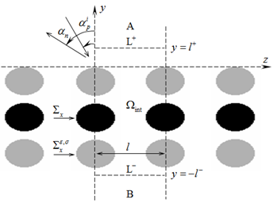

Figure 2. The geometry of model problems (14).

The methods for the analysis of periodic structures using the time-domain formalism are based mainly on standard grid sampling [43, 44] of scalar or vector initial boundary value problems in the volume  representing a limited part of a plane or rectangular in cross section Floquet channel (see Figure 2). This volume includes one period of a grating (the region free of metal), and it is closed from the sides of its reflection and transmission zones by virtual boundaries, where, as a rule, the approximate absorbing conditions are imposed [45–51]. The approximate absorbing conditions can be a possible source of unpredictable errors in calculations when analyzing resonant scattering regimes, i.e., when it is necessary to amplify the ‘observation’ time for converting the results obtained in the time domain to the ordinary amplitude-frequency characteristics. As for the reduction of the original problem to the problem formulated in one Floquet channel, there is a questionable situation connected with ‘oblique incidence’ of the exciting plane pulsed wave. The fact is that an obliquely incident wave at any fixed moment of time, which we would like to call the initial one, will have already ‘covered’ a part of the infinite periodic structure and thus generate a secondary, scattered field. This means that the model initial boundary value problem that describes the process cannot be formulated correctly as its initial conditions are determined by its solution. And manipulations to ‘smooth out’ such contradiction, which is often used, does not change the matter. For this reason, many researchers are restricted to considering only one case – the case of a normal incidence. On the other hand, we adjust the situation radically: we correctly formulate the model initial boundary value problems of the electromagnetic theory of gratings, allowing us by transformation to the frequency range, to determine all the main characteristics of scattering process of monochromatic plane waves incident ‘obliquely’ on a periodic structure. At the same time, we impose the exact absorbing conditions (EACs) on the virtual boundaries in the cross section of the Floquet channel that do not distort the physics of the processes under simulations.

### 3.1. 2-D Models for Infinite Gratings. Time-Domain Representations

Space-time transformations of - and -polarized waves generated by limited in plane  and uniform along the -axis sources near the *one-dimensionally periodic grating* (see Figure 2: structures are uniform along the -axis and periodic with the period  along the -axis) are described by the following scalar problems [14]:

 (14)

Here, ,  in the case of  
*-*polarization and ,  in the case of *-*polarization;  and  are the electric and magnetic field vectors;  are the Cartesian coordinates;  is the extraneous current density vector; the piecewise-constant functions  and  are the specific conductivity and relative permittivity of the grating’s non-magnetic elements;  is the impedance of free space;   
 and  are the electric and magnetic vacuum constants. The surfaces  of perfectly conducting elements of a grating and the surfaces  of discontinuities of its material parameters are assumed to be sufficiently smooth. In case of   
-polarizations, nonzero components of the electromagnetic field lying in the plane  are determined by the expressions

,

and, in the -case, by the expressions



It is known [14] that the *initial boundary value problems* (14) can be formulated such that it is uniquely solvable in the *Sobolev space* , where  is the observation interval*.* Let us suppose that all necessary conditions for the unambiguous solvability of the problems (14) are fulfilled (the *source functions* , , and  are compactly supported in the closure  of the domain , and so on) and discuss the following important question.

The analysis domain  in (14) is the part of the  plane bounded by .  is unbounded, and should be reduced to the numerical solution to problems (14). For this purpose, let us introduce the complex-valued functions , which are the *Fourier images* of the real-valued functions  (,  and ) describing the true sources:

 (15)

From (15) it follows that

 (16)

The use of the *quasiperiodic sources*  together with the superposition principle allows one to restrict the domain of analysis to  (to the part of the *Floquet channel* ). The problems (14) are represented in the following equivalent form:

 (17a)

 (17b)

The problems (17b) are open since the domain  extends to infinity along the -axis. It is a serious obstacle to the use of finite-difference or finite-element methods [43, 44] for numerical solution. On the *virtual boundaries*  and  of the domain  containing all sources and grating’s elements (Figure 2), the field  is formed by *outgoing pulsed waves*. This enable us to replace *open problems* (17b) with the *closed problems* (see [13, 14])

 (18a)

 (18b)

 (18c)

Here and farther, the upper index ‘new’ is omitted. Formulas (18b) and (18c) allow to calculate the field  in the domains  and  from its values on the virtual boundaries . Here,  are the Bessel cylindrical functions and the asterisk ‘’ stands for the complex conjugation. The transverse functions , ,  form a complete orthonormal system in the cross section of Floquet channel . Thus, for ,  and  the following representations for the sought-for field are correct:

 (19)

Here and below, the upper indexes ‘’ and ‘’ correspond respectively to the areas  and . The EACs  are obtained by substituting the values  () and  () into (18b) and (18c).

Suppose all sources are ‘relocated’ from the domain  into the domain , where they generate the *pulsed wave*

 (20)

which is incident to the boundary  at . Then the problems (18) should be rewritten in the form [14]:

 (21a)

 (21b)

 (21c)

Here,

 (22a)

 (22b)

are the secondary field in the reflection and transmission zones of the grating, while the EACs  in (21a) are obtained by substituting the values  and  into (21b) and (21c).

### 3.2. 2-D Models for Infinite Gratings. Frequency-DomainRepresentations

The solution  to the problems

 (23a)

 (23b)

 (23c)

and the solution  to the problems (21) can be connected [16] by the following integral transform

 (24)

Here,  for monochromatic -polarized waves and  for -polarized waves;  is a *complex wavenumber* (frequency parameter or frequency); ; , ,  and  are *vertical and horizontal wavenumbers* for *spatial harmonics* (plane waves)  and  propagating in the domains  and  with attenuation (when ) or without it (when ). According to (24), the time-dependence for monochromatic components of any signal is defined by the factor .

In formulas (23b) and (23c), the terms with complex-valued amplitudes  correspond to the *monochromatic wave*  incident on the boundary , while the terms   
with amplitudes  and  correspond to the *scattered   
(secondary) waves*  and  in  and . If we correlate (22) with (23b) and (23c), it becomes evident that



Consider now frequencies  such that  and  (*physical values of the frequency parameter* ,  is the wavelength). Let also, as previously, a grating (Figure 2) be excited from the domain , but

 (25)

To emphasize such an excitation technique, we replace the subscript ‘’ in the identifiers , , ,  by the double index ‘’.

In the frequency domain, a periodic structure is characterized by the *reflection coefficient*  (coefficient of conversion of the -th incident harmonic into the -th reflected harmonic) and the *transmission coefficient*  (coefficient of conversion of the -th incident harmonic into the -th transmitted harmonic) given by the following formulas:

 (26)

The elements  and  of the *generalized scattering matrices*  and  are related by the *energy balance equations* [12, 14, 32]

 (27)

and by the *reciprocity relations* [12, 14, 32]

 (28)

which are the corollaries from the *Pointing theorem* on complex power and the *Lorentz lemma* [52]. It should be obvious that for excitation from the domain , the generalized scattering matrices  and  are determined in the same way. In (27), we have used the following designations:



Every harmonic



of the field  or , for which  and  (for which , the frequencies  are known as *threshold frequencies or threshold points* [40]), is a homogeneous plane wave propagating away from a grating at the angle  into the reflection zone (), and at the angle  into the transmission zone (). All angles are measured anticlockwise from the -axis in the plane  (Figure 2). For , the angle  is the angle of incidence of the plane wave  to a grating. It is obvious that the propagating direction of each homogeneous harmonic of the secondary field depends on its number , as well as on the values of  and . The angle between the propagation directions of the incident and the ()-th reflected plane wave  is determined from the equation . At  the corresponding harmonic propagates countercurrent to the incident wave. Initiation of the nonspecular reflected mode of this kind is called the *auto-collimation phenomenon*. According to (27), the values

 (29)

determine the relative part of energy lost to absorption and directed by a grating into the relevant spatial harmonic.

If a grating is excited by an inhomogeneous plane wave (), the *near-field to far-field conversion efficiency* is determined by the value of  (see (27)), which in this case is nonnegative and

 (30)

As follows from (28) and the equalities  and , one can study the excitation of a grating by an inhomogeneous plane wave within the context of conventional for the gratings theory diffraction problems: a structure is excited by homogeneous plane wave  and the coefficient of conversion into damped ()-th spatial harmonic  is calculated.

The presented models have two parameters ( and ) which determine the size of the computational domain of grid methods, and, consequently, their efficiency, and, of course, they have an impact on the results of computational experiments. We have to clarify what exactly this impact consists in. This is important for an unambiguous physical interpretation of the results obtained both under the terms of different models and under the terms of one model with different parameters  and .

Let us, for example, consider in detail the following case: a semitransparent grating with fixed virtual boundaries  is excited by a plane homogeneous or inhomogeneous wave . In its reflection ) and transmission () zones, according to (23) and (26), there spatial harmonics have a form

 (31)

We now introduce the virtual boundaries  that the parameters  correspond to. For these boundaries, the fields of the incident wave and space harmonics (31) are as follows: ,



(32)

Representations (31) and (32) correspond to the same physical object, therefore



Hence it follows that when working with homogeneous harmonics  the choice of virtual boundaries affects only the phase’s magnitude of the reflection and transmission coefficients in the corresponded representations for waves  and . In a frequently analyzed case ,  the change in modulus  and  is determined by the factor , and the change in the phase of the quantities  and  – by the factors  and .

### 3.3. 2-D Models for Infinite Gratings. The Case of an ‘Arbitrary Incidence’ of Initial Wave

The main results of the previous subsections are selected, basically, from our books [14, 17]. Without no additional justifications, their properties permit us to solve numerically, pretty fast and with given accuracy almost any problem of the classical electromagnetic theory of gratings, which studies the characteristics of one-dimensional periodic structures (gratings of finite thickness and periodic boundaries between media), placed in a field of ‘obliquely incident’ () homogeneous or inhomogeneous plane waves. Indeed, the geometry and the values of material parameters in model problems (21) being solved numerically by the finite-difference or finite element method, are virtually not limited by anything. The domain of analysis (the computation space of grid methods) in these problems is minimal; conditions imposed on its boundaries are exact. Therefore, the implemented computational schemes (the schemes of the EAC-method) are stable, and the magnitude of their errors is predictable and controlled [18]. The results obtained when solving time-domain problems (21) are easily converted into standard *amplitude-frequency characteristics* ofgratings excited by homogeneous and inhomogeneous plane waves (see Subsection 3.2), including the case when a one-dimensional periodic structure with  and  is excitedby *‘arbitrary incident’ waves* ). In this case, omitting the factor ,  in the field components, instead of (23), we arrive to the following scalar problems:

 (33a)

(33b)

 (33c)

Here,  for monochromatic -polarized waves  and  for -polarized waves ; , ,  and ,  are the vertical and horizontal wavenumbers for spatial harmonics (plane waves) propagating in the domains  and  with attenuation (when ) or without it (when ). In the case of -polarization, nonzero components of the electromagnetic field lying in the plane  are given by the relations



and in the case of -polarization – by the relations



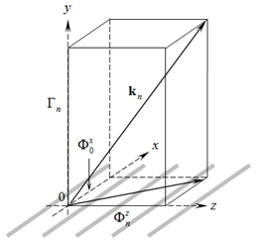

Figure 3. To the definition of the directions of propagation of spatial harmonics of the secondary field for the grating placed in the field of an ‘arbitrarily incident’ plane wave.

It is obvious, the problems (23) and (33) are equivalent up to change of variables ,  and . However, in this case, the rays determining the propagation direction of spatial harmonics  and  of the periodic structure do not belong anymore to the same plane . Every harmonic for which  and  is a homogeneous plane wave propagating away from the grating along the vector  , ,  (in the domain ; see Figure 3) or  (in the domain ). The frequencies  such that  () are known as threshold frequencies or threshold points [40]. At those points, a damped spatial harmonics of order  with  are transformed into a propagating homogeneous pane waves. If  and , the spatial orientation of incidence wave is determined by the vector  , , .

### 3.4. 2-D Models for Finite in Plane Objects

To calculate the electromagnetic characteristics of finite in the plane  crystals and crystals with defects, we suggest a rigorous approach [7, 8, 14, 16, 17] which is based on the solution to the following model initial boundary value problems (see also Figure 4):

 (34)

Basic notation here and below are identical to those we have introduced in previous subsections of this section. Note the following important differences. The computation domain  in (34) is the part of the plane  bounded by the contours  together with the virtual boundaries  (input and output ports in the cross-sections of the virtual waveguides  and ) and rectangular boundary  separating the domain  and the free space domain . The circle  of the radius  and centered on the Cartesian (, ) and polar (, ) coordinates covers all current sources , the scattering inhomogeneities of the region , and is completely contained in it.

The structure is excited by current sources  and/or by a pulsed wave ,  of the plane-parallel waveguide  - or -wave), incident~~~~ on the virtual boundary  at time moments .

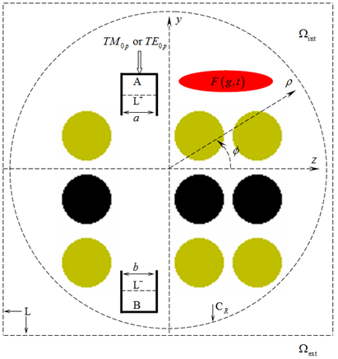

Figure 4. Geometry of the model problems (34), section by plane .

The exact absorbing conditions , , and  for the virtual boundaries provide an ideal model for the outgoing from  into domains ,  and  waves

 (35)

Here,  in the case of -polarization and  in the -case.

Operators ,  and complete orthogonal systems of transverse functions , on the corresponding intervals are defined in [7, 8, 11, 12, 14]. From the solution to the problems (34) we determine the space-time amplitudes ,  for values  and  corresponding to the boundaries  and the circle . The values ,  required for the construction of the radiation pattern of the emitter we obtain from  by using the so called transport operators [12, 16, 17, 53–55]. The transition to the amplitude-frequency characteristics, after solving problem (34) and determining the function  on  and at time moments ,  is performed with the integral transformation (24) (the integral transformation  or ; see details in Subsection 3.2). As a result, the following values are available for the analysis of the physics of processes:

* spatial distribution of values  and other nonzero components of the field , , both at any fixed point in time  and at any finite time interval  in the form of a corresponding dynamic picture (see examples in works [14, 16]);
* space-time amplitudes ,  of pulse waves (35) at virtual boundaries  and  at any finite time interval ;
* ,  and  – three magnitudes describing incident to the structure through the virtual boundary , radiated through this boundary  or through boundary  into the waveguide  or , and radiated into free space  through the virtual boundary  (all within a certain period of time ) energies’ values;
* spatial patterns of the harmonic field  components, 
*  and  – the transformation coefficients of - or -wave coming from the waveguide  through the boundary  to - or -waves reflected into the waveguide  and transmitted to the waveguide ;
*  – the efficiency of transformation of the exciting monochromatic - or -wave into the radiation field;
* , ,  – the normalized radiation pattern calculated along the arc ;
*  – an angle determining the orientation of the main lobe of : ;
*  – the half-power beam width: , , where  and .

Here, , as ever, is a wavenumber (frequency parameter or just frequency),  is a wavelength in free space,  is an upper time limit of the observation interval . For all , the function  undergoing the transformation is set to zero.  is a tangential component of harmonic electric field on the circle ,  is a portion of the energy absorbed in imperfect dielectrics;   is a portion of the energy of - or -wave transmitted (reflected) into the waveguide  (). Values of ,  and  are determined by integrating over  of values of instantaneous powers ‘transferring’ across the corresponding boundaries within the interval  (see, for example, works [16, 17, 56–58]). In the framework of the model problems (34), not only the function  is calculated, but also values of all its components:   and .

## 4. Some Physical Results Obtained by the Method of Exact Absorbing Conditions

In this section we present some physical results obtained by EAC-method concerning such properties of limited in space photonic crystals, which both theorists and applied scientists usually take with interest.

Simple photonic crystal, which was already examined in [3], was chosen as a basis for the analysis of bounded in space structures, structures with a defect, and their modifications. This crystal was constructed of circular dielectric cylinders (, ) whose axes are parallel to the -axis. Intersecting with the planes , the axes of the cylinders give rise to nodes of a rectangular mesh grid, which is infinite in both  and  directions, the grid cell size is  (). The cylinder’s radius is .

### 4.1. Forbidden Zones of Limited in Thickness and Finite Photonic Crystals

Let . From the above photonic crystal, we ‘cut out’ (by planes  the gratings with thickness  (, ) which varies from  to  (see Figure 5), and excite them by normally incident  ultra-wideband - or -polarized pulses

 (36)

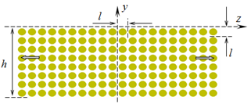

Figure 5. The crystal of finite thickness.

Here,  is the Heaviside step function, parameters  and  set the center frequency of the pulse  and the band  () which it occupies [12, 16], and the parameters  and  correspond to signal  delay time and its duration respectively.

Within the frequency range , the gratings (we shall call them 1-D periodic crystals) operate in single-mode regime [40], i.e., in the domains of reflection and transmission, only principal spatial harmonics (harmonics with ) can propagate without decay. The energy of waves transmitted into the domain  is shown in Figure 6 (-case) and Figure 7 (-case).

The supposed band gaps (BGs) or forbidden zones (frequency bands, where ) are only slightly marked in the case of three-layer crystal (Figure 6). For the four- and five-layer crystals, the BGs contours become clearer and are finally formed for the crystals containing 10 or more layers.

Up to the left border of the first of such zones (limited by the value ), a photonic crystal of finite thickness operates as a homogeneous dielectric layer: it transfers completely a normally incident plane wave on frequencies  corresponding to half-wave resonances along its thickness. The equivalent permittivity of such layer in the case of ten-layer crystal equals approximately to 5.2.

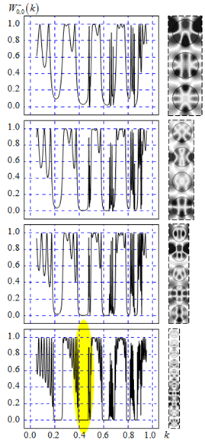

Figure 6. Forbidden zones formation when increasing the crystal thickness.   
-polarization of the field, . On the right – free oscillations in the structures, patterns of , , .

In case of -polarization of the field (see Figure 7), the process of the forbidden zones formation also ends when the number of layers in the periodic structure is up to ten. The frequency bands that occupy these zones partially overlap with the BGs of the normally incident -polarized waves (see Figures 6 and 7).

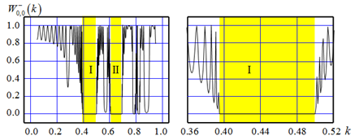

Figure 7. Forbidden zones of the crystal with thickness . The case of -polarization, .

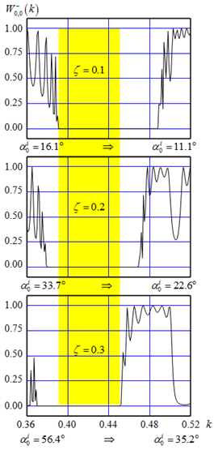

Figure 8. To Figure 7. Drift of bandgap  of the crystal when changing the parameter  (when the angle  of the incidence of -polarized plane wave changes).

For instance, the zone  in -polarization case intersects with the zone  in the -case in the interval (the bandwidth is ). The zone  in -polarization case intersects with the zone  in -case in the interval  (the bandwidth is ).

This computational experiment that is the same as described above, but for -polarized pulse , occupying the band , and for values ,  and , has shown that with increasing , the BG , almost without changing its width, is drifting towards lower values  (Figure 8). The greater value of the angle  at which the wave  comes on the grating (on a crystal limited in thickness) corresponds to the greater value of . Summarizing the information provided in Figures 7 and 8, we can conclude that the crystal with the thickness  does not transmit -polarized waves, which arrive at angles , for all  (the width  of this band is approximately ).

BGs of crystals of finite thickness do not coincide with BGs of 2-D periodic photonic crystals [3] and do not coincide with BGs of finite crystals limited in the -plane and homogeneous in the -direction (Figure 9). The nature of these mismatches can be understood comparing the curves of Figures 10 and 11.

Figure 10 depicts in more details the fragment of Figure 6 marked with an oval (the second BG of 10-layer crystal). In Figure 11, the same frequency band with the same scale is presented for a finite crystal excited by a point source of -polarized waves, the field spectrum is shown at six different observation points  to .

The data presented in Figures 9, 11, and 12 have been obtained from the solution to (34), namely the field  generated by the current pulse , . The point  (central point of the current source) is located in the center of the crystal,  is the source’s radius, and . The parameters of the function  are the same as in (36). After switching off the power at the moment , the field  is formed by a variety of weakly decaying free oscillations corresponding to different eigenfrequencies  ,  [16, 26, 27, 53, 59]. The superposition of these oscillations results in very dynamic changes in the pattern of ; the structure, justifying the name ‘crystal’, creates surprisingly nice lace-like and practically non-repeating patterns (Figure 12).

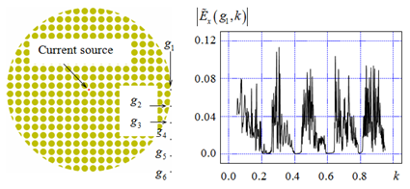

Figure 9. The excitation of the finite crystal by pulsed current. The geometry of the structure and spectral amplitudes of  field component calculated at the observation point .

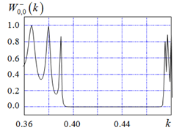

Figure 10. To Figure 6. The second BG of 1-D periodic crystal.

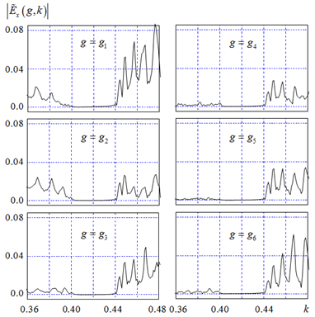

Figure 11. The second BG of finite crystal. Spectral amplitudes of  field component in observation points .

### 4.2. Synthesis of 2-D Photonic Crystals of Finite Thickness with Ultra-Wide BGs

In this subsection we propose and implement in a set of computational experiments a simple approach to solve the problem of synthesis of 2-D photonic crystals of finite thickness with ultra-wide BGs for the plane incident waves. The results are given for the case of normal incidence of -polarized wave; similar structures can be easily synthesized in the case of an arbitrary polarization of the field (where - and -polarized components are present) and under additional requirements concerning the interval of angles of arrival of an obliquely incident wave.

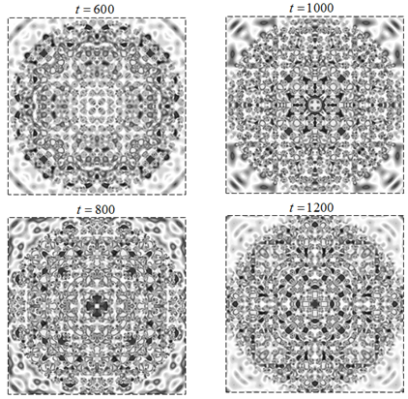

Figure 12. Fields of eigenoscillations in a finite crystal excited by a pulse current . ,  patterns at different times .

Let us excite the five-layer crystal constructed of dielectric rods of the radius  with permittivity varying from  to  by -polarized pulse (36) with  (normal incidence). Further on let us define the three values of  (, , ), providing each corresponding crystal in the single-mode range  with BGs, covering such intervals of frequency range, that if these BGs are put in the same draft all together, they cover without breaks a fairly wide range of the frequency parameter  variation (see three upper fragments in Figure 13). Having constructed a single crystal, containing fifteen layers by means of putting together three blocks of five-layer crystals, we obtain a structure with a BG in the interval , having the width , that is approximately equal to 78.16% (see two lower fragments in Figure 13).

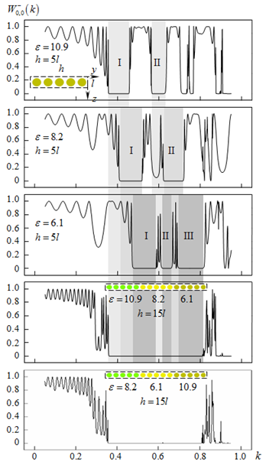

Figure 13. The synergistic effect of the joint operation of the three thick photonic crystals, .

The bandwidth of such BG is practically insensible to the sequence of five-layer crystals blocks in design of new crystal structure consisting of fifteen-layers. A crystal of twelve layers composed of four-layer crystal blocks still does not lose the ability to form a BG of the same width and with acceptable qualitative deviations, but in the case of a nine-layer crystal, the deviations become already essential (Figure 14).

Crystals constructed of four- or five-layer blocks, differing only in the radius of rods also form a wide wave range BG. Figure 15 presents results of the simulations for the synthesized model crystal having the width  of the BG  that is approximately equal to 66.11%.

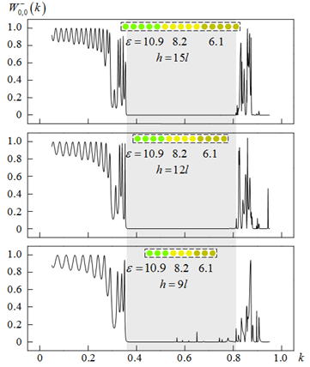

Figure 14. Qualitative changes in the BG of the synthesized crystal with a decrease in number of layers in its constituent parts.

Data presented in Figure 16, bring us a little closer to understanding the physics of the processes, influencing the formation of crystals’ characteristics. This case is similar to the one depicted in three upper fragments of Figure 13. The five-layer crystal with parameters ,  (see third fragment in Figure 13) was excited by a super-narrow Gaussian pulse

 (37)

(the upper fragment in Figure 16) at two center frequencies . The first point  corresponds to  located in the middle of the BG  of the crystal. The second –  – corresponds to the frequency, providing tunneling of the incident energy – the crystal becomes totally transparent for electromagnetic waves. Analysis of the behavior of spatial-temporal amplitude values  and  of pulses , , and patterns  within the computational domain, taken at the moments  for  and  for , arrives to the conclusion [16, 26, 27, 59]:

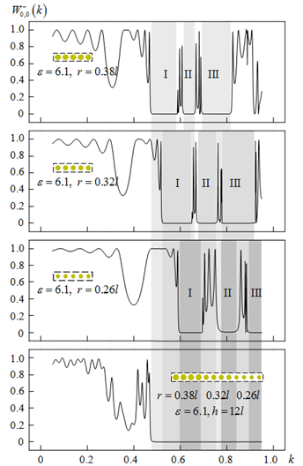

Figure 15. The synergistic effect of the joint operation of three thick photonic crystals: , .

* The effects influencing the formation of crystals’ BGs are not resonant;
* The tunneling effect – the mode of complete transparency – under consideration is associated with the excitation of a low-Q free oscillation in the structure, its field pattern can be seen to the right of lower fragment of Figure 16. The values  and  of complex eigenfrequency , corresponding to this free oscillation, are determined by the characteristics of the pulse  [26, 27].

The results of simulation proved the suggested ideology: BGs of limited in thickness 2-D photonic crystals can be significantly increased due to the synergistic effect of the joint operation of two or three photonic crystals differing only in the internal structure of the crystal’s unit cells.

The method of synthesis of the corresponding structures proposed in this subsection is very simple and easily implemented in almost any reasonably formulated problem. It looks rather promising for efficient and trade-off design and synthesis of different frequency selective devices key structures.

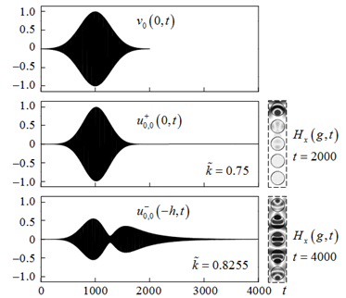

Figure 16. Excitation of a five-layer crystal with parameters ,  by narrowband pulse (37).

### 4.3. Resonant Cavities in Finite Photonic Crystals

Consider a square () finite crystal with a cavity made of 392 dielectric cylinders (Figure 17). The crystal is excited by the current source , , , ,  , , -polarization of the field. The pulse  covers the frequency band  that is completely contained in the second BG of the periodic crystal (see Figure 10) and totally covers the second BG  of the circular ‘compact’ crystal (see Figure 11).

Using the results of [16, 26, 27, 59] and studying the behavior of the spectral amplitudes  of the field ,  at the observation points  to  (Figure 17), we conclude that the cavity could support high-Q free oscillations on complex eigenfrequencies ,  with the real part values ,  and . Then, exciting the cavity by the narrowband Gaussian pulse



(38)

we can determine the field configuration of free oscillations. The source (38) and the observation point  are placed in the antinode of each oscillation. The Q-factors are estimated from the behavior of  within the interval  (regime of free oscillations after the end of excitation, Figure 18).

The oscillations  and , which correspond to the eigenfrequencies  and , have quasi-infinite Q-factor (see Figure 18). This is expected, since the values  and  are located in the BG of the finite crystal. The real part of the eigenfrequency , which corresponds to the oscillation , is outside the BG of the finite crystal. The field intensity of this oscillation first decreases due to radiation losses (Figure 18), and then slightly increases due to coupling with other free oscillations whose field only partially penetrates into the cavity, and eigenfrequencies’ real parts only slightly differ from .

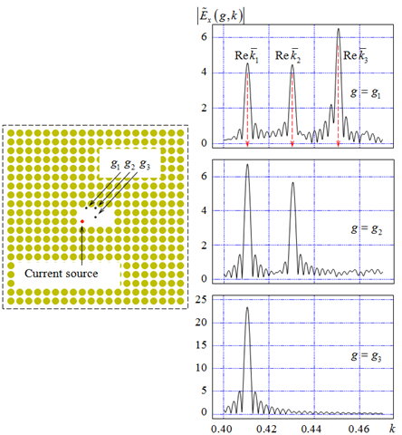

Figure 17. Definition of eigenfrequencies of the resonant cavity in a finite photonic crystal.

Let us now discuss applications of resonant cavities in photonic crystals, namely storage units for electromagnetic energy compressors. Compressors are devices which convert long low-amplitude input pulses into short high-amplitude output pulses. Usually it is achieved by accumulating the input energy in a storage unit for a relatively long time, and then releasing the accumulated energy as a very short high-amplitude pulse [16, 17, 56–58].

As a base for the storage unit, we use the photonic crystal cavity from the previous example and add a feeding waveguide to it. The geometry of the storage unit, the feeding waveguide, the position of a current source, and the observation points are sketched in Figure 19. The source

 (39)

generates, inside the waveguide, quasi-monochromatic -wave. Here,  is a trapezoidal envelope, which is equal to zero when ,  and has unit value when ; ,  is the eigenfrequency of the storage operating oscillation   
(-eigenmode).

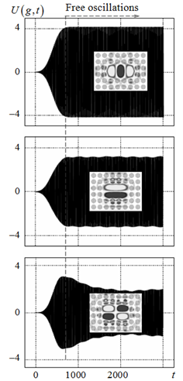

Figure 18. Definition of the field configuration and the Q-factor of eigenoscillations in resonant cavity.

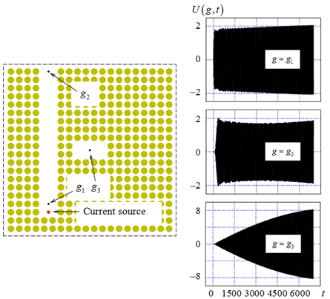

Figure 19. Evaluation of the effectiveness of energy storage in the resonant cavity of finite crystal.

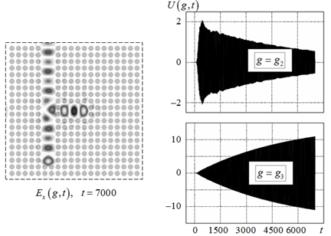

Figure 20. Energy storage with increasing coupling between resonator and power supplying waveguide.

The decrease of the excitation’s field strength on the way from the point  to the point  is mainly caused by the energy takeoff and accumulation in the resonant cavity. The value of  slightly differs from the one defined above (). The reason is a non-zero coupling between the cavity and the waveguide. Accounting for such corrections is crucial. Even a very small deviation of the excitation’s central frequency  from the real part of the eigenfrequency of the operating oscillation  spoils the energy accumulation process: the intervals when the field strength grows in the storage unit are alternated by the intervals of the same duration when the field strength decreases to the initial level. The period of these alterations is inversely proportional to  [16, 57].

The initial configuration has two layers of dielectric cylinders between the cavity and the feeding waveguide (Figure 19). The two-layer barrier appears too thick; it significantly weakens the waveguide-cavity coupling, which results in non-optimal energy accumulation. The efficiency of energy accumulation is rather low in the beginning of the process. It could be seen from almost no difference between  at the point  (near the excitation source) and at point  on the opposite end of the feeding waveguide (Figure 19). Such minor decrease of the amplitude of  at  means that only a small fraction of the input energy is transferred into the cavity. Moreover, the efficiency declines after , note the growing amplitude of  at  for  (Figure 19). At the moment when the excitation is turned off, the amplitude of the oscillation in the cavity ( at ) is only four times larger than the amplitude of excitation.

Removing one layer of the dielectric cylinders between the cavity and the waveguide (Figure 20), we significantly improve the energy accumulation process. The accumulation efficiency remains high throughout the whole duration of excitation, note the continuously descending amplitude of  at . And the field intensity in the storage unit at  is now six times higher than the excitation amplitude and may grow further with a longer excitation. Simulation parameters are almost the same as for the case of Figure 19. The only significant difference is that the central frequency of the excitation is set to . This change is due to the geometry change (one layer of the dielectric cylinders between the waveguide and cavity was removed).

It should be noted that EAC-method allows to obtain with high accuracy both the above-mentioned characteristics of the accumulation process, and all other characteristics related with the formation and radiation of powerful short pulses [16, 17, 56–58].

### 4.4. Waveguide Components

It is possible to create various waveguide components operating in one of BGs of a photonic crystal by simply removing a certain number of dielectric cylinders from a crystal. We have carried out numerical simulations for several examples based on photonic crystal waveguide junctions with common feeding channel (see Figure 21; the same finite square crystal ,  is the basis). The results are briefly summarized below.

Exciting the regular waveguide segment with -wave

 (40)

arriving from the parallel-plane waveguide  and studying the signal transmitted through the crystal into the waveguide  (, see Subsection 3.4), we have found out that:

* In the frequency band , being excited by the pulse , the waveguides  and  are almost perfectly matched with the waveguide in photonic crystal.
* -wave, which is excited in the crystal, passes from  to  without losses.
* The propagation constant  of -wave in the crystal changes from  to  in the band  (Figure 21). For the waveguides  and , the propagation constants  of -waves are , :  and .
* The first two cut-off points of -waves in the crystal are  and .

In the calculations of  and the cut-off points , it was assumed that the field  of the monochromatic -wave in the crystal is similar to the -wave’s field in a parallel-plane waveguide , and thus its pattern is described by the function , and . Clearly, in this case, the value  is determined by the phase difference  at the points ,  on the waveguide’s axis such that  (see Figure 21).

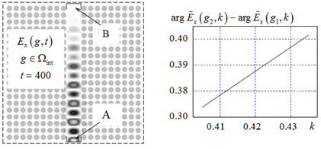

Figure 21. Segment of the regular waveguide in a finite photonic crystal. Excitation with a pulsed -wave (40).

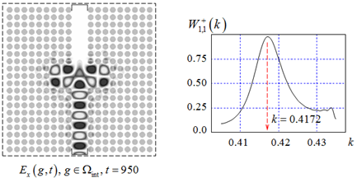

Figure 22. The total reflection of -wave by symmetric waveguide widening.

In view of the above, we design a transparent waveguide discontinuity (symmetric widening, Figure 22), which, if we continue the analogy with classic waveguides [60], totally reflects incident -wave at certain frequencies in the range . The necessary condition for this is that the next higher order -wave propagating here should be trapped in the widening. This is satisfied as the structure is symmetric. Thus, the antisymmetric -wave (estimated cut-off point ) cannot be generated by symmetric -wave in the zones of reflection and transmission.

Simulation results confirm our hypotheses. A monochromatic -wave is almost completely reflected by the transparent discontinuity on the frequency  (Figure 22). Here,  is a complex eigenfrequency corresponding to -oscillation (it has five antinodes along the -axis and two antinodes along the -axis) in the widening with a considerably high Q-factor. This becomes clear (see for example [16, 26, 27, 59]) when we consider the structure being excited by the quasi-monochromatic pulse wave



(41)

The field configuration corresponding to the total reflection is already well established for  (see the pattern  in Figure 22).

The effect of nearly complete reflection of -waves also can be implemented on T-junctions, whose geometry and amplitude-frequency characteristics are presented in Figures 23 and 24. T-junctions could operate in three different regimes. (i) The major part of the input energy is reflected back into the feeding waveguide. This regime is marked with rather high level of the reflection coefficient . (ii) The major part of the input energy is transmitted into the lateral waveguides. This regime is marked with rather low level of . (iii) The input energy is distributed equally between three waveguides 

It can be stated quite confidently that a T-junction in a crystal is also a frequency-selective element, whose characteristics are influenced by resonant (eigen) oscillations of the field excited in the cavity coupling all three waveguides. The real parts of complex eigenfrequencies  of these oscillations are very close to the frequencies at which the corresponding regimes operate. These frequencies are used as the central frequency  of the excitation signal (41) to determine field patterns and Q-factors of eigenoscillations (see the patterns in Figures 23, where , and 24, where ). To observe pronounced field patterns of eigenmodes, it is necessary to wait until the excitation is turned off, and see how  changes as  increases [16, 59]. A field pattern corresponding to a particular regime often manifests itself rather clearly even before the power is turned off (e.g., see Figures 23 and 24). It is also necessary to meet the following requirement: frequencies corresponding to other high-Q eigenoscillations have to fall out of the frequency range covered by the excitation.

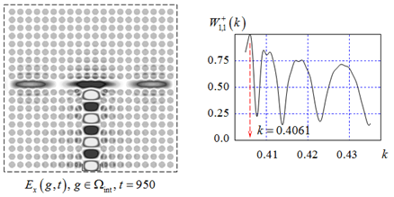

Figure 23. Characteristics of T-junction with narrow lateral channels.

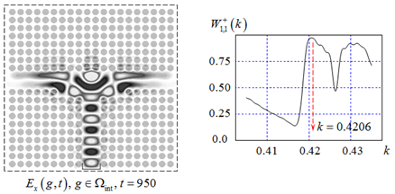

Figure 24. T-junction with resonant widening of coupling region.

### 4.5. Radiation Effects in Crystals’ Passbands

Exciting a waveguide (Figure 21) with a ultrawideband pulsed -wave, whose frequency spectrum covers the passband of a finite crystal between its second and third BGs, we studied the propagation of waves in a crystal. As a result, we fixed the waves whose front dynamics permitted us to identify them with the waves arising from the backward Vavilov-Cherenkov radiation [61].

Studying the spectral composition of these waves after they leave the crystal, we determined the frequencies on which the waves’ amplitudes reach maximum. Then, we did a series of simulations to determine the radiation characteristics of the finite heart-shaped (Figure 25) and square (Figure 26) crystals on the frequencies close to the ones corresponding to maximal amplitudes. The results of these numerical experiments are presented below.

The heart-shaped crystal is excited by the narrowband pulse (41) with the central frequency . This pulse covers the frequency band . The beginning of this band coincides with the boundary of the second BG of a finite crystal, hence the radiation efficiency  is very low here. At the frequency , the efficiency is , and a large part of the radiated energy is carried by the waves propagating in free space in the directions  and . These are the Vavilov-Cherenkov radiation waves, and these are backward waves – when crossing the lower boundary cut at angles  and , they do not refract.

This fact is illustrated in Figure 26. The simulation conditions are the same as in the case of Figure 25, but the crystal is square now. Reverse refraction leads to the ‘collision’ of the radiated waves under the lower boundary of the structure and to the formation of rather powerful diagram lobes directed upwards symmetrically to the axis  at angles  and .

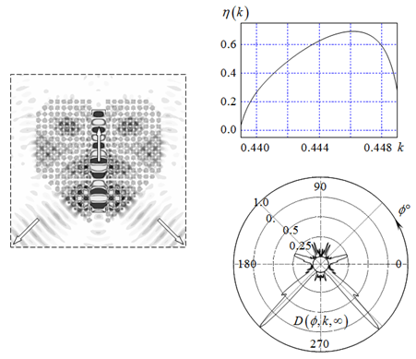

Figure 25.  pattern at . The efficiency of radiation and radiation pattern at frequency **.

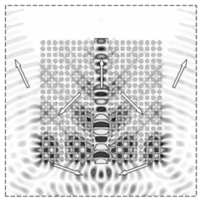

Figure 26. Reverse refraction: focusing of the field under plane boundary of the crystal.  pattern at .

## Conclusion

At the beginning of this chapter, the questions related to the algorithms and to numerical solution of spectral problems of electromagnetic theory of 2-D photonic crystals are analyzed. The actuality of the research area is obvious – the quality of the important results both for the theory and practice which obtained on the corresponding background mostly depends on how accurate the dispersion characteristics of the considered structures are calculated. For the indicated problems the conditions, which performance is necessary for construction of stable and convergent numerical schemes, are formulated. The possibility of analytical regularization is demonstrated and the techniques for increasing the convergence rate of obtained results are indicated.

The chapter proposed and implemented a new approach to the analysis of 2-D spatially limited photonic crystals and various functional elements on their basis. The approach is based on EAC-method and provides accurate and reliable numerical results even for long-duration simulations and resonant waves scattering. New results were obtained concerning BGs and passbands of finite crystals, electromagnetic characteristics of resonant cavities and basic waveguide components in photonic crystals, energy accumulation in resonant cavities, and radiation effects caused by the so-called backward waves in photonic crystals. The analysis and the results similar to those presented in Section 4 can serve as a basis for efficient diagnostics schemes for photonic crystals. They should provide an accurate evaluation of constitutive parameters and help to design new devices with required specification.

The chapter presented only a part of important details regarding the developed approach, and electromagnetic waves scattering and propagation in photonic crystals, so the work in this direction will continue.

This research has been partially funded by the Science Committee of the Ministry of Education and Science of the Republic of Kazakhstan (Grant No. AP08855557).

## References

1. Yablonovitch, E. “Inhibited Spontaneous Emission in Solid-State Physics and Electronics.” *Physical Review Letters* 58, (1987): 2059–2062.
2. John, S. “Strong Localization of Photons in Certain Disordered Dielectric Superlatices.” *Physical Review Letters* 58 (1987): 2486–2489.
3. Joannopoulos, J., S. Johnson, J. Winn, and R. Meade. *Photonic Crystals.* *Molding the Flow of Light*. Princeton: Princeton University Press, 2008.
4. Butt, H., Q. Dai, and T. Wilkinson. “Photonic Crystals & Metamaterial Filters Based on 2D Arrays of Silicon Nanopillars.” *Progress In Electromagnetics Research* 113 (2011): 179–194.
5. Ivansson, S. “Designing 2D Photonic Crystal Slabs with Transmission Gaps for Solid Angle as Well as Frequency Variation.” *Advances in Acoustics and Vibration* 2014 (2014): Article ID 317890.
6. Vanbesien, O., N. Fabre, X. Melique, L. Lalouat, B. Cluzel, F. de Fornel, and D. Lippens. “Photonic Crystal Based Subwavelength Imaging and Cloaking Optical Devices.” *PIERS Online* 5, no. 3 (2009): 216–220.
7. Sirenko, Y. “Exact ‘Absorbing’ Conditions in Outer Initial Boundary Value Problems of the Electrodynamics of Nonsinusoidal Waves. Part 2: Waveguide Units and Periodic Structures.” *Telecommunications and Radio Engineering* 57, no. 12 (2002): 1–31.
8. Sirenko, Y. “Exact ‘Absorbing’ Conditions in Outer Initial Boundary-Value Problems of the Electrodynamics of Nonsinusoidal Waves. Part 3: Compact Inhomogeneties in Free Space.” *Telecommunications and Radio Engineering* 59, no. 1-2 (2003): 1–31.
9. Sirenko, Y. “Exact ‘Absorbing’ Conditions in Outer Initial Boundary-Value Problems of the Electrodynamics of Nonsinusoidal Waves. Part 5: Plausible Extensions and Unresolved Problems.” *Telecommunications and Radio Engineering* 59, no. 5-6 (2003): 1–27.
10. Sirenko, Y. and N. Yashina. “Time Domain Theory of Open Waveguide Resonators: Canonical Problems and a Generalized Matrix Technique.” *Radio Science* 38, no. 2 (2003): VIC 26-1–VIC 26-12.
11. Sirenko, K. and Y. Sirenko. “Exact ‘Absorbing’ Conditions in the Initial Boundary Value Problems of the Theory of Open Waveguide Resonators.” *Computational Mathematics and Mathematical Physics* 45, no. 3 (2005): 490–506.
12. Sirenko, Y., S. Strom, and N. Yashina. *Modeling and Analysis of Transient Processes in Open Resonant Structures*. *New Methods and Techniques*. New York: Springer, 2007.
13. Sirenko, K., Y. Sirenko, and N. Yashina. “Modeling and Analysis of Transients in Periodic Gratings. I. Fully Absorbing Boundaries for 2-D Open Problems.” *Journal of the Optical Society of America A* 27, no. 3 (2010): 532–543.
14. Sirenko, Y. and S. Strom (eds). *Modern Theory of Gratings. Resonant Scattering: Analysis Techniques and Phenomena*. New York: Springer, 2010.
15. Sirenko, K., V. Pazynin, Y. Sirenko, and H. Bagci. “An FFT-Accelerated FDTD Scheme with Exact Absorbing Conditions for Characterizing Axially Symmetric Resonant Structures.” *Progress In Electromagnetics Research* 111 (2011): 331–364.
16. Kravchenko, V., Y. Sirenko, and K. Sirenko. *Electromagnetic Wave Transformation and Radiation by the Open Resonant Structures. Modelling and Analysis of Transient and Steady-State Processes*. Moscow: Fizmathlit, 2011.
17. Sirenko, Y. and L. Velychko (eds). *Electromagnetic Waves in Complex Systems: Selected Theoretical and Applied Problems*. New York: Springer, 2016.
18. Sirenko, Y., V. Pazynin, K. Sirenko, and N. Yashina. “Exact Absorbing Conditions for Initial Boundary Value Problems of Computational Electrodynamics. Review.” Book Chapter 3 in Avci, M. (ed). A Closer Look at Boundary Value Problems 43–124. New York: Nova Science Publishers, 2020.
19. Sirenko, K., Y. Sirenko, H. Sliusarenko, and N. Yashina. “Analytical Grounds for Spectral Theory of 2-D Photonic Crystals.” *Telecommunications and Radio Engineering* 75, no. 16 (2016): 1417–1433.
20. Sirenko, Y., H. Sliusarenko, and K. Balabekov. “Doubly-periodic Electrodynamic Structures: Methods and Analysis Results. A Review.” *Telecommunications and Radio Engineering* 75, no. 19 (2016): 1705–1719.
21. Sautbekov, S., Y. Sirenko, and H. Sliusarenko. “Doubly-periodic Photonic Crystals: Spectral Problems Analysis.” *Progress In Electromagnetics Research Letters* 66 (2017): 71–77.
22. Ney, M., K. Sirenko, Y. Sirenko, H. Sliusarenko, and N. Yashina. “2-D Photonic Crystals: Electromagnetic Models of the Method of Exact Absorbing Conditions.” *Telecommunications and Radio Engineering* 76, no. 3 (2017): 185–207.
23. Burambayeva, N., Y. Sirenko, S. Sautbekov, A. Vertiy, and N. Yashina. “Synthesis of 2-D Photonic Crystals of Finite Thickness with Ultra-wide Bandgaps.” *Telecommunications and Radio Engineering* 78, no. 19 (2019): 1691–1699.
24. **Lourtioz**, J.-M., H. Bensty, V. Berger, J. Gerard, D. Maystre, and A. Tchelnokov. *Photonic Crystals: Towards Nanoscale Photonic Devices*. New York: Springer, 2005.
25. Johnson, S. and J. Joannopoulos. “Block-iterative Frequency-domain Methods for Maxwell’s Equations in a Planewave Basis,” *Optics Express* 8, no. 3 (2001): 173–190.
26. Velychko, L., Y. Sirenko, and O. Velychko. “Time-domain Analysis of Open Resonators. Analytical Grounds.” *Progress In Electromagnetics Research* 61 (2006): 1–26.
27. Velychko, L. and Y. Sirenko. “Controlled Changes in Spectra of Open Quasi-optical Resonators.” *Progress In Electromagnetics Research B* 16 (2009): 85–105.
28. Vaynikko, G. and O. Karma. “On Rapidity of Convergence of Approximate Methods in Problem of Eigenvalues with Nonlinear Occurrence of Parameter.” *Zhurnal Vychislitelnoy Matematiki I Matematicheskoy Fiziki* 14, no. 6 (1974): 1393–1408.
29. Hokhberg, I. and M. Krein. *Introduction into the Theory of Linear not Self-Adjoint Operators*. Moscow: Nauka, 1965.
30. Hutson, V. and J. Pym. *Applications of Functional Analysis and Operator Theory*. New York: Academic Press, 1980.
31. Titchmarsh, E. *Eigenfunction Expansions Associated with Second-order Differential Equations*. Oxford: Clarendon Press, 1958.
32. Shestopalov, V. and Y. Sirenko, *Dynamic Theory of* Gratings. Kiev: Naukova Dumka, 1989.
33. Keldysh, M. “On the Completeness of Eigenfunctions of Some Classes of Non-selfadjoint Linear Operators.” *Russian Mathematical Surveys* 26, nо. 4 (1971): 15–44.
34. Hokhberg, I. and Y. Seagul. “Operator Generalization of the Theorem about Logarithmic Residue and the Rouche Theorem.” *Matematicheckiy Sbornik* 84, nо. 4 (1971): 607–629.
35. Reed, M. and B. Simon. *Methods of Mathematical Physics. IV: Analysis of Operators*. New York: Academic Press, 1978.
36. Hardy, G., J. Littlewood, and G. Polya. *Inequalities*. Cambridge: Cambridge University Press, 1934.
37. Shestopalov, V., A. Kirilenko, and S. Masalov. *Matrix Convolution-type Equations in the Diffraction Theory*. Kiev: Naukova Dumka, 1984.
38. Shestopalov, V., L. Lytvynenko, S. Masalov, and V. Sologub. *Wave Diffraction by Gratings*. Kharkov: Kharkov State University Press, 1973.
39. Petit, R. (ed). *Electromagnetic Theory of Gratings*. New York: Springer, 1980.
40. Shestopalov, V., A. Kirilenko, S. Masalov, and Y. Sirenko. *Resonance Wave Scattering. Vol. 1. Diffraction Gratings*. Kiev: Naukova Dumka, 1986.
41. Neviere, M. and E. Popov. *Light Propagation in Periodic Media: Differential Theory and Design*. New York: Marcel Dekker, 2003.
42. Sirenko, K., Y. Sirenko, and N. Yashina. “Modeling and Analysis of Transients in Periodic Gratings. II. Resonant Wave Scattering.” *Journal of the Optical Society of America A* 27, no. 3 (2010): 544–552.
43. Taflove, A. and S. Hagness. *Computational Electrodynamics: The Finite-Difference Time-Domain Method*. Boston: Artech House, 2005.
44. Jin, J. *The Finite Element Method in Electromagnetics*. New York: John Wiley & Sons, 2002.
45. Engquist, B. and A. Majda. “Absorbing Boundary Conditions for the Numerical Simulation of Waves.” *Mathematics of Computation* 31, no. 139 (1977): 629651.
46. Mur, G. “Absorbing Boundary Conditions for the Finite Difference Approximation of the Time-domain Electromagnetic Field Equations.” IEEE Transactions on Electromagnetic Capability 23, no. 4 (1981): 377382.
47. Fang, J. “Absorbing Boundary Conditions Applied to Model Wave Propagation in Microwave Integrated Circuits.” IEEE Transactions on *Microwave Theory and Techniques* 42, no. 8 (1994): 1506–1513.
48. Mei, K. and J. Fang. “Superabsorbtion – a Method to Improve Absorbing Boundary Conditions.” IEEE Transactions on Antennas and Propagation 40, no. 9 (1992): 1001–1010.
49. Betz, V. and R. Mittra. “A Boundary Condition to Absorb Both Propagating and Evanescent Waves in a FDTD Simulation.” *IEEE Microwave and Guided Wave Letters* 3, no. 6 (1993): 182–184.
50. Berenger, J.-P. “A Perfectly Matched Layer for the Absorption of Electromagnetic Waves.” *Journal of Computational Physics* 114, no. 1 (1994): 185–200.
51. Berenger, J.-P. “Three-dimensional Perfectly Matched Layer for Absorption of Electromagnetic Waves.” *Journal of Computational Physics* 127, no. 2 (1996): 363–379.
52. Rothwell, E. and M. Cloud*. Electromagnetics*. New York: CRC Press, 2001.
53. Sirenko, Y. *Simulation and Analysis of Transient Processes in Open Periodic, Waveguide, and Compact Resonators*. Kharkov: EDENA, 2003.
54. Sirenko, K. “Transport Operators in the Axially-symmetrical Problems of the Electrodynamics of Pulsed Waves.” *Elektromagnitnye Volny I Elektronnye Sistemy* 11, no. 11 (2006): 15–26 (2006).
55. Kravchenko, V., K. Sirenko, and Y. Sirenko. “Transport Operators and Exact Absorbing Conditions in the Plane Problems of the Electrodynamics of Pulsed Waves for Compact Open Resonators with the Waveguide Feeder Line.” *Elektromagnitnye Volny I Elektronnye Sistemy* 14, no. 1 (2009): 4–19.
56. Kuzmitchev, I., P. Melezhyk, V. Pazynin, K. Sirenko, Y. Sirenko, O. Shafalyuk, and L. Velychko. “Model Synthesis of Energy Compressors.” *Radiofizika I Elektronika* 13, no. 2 (2008): 166–172.
57. Sirenko, K., V. Pazynin, Y. Sirenko, and H. Bagci. “Compression and Radiation of High-power Short Radio Pulses. I. Energy Accumulation in Direct-flow Waveguide Compressors.” *Progress In Electromagnetics Research* 116 (2011): 239–270.
58. Sirenko, K., V. Pazynin, Y. Sirenko, and H. Bagci. “Compression and Radiation of High-power Short Radio Pulses. II. A Novel Antenna Array Design with Combined Compressor/Radiator Elements.” *Progress In Electromagnetics Research* 116 (2011): 271–296.
59. Sirenko, Y., L. Velychko, and F. Erden. “Time-domain and Frequency-domain Methods Combined in the Study of Open Resonance Structures of Complex Geometry.” *Progress In Electromagnetics Research* 44 (2004): 57–79.
60. Shestopalov, V., A. Kirilenko, and L. Rud’. *Resonance Wave Scattering. Vol. 2. Waveguide Discontinuities*. Kiev: Naukova Dumka, 1986.
61. Luo, C., M. Ibanescu, G. Steven, S. Johnson, and J. Joannopoulos. “Cherenkov Radiation in Photonic Crystals.” *Science* 299 (2003): 368–371.

***Reviewed by Prof. Panayiotis Frangos***,

School of Electrical and Computer Engineering,

National Technical University of Athens.

E-mail: [pfrangos@central.ntua.gr](https://e.mail.rumailto:pfrangos@central.ntua.gr/)

LCH

1. * Corresponding Author’s Email: yks2002sky@gmail.com.