Alternative Energy Sources, Materials & Technologies (AESMT’18), Volume XX, (pp. XX - XX) 2018
Evaluation of wind power potential in Shelek corridor (Kazakhstan) using Weibull distribution function
S.A.Bolegenova¹, R. K. Manatbaev¹, Zh.Shortanbaeva¹, Sh.Yershin², Zh.E.Baizhuma^{1*}
¹ al-Farabi Kazakh national university, Faculty of physics and technology, Dept. of Thermal physics and Technical Physics, al-Farabi ave. 71, 050040, Almaty, Kazakhstan
² al-Farabi Kazakh national university, SRI for mathematics and mechanics, al-Farabi ave. 71, 050040, Almaty, Kazakhstan

Kazakhstan currently has one of the highest, per capita, carbon footprints in the world. There are heavy reliance (approx 85%) on coal for electricity production in Kazakhstan. Coal is a very carbon intensive fuel. A drive to moderate coal’s contribution to electricity production provides a driver for wind energy development. Finding a suitable location requires a detailed and often costly analysis of local wind conditions. Wind resource assessment is a crucial first step in gauging the potential of a site to produce energy from wind turbines. In this paper, the wind energy potential of Shelek corridor, located in the Almaty region in Kazakhstan were examined. Local wind speed distributions are represented by Weibull statistics. The results show that the average annual mean wind speed variation for Shelek corridor ranges from 4.0 to 8.0 m/s. The wind power density variation based on the Weibull analysis ranges from 280.0 to 320.0 W/m².
Keywords: wind power, energy production, renewable energy, MERRA, Weibull distribution
© 2016 Bulgarian Academy of Sciences, Union of Chemists in Bulgaria

INTRODUCTION
For nowadays Kazakhstan is among the top 20 countries which produce the highest carbon dioxide emission per capita. There are several reasons of this such as a small population per square kilometer, a strong dependence of the power plant on coal. Coal emits very high amount of carbon dioxide to the atmosphere. It means that wind electric stations will be attractive opportunity for Government and business sector. Investing in such projects is commercially feasible. [1]
Kazakhstan’s geographical location is very suitable to develop wind energy stations with power up to 760 GW. For instance; Shelek corridor has potential to produce power from wind energy aprroximately 3200 kW/h/MW [2].
The performance of the wind power conversion system depends on a wide range of criteria including a lot of aspects. [3] The characteristics of the wind tendency are one of the main and influential parameters that support when determining the suitability of a site for the use of wind energy. Due to the stochastic nature of the wind, several models were developed to analyse the available wind data in order to obtain the characteristics of any wind mode. One of these established models operates on the basis of the Weibull distribution [3]. This article presents the details of the analysis based on the Weibull distribution of wind data, from the NASA’s Modern-Era Retrospective Analysis for Research and Applications.
KAZAKHSTAN’S WIND POWER MARKET
The Republic of Kazakhstan has the ninth largest territory in the world. It is about 2.7 million km². However, Kazakhstan is one of the countries with the least population density in the world (5.5 persons per km²). There are three cities with population over 1 million people: Astana, Almaty and Shymkent.
Kazakhstan has huge resources of fossil fuels such as coal, oil, gas and uranium. These resources are being actively exporting. For instance, Kazakhstan produces just less than 100 million tons of coal and approximately 35% of this is exported to the neighbouring countries. 1.5 million barrels of oil produced per one day. And 75% of them sold to the China and Russia.
There is no any country in the world which produces more uranium than Kazakhstan. According to the data in 2009 year 27.6% of world’s uranium production was made by Kazakhstan.
Excess of energy resources is the main factor hindering the development of renewable energy sources in Kazakhstan.
Based on the outcomes of the World Summit on Sustainable Development held at Johannesburg in 2002 Kazakh government accepted Sustainable Development Concept for 2007 – 2024. That Concept was devoted to sustainable use of renewable resources and alternative energy in Kazakhstan. Efficient and sustainable use of renewable resources and alternative energy sources will be possible if:
- innovative technologies in use of land, water, forestry, fishery, biological resources and renewable sources of energy will be introduced;
- efficient use of hydropower resources, solar and wind resources and other renewable resources and alternative energy sources will be simulated;
- the Centers for distribution of international experience in the area of energy and resource efficiency and use of renewable sources of power will be established.
Considering all of the above, it is possible to list the main challenges which are the strong drivers for the development of wind energy in Kazakhstan:
- the old power generation infrastructure;
- high amount of transition and distribution loses;
- The highest carbon footprints in the world.
As a result, since 2012 year the amount of installed capacity by the onshore wind turbines has increased 65 times. It can be shown in the diagram below.
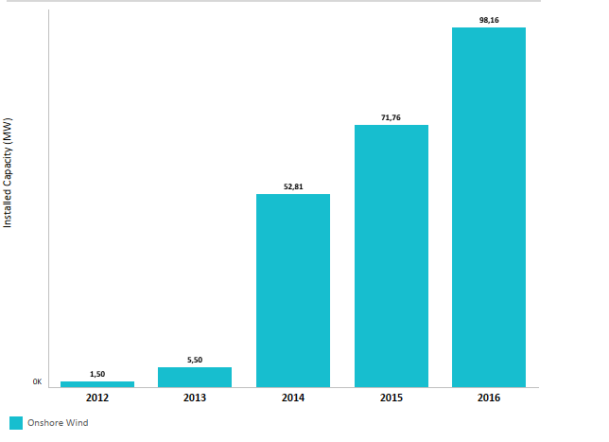
Fig.1 Trends in renewable energy (Installed capacity).
In 2012 installed capacity was only 1.5MW, the first wind power station was installed in Kordai, Zhambyl region. Next year power production increased three times. 2014 year was significant for Kazakhstan wind power market, because the second wind power station was set up in Ereimentau, Akmola region. And it drove to fundamental growth in the installed capacity: from 5.5MW in 2013 to the 52.81MW in 2014. In 2015 and 2016 there were still positive trends in the installed capacity. Compared to 2014 year, potential power produced from the wind rose by the 40% each year.
DATA COLLECTION AND ANALYSES
There are two ways of obtaining data. First way is analysing of production data. The benefits of using production data are that they are reflecting true fluctuations and do not require any additional calculations. But this approach is applicable to the places where a wind turbine has already been installed. The second way is using data from the weather station. However, that way has several disadvantages: it is not available; data records sometimes not complete. Moreover to that, to calculate a new location, you need to install anemometers. This is not economically profitable. [4]
In Kazakhstan there is no free available wind speed data at the moment. Companies should measure wind data themselves. Previously a wind atlas of Kazakhstan was created in the framework of the UNDP / GEF Project and the Government of the Republic of Kazakhstan "Kazakhstan is an initiative to develop the wind energy market". However, at this moment that site is not available.
Ritter et all [4], recommended an alternative dataset which is providing wind power analysis and reanalysis data, such as Modern-Era Retrospective Analysis for Research and Applications (MERRA) data provided by NASA [5]. MERRA offers wind data all over the world and an hourly temporal resolution since 1979. It consist two components at three different heights (2 m, 10 m and 50 m above ground). A northward and an eastward wind component are helpful to derive the wind speed and wind direction at various turbine heights [6].
In this study the data used from “MERRA-2 inst1_2d_asm_Nx: hourly, instantaneous, Single-Level, Assimilations, Single-Level Diagnostics V5.12.4” during the period from 01.01.2015, until 28.02.2018 for each day. We used the northward and eastward wind speed at the heights of 2m, 10m and 50m above the ground. To cover all Shelek corridor grid points with a latitude between 44⁰E and 47.5⁰E and a longitude between 73.5⁰N and 77.8⁰N are used.
ESTIMATION OF WEIBULL PARAMETERS
In recent years, more attention has been paid to the Weibull distribution, as suggested by the nearby approximation of the probabilistic laws of a number of natural phenomena and is expected to ensure a good correspondence to the experimental data.[7]
Mathematically, i.e. The Weibull distribution function of the two parameter functions is expressed as:
$f(v)=\frac{k}{c}{(\frac{v}{c})}^{k-1}e^{-({\frac{v}{c})}^{k}}$
The integral distribution function F (x) is given by:
$F\left(v\right)=1-e^{-({\frac{v}{c})}^{k}}$
Where v is the wind speed, k is the shape factor and c is the scale parameter. The shape factor k is the main factor in determining the uniformity of the wind. The uniformity of the wind changes direction with a change to i. with increasing k, the uniformity of the wind increases.
It has been established that almost all parameters, such as wind speed, wind speed probability, must be within a certain range, the energy is available in a certain mode, etc., are necessary to fully appreciate the dignity of the wind regime, depend on the rough calculation of these values of k and c [8].
k and c parameters can be found with the several methods such as the power density method; least square method, Modified likelihood method etc. [9]. The methods are briefly discussed below
1) Standard deviation method
The standard deviation method gives the ratio between the mean (v_{m}) and the standard deviation (σ_{v}):
${\left(\frac{σ_{v}}{v_{m}}\right)}^{2}=\frac{Γ\left(1+\frac{2}{k}\right)}{Γ^{2}\left(1+\frac{1}{k}\right)}-1$ (1)
After k is determined, c is determined as:
$c=\frac{v_{m}}{Γ\left(1+\frac{1}{k}\right)}$ (2)
In a simple methodology, an acceptable approximation for k and c can be approximated:
$k={\left(\frac{σ_{v}}{v_{m}}\right)}^{-1.090}$ (3)
$c=\frac{2v_{m}}{√π}$ (4)
2) Empirical method (EM)
A special case of the method of moments, the empirical method determines k & c, as in equations (2):
$$k={\left(\frac{σ}{\overline{v}}\right)}^{-1.086}$$
$$c=\frac{\overline{v}}{Γ\left(1+\frac{1}{k}\right)}$$
$$Γ\left(x\right)=\int_{0}^{∞}{t^{x-1}e^{-t}dt}$$
3) Power density method (PDM)
This is the one of the most important methods of determining k and c. First of all, energy pattern factor E_{pf} is calculated by the division of cubic wind speed to cube of mean wind speed [9-10]. After that k and c may be found by formula (5):
$k=1+\frac{3.69}{{E_{pf}}^{2}}$ and $c=\frac{\overline{v}}{Γ(1+\frac{1}{k})}$ (5)
4) Modified likelihood method (MLM)
That method was proposed by Stevens and Smulders [10] and describes k and c by the following formulas:
$$k={\left[\frac{\sum_{i=1}^{n}{v_{i}^{k}ln\left(v_{i}\right)}}{\sum_{i=1}^{n}{v_{i}^{k}}}-\frac{\sum_{i=1}^{n}{ln\left(v_{i}\right)}}{n}\right]}^{-1}$$
$$c={\left(\frac{1}{n}\sum_{i=1}^{n}{v_{i}^{k}}\right)}^{1/k}$$
RESULTS AND DISCUSSION
In this study the data used from 01.01.2015, until 28.02.2018 for each day. The northward and eastward wind speed at the heights of 2m, 10m and 50m above the ground were horizontally interpolated by the formula [4]
$v_{m}=\sqrt{u_{h}^{2}+v_{h}^{2}}$. (6)
Monthly mean values of wind speed are shown in the tables 1-3. The frequency distribution of the data is shown in Table 4.

Table 1. Monthly mean velocities at height of 2m
Month | Mean velocity m/s
 | 2015 | 2016 | 2017 | 2018
January | 2.7242 | 3.3995 | 2.9572 | 5.9183
February | 3.4051 | 3.6068 | 2.8878 | 3.0978
March | 2.2784 | 2.8207 | 3.4395 | -
April | 2.0906 | 2.2409 | 1.6123 | -
May | 1.5377 | 2.8716 | 2.6959 | -
June | 2.4187 | 1.0863 | 0.8440 | -
July | 2.4385 | 1.3534 | 2.4462 | -
August | 1.9352 | 5.6995 | 4.1758 | -
September | 2.5953 | 5.6995 | 2.6755 | -
October | 2.0809 | 2.5965 | 2.1037 | -
November | 2.2991 | 2.3995 | 2.5797 | -
December | 2.9105 | 2.5473 | 3.1505 | -

Table 2. Monthly mean velocities at height of 10m
Month | Mean velocity m/s
 | 2015 | 2016 | 2017 | 2018
January | 3.3320 | 3.6725 | 3.3897 | 6.4588
February | 3.8281 | 4.0027 | 3.4253 | 3.6344
March | 2.9956 | 3.2741 | 4.0367 | -
April | 2.3681 | 2.6763 | 2.0381 | -
May | 1.8185 | 3.0655 | 2.9150 | -
June | 2.8588 | 1.2251 | 0.9799 | -
July | 3.0926 | 1.4276 | 2.9774 | -
August | 2.4606 | 6.4904 | 4.7401 | -
September | 3.0329 | 6.4904 | 3.3571 | -
October | 2.4876 | 3.0643 | 2.6479 | -
November | 2.7427 | 3.0442 | 2.9889 | -
December | 3.4514 | 2.9444 | 3.7378 | -

Table 3. Monthly mean velocities at height of 50m
Month | Mean velocity m/s
 | 2015 | 2016 | 2017 | 2018
January | 5.4955 | 5.8329 | 5.8604 | 9.8087
February | 5.8815 | 6.2380 | 5.3924 | 5.6900
March | 4.3439 | 6.3175 | 6.0201 | -
April | 3.7365 | 4.8102 | 3.1457 | -
May | 2.4771 | 4.1304 | 4.5861 | -
June | 4.7340 | 4.1634 | 1.7987 | -
July | 4.9166 | 1.6786 | 4.7932 | -
August | 4.0327 | 2.2848 | 7.8409 | -
September | 4.7945 | 9.3863 | 5.1376 | -
October | 3.8964 | 9.3863 | 4.1561 | -
November | 4.6451 | 5.0147 | 4.9872 | -
December | 5.4955 | 4.5663 | 6.0211 | -

According to these table the highest speed was detected in January, 2018 and reached almost 6m/s in between 2015 and 2017, and over 9m/s in 2018. Respectively in the beginning of summer there always was low wind speed. The least meaning of wind speed for summer is 0.9m/s.
Collected speed data was also divided to the intervals to find more common velocity. It was observed that the most frequent velocity at height 2m is 2÷3 m/s (0.58). As for 10 m height 3÷4 m/s repeated with almost 40% frequency. The wind speed of 4-6 m / s at the height of 50 m was repeated at a frequency of 0.6.
Table 4. Wind velocity distribution
Wind  Speed,m/s | Frequency
 | 2 m | 10 m | 50 m
0÷1 | 0.03 | 0.03 | 0.00
1÷2 | 0.13 | 0.08 | 0.05
2÷3 | 0.58 | 0.34 | 0.05
3÷4 | 0.16 | 0.39 | 0.08
4÷5 | 0.03 | 0.08 | 0.37
5÷6 | 0.08 | 0.00 | 0.24
6÷7 | 0.00 | 0.08 | 0.11
8÷9 | 0.00 | 0.00 | 0.03
9÷10 | 0.00 | 0.00 | 0.00

As we can see from the table, when the height is increasing the value of velocity is also increases. Thus, wind speed data at these three heights could be vertically extrapolated to the turbine height [11].
From the above formulas and wind data, the results for shape and scale parameters are calculated using various methods described above is indicated in Table 5.

Table 5. Wind velocity distribution
Methods | Frequency
 | 2 m |  | 10 m |  | 50 m
 | k | c | k | c | k | c
SDM | 2.74 | 3.14 | 2.93 | 3.66 | 3.10 | 5.74
EM | 2.53 | 3.13 | 2.70 | 3.65 | 2.86 | 5.72
PDM | 2.73 | 3.12 | 2.92 | 3.63 | 3.09 | 5.70
MLM | 2.62 | 3.13 | 2.76 | 3.63 | 2.93 | 5.70

Accuracy of calculations was checked by the following three methods: RMSE, 𝑅2 and 𝐶ℎ𝑖 - 𝑆𝑞𝑢𝑎𝑟𝑒 tests:
$$RSME={\left[\frac{1}{N}\sum_{i=1}^{N}{{\left(y_{i}-x_{i}\right)}^{2}}\right]}^{1/2}$$
$$χ^{2}= \frac{\sum_{i=1}^{N}{{\left(y_{i}-x_{i}\right)}^{2}}}{N-n}$$
$$R^{2}=\frac{\sum_{i=1}^{N}{{\left(y_{i}-z_{i}\right)}^{2}}-\sum_{i=1}^{N}{{\left(y_{i}-x_{i}\right)}^{2}}}{\sum_{i=1}^{N}{{\left(y_{i}-z_{i}\right)}^{2}}}$$
Where y_{i} is observed frequency and x_{i} Weibull’s frequency, N is a number of observations, n is a number of used constants. The results are shown in a table below
Table 6. Wind velocity distribution
Tests | SDM | EM | PDM | MLM
RSME | 0.675 | 0.0678 | 0.0692 | 0.0673
Chi-square | 0.063 | 0.0063 | 0.0067 | 0.0061
R² | 09485 | 0.9469 | 0.9472 | 0.9466

As shown in Figures 1-6, all the methods discussed show more or less similar results, even if the maximal likelihood method and the energy properties are a little more accurate and, therefore, can be considered as the most appropriate.

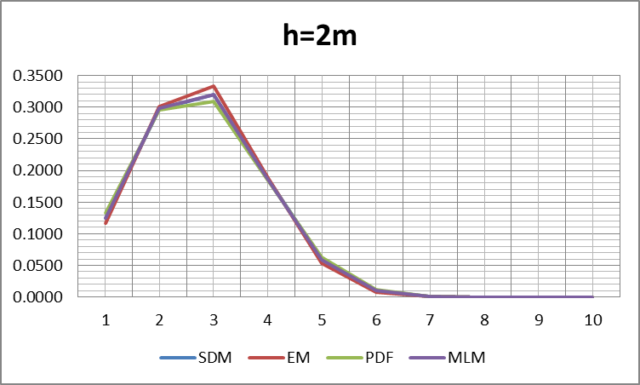
Fig.2 Weibull distribution at the height of 2m.
As we can see from the graph, the most probable wind speed at this height is under 3 m/s. And our calculations have shown the mean value of the velocity is 2.78m/s.
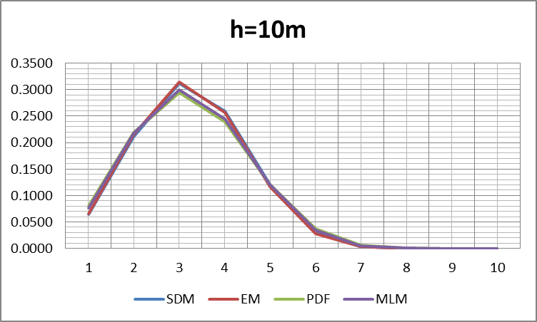
Fig.3 Weibull distribution at the height of 10m.
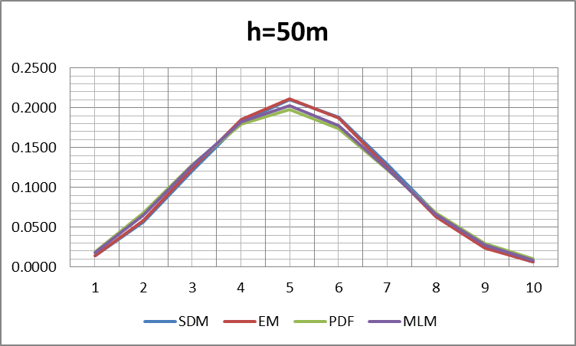
Fig.4 Weibull distribution at the height of 50m
Weibull probability distributions for the three different heights
According to the Fig.3 we can see that the most probable wind speed occurs at speed 5 m/s with a probability of 22.5%. This means that at Shelek corridor the wind speed that often arises at 5 m/s.
Usually, 4-5 m/s is an ideal wind speed for wind turbines. However, the use of wind energy is commercially installed only for high (8-9 m/s) and medium (6-7 m/s) wind conditions. If wind energy is available in low wind conditions, it is possible to develop turbines specifically for these regions, which will help to reduce dependence on fossil fuels.
To analyze the wind energy potential there is also mean power density based on Weibull distribution must be calculated. [14]
$P_{WD}=\frac{1}{2}ρc^{3}Γ(1+\frac{3}{k})$ (5)
Where c shape factors which were calculated by the four methods described below. ρ is air density related to the pressure, temperature and humidity. However, air density has not significant effect on wind resource calculations, thus it can be taken as a constant value 1.225 g/cm³.
On the other hand mean power density can be calculated by the formula:
$P_{REF}=\frac{1}{2}ρ{\overline{v}}^{3}$ (6)

CONCLUSIONS
The potential of wind energy in Shelek corridor have been studied in this analysis using widely used Weibull distribution technique. The Weibull parameters such as shape factor and scale factor have been calculated by four different methods such as least squares method, power density method, empirical method and modified likelihood method. Relative percentage of error and chi-square error has been analyzed for each method and also calculated the efficiency of these methods. The wind data was obtained from NASA Modern-Era Retrospective Analysis for Research and Applications “MERRA-2 inst1_2d_asm_Nx: hourly, instantaneous, Single-Level, Assimilations, Single-Level Diagnostics V5.12.4” during the period from 01.01.2015, until 28.02.2018 for each day.
The results found that Shelek complex is prospective site to set up vertical axed wind turbine. The results have been verified by Weibull distribution technique where Weibull shape factor and scale factor were calculated using four different approaches. The statistical analysis also found the modified likelihood method is more efficient method with minimum error in the wind data analysis. The study presented the potential of Shelek corridor to produce pure energy using wind power.
NOMENCLATURE
k – scale factor;
c – shape factor;
Г – gamma function;
E_{pf} – energy pattern factor;
σ – standard deviation;
RSME – Relative Square mean error;
$χ^{2}$ – Chi-square
REFERENCES
[1] Lessons learnt from the UNDP-GEF project “Kazakhstan — Wind Power Market Development Initiative”, Final report, 2011
[2] M.Karataev, Michele L. Clarke, Current energy resources in Kazakhstan and the future potential of renewables: A review, European Geosciences Union General Assembly, (2014)
[3] M.Shoaib, I.Siddiqui, Y.M.Amir, S.Ur Rehman, Evaluation of wind power potential in Baburband (Pakistan) using Weibull distribution function, Renewable and Sustainable Energy Reviews 70, 1343–1351 (2017)
[4] M.Ritter, Z.Shen, B.L.Cabrera, M.Odening, Designing an index for assessing wind energy potential, Renewable Energy, 83, 416-424 (2015)
[5] M.M.Rienecker et al, MERRA: NASA’s Modern-Era Retrospective Analysis for Research and Applications, Journal of climate, 24, 3624 (2011)
[6] K.J.Thuryan, D.Strickland, D.E.Berg, Power of wind turbines with a vertical axis of rotation, Aerocosmic technics, 1988
[7] M.Ritter, Z.Shen, B.L.Cabrera, M.Odening, L.Deckert, A new approach to assess wind energy potential, Energy Procedia 75, 671 – 676 ( 2015 )
[8] N.Nawri et al., The wind energy potential of Iceland, Renewable energy, 69, 290-299 (2014)
[9] A. K. Azad, M. G. Rasul1, Rubayat Islam, Imrul R. Shishir, Analysis of wind energy prospect for power generation by three Weibull distribution methods, Energy Procedia 75, 722 – 727 ( 2015 )
[10] S.H.Pishgar-Komleh, A.Akram, Evaluation of wind energy potential for different turbine models based on the wind speed data of Zabol region, Iran, Sustainable Energy Technologies and Assessments 22, 34-40 (2017)
[11] M.Ritter, L.Deckert, Site assessment, turbine selection, and local feed-in tariffs through the wind energy index, Applied Energy, 185,1087-1089 (2017)
[12] A.Sarkar, G.Gugliani,S.Deep, Weibull model for wind speed data analysis of different locations of India, KSCE Journal of Civil engineering, 21, 2764-2776, 2017
[13] P.Wais, A review of Weibull functions in wind sector, Renewable and Sustainable Energy Reviews, 70, 1099-1107, 2017

